# PLAXIS 3D Lesson 5:

**Learning Objective**: This lesson aims to teach you how to create and analyze the effects of a cavity and a concrete pipe on stress distribution and settlement of a square footing.

* Open the lesson 3 project (bearing capacity of square footing-load), click on **File** and then **Save project as**…to save a copy of project for further editing.

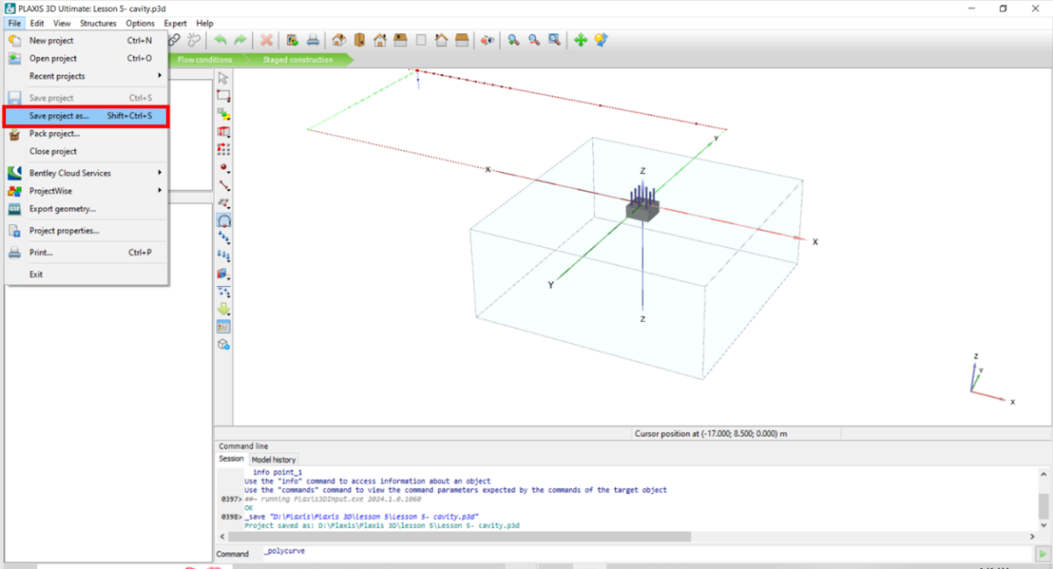

* In the opened window, choose a name for the project for example type in : **Lesson 5- cavity**
* Click **Save.**

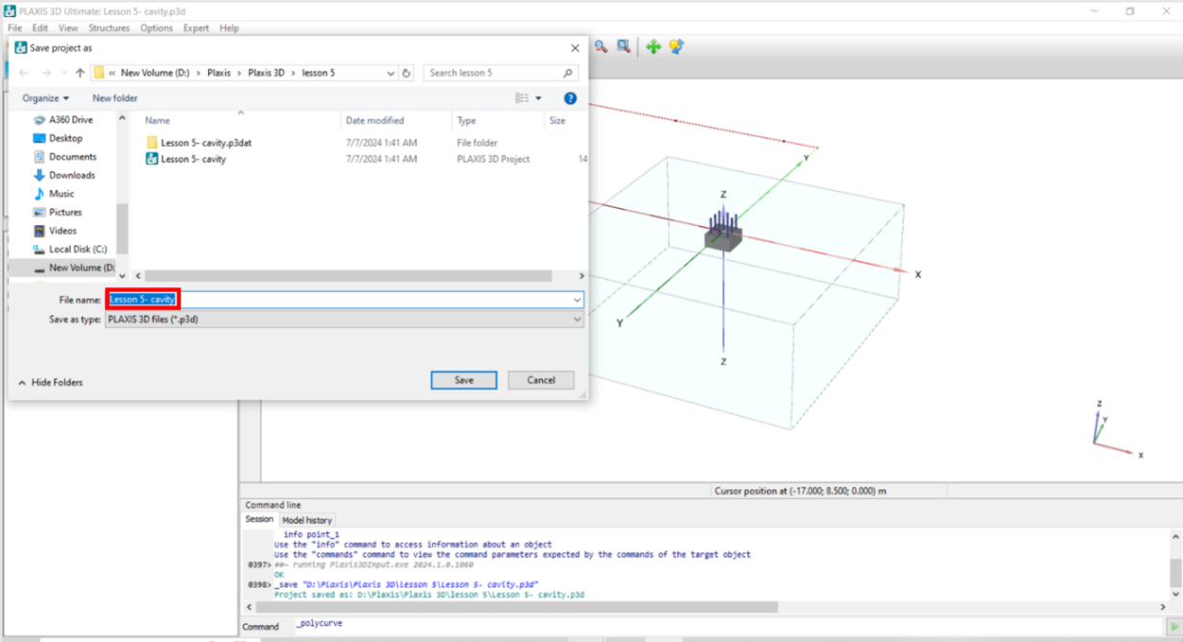

**Task 1: Create a Cavity**

* To create a cavity, click on the **Structures** mode, click on the **Front view** icon to change the view to locate start point of the cavity surface.
* Click on **Start designer** and in its subsection, click on **Create polycurve**.
* Place the start point in: x=0, y= -5, z= -2.5 in the model

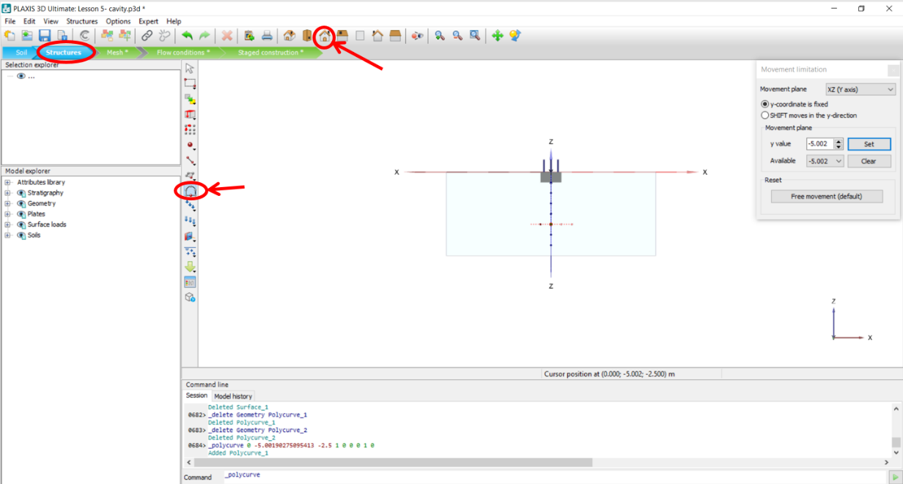

* In the opened window, click on the **Segments** tab, click on the **Circle**, enter circle Radius value : 0.5

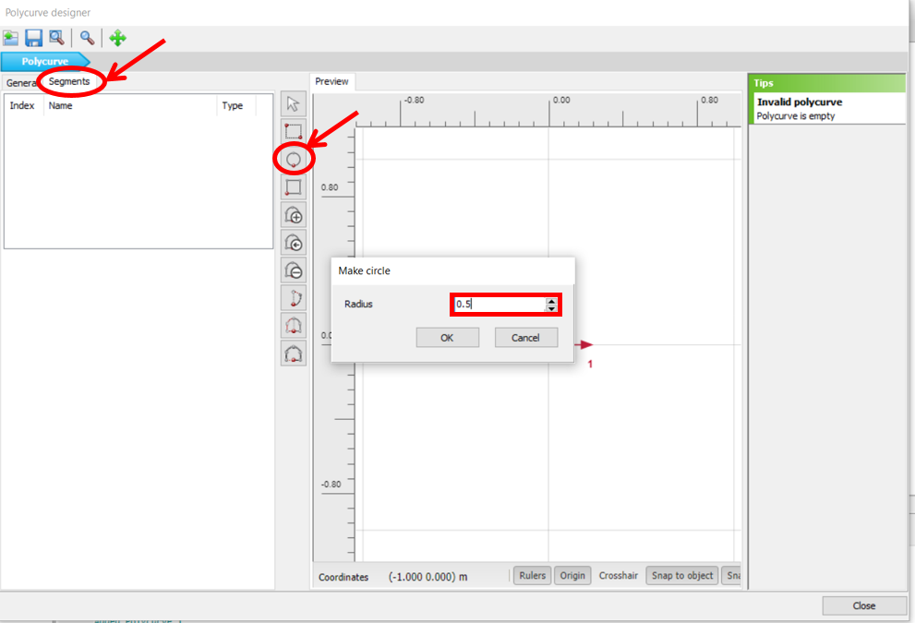

To adjust the created circle, click on the **General** tab, change the followings:

* Enter **Axis 2** value in **Offset to begin point**: -0.5
* Change **Orientation Axis 1** to Z-axis by clicking on drop-down arrow and choosing Z-axis
* Change **Orientation Axis 2** to X-axis by clicking on drop-down arrow and choosing X-axis
* Click **Close**.

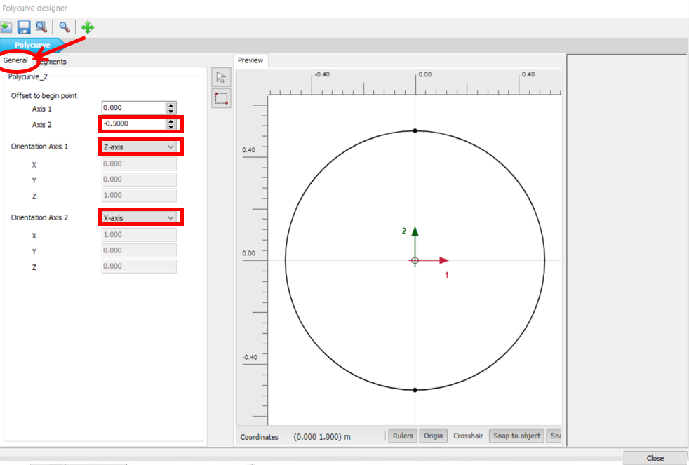

* To create cavity volume, first, the created circle should be changed to surface, make sure the circle is selected, right click on the circle object in the 3D model, click **Create**, and then click on **Create surface**.

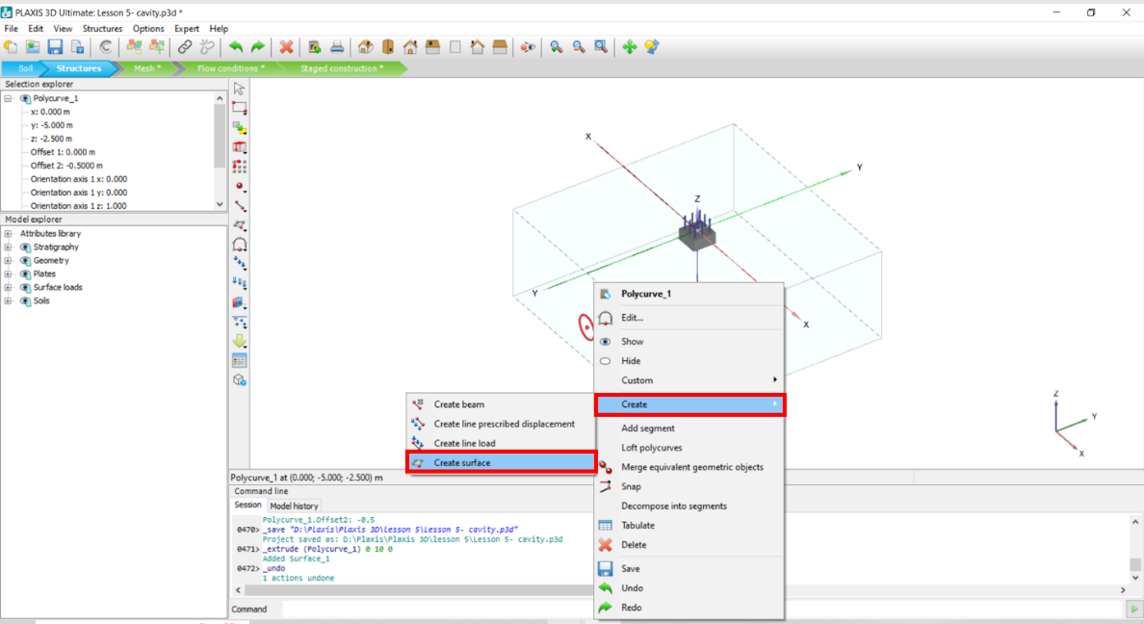

* Select the created surface object in the 3D model, click on the **Extrude** icon.
* In the opened window, enter y value: 10
* Click **Apply** and close the window.

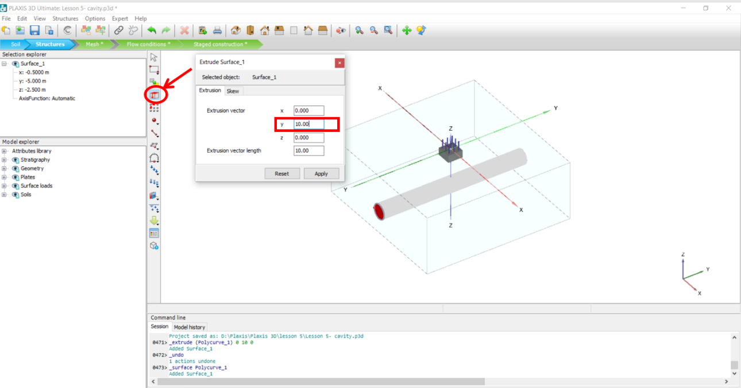

* To assign soil material to the just created cavity volume, in the **Model explorer**, click on the + sign next to **Volumes**, click on the + sign next to **Volume_2**, choose the volume **Material** by clicking on the drop-down arrow, and choose “Silt”.

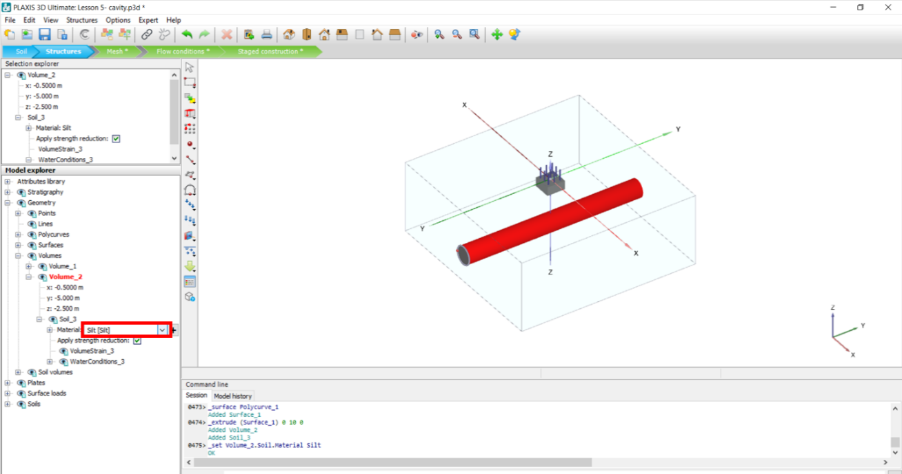

**Task 2: Create a Concrete Pipe**

* To create a concrete pipe, click on the circle line you created for the cavity in task 1, click the **Extrude** icon, and in the opened window, enter y value: 10
* Click **Apply** and close the window.

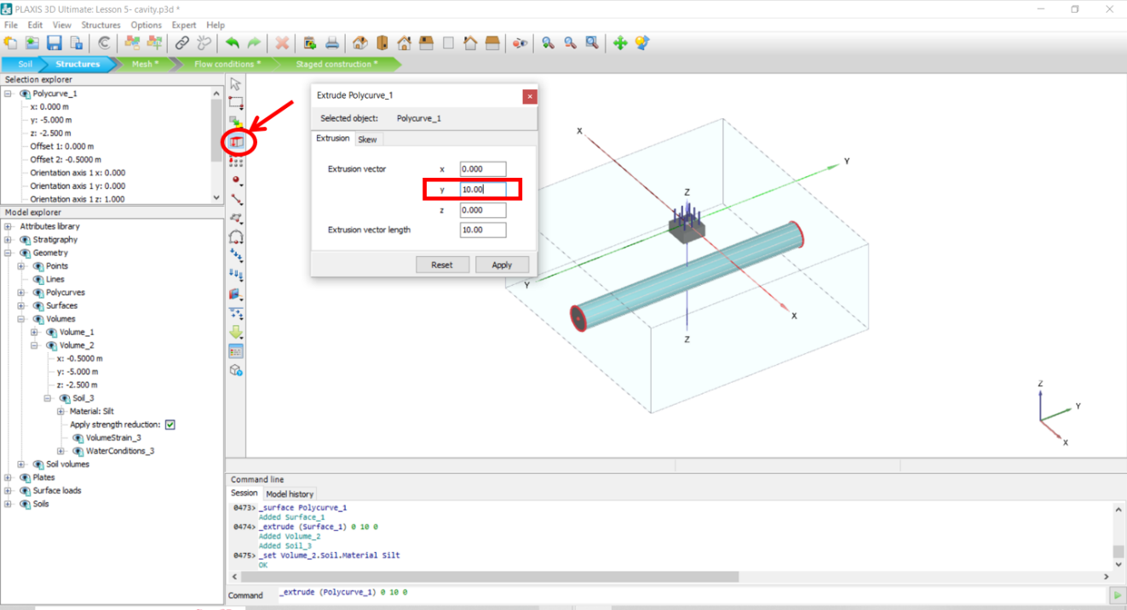

* Right-click on the created cylinder shape surface, click **Create**, and then select **Create plate.**

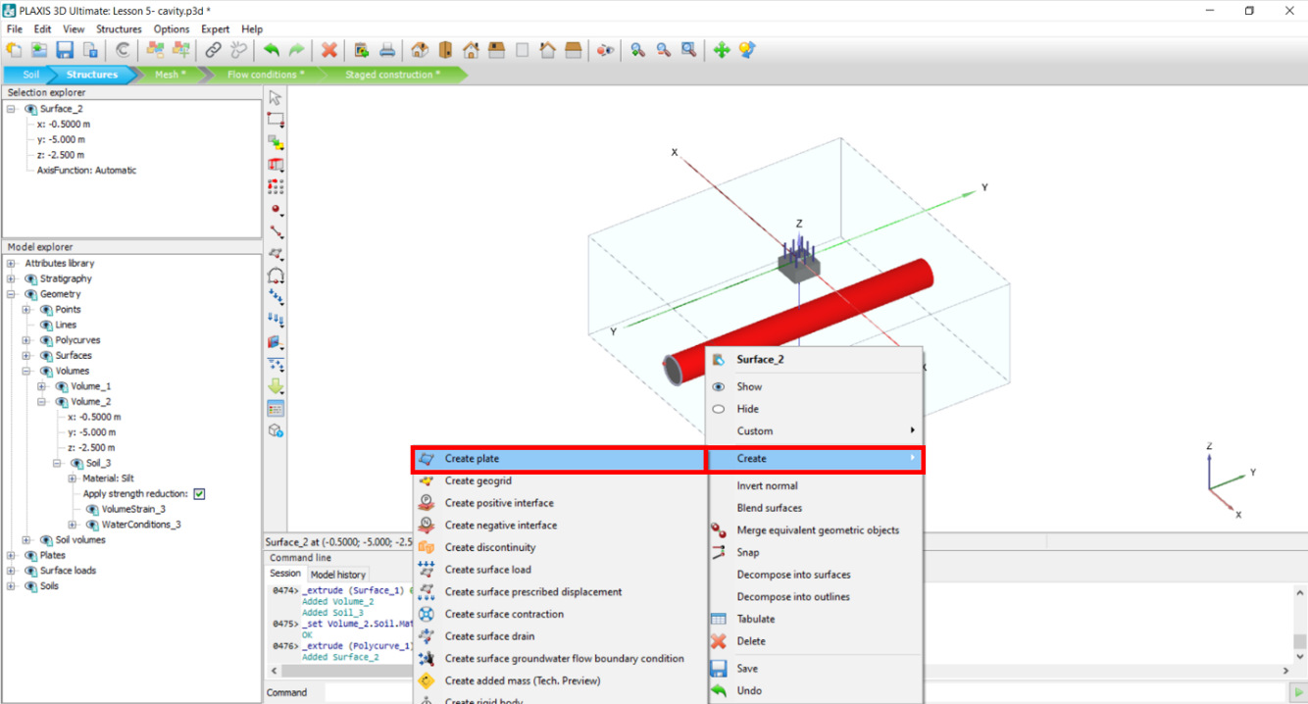

* To define concrete for the pipe, click on **Show material** (figure below), in the opened window, **set type** on “Plates” by clicking on the drop-down arrow (see figure below):
* Right-click on the defined concrete and click **Copy.**

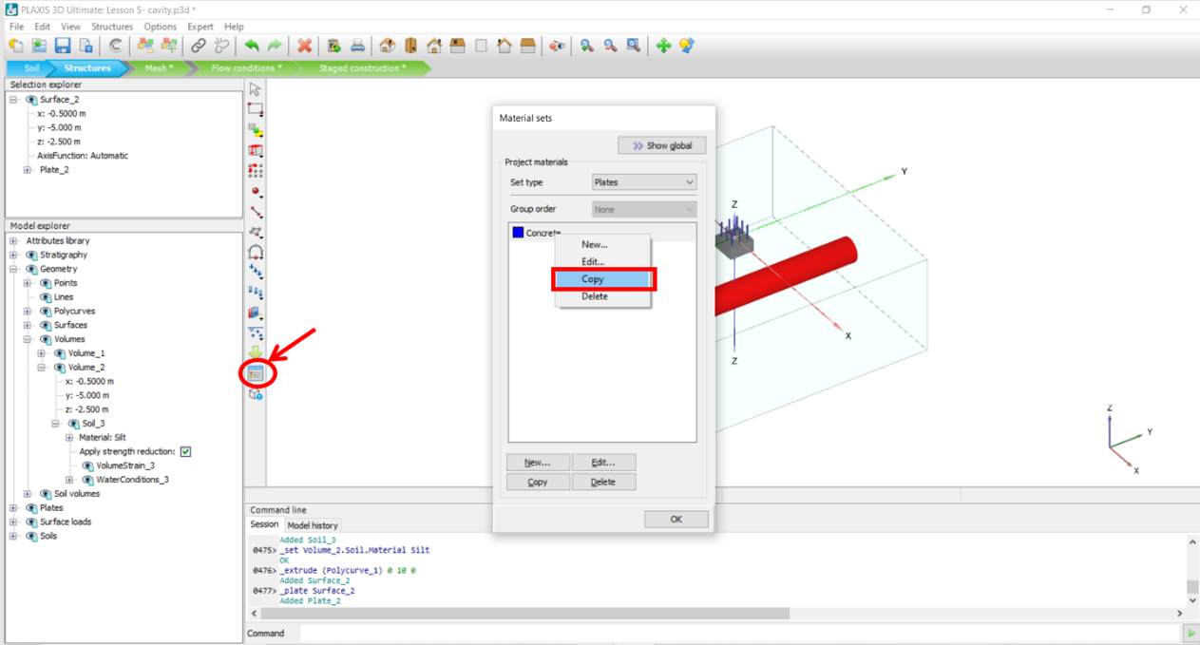

* In the opened window, in the **General** tab, type in “ Concrete-pipe” in the **Identification** box.

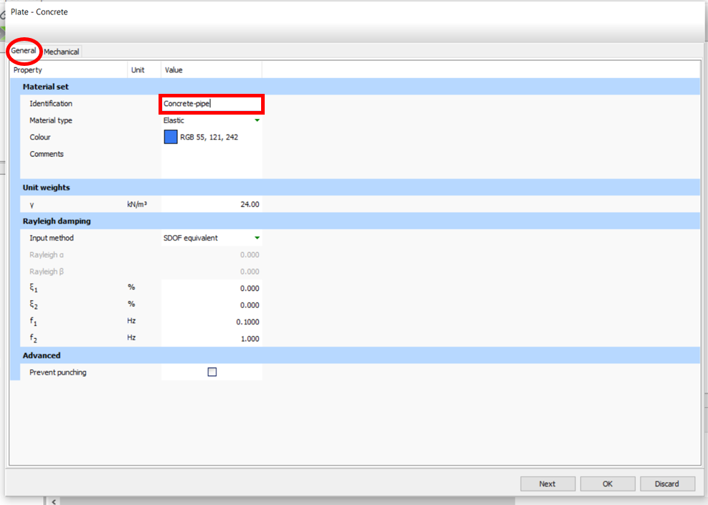

* Click on the **Mechanical** tab, change **d** value to 0.05 (which represents 5 cm thick concrete)
* Click **Ok**.

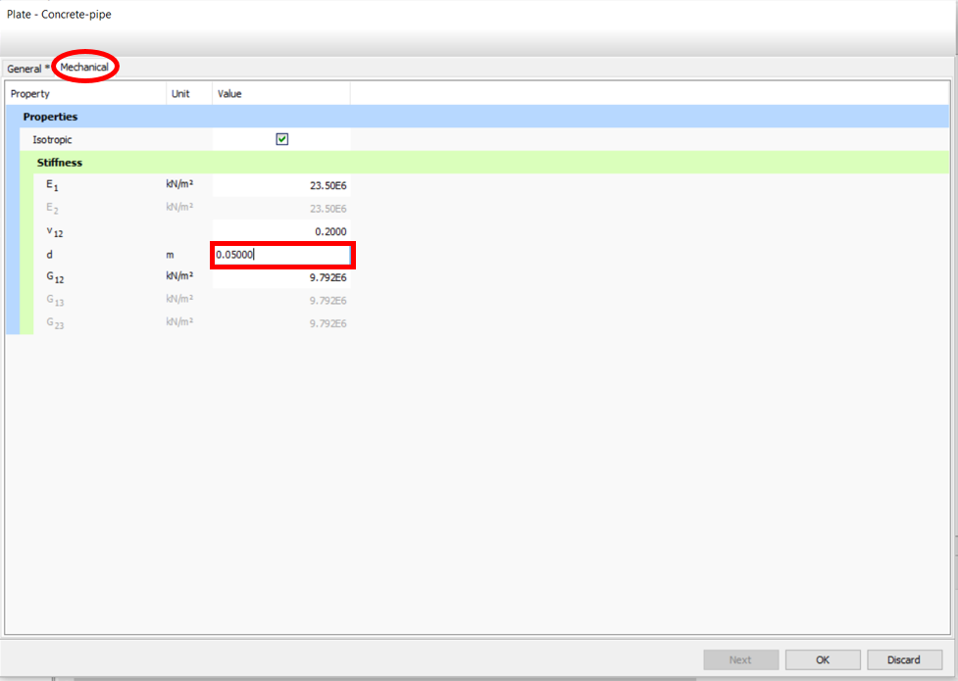

* To assign concrete material to the pipe, in the **Model explorer**, click on the + sign next to **Plates**, click on the + sign next to **Plate_2**, choose **Material** by clicking on the drop-down arrow, and click on “Concrete-pipe”.

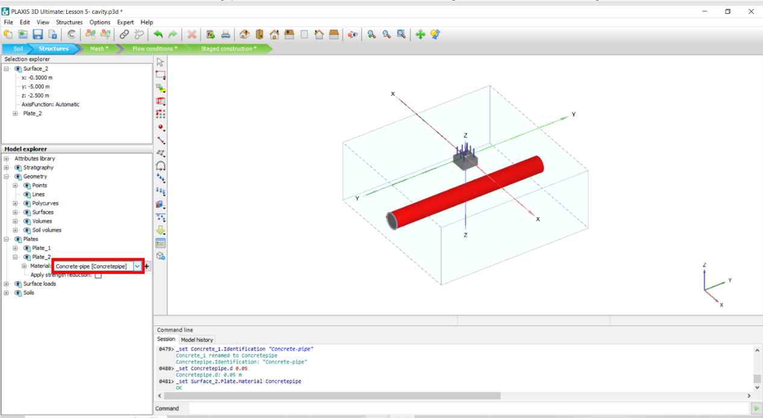

**Task 3: Adjust Load Values**

* To change the assigned load value, in the **Model** **explorer**, click on the + sign next to **Surface loads**, click on the + sign next to **SurfaceLoad_1**, change σz value to -200 kN/m2

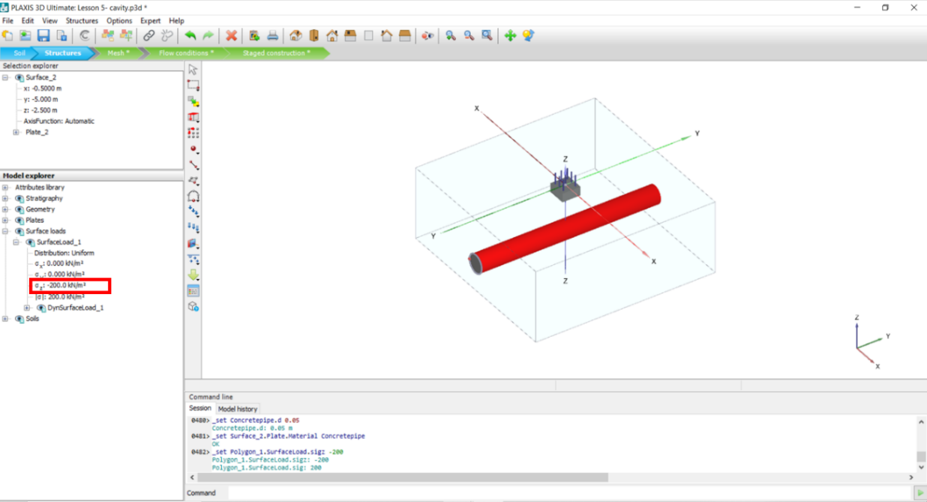

**Task 4: Mesh and Calculation**

* To mesh the model appropriately, go to **Mesh** mode. Click on the **Refine mesh** icon, then click on the two object volumes in the 3D model that are selected and specified with Red color in the figure below. Each click provides a finer mesh in the specified section.
* Click on **Coarsen mesh** and then on the soil volume shown with a Green color in figure below.
* Click **Generate mesh.**

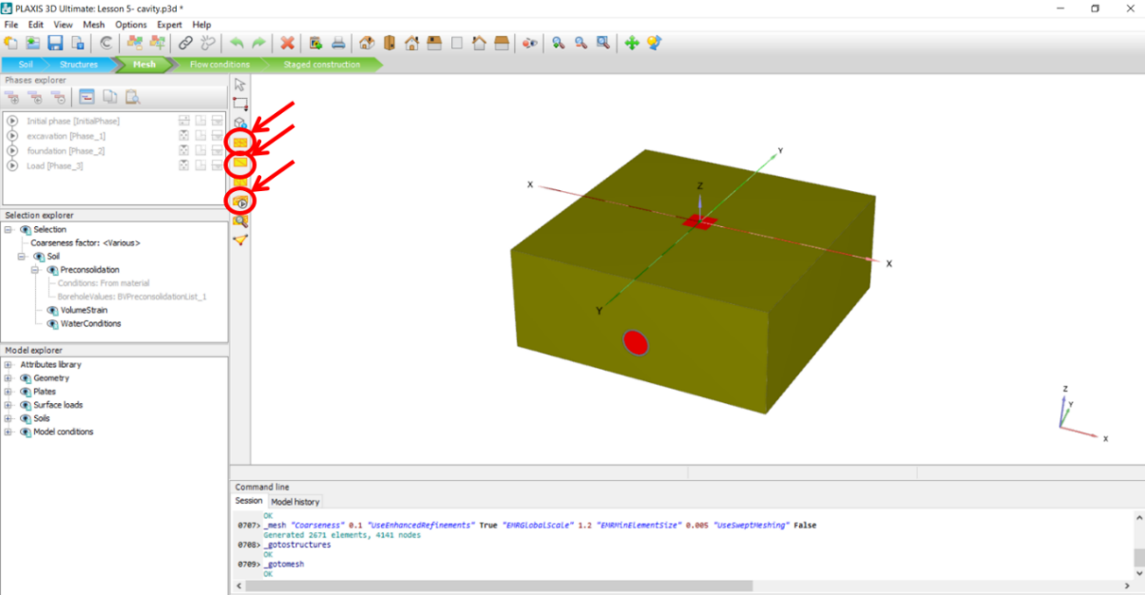

* By clicking on **View generated mesh**, you should be able to see a meshed model that has finer mesh in the specified sections which is gradually changed to the coarsen size.

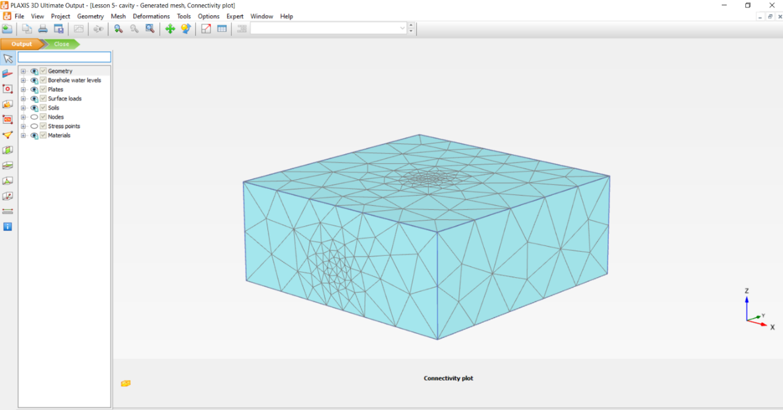

* To choose a point for calculations, click on the **Select point for curves** icon.

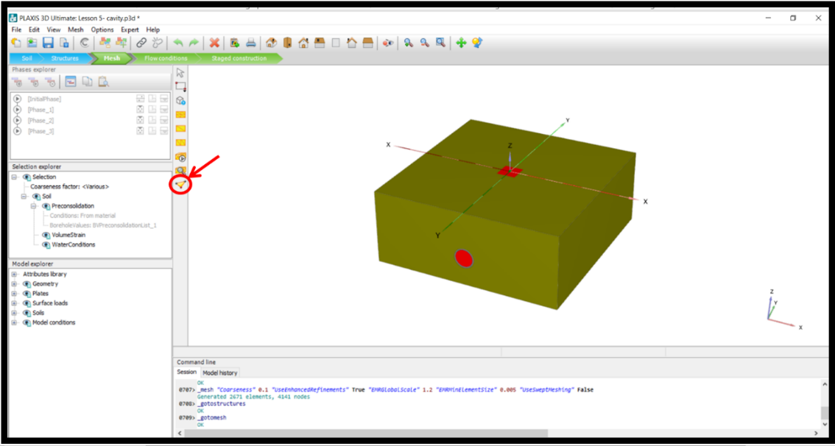

* In the opened window, type in -0.5 in z box and choose the corresponding node. Note that the data selected should be from Plate.
* Click **Update.**

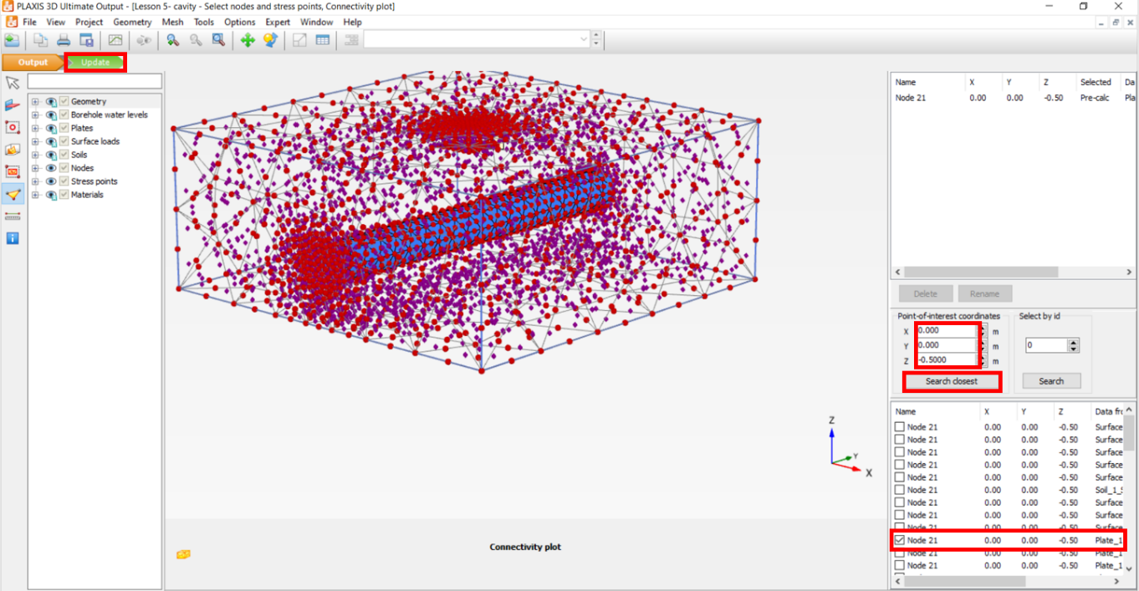

**In this part, the effect of cavity and concrete pipe will be investigated:**

* To understand the effect of the cavity in soil, first analyze the model without the cavity. Click on the **Staged construction** mode.
* Make sure that the **Soil_3** in the **Model explorer** is checked for all phases(InitialPhase, Phase_1, Phase_2, Phase_3)
* Click **Calculate** and then **View calculation results**.

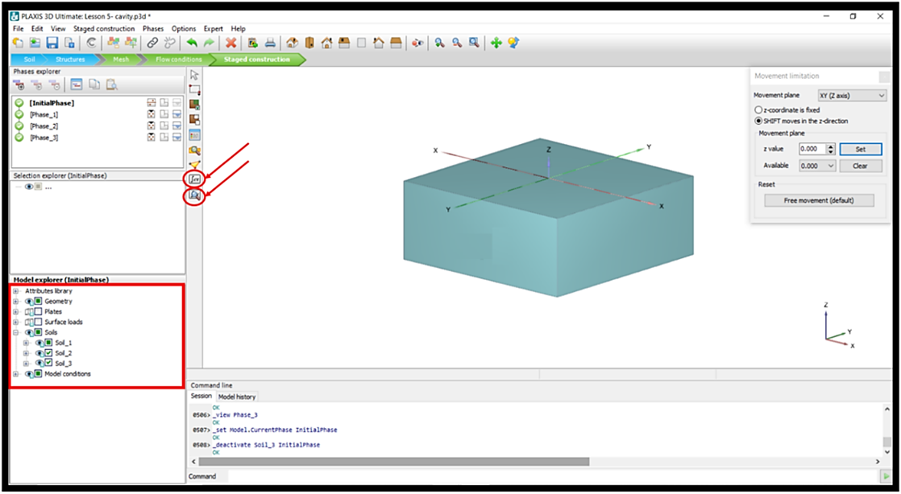

* To plot the Load-Displacement curve, in the opened window, click on **Curve manager**.
* In the opened window, click **New**.

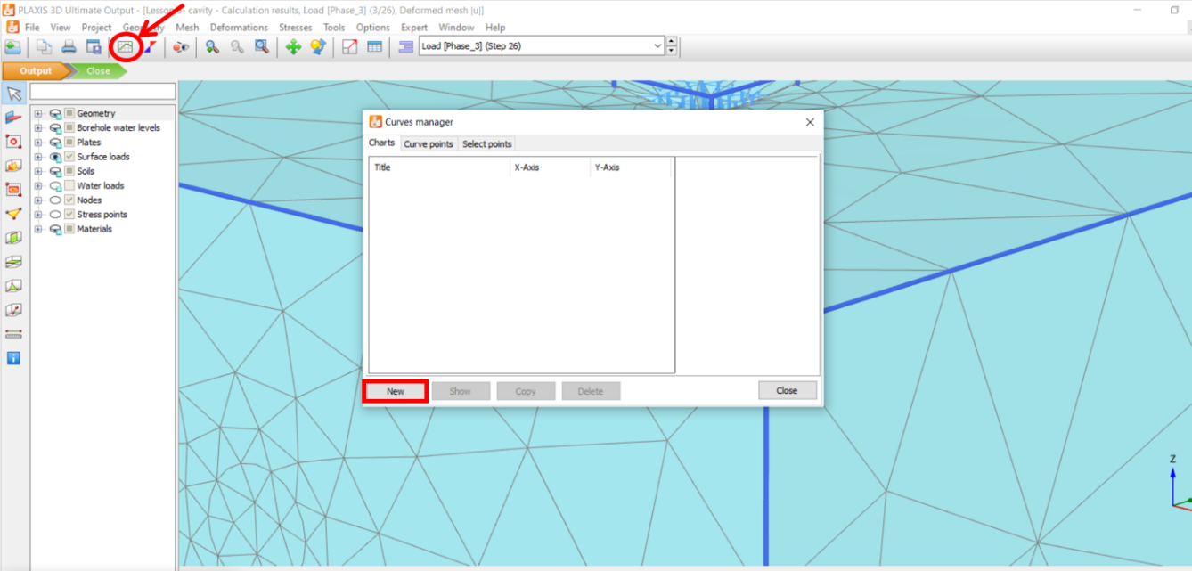

* In the **X-Axis**, choose the project, click on the + sign next to **Multiplier,** and click on **ƩMstage**
* In the **Y-Axis**, choose the selected Node, click on the + sign next to **Deformation**, click on + sign next to **Total displacement,** and click on **uz**
* Click **OK.**

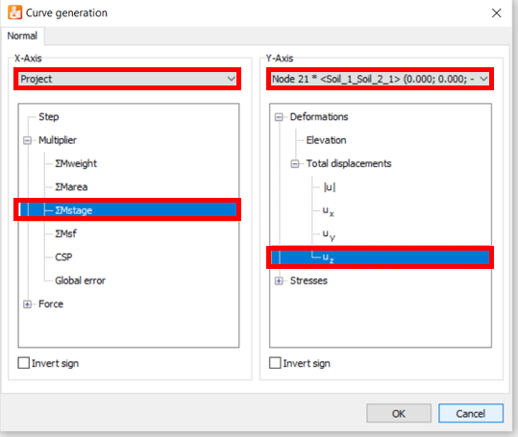

* To remove undesired points in the plotted curve, right-click on the plot sheet and click on **Setting.**

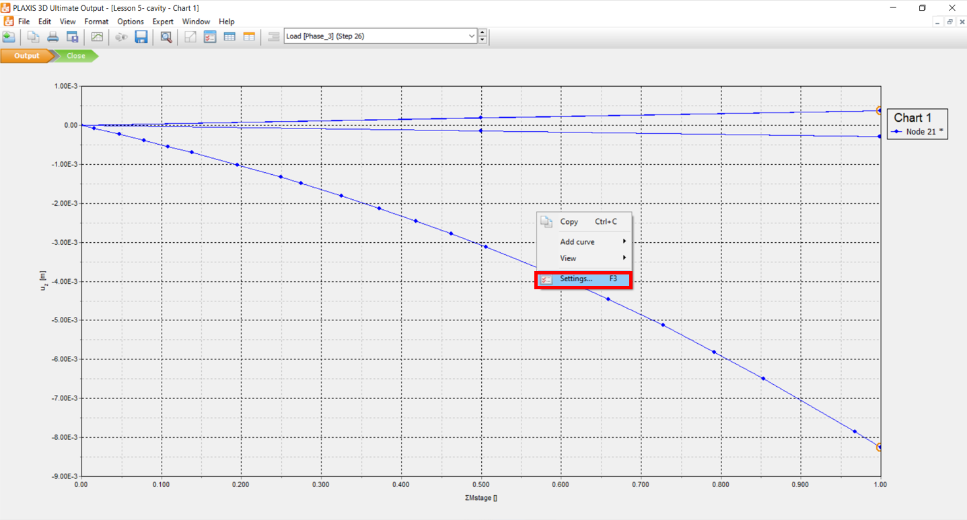

* In the opened window, go to the Node tab, click on the **Phases**, and make sure to uncheck all phases except the Phase_3.
* Click **OK.**

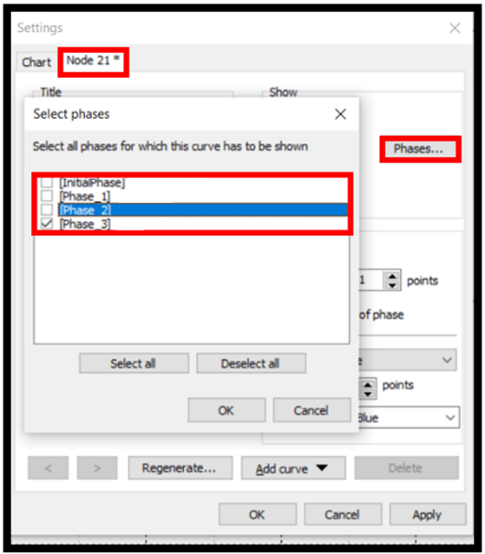

* To observe the result of total displacement in the cross-section, click on the **Vertical cross section** icon and click on the two desired points on the two sides of the model:

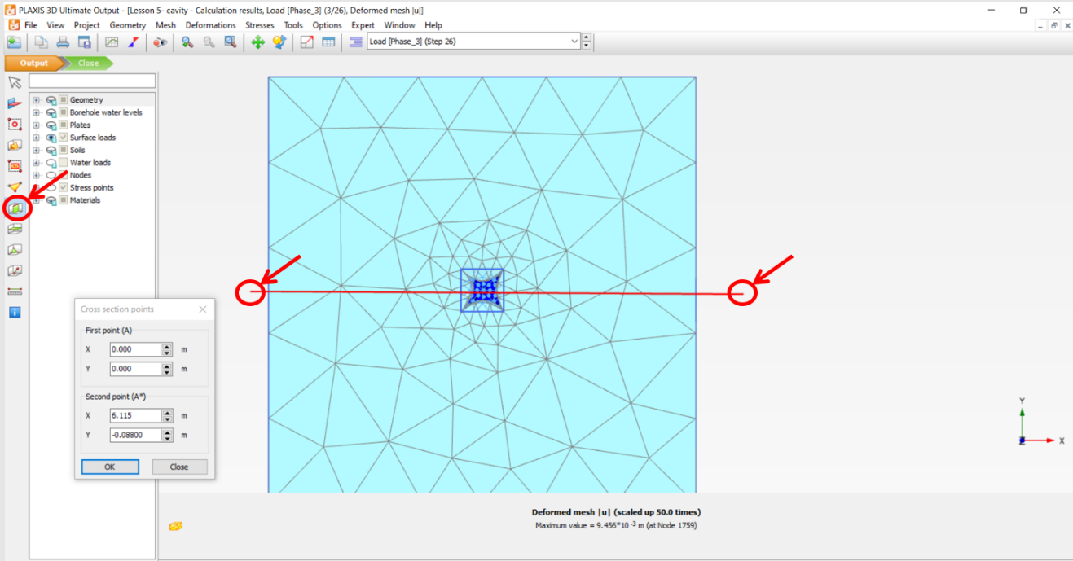

* To view the contours from the front view, click on **View** in the toolbar, and then click on **Viewpoint.**

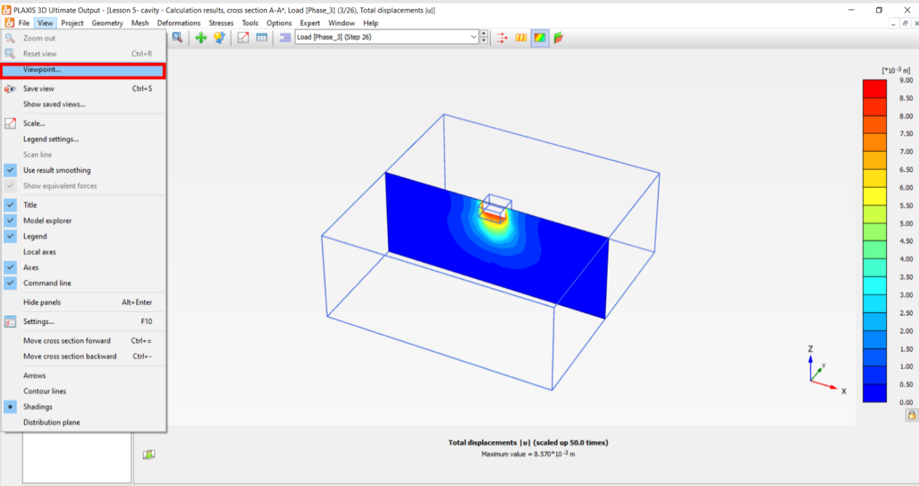

* In the opened window, click on **Front view**, click on **Apply** and close the window.

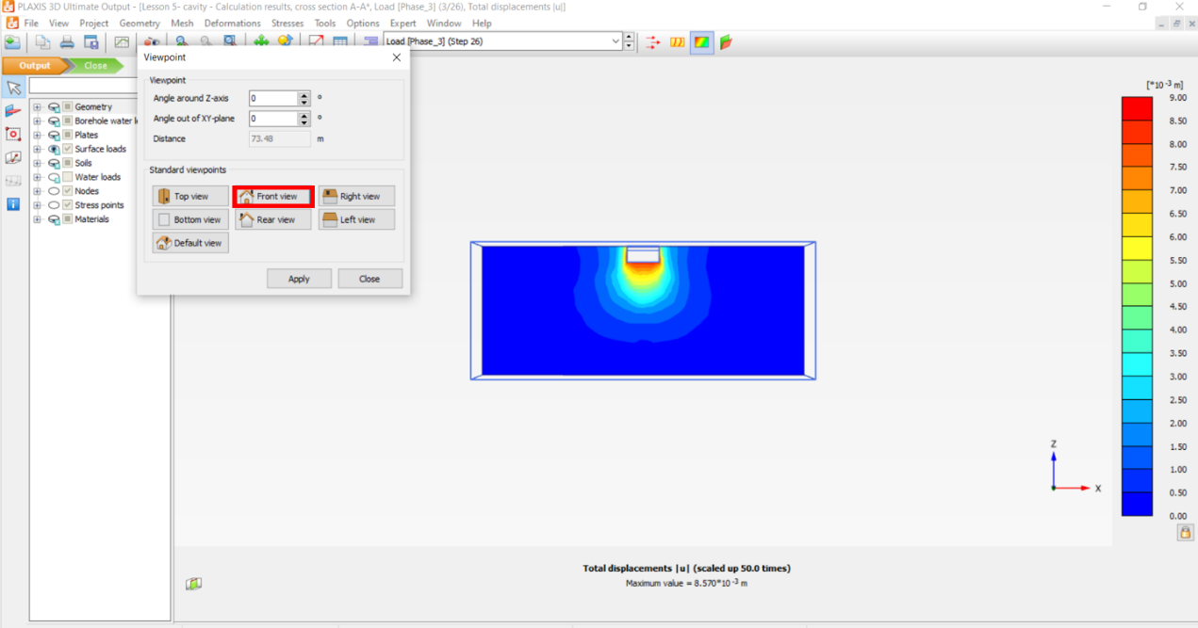

* You should be able to see a displacement contour as shown below:

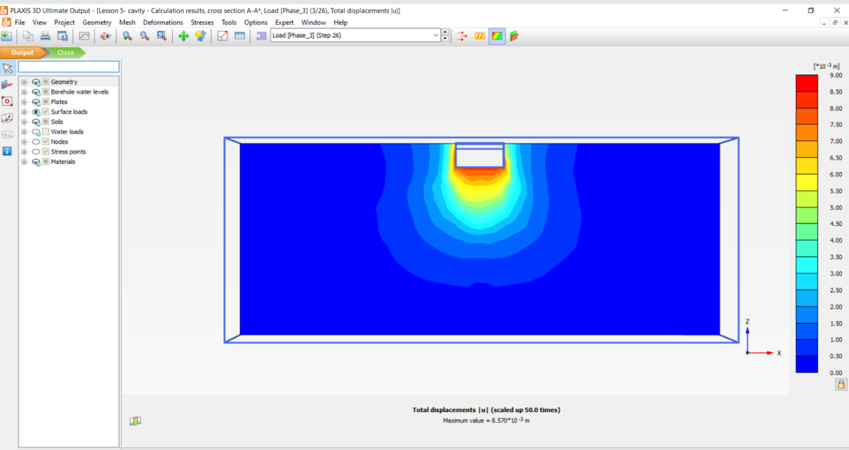

* Now, to investigate the effect of the cavity, make sure **Soil_3** is unchecked in all phases (Initial phase, Phase_1, Phase_2, Phase_3).

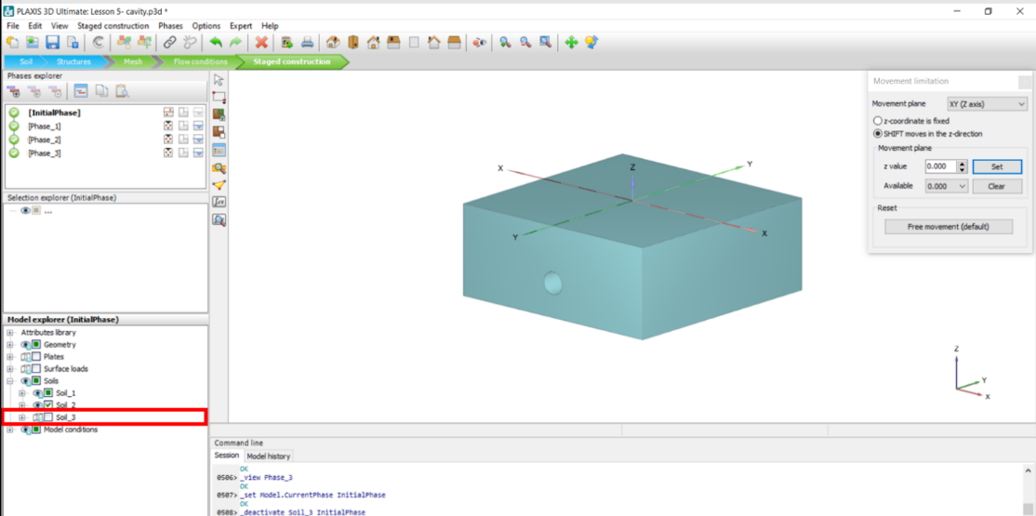

* Perform the **Task 5 (Mesh and Calculations)** again as explained above.
* You should be able to see a displacement contour as shown below:

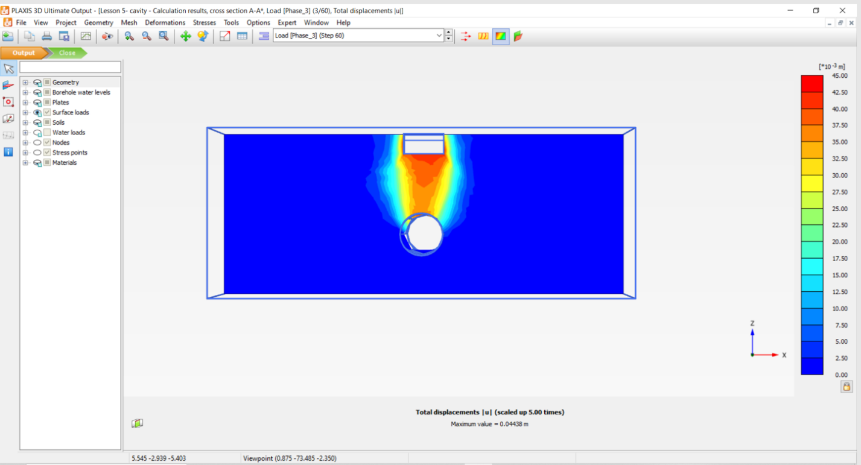

* To investigate the effect of concrete pipe, make sure **Plate_2** is checked in all phases (InitialPhase, Phase_1, Phase_2, Phase_3) and **Soil_3** is unchecked in all phases (InitialPhase, Phase_1, Phase_2, Phase_3)
* Perform **Task 4 (Mesh and Calculations)** as explained above.

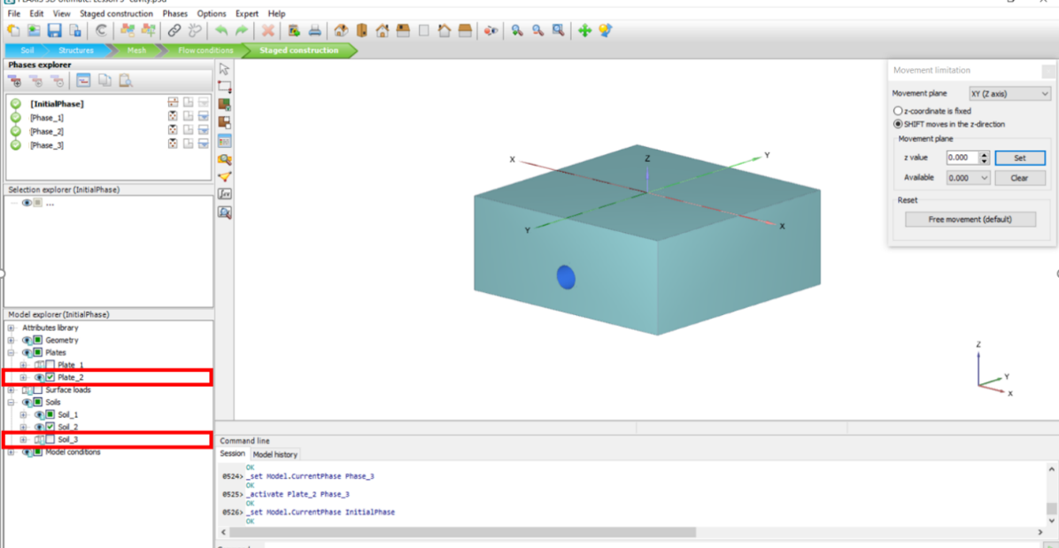

* You should be able to see a displacement contour as shown below:

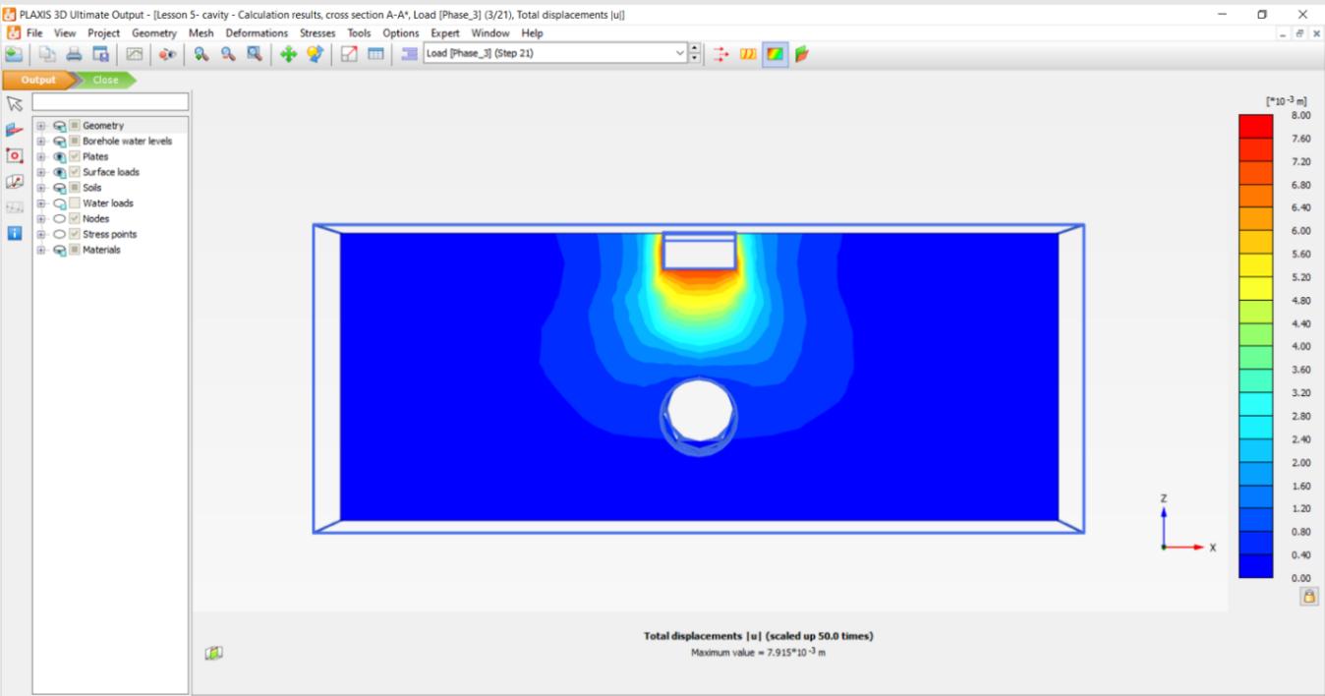

* Export the load-displacement data to an Excel file as explained before and plot the three load-displacement curves for the foundation without a cavity underneath it, with a cavity underneath it, and the concrete pipe underneath it in one plot.
* Below, you can see the Load-Settlement plots for the different conditions:

**Question:**

**Are the results shown in the figure above reasonable? Explain why?**