**PLAXIS 3D Lesson 8:**

**Learning Objective:** This lesson is intended to teach you how to model group reinforced concrete piles using PLAXIS3D.

**Starting a new project**

* Open PLAXIS 3D software and start a new project.

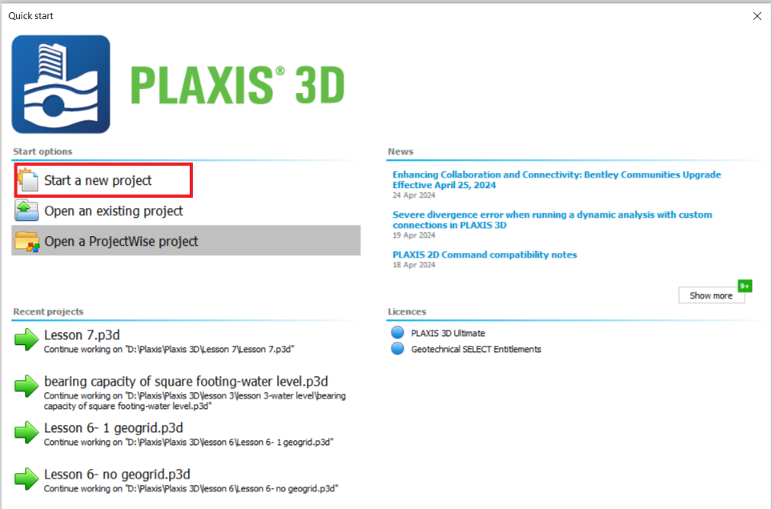

* In the opened window, choose a name for the project. For example, type in “ Lesson 8”.

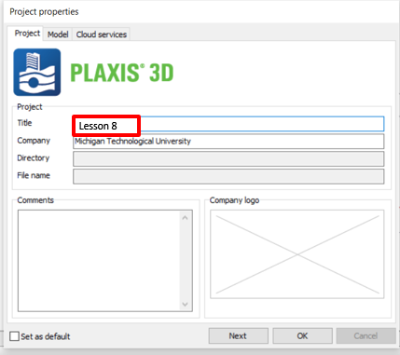

* Click on the **Model** tab, and enter contour values as follows:
* Xmin: -15 m, Xmax:15 m, Ymin: -15 m, Ymax: 15 m, and click **OK.**

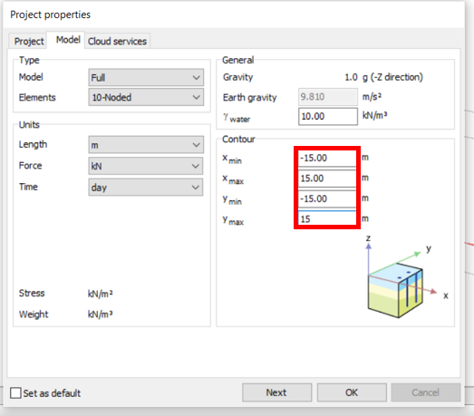

**Task 1: Define Soil Layer and Water Elevation**

* Click on **Create borehole**, and then click on the corner (x=-15, y=-15) of the model. In the opened window, click **add**. In the **Bottom** box under Borehole_1, enter “-25”.
* In the **Head** box, enter “-3”
* Click **OK.**

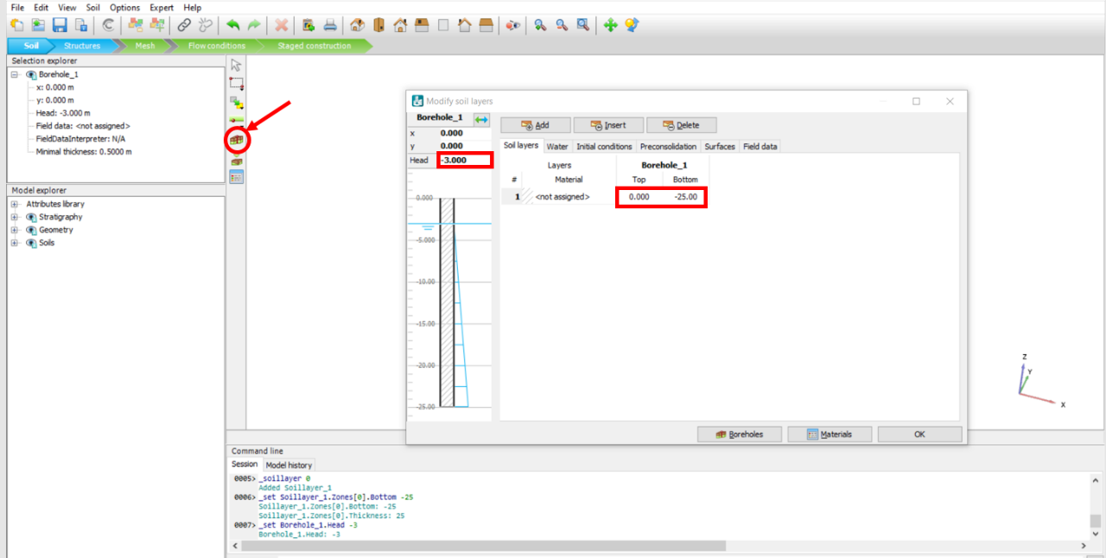

* Click on the **Show** **Materials** icon. In the opened window, keep **Set type**, “Soil and interfaces”, and click on the **New** icon.

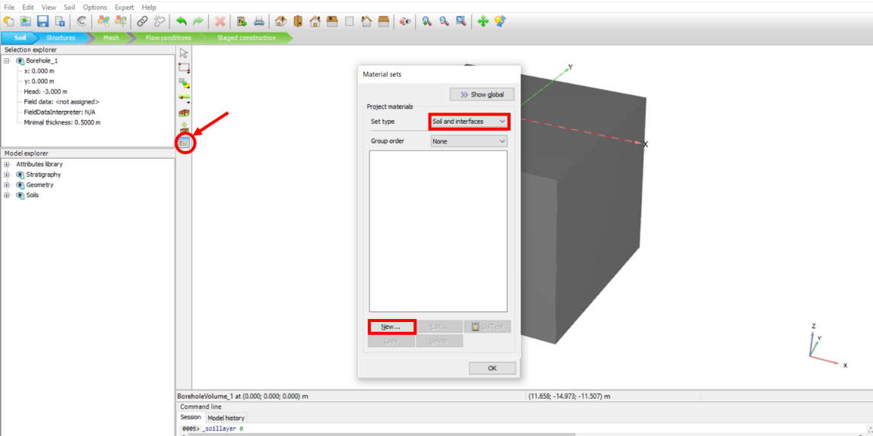

* In the opened window, choose a name for the soil. For example, type in “Soil” in the **Identification** box.
* Enter soil unit weights as follows: γunsat :16 kN/m3, γsat :18 kN/m3

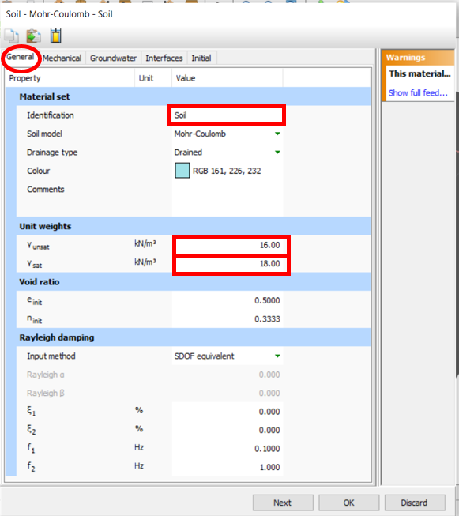

* To define Mechanical properties of the soil, click on the **Mechanical** tab and enter them as follows: $E_{ref}^{'}$: 8000 kN/m3, ט(nu): 0.3, : 12 kN/m3, ø’(phi): 22

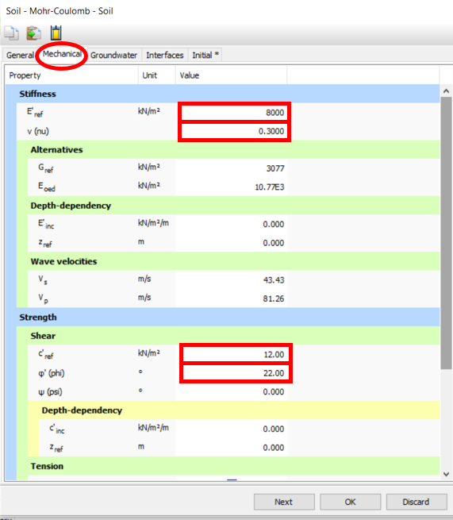

* To define Interfaces properties manually, click on the **Interfaces** tab. In the **Strength** section, change **Strength determination** to “ Manual” by clicking on the drop-down arrow of its box.
* Inter **Rinter** value: 0.6 (Rinter is the shear reduction factor at the interface between a structural element and soil).
* Click **OK.**

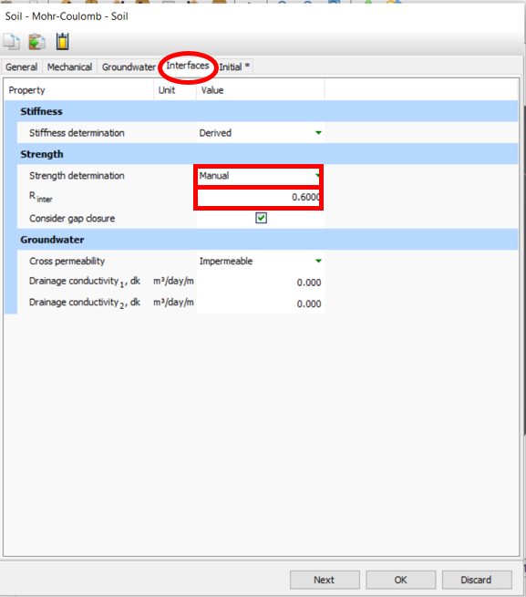

* To define reinforced concrete piles properties, in the Materials window, keep **Set type**, “Soil and interfaces”, and click on the **New** icon.
* In the opened window, choose a name for the pile. For example, type in “Pile” in the **Identification** box.
* To define pile behavior, change **Soil model** to “Linear Elastic” by clicking on drop-down arrow next to its box.
* To define pile drainage type, change **Drainage type** to “Non-porous” by clicking on drop-down arrow next to its box.
* Enter pile unit weights as follows: γunsat :26kN/m3

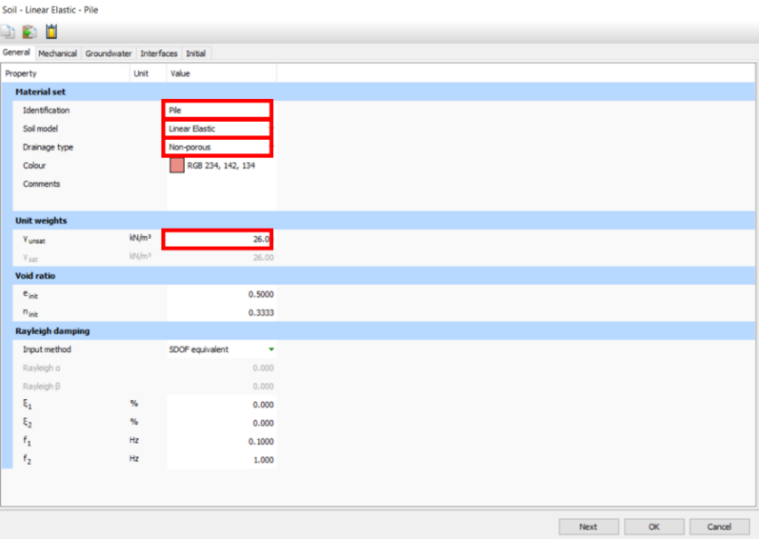

* To define Mechanical properties of the reinforced pile, click on the **Mechanical** tab and enter them as follows: $E_{ref}^{'}$: 29.5E6 kN/m2, ט(nu): 0.2

Calculations: E is the equivalent Modulus of elasticity for concrete and steel composition and can be calculated as follows:

E= Ec (1 - ρ) + Es ρ

Es= Modulus of elasticity of the steel, Ec=Modulus of elasticity of the concrete, ρ=Steel ratio= As/ A, As=Cross-sectional area of the steel, A=Total cross-sectional area

Cosidering : Ec = 25E6 kN/m3, Es= 2.5E8 kN/m3, ρ= 2% => E= 29.5E6

Calculations: γ is the equivalent density for concrete and steel composition and can be calculated as follows:

γ= γc (1 - ρ) + γs ρ

γs= Density of the steel, γc=Density of the concrete, ρ=Steel ratio= As/ A, As=Cross-sectional area of the steel, A=Total cross-sectional area

Cosidering : γc = 25 kN/m3, γs= 78.5 kN/m3, ρ= 2% => γ= 26

* Click **OK**.

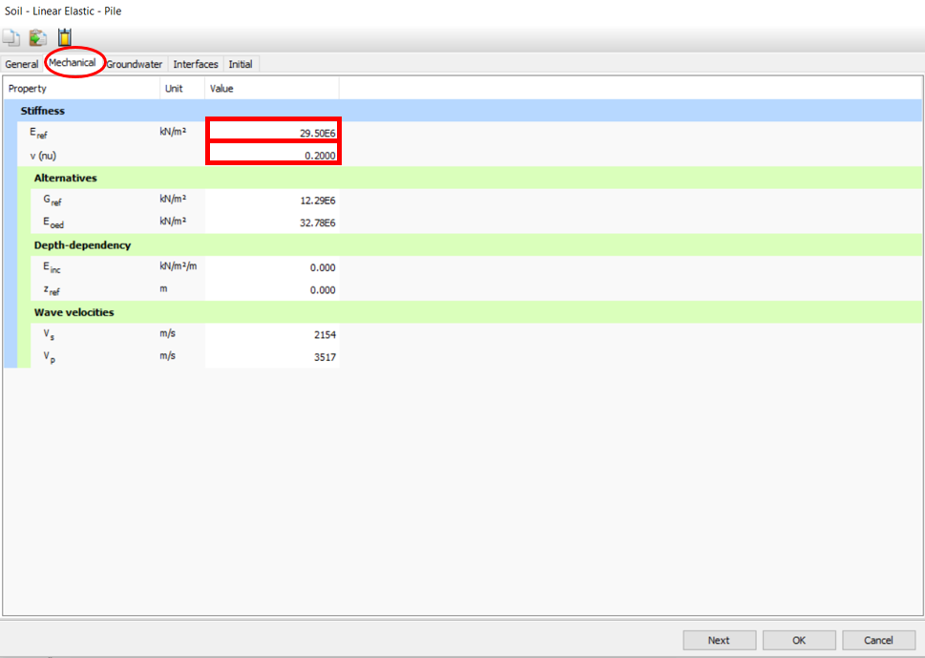

* To define concrete material (for pile cap), in the Material window, change **Set type** to “Plates”, then click on the **New** icon.

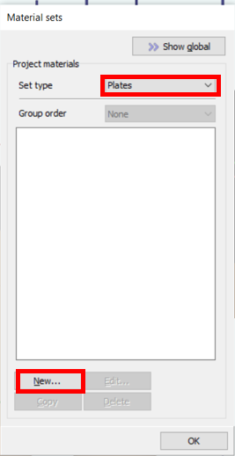

* In the opened window, choose a name for the concrete. For example, type in “Concrete” in the **Identification** box.
* To define pile cap behavior, change the **Material type** to “Elastic” by clicking on drop-down arrow next to its box.
* Enter pile cap unit weights as follows: γ:25 kN/m3

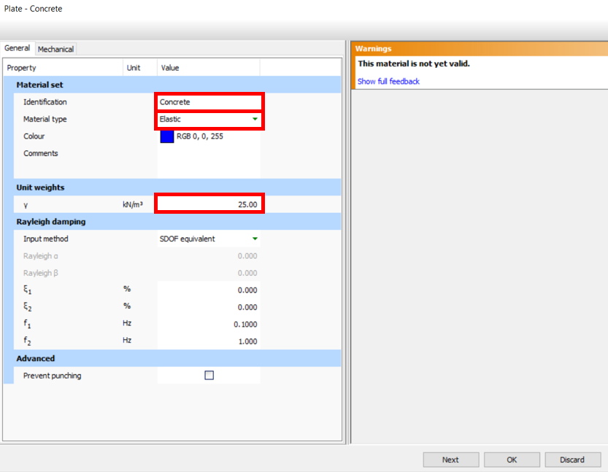

* To define Mechanical properties of the concrete, click on the **Mechanical** tab and enter them as follows: E1: 25E6 kN/m2, v12: 0.2, d: 0.5 m, G12: 10.42E6 kN/m2

The v12, and G12​ notations refer to the Poisson’s ratio, and shear modulus in the plane of the first and second axes (x and y axes), respectively.

* Click **OK**.

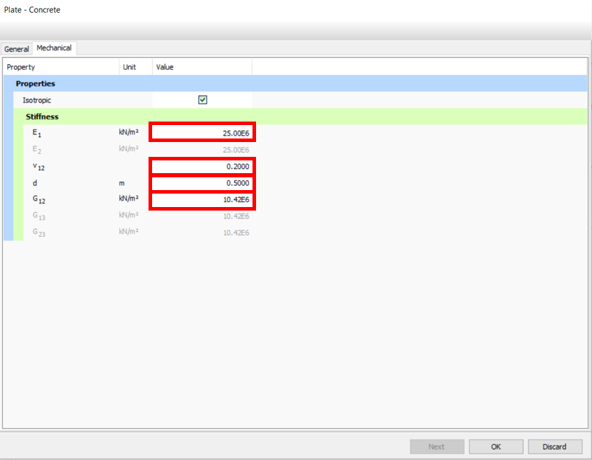

* To assign soil properties to the soil layer, in the **Model explorer**, click on the + sign next to **Soils**, click on the + sign next to **Soil_1**, click on the drop-down arrow next to **Materials,** and click on “Soil [Soil]”

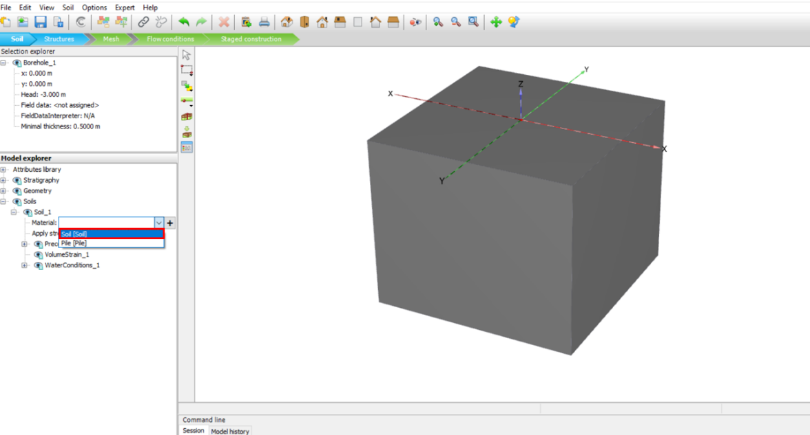

* To create a pile, click on the **Structures** mode, click on the **Start designer icon,** and then on **Create polycurve**. Click on (X=-3, Y=3, Z=0) in the 3D model. In the opened window, click on the **Segment** tab, click on the **Circle** icon, and in the opened window, enter **Radius** value : “0.3”. Click **OK**.

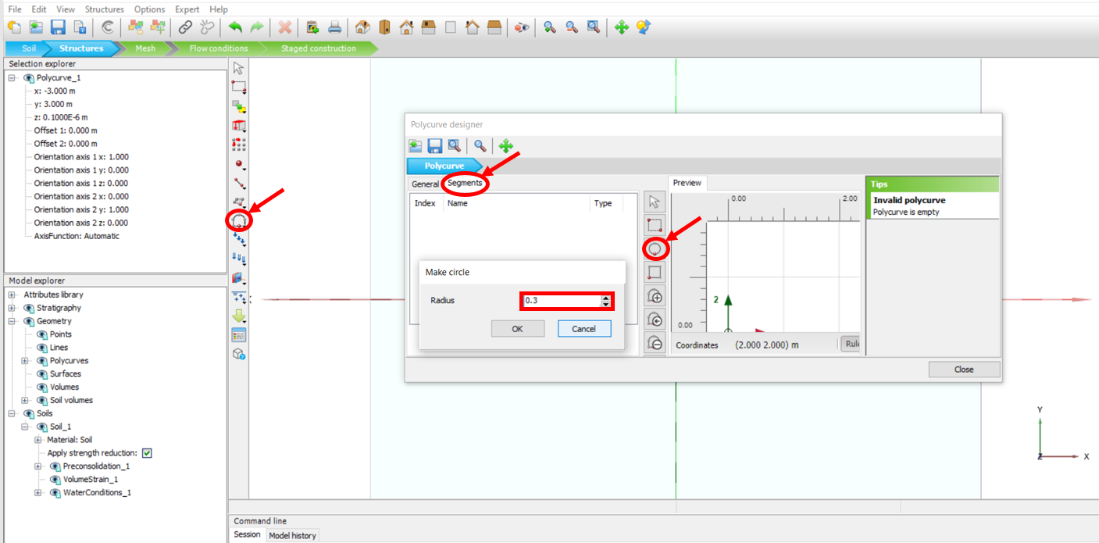

* Click on the **General** tab, enter **Axis 2** value “-0.3”, and click **Close**.

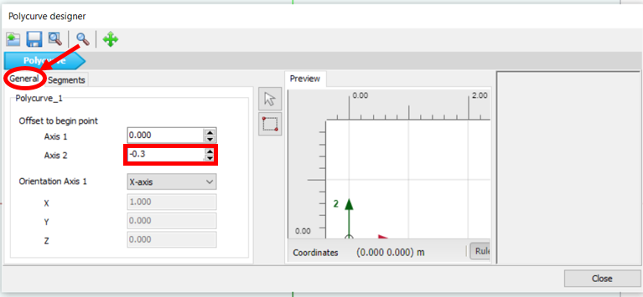

* Right-click on the just created circle, click on **Create**, and then on **Create surface**.

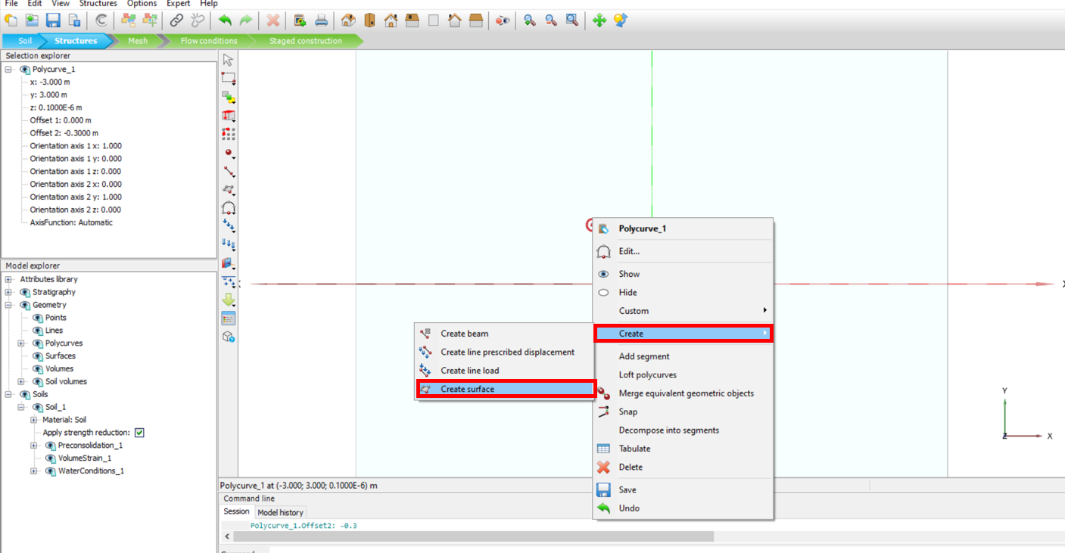

* To create multiple piles, while both the created surface and the circle are selected, click on the **Create array** icon. In the opened window, click on drop-down arrow next to **Shape** and click on “1D, in x direction”, enter **Distance between columns** value: “6”

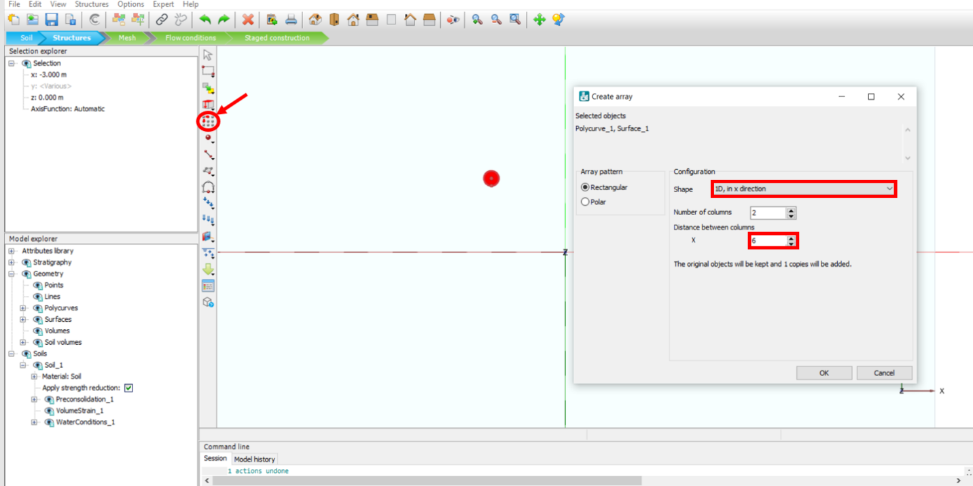

* While all created circles and surfaces are selected, click on the Create array icon, in the opened window, click on the drop-down arrow next to **Shape** and click on “1D, in y direction”, enter **Distance between columns** value: “-6”

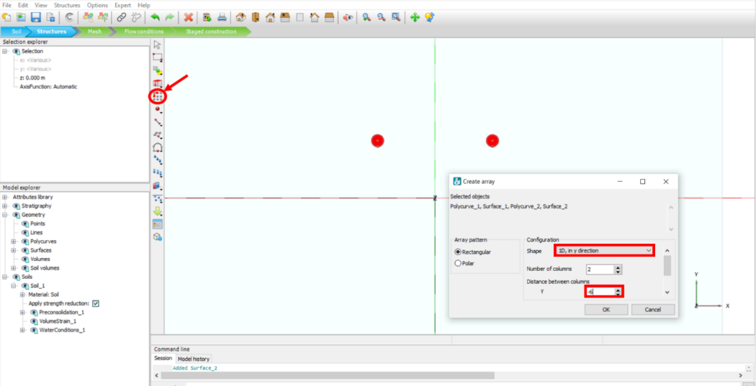

* While all the created circles and surfaces are selected, click on the **Extrude** icon. In the opened window, enter z value: “-12”

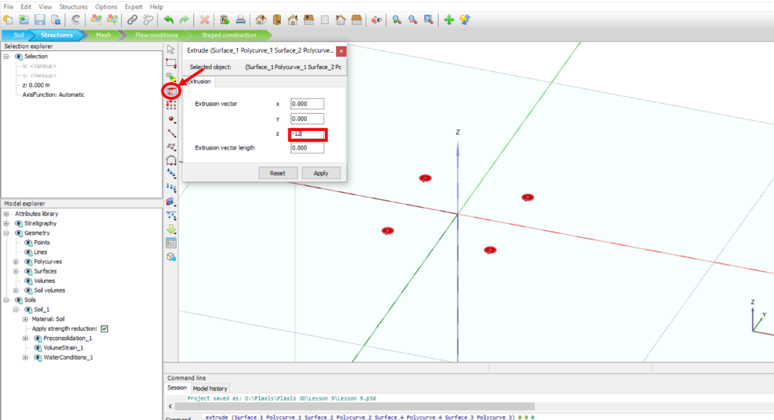

* Select top circles and surfaces, right click on them, and then click **Delete**.

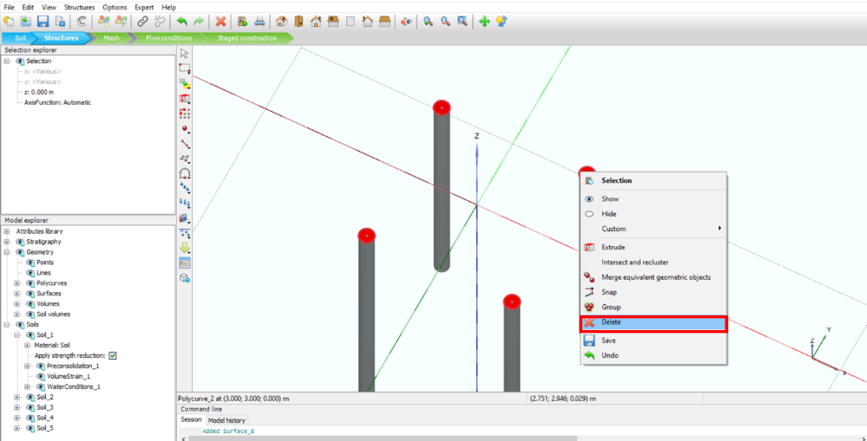

* Select the surrounding surfaces of the piles, right click on one of them while they are all selected, and click on **Create**. Then, click on **Create positive interfaces.**

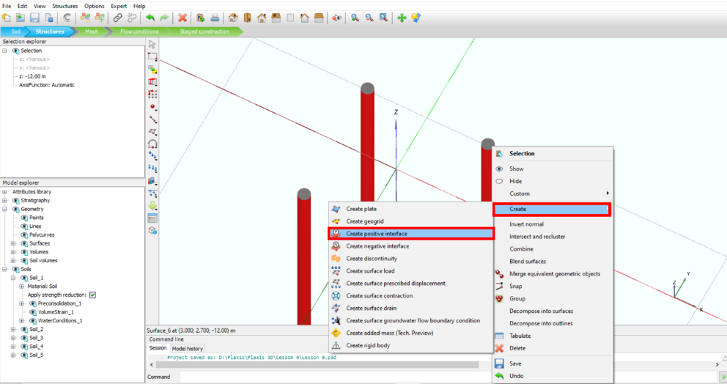

* To adjust spacing for the further designs, click on the **Options** icon in the toolbar, then click on **Visualization settings.**

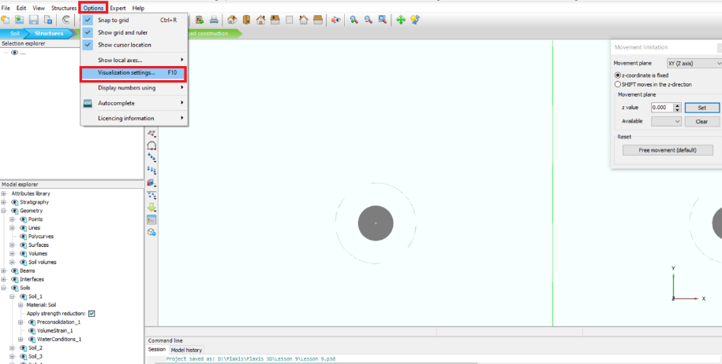

* In the opened window, enter Spacing value:” 0.3” , and click **OK.**

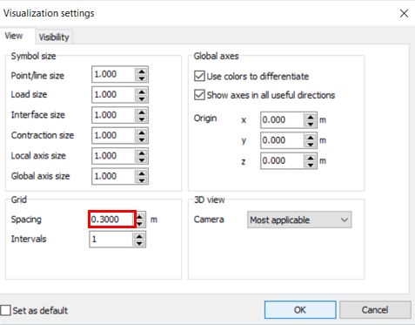

* To create a surface cap of the piles, click on the Create surface icon, then click on following points to create a surface (you can click on random points and enter values in the opened window while you are creating them) :

(X: -3.6, Y: 3.6, z: 0), (X: -3.6, Y: 3.6, z: 0), (X: 3.6, Y: 3.6, z: 0), (X: 3.6, Y: -3.6, z: 0)

* Right click on the just created surface, click on the **Create** icon, and then click on **Create plate.**

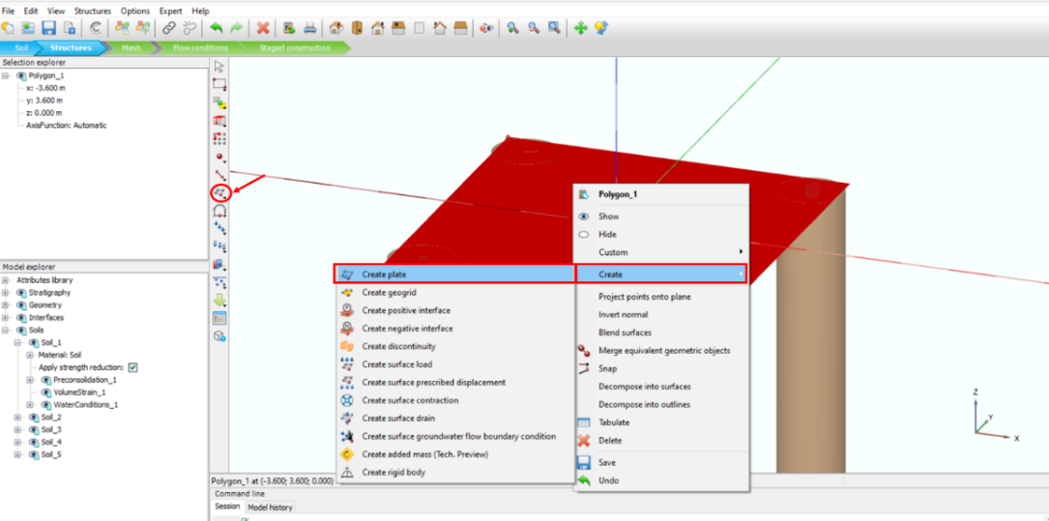

* In the **Model explorer**, click on the + sign next to **Plates**, then click on the + sign next to Plate-1, click on drop-down arrow next to Materials, and choose “Concrete”.
* In the **Model explorer**, click on **Interfaces.** In the **Selection explorer,** change the Material mode to “From adjacent soil” by clicking on drop-down arrow next to its box.

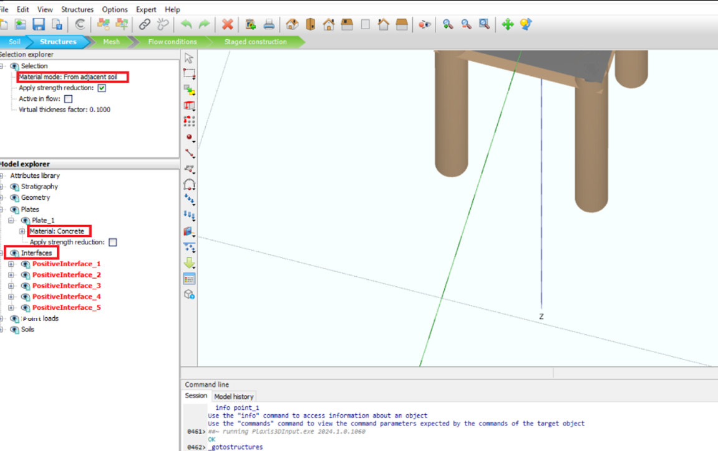

* Select the created plate surface, right click on that, and click on the **Create** icon. Then, click on **Create positive interface.**

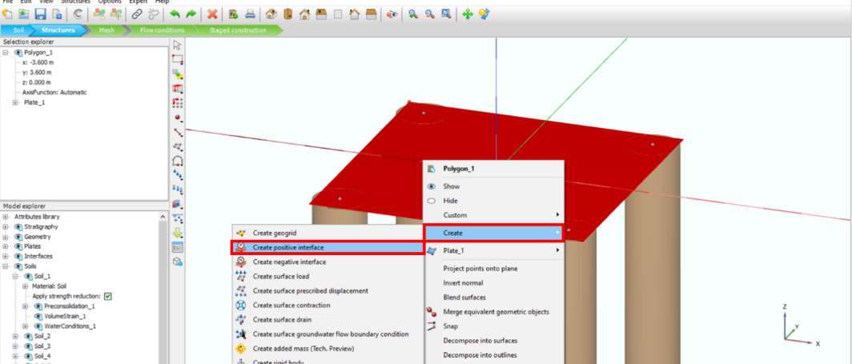

* To assign a point load, click on **Create Load**, and then click on the **Create point load.**
* Click on the center of the plate and place the point load in x,y,z=0 coordinate.

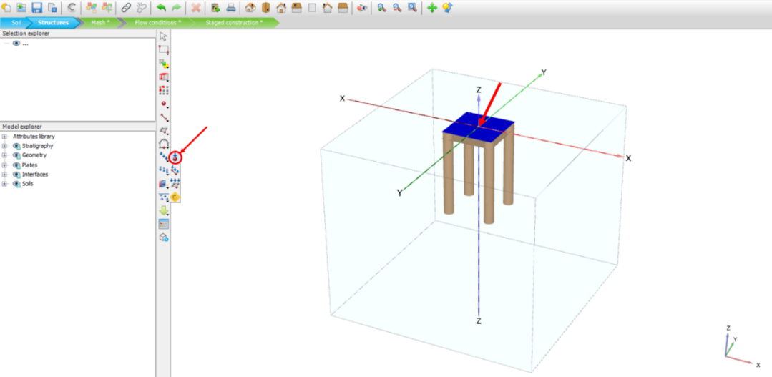

* In the **Model explorer**, click on the + sign next to the **Point loads**, click on the + sign next to the **PointLoad_1**, enter **Fz** value: “-1000”

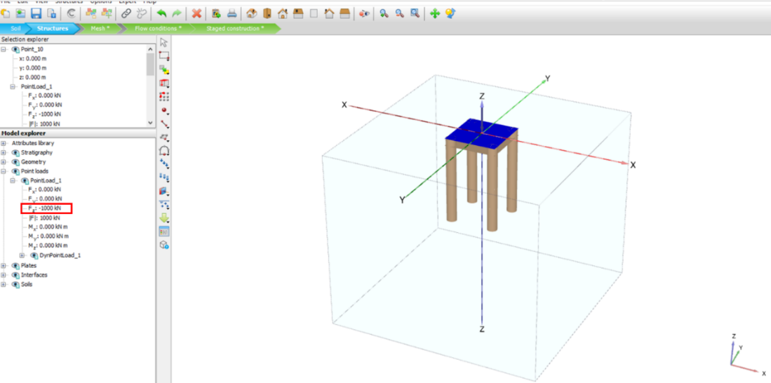

* Go to **Mesh** mode and click on **Generate mesh**. In the opened window, click on the drop-down arrow next to the **Element distribution** and choose ”Very coarse”, then click **OK.**
* Click on the **Select points for curves** icon to select a point for calculation.

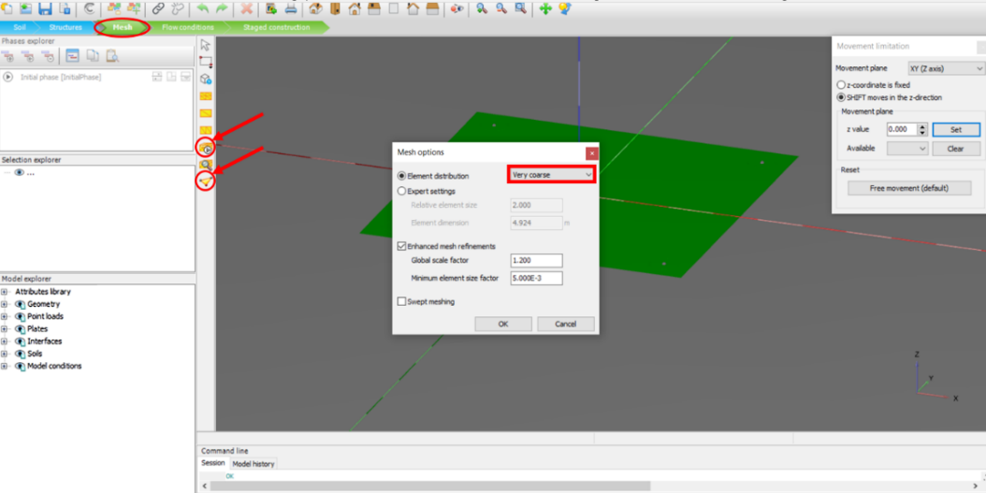

* In the opened window, in the **Point of interest coordinates** section, enter considered value (x,y,z=0). Click on the **Search closest** icon, check the box next to the desired node (choose a point with data from plate), and then click on the **Update** icon.

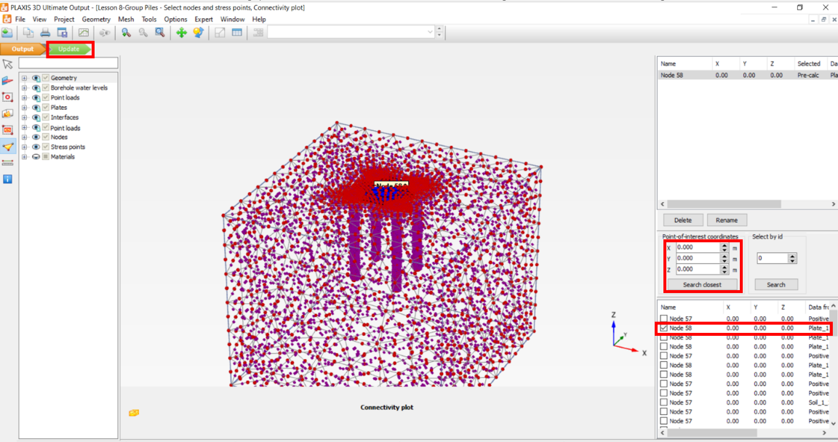

* Go to **Staged construction** mode and click on the **Add phase** icon to add a new phase.

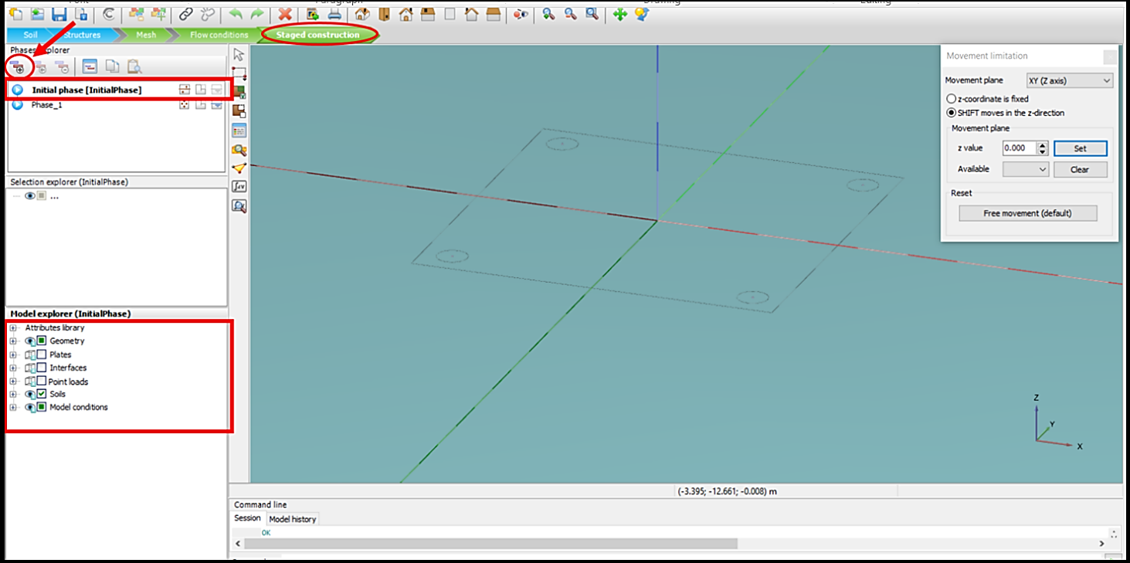

* In the **Phases explorer** section, click on **Phase_1**, make sure **Plates** and **Interfaces** are checked in the **Model explorer** section.
* In the **Model explorer**, click on the + sign next to the **Soils**, then click on the + sign next to the **Soil_2**, click on drop-down arrow next to the Materials and choose “Pile”. Do the same for **Soil_3, Soil_4,** and **Soil_5.**

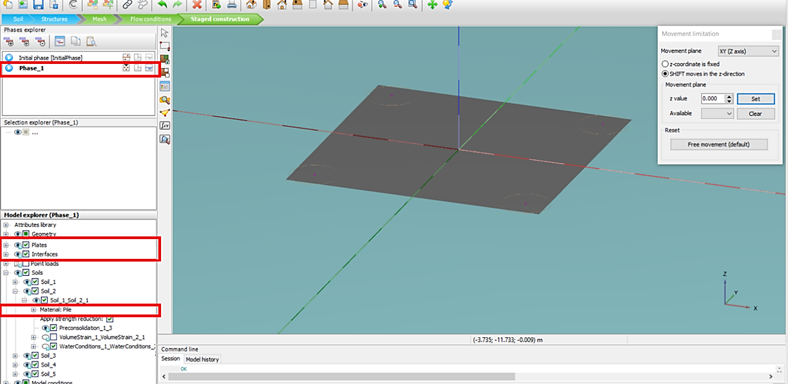

* Click on **Add phase** to add a new phase. Click on the Edit icon, in the opened window, in **Deformation control parameters**, make sure to check the box next to “Reset displacement to zero”, and then click **OK.**

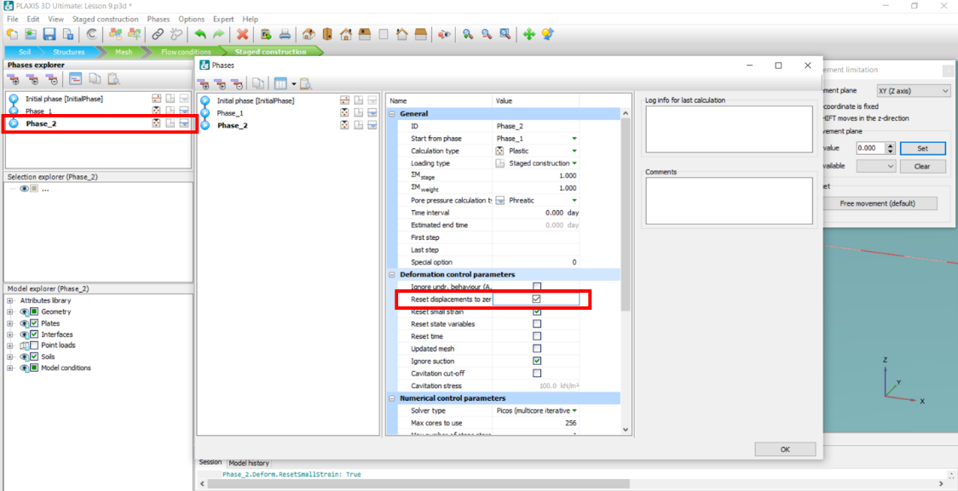

* In Phase_2, make sure to check the box next to **Point loads** in the **Model explorer.**
* Click on the **Calculate** icon. After the calculation is completed, click on **View calculation results**.

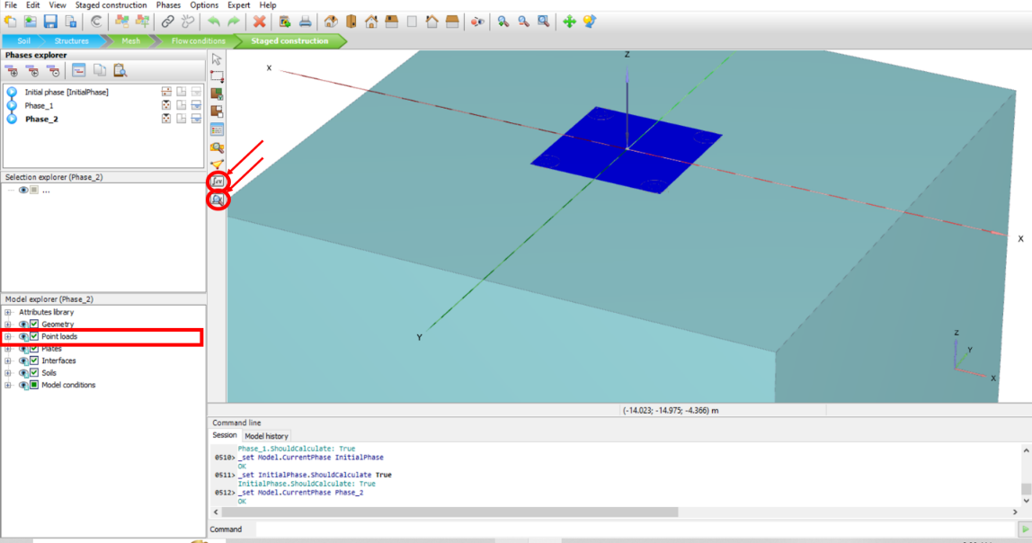

* 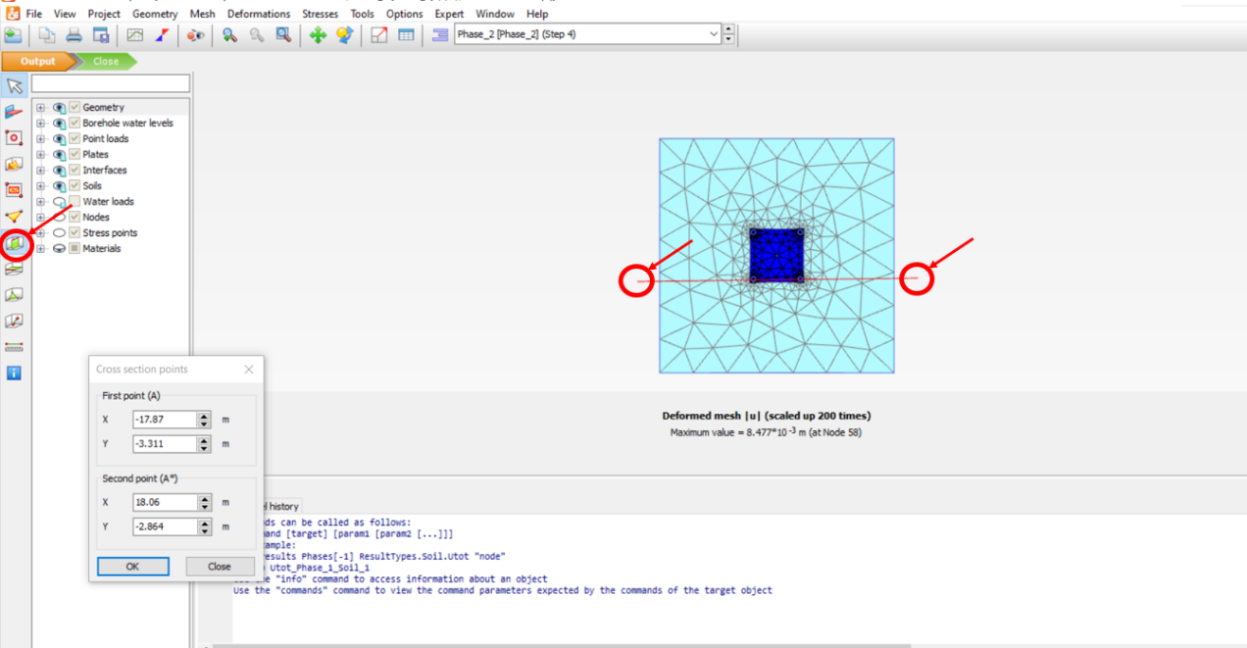In the opened window, click on the **Vertical cross section** icon and specify the start and end points of the cross-section (make sure the cross-section passes through the two front piles).
* To see the total displacement shading, click on the **Deformation** tab in the toolbar, then click on the **Total** **displacement** icon, and click on **uz**

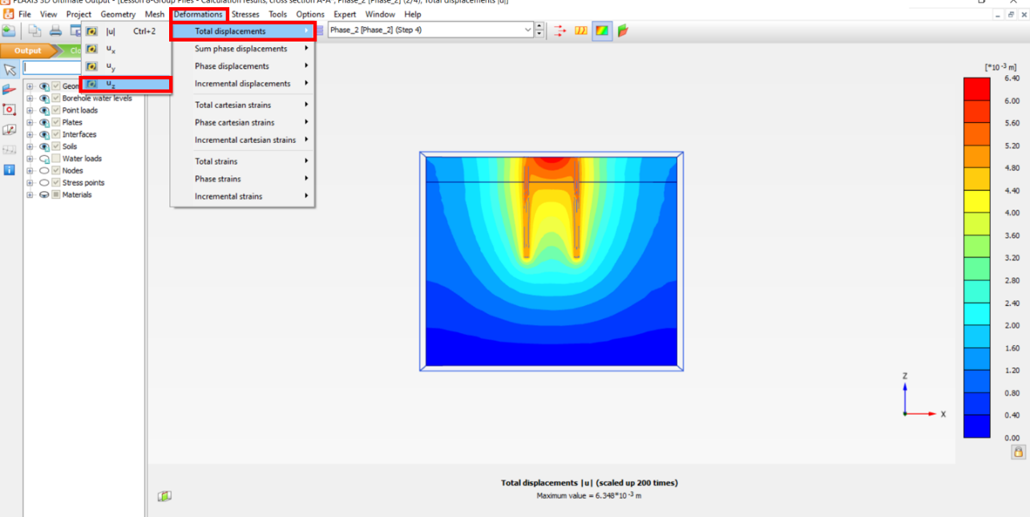

* The figure below shows Load-Displacement curve of the 3D model:

