PLAXIS 3D Lesson 7:

Learning Objective: This lesson is intended to teach you how to model a pile in a numerical model with two different approaches (Volume pile and Embedded beam)
Part 1: Volume pile
Starting a new project
- Open PLAXIS 3D software and start a new project.
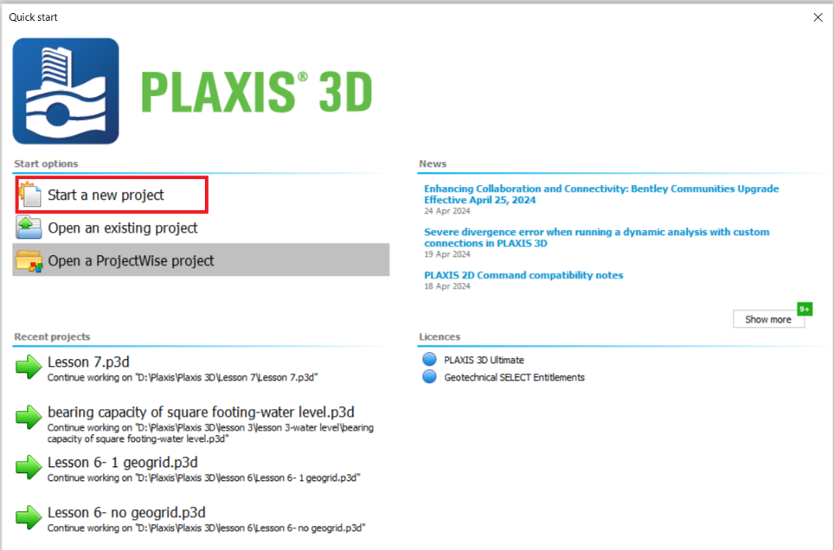
- In the opened window, choose a name for the project. For example, type in “ Lesson 7- Volume pile”.
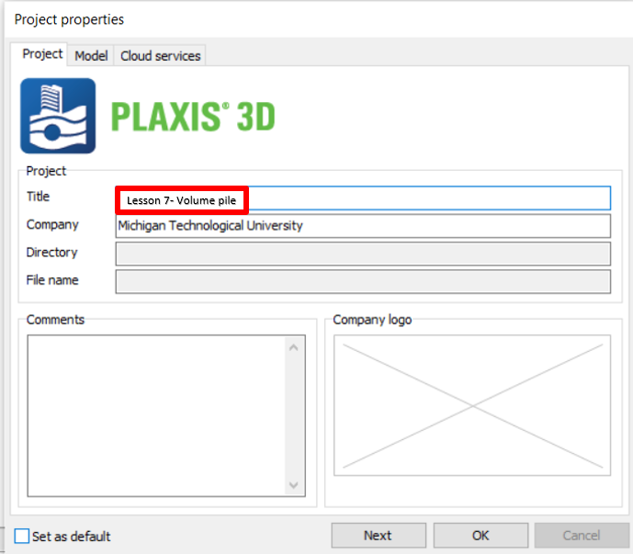
- Click on the Model tab, and enter contour values as follows:
- Xmin: -5 m, Xmax:5 m, Ymin: -5 m, Ymax: 5 m, then click OK.
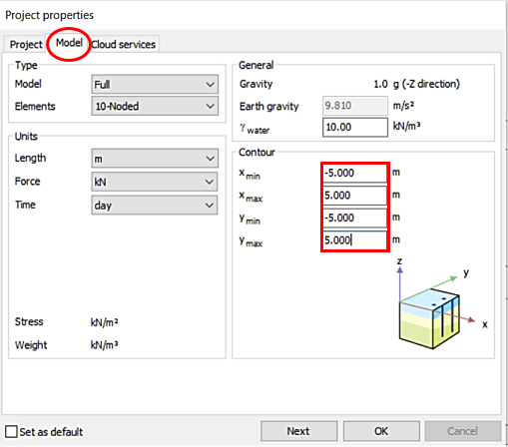
Task 1: Define Soil Layer and Water Elevation
- Click on Create borehole, and click on the corner (x=-5, y=-5) of the model. In the opened window, click add. In the Bottom box under Borehole_1, enter “-40”.
- In the Head box, enter “-40”.
- Click on Materials in the same window.

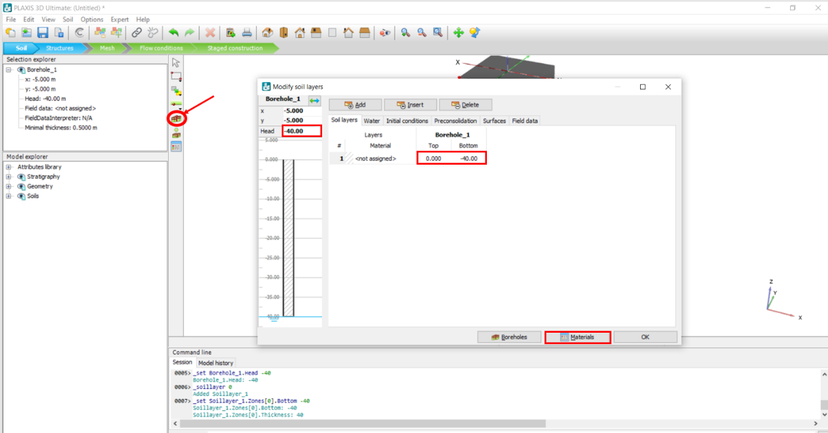

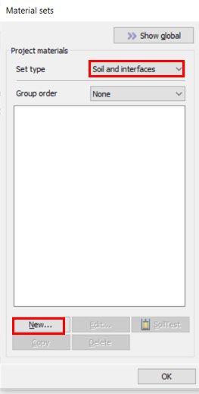
- In the opened window, keep Set type, “Soil and interfaces”, and click New.

- In the opened window, choose a name for the soil, for example, type in “Clay” in the Identification box.
- Click on the drop-down arrow in the Drainage type box and choose Undrained A.
- Enter soil unit weights as follows: γ_{unsat} :16 kN/m³, γ_{sat} :19 kN/m³
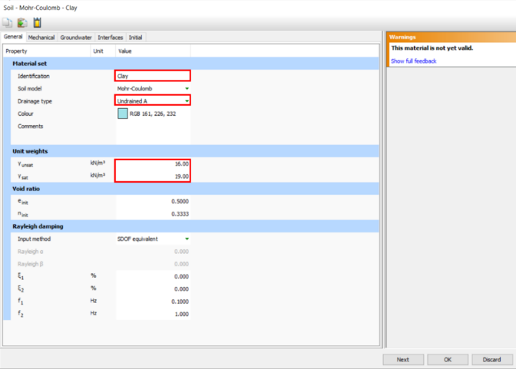
- To define the Mechanical properties of the soil, click on the Mechanical tab and enter them as follows: $E_{ref}^{'}$: 8000 kN/m³, ט(nu): 0.3, $C_{ref}^{'}$: 30 kN/m³, ø’(phi): 15
- Click OK.
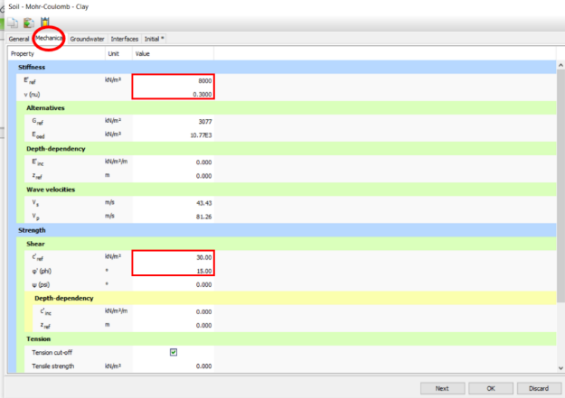
- In the Layers section, click on the drop-down arrow under Material and click on the soil you just created (Clay).
- Click OK.
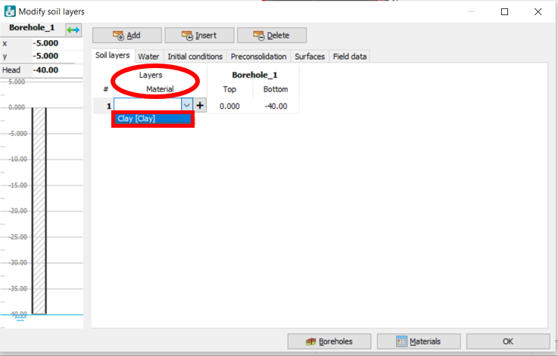

Task 2: Model a Pile and Cap
- To model a pile, go to Structures mode, click on Start designer, and click on Create polycurve. In the 3D model, click on the top surface center (X,Y=0) of the model to place the start point.
- In the opened window, click on the Segments table and select Circle. To draw a pile with 1 m in diameter, enter Radius value “0.5”.
- Click OK.
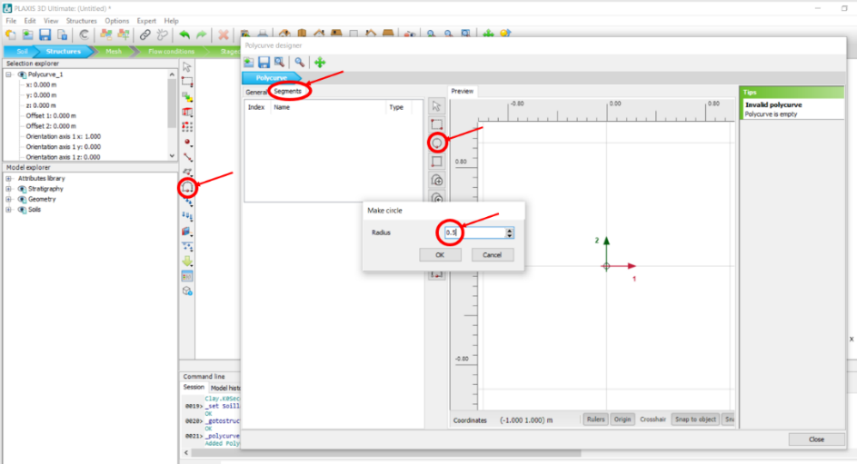
- In the same window, click on General tab. Enter Axis 2 value “-0.5” to move the circle and place its origin on the center of the model.
- Click Close.
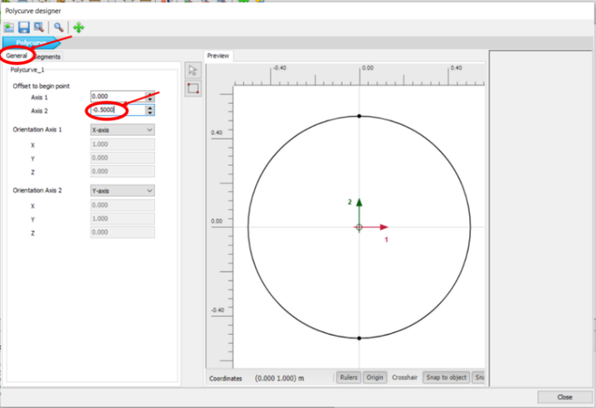
- Right click on the just created circle polycurve, click Create, and then Create surface.
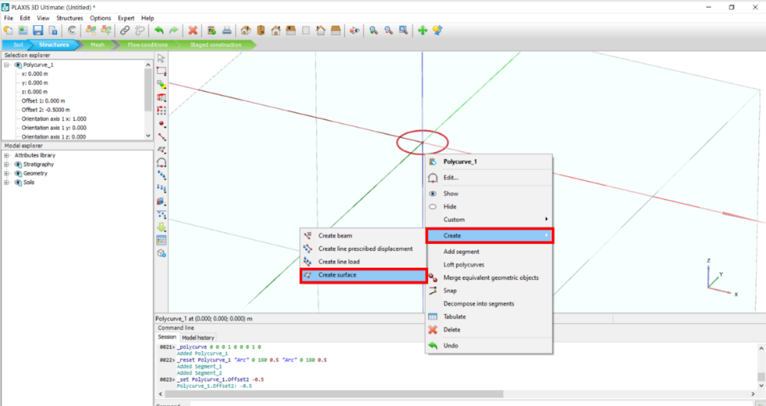
- To model a 10 meter in length pile, select the surface and the circle polycurve that was just created (by clicking on them in the 3D model), click on Extrude, and in the opened window enter z value “-10” .
- Click Apply and close the window.
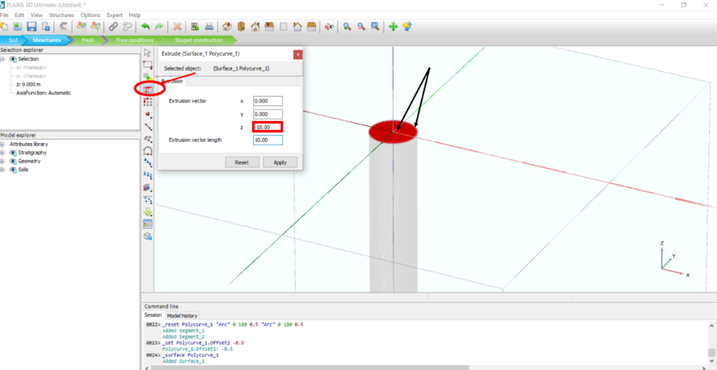
- Select the top surface again (by clicking on the surface in the 3D model) and click on Create array. In the opened window, click on drop-down arrow next to Shape, choose “1D, in z direction”.
- To assign Distance between columns value, in front of Z box type in “-10”.
- Click OK.
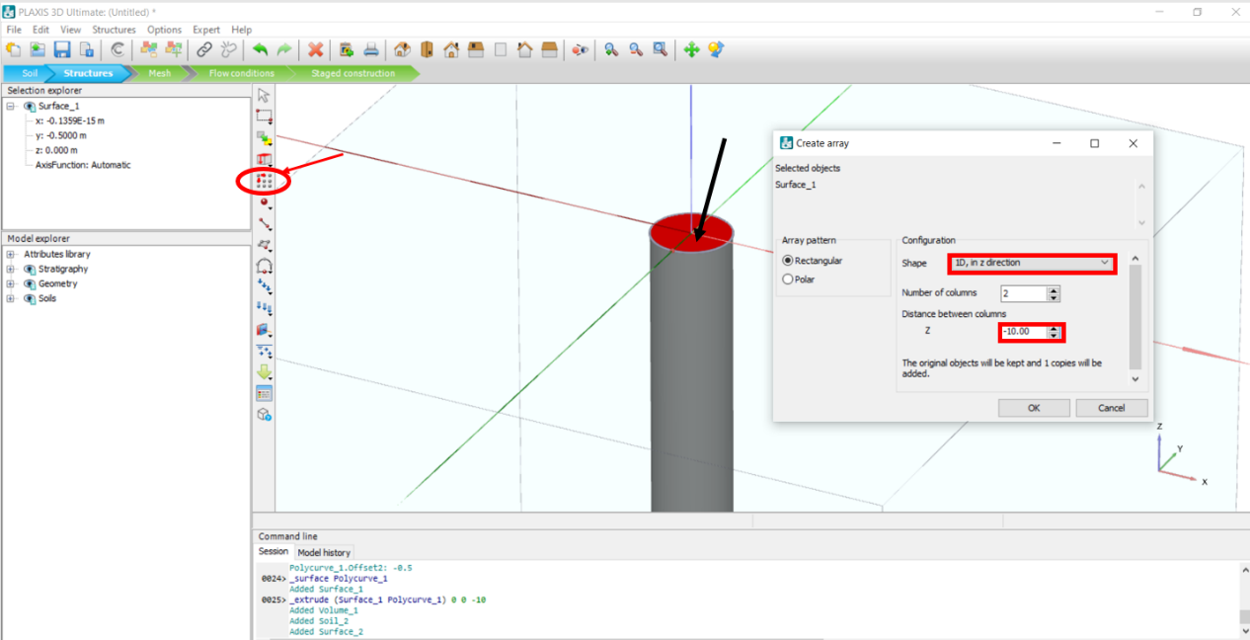

- Click on the Rotate camera icon and rotate the model so you can see the bottom surface of the pile. Select the surrounding surface of the pile by clicking on it in the 3D model. Press and hold the control key on your keyboard and select the bottom surface of the pile in the 3D model. Right click on selected surfaces. Click Create, then click on Create negative interface.
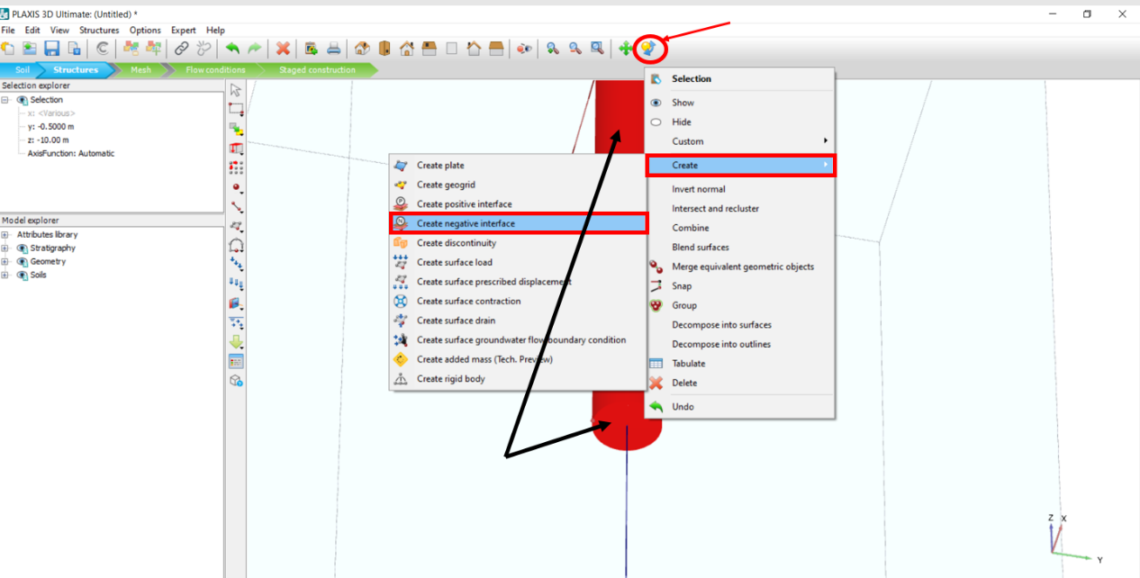

- Select the top surface and its surrounding circle polycurve, right click on that and click Delete.
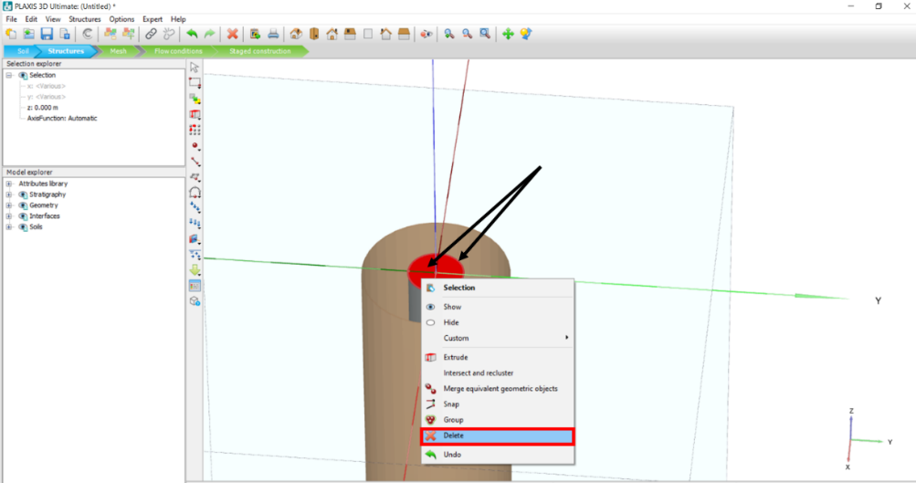
- To create pile cap, click on the Create surface icon, draw a 2*2 square by clicking on following points or entering them in the Surface points window:
(X: 1 , Y: -1 , Z: 0) , (X: -1 , Y: -1 , Z: 0) , (X: -1 , Y: 1 , Z: 0) , (X: 1 , Y: 1 , Z: 0)
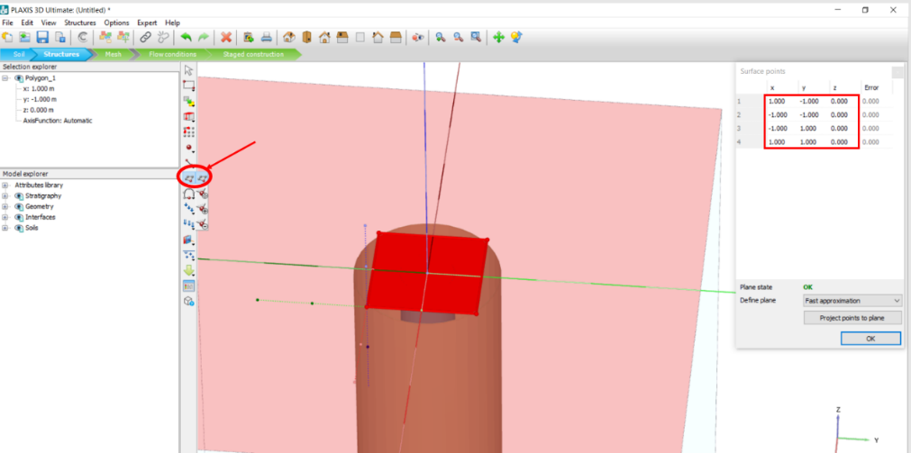
- Right click on the just created surface, click Create, and then click on Create plate.
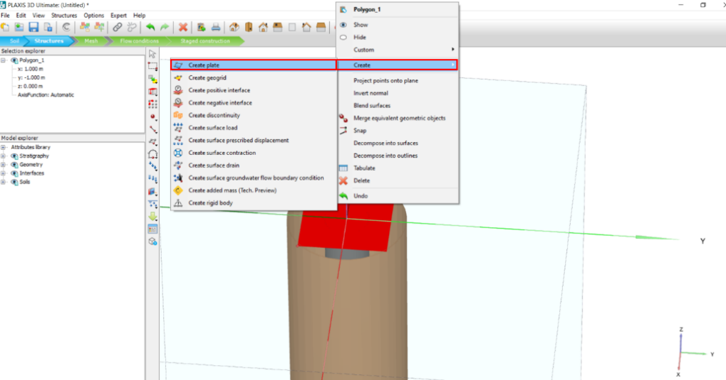
- To assign concrete material to the pile cap, click on the Show materials icon. In the opened window, click on drop-down arrow next to Set type, and click on Plates.
- In the same window, click on New to define concrete properties.
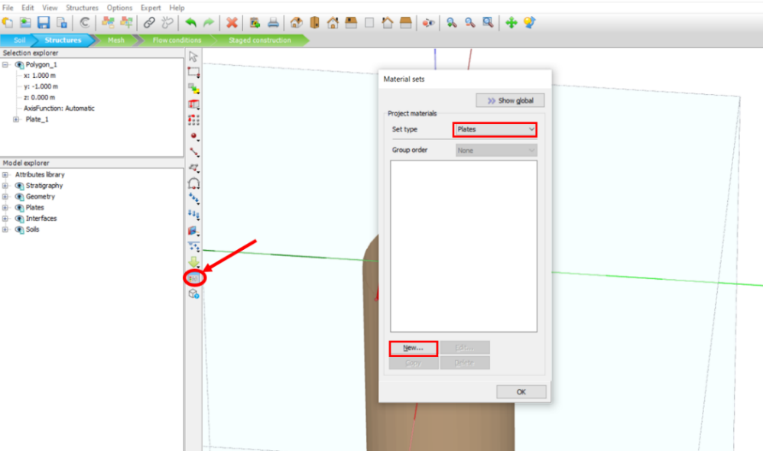
- In the General tab, add “Concrete” as the name in Identification box.
- Click on the drop-down arrow in the Material type box (see the figure below). Change the Material type to Elastic and type in 24 kN/m³ for the unit weight:
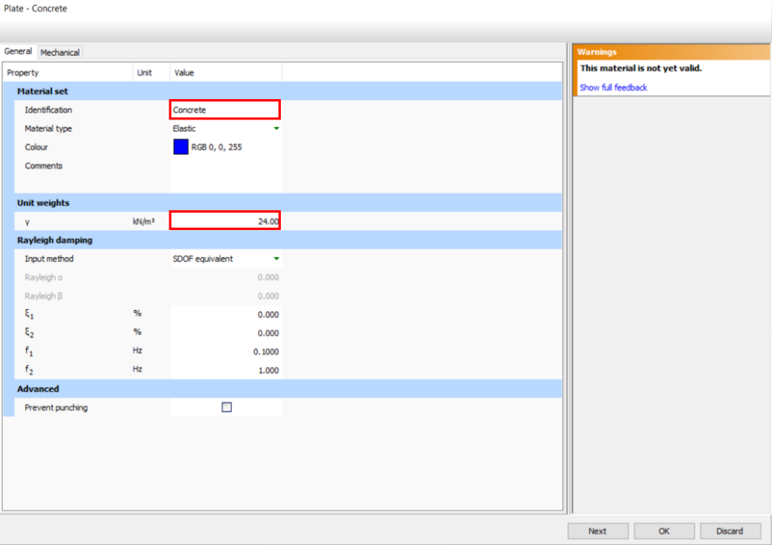

- Click on the Mechanical tab:
- In this window, change the E1 (Young’s modulus) to 23500000 kN/m², $υ_{12}$ to 0.2, and the d (thickness of the concrete) to 0.5, and click OK.
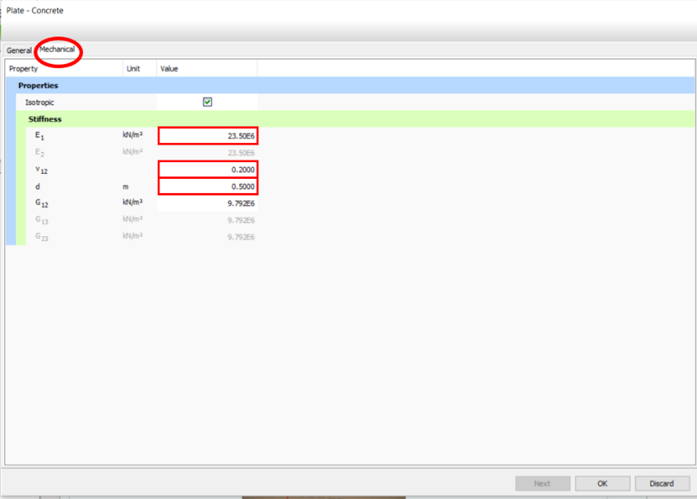
- Assign defined concrete material by dragging the created item and dropping on the plate surface.
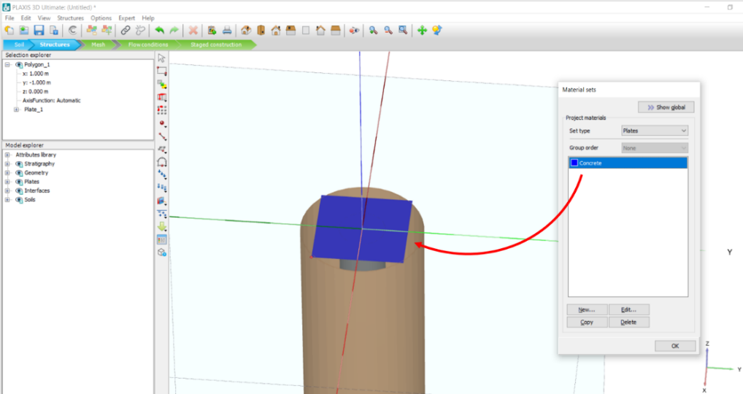
- To assign the interface to the plate, right click on the created plate surface, click Create, and then click on Create positive interface.
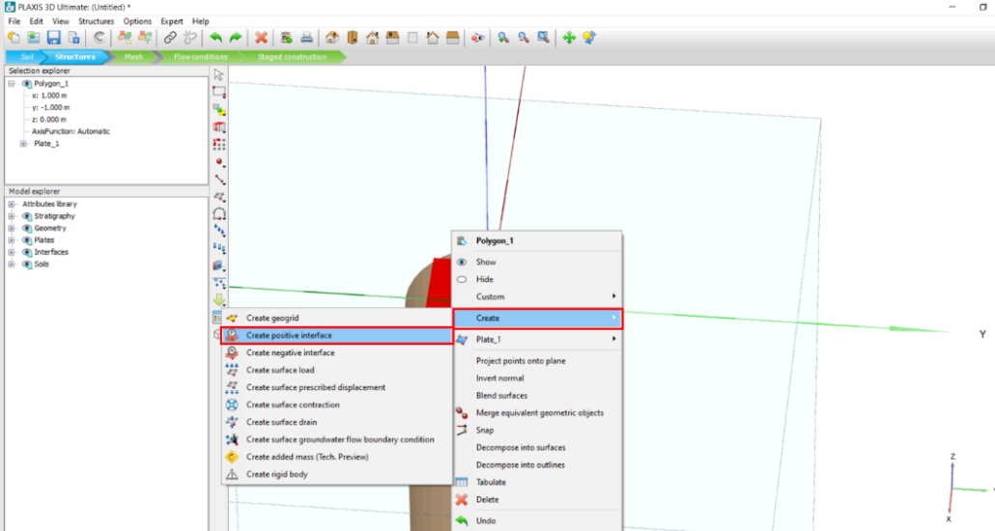
Task 3: Define Pile Material
- To define pile material, click on Show materials icon.
- In the opened window, in Set type, keep Soil and interfaces.
- Click New.
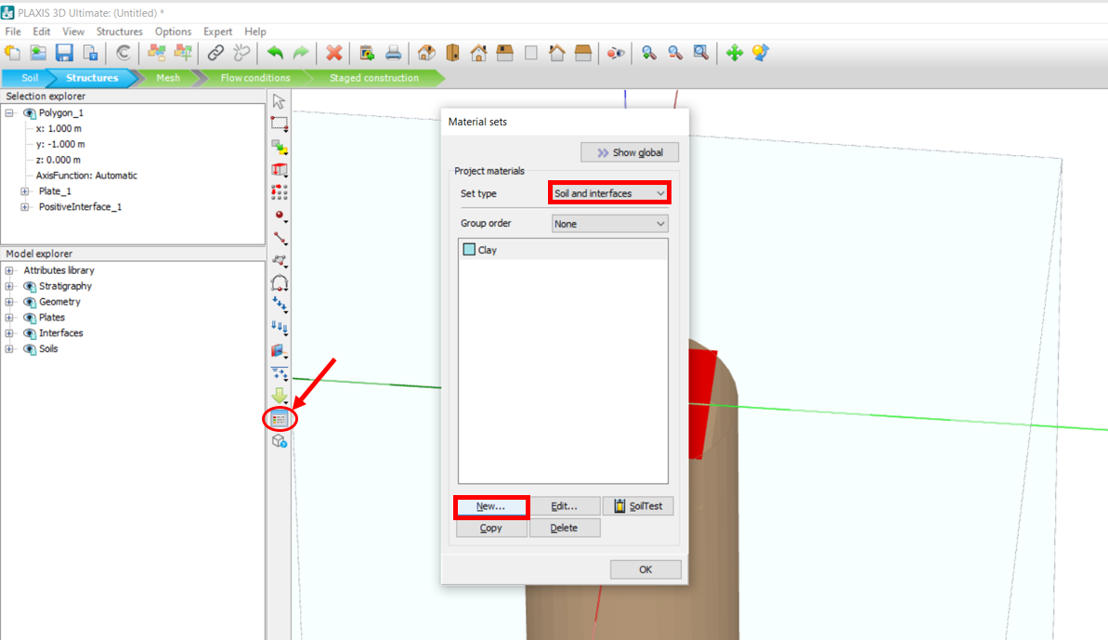
- In the opened window, type in ”Pile” in the Identification box.
- To model pile behavior, click on the drop-down arrow in the Soil model box and choose “ Linear Elastic”.
- To define Drainage type, click on drop-down arrow next to that and choose Non-porous.
- Enter the pile unit weight. For example, enter ${}_{unsat}$: 24 kN/m³
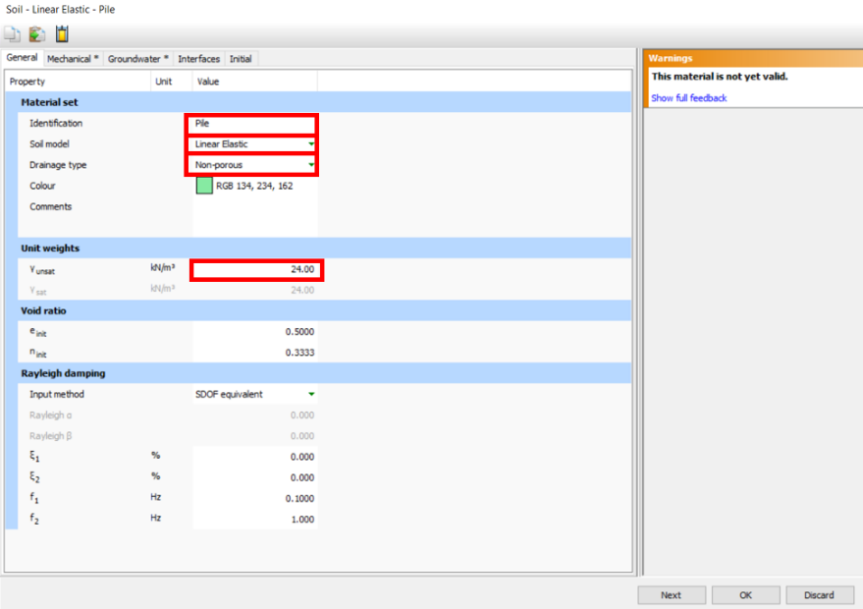

- Click on the Mechanical tab to enter the mechanical properties of the pile. Enter the values as following: E_{ref} : 23.5E6 kN/m², ט(nu) : 0.2
- Click OK.

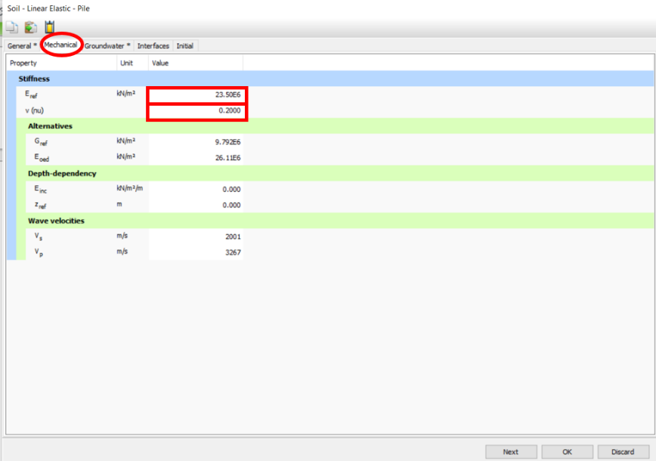

Task 4 : Assign point load
- To assign a point load to the model, click on the Create point load icon, place the point load in:
X: 0 , Y: 0 , Z: 0 coordinates in the center of pile cap.
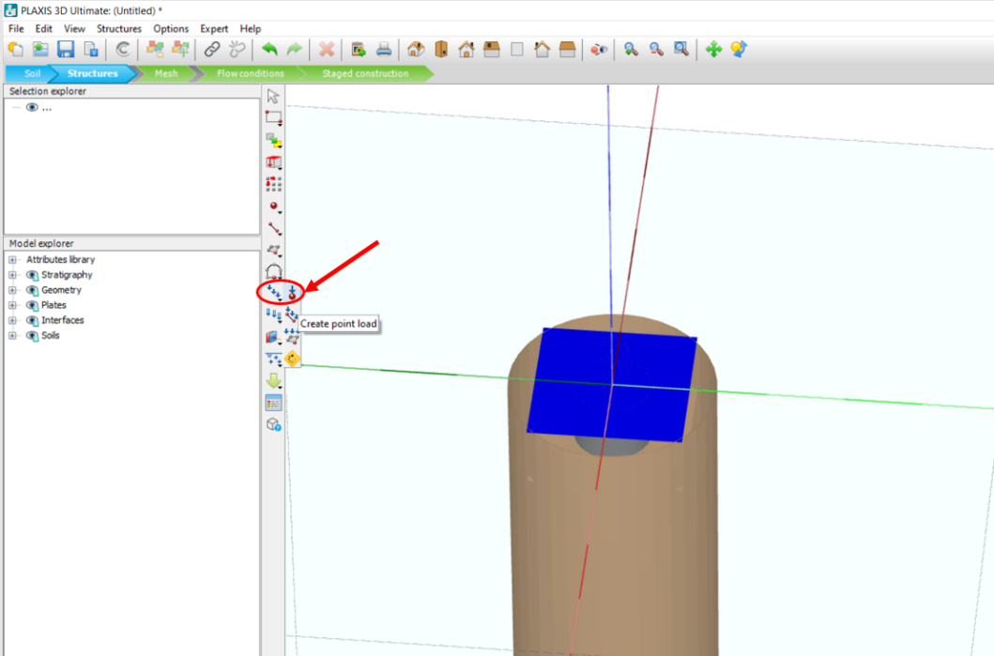

- Place the load in the center of the plate. In the Model explorer, click on the + sign next to Point loads, then click on the + sign next to PointLoad_1, enter Fy value: “-4000”
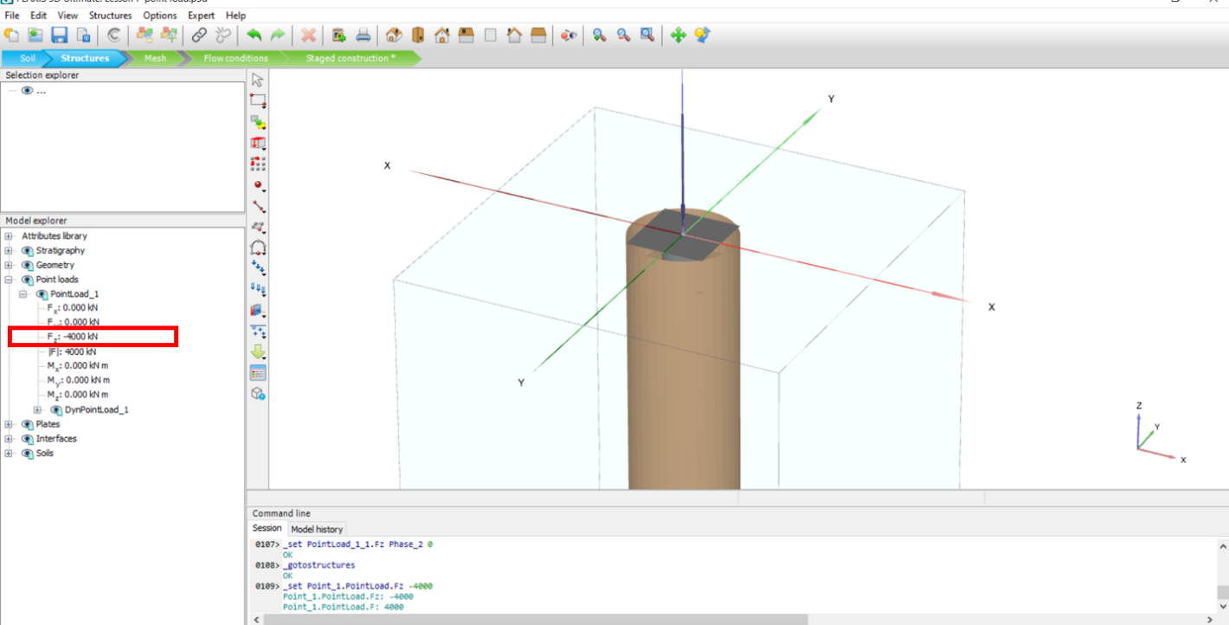

Task 5: Mesh Generation
- Go to Mesh mode.
- Click on the Generate mesh icon and in the opened window choose Very coarse as the mesh size.
- Click OK.
- Click on the Select points for curves icon to select a point for calculations.
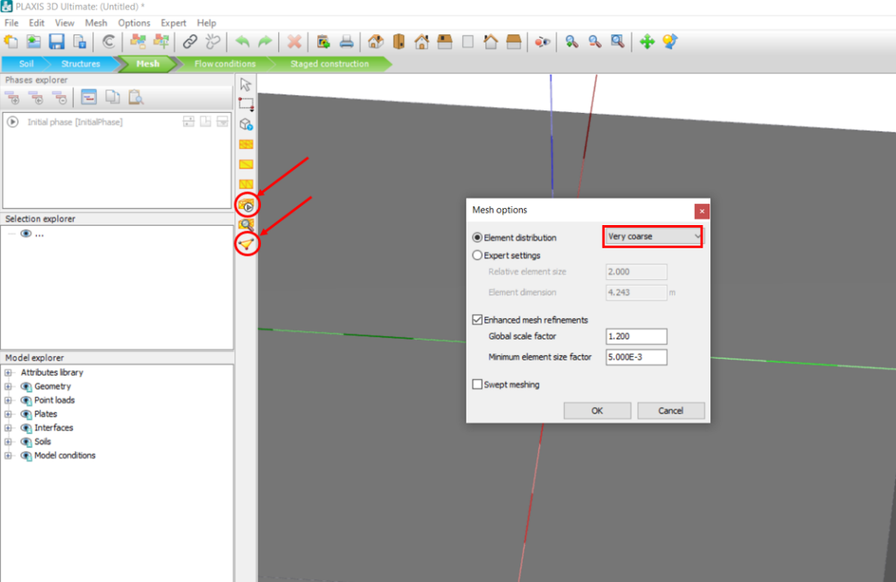
- In the opened window, click on search closest and search for the closest point to the footing. After choosing that, click Update.
Remember, the data must be from the Plate.
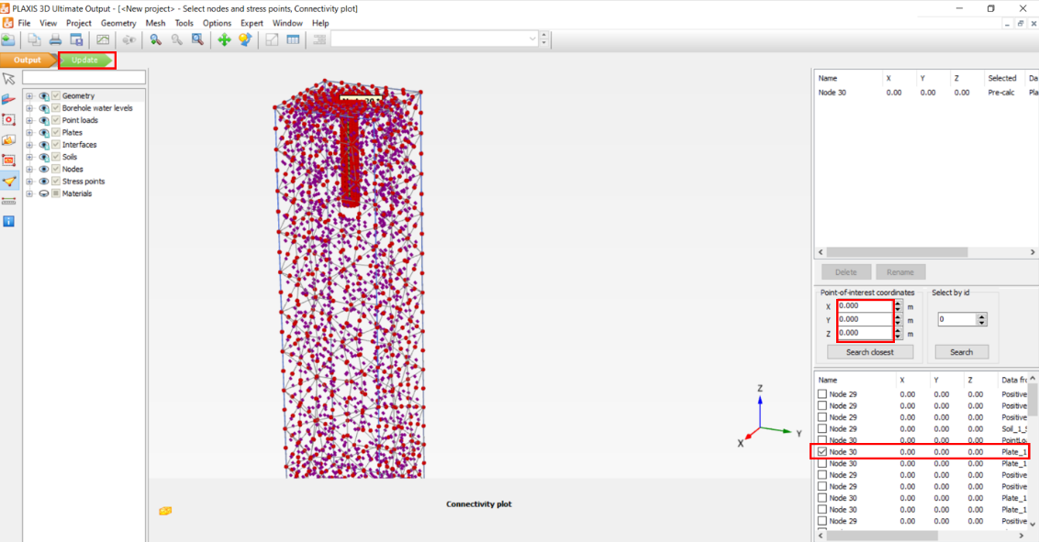.

Task 6: Staged Construction and Calculation
- Go to Staged construction mode.
- Make sure all the soils (Soil_1, Soil_2) are activated in the Initial phase (check the box next to each of them In the Model explorer).
In this phase, all the soils materials are Clay and no changes are needed.
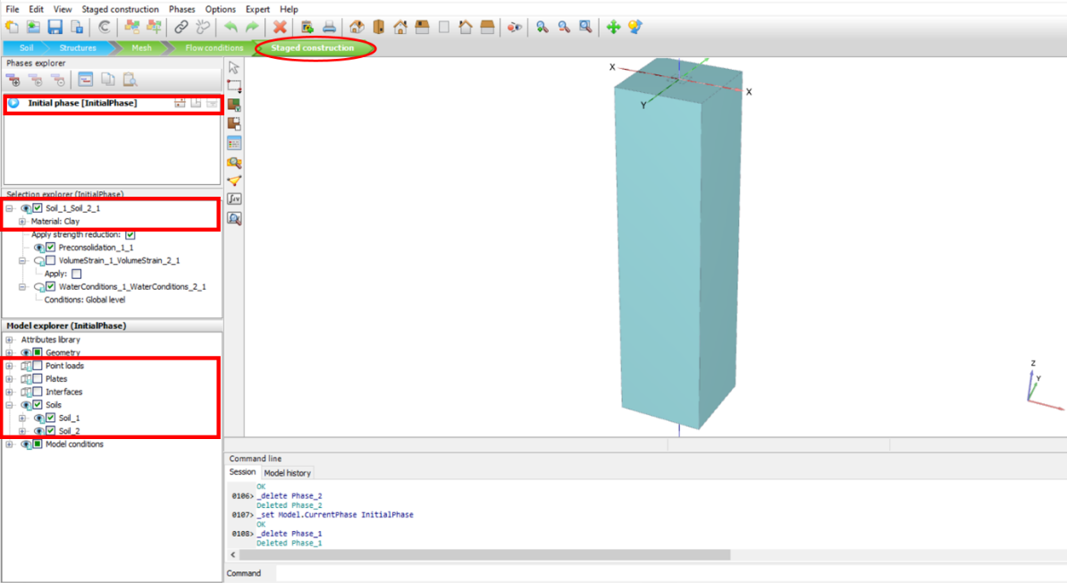
- In the Phases explorer section, click on Add phase to assign pile elements.
- Check the boxes next to Plates, Interfaces, Soil_1, and Soil_2.
- To assign pile material, Click on Soil_2 in the Model explorer, in the Selection explorer (Phase_1), change the Material to “Pile”.
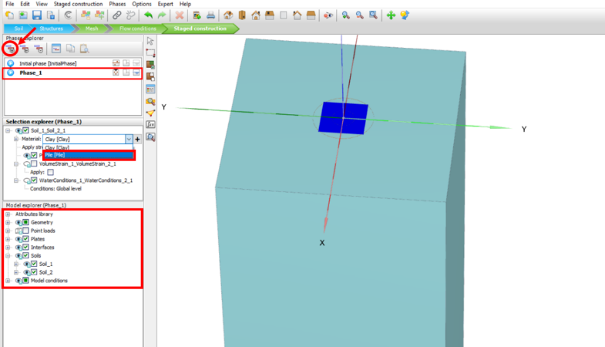
- To assign a load, in the Phases explorer section, click on Add phase.
- Check the box next to Point loads
- Make sure Soil_2 material is changed to Pile as explained in phase 1.
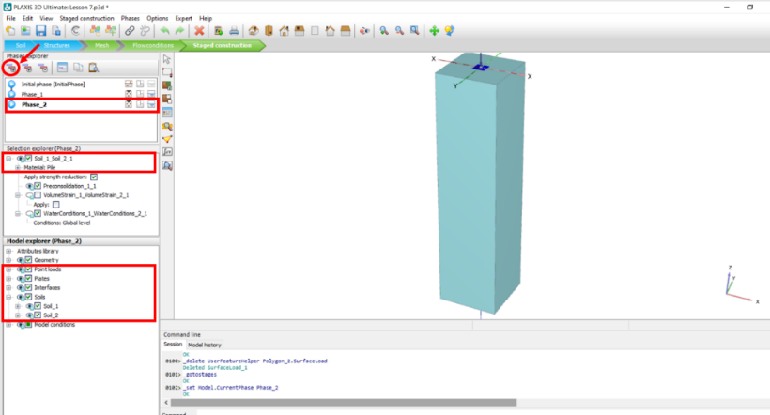
- Make sure to “Reset the displacement to zero” in Deformation control parameters by clicking on Edit.
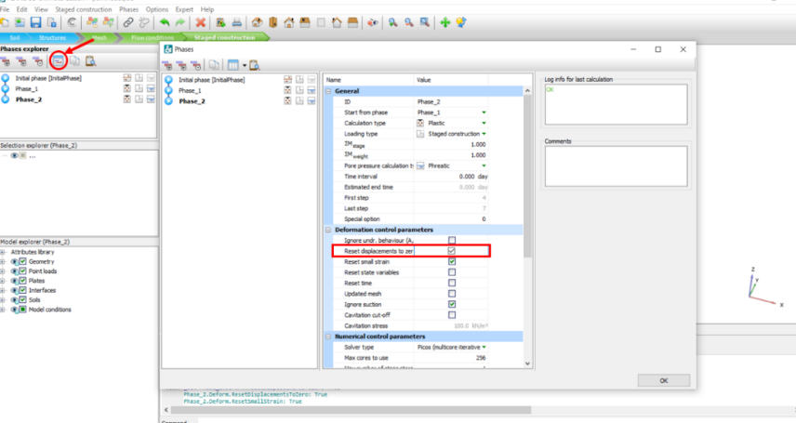
- Click Calculate.
- When the calculations are completed, click View Calculation results.
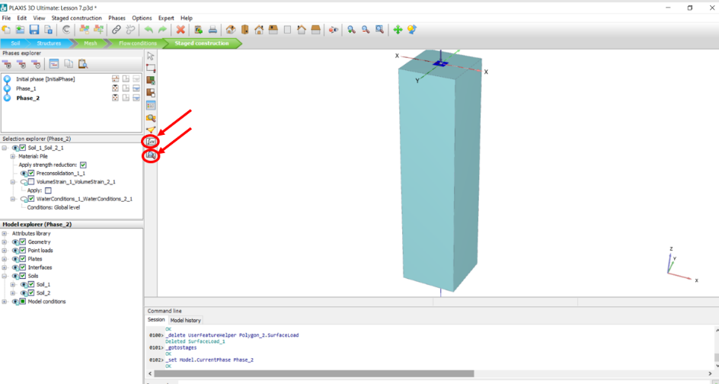
- In the opened Output window, click on Stresses, and then click on Plastic points to see the plastic points.
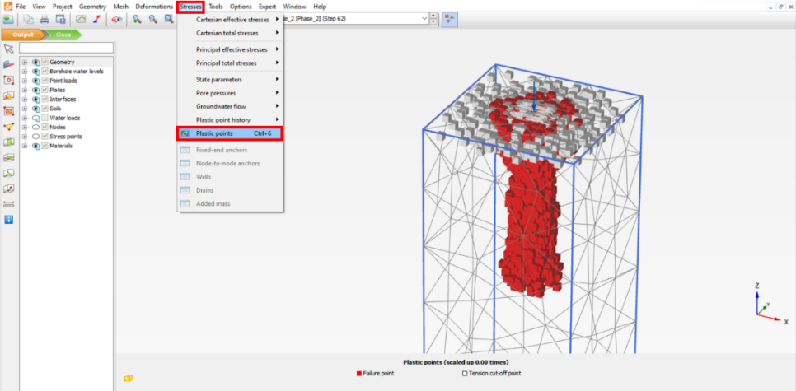
- To see the structural forces, click on Structural forces in volume piles.
- In the opened window, check mark the box next to Pile, click on Detect, and then click Close.
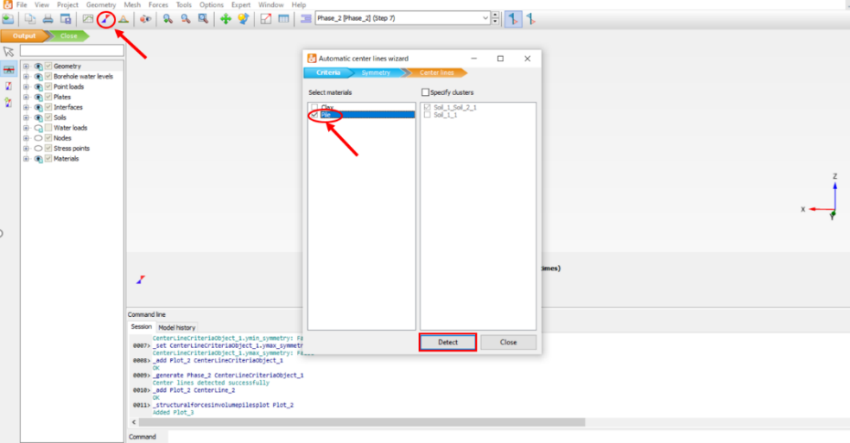
- In the figure below, you can see Axial forces distribution.
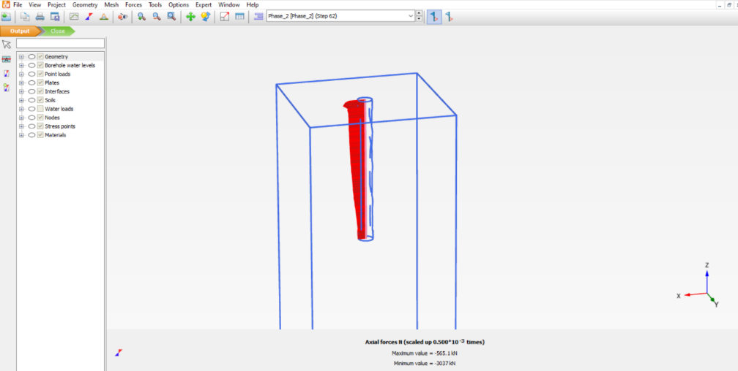
- Click Close to close the current open window and again on the View calculation results icon.
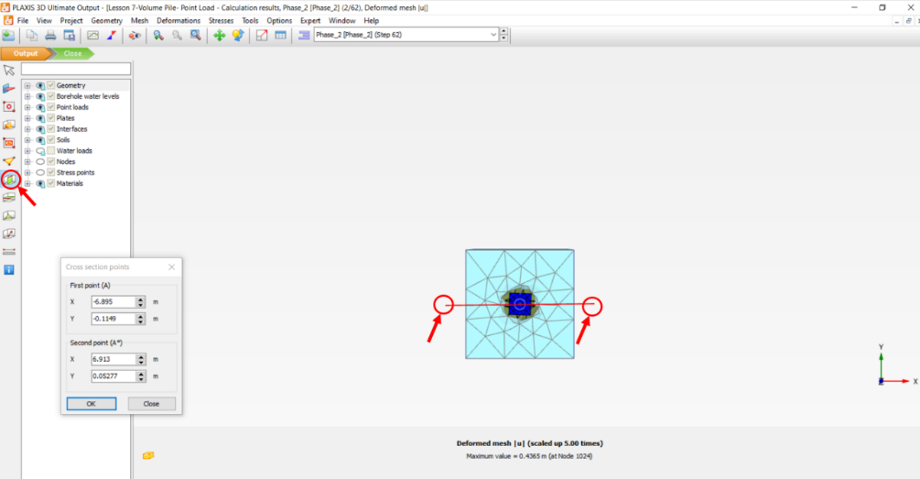
- In the opened window, click the Vertical cross section and specify start and end points of cross-section line.
- Click Deformation, Total displacement, and then click on u_{z}.
- In the figure below, you can see total deformation in the model:
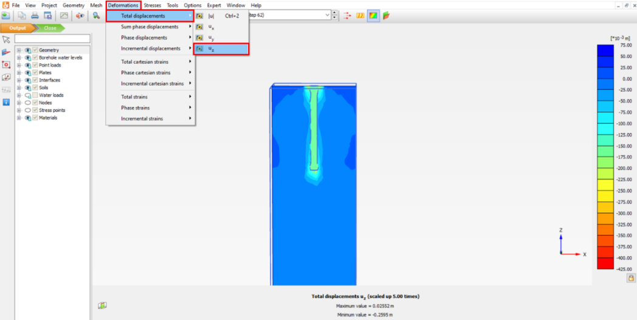
- To plot the Load-Displacement curve, click on the Curve manager icon. In the opened window, click on New.
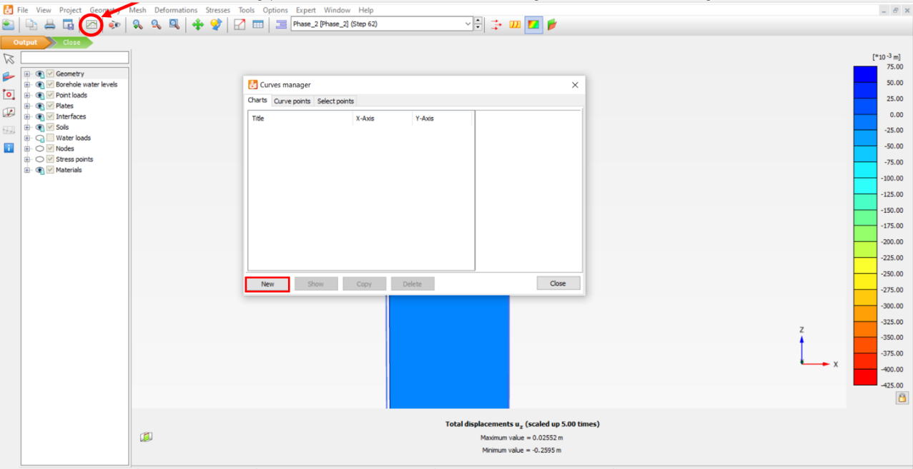
- In the opened window, in the X-Axis section, choose the desired “Node” by clicking on the drop down arrow in the box under the X-Axis. Click on the + sign next to Deformation, then click on the + sign next to Total displacements, and then click on u_{z}. Check mark the box next to the Invert sign.
- In the Y-Axis choose “Project” by clicking on drop-down arrow under the Y-Axis. Click on the + sign next to Multiplier, and then click on ƩMstage.
- Click OK.
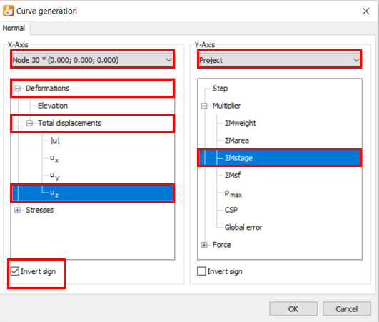

- Remember to delete the undesired points by right-clicking on the plot, Settings, the Node tab, Phases, and unchecking all the phase boxes except “Phase_2”.
- In the figure below, you can see Load-Displacement curve:
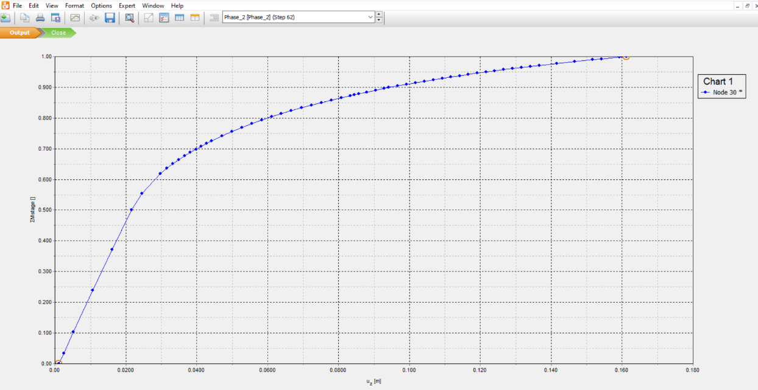

Task 7: Assign surface load
- To compare the effect of point load and surface load, go back to the PLAXIS3D input window, and click on the Structures mode.
- Click on create load and choose the Create surface load icon. Create a surface with the following coordinates in z=0 elevation: (x=-1, y=-1), (x=-1, y=1), (x=1, y=1), (x=1, y=-1),
- In the Model explorer section, click on the surface loads. Then, in the Selection explorer, enter σz value : -1000 kN/m2 (Note: This value is used to compare the results of two different loadings (point load and surface load), so the stress will be the same in both cases.)
Fz=4000kN, Surface area= 2*2= 4m² => σ_{z}=4000/4=1000 kN/m²
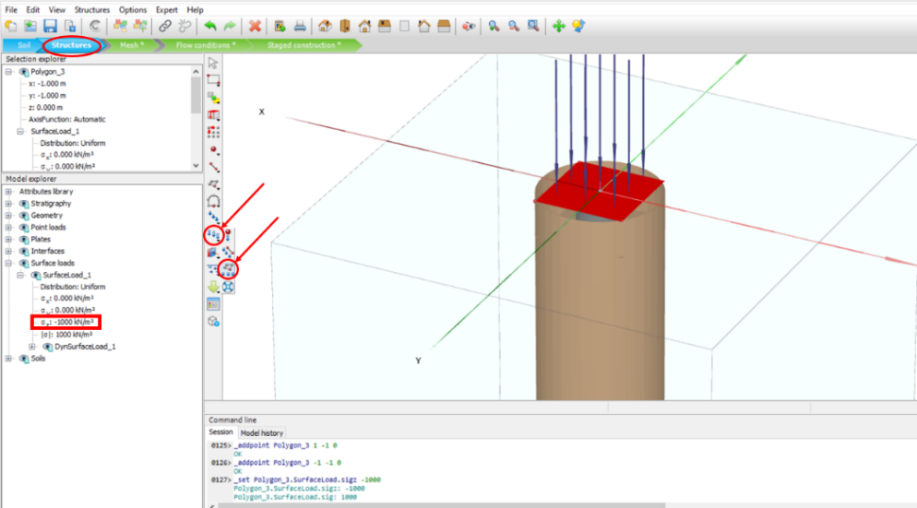
- In the Model explorer section, click on the + sign next to Point loads, right click on PointLoad_1 and click Delete.
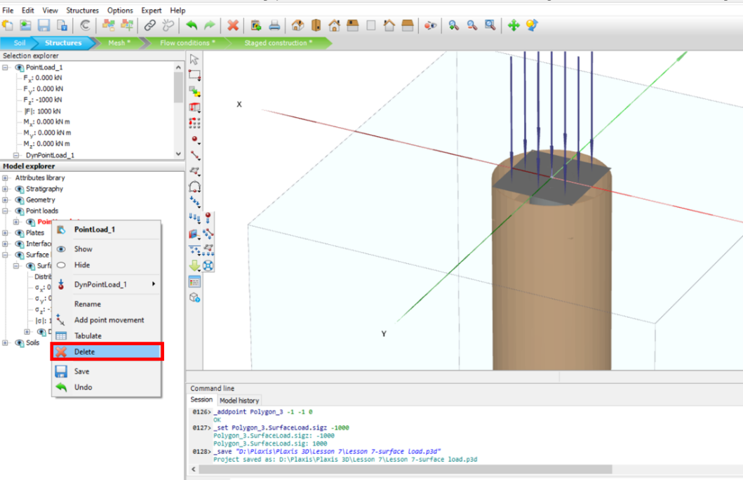

- Repeat Tasks 5 and 6 (only this time make sure that in the Stages construction step, in phase_2, box next to Surface loads is checked.
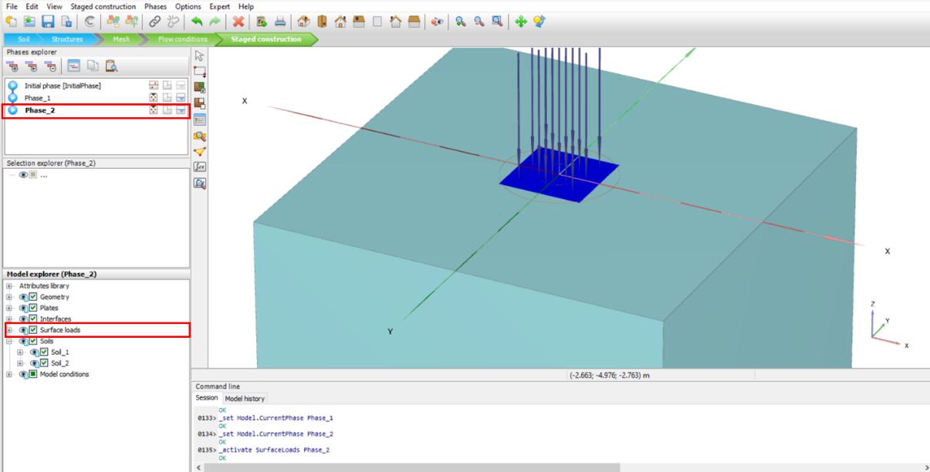

- In the figure below, you can see Plastic points in the model:
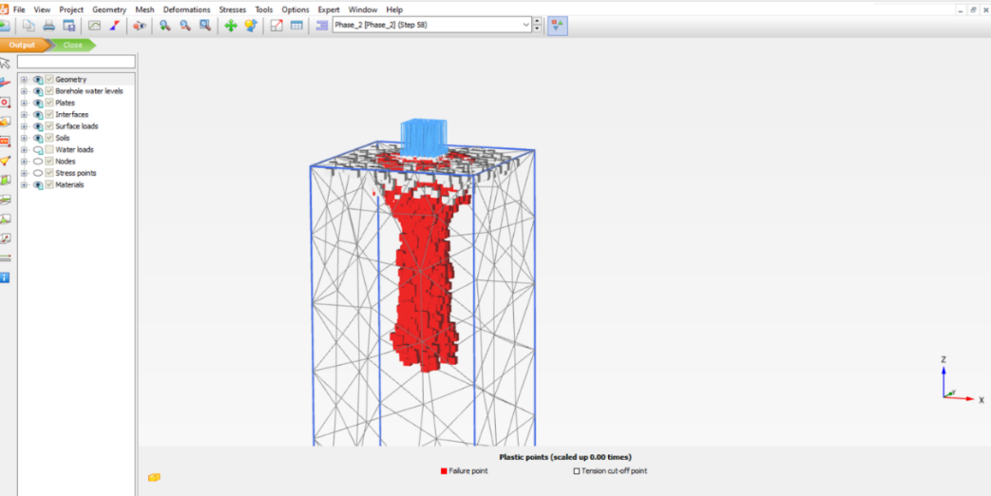
- In the figure below, you can see Axial force distribution in the model:
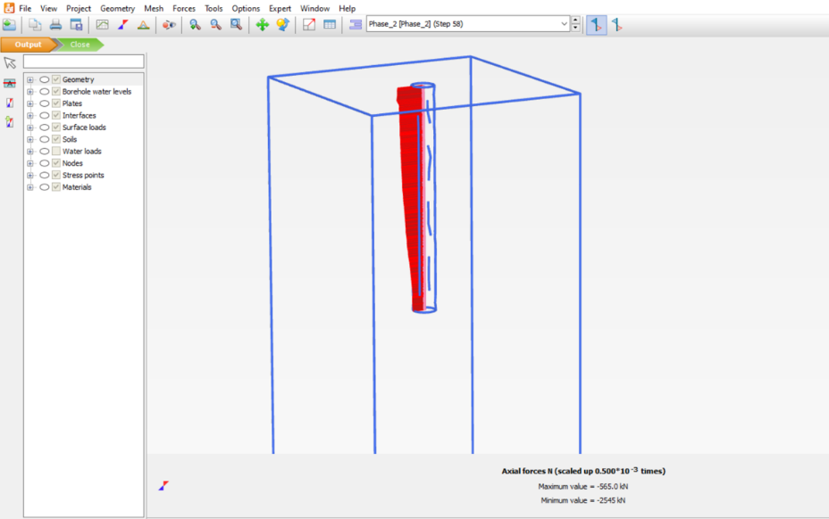
- In the figure below, you can see total deformation in the model:
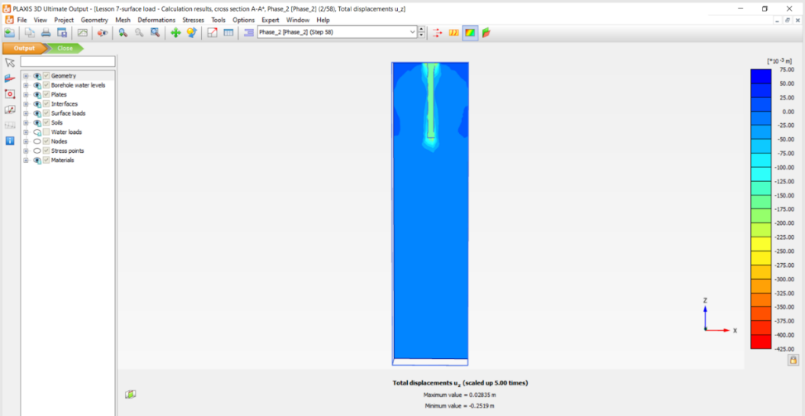
• In the figure below, you can see the Load-Displacement curve:
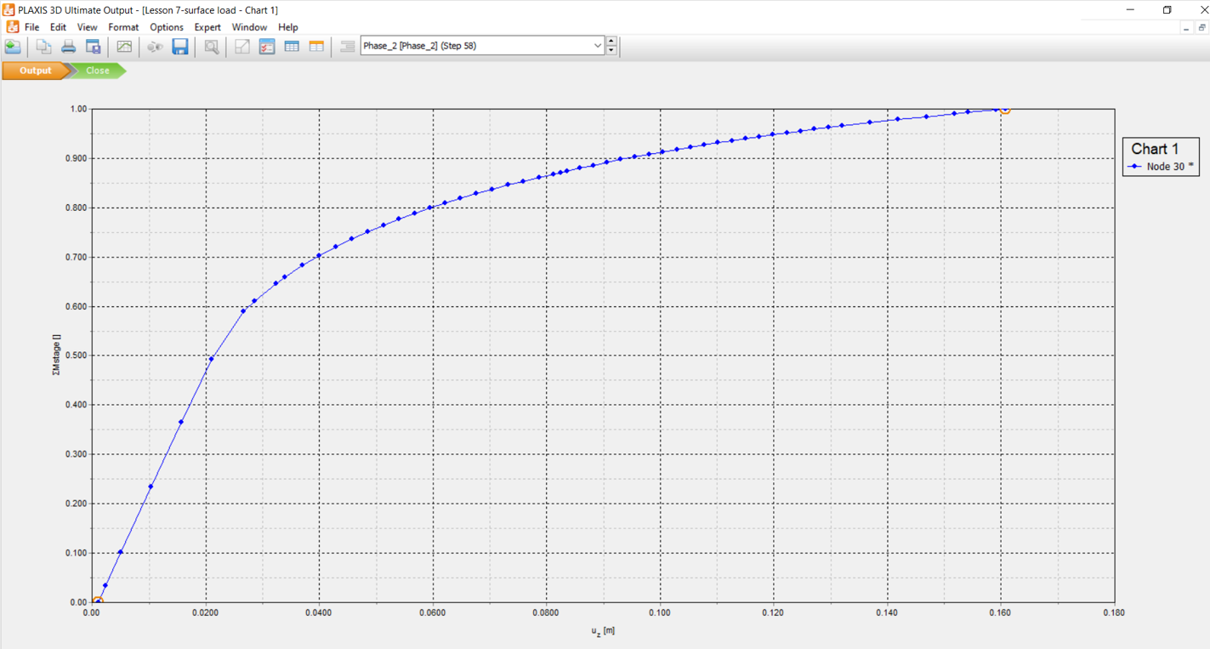

Part 2: Embedded beam
Starting a new project
- Open the PLAXIS 3D software and start a new project.
- In the opened window, choose a name for the project. For example, type in “ Lesson 7- Embedded beam”.
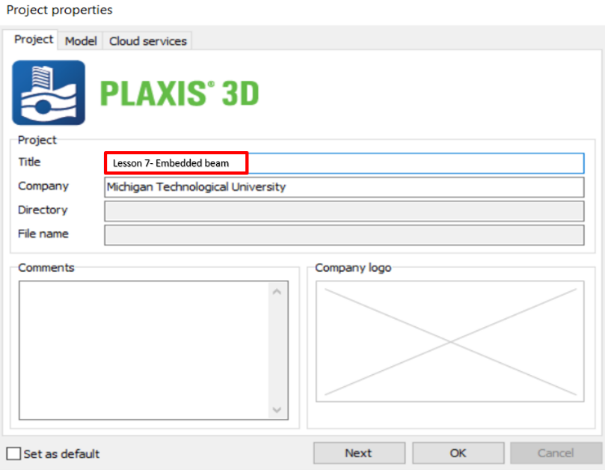
- Click on the Model tab, and enter contour values as follows:
- Xmin: -5 m, Xmax:5 m, Ymin: -5 m, Ymax: 5 m, and then click OK.
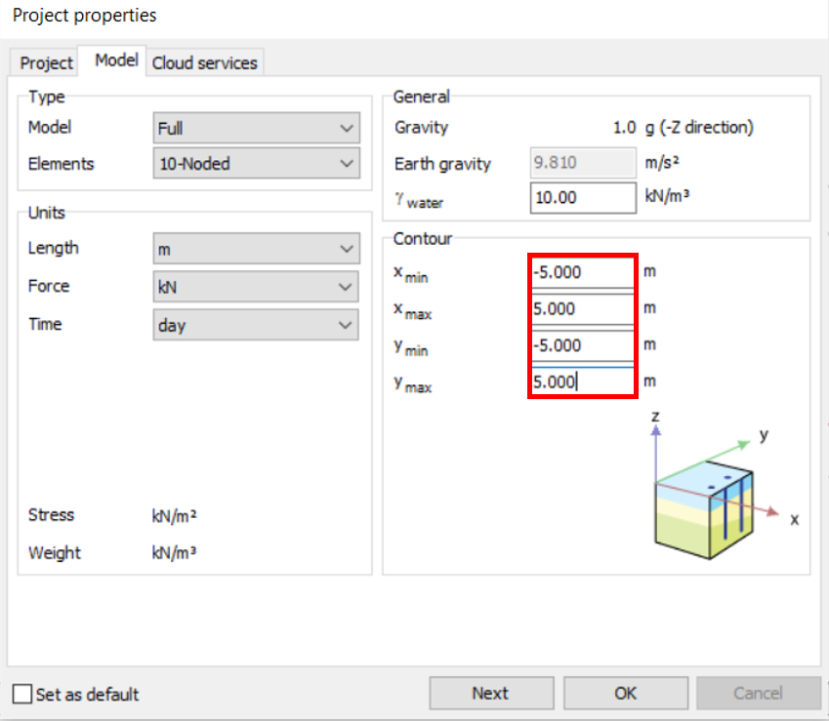
Task 7: Define Soil Layer and Water Elevation
- Click on the Create borehole icon and click on the corner (x=-5, y=-5) of the model. In the opened window, click add. In the Bottom box under Borehole_1, enter “-30”.
- In the Head box, enter “-30”
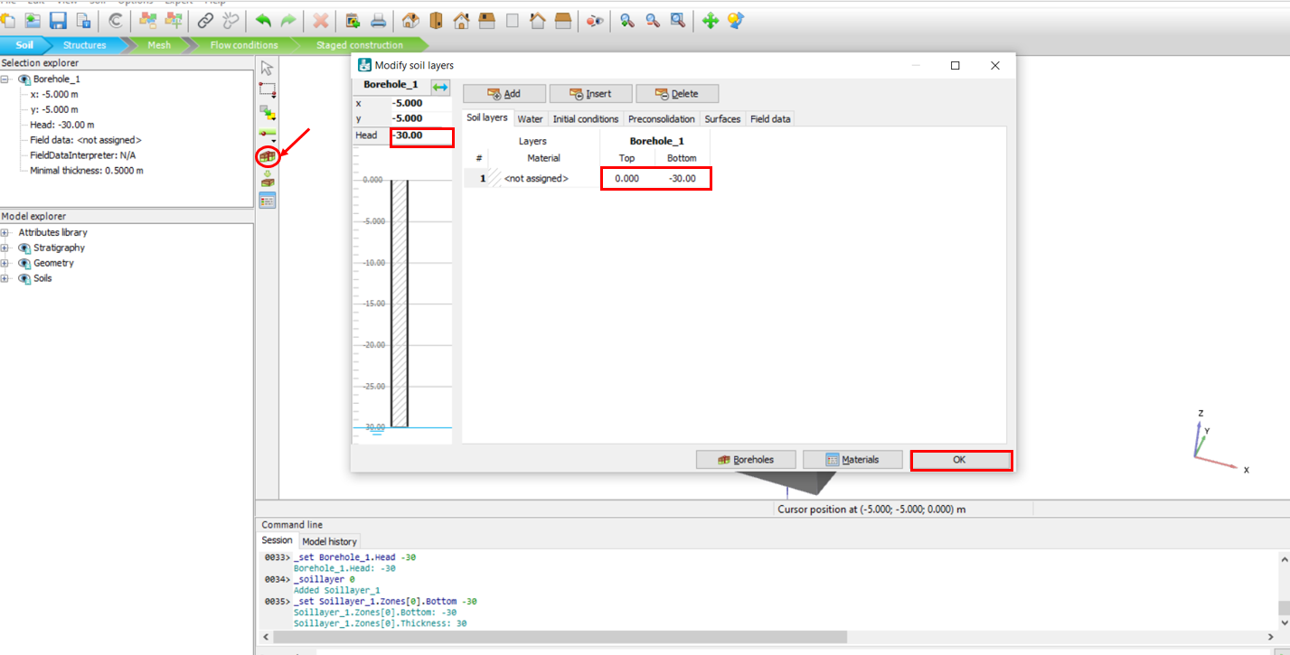

- Click on the Materials icon to define the soil’s properties.
- In the opened window, keep Set type, “Soil and interfaces”, and click on the New icon.
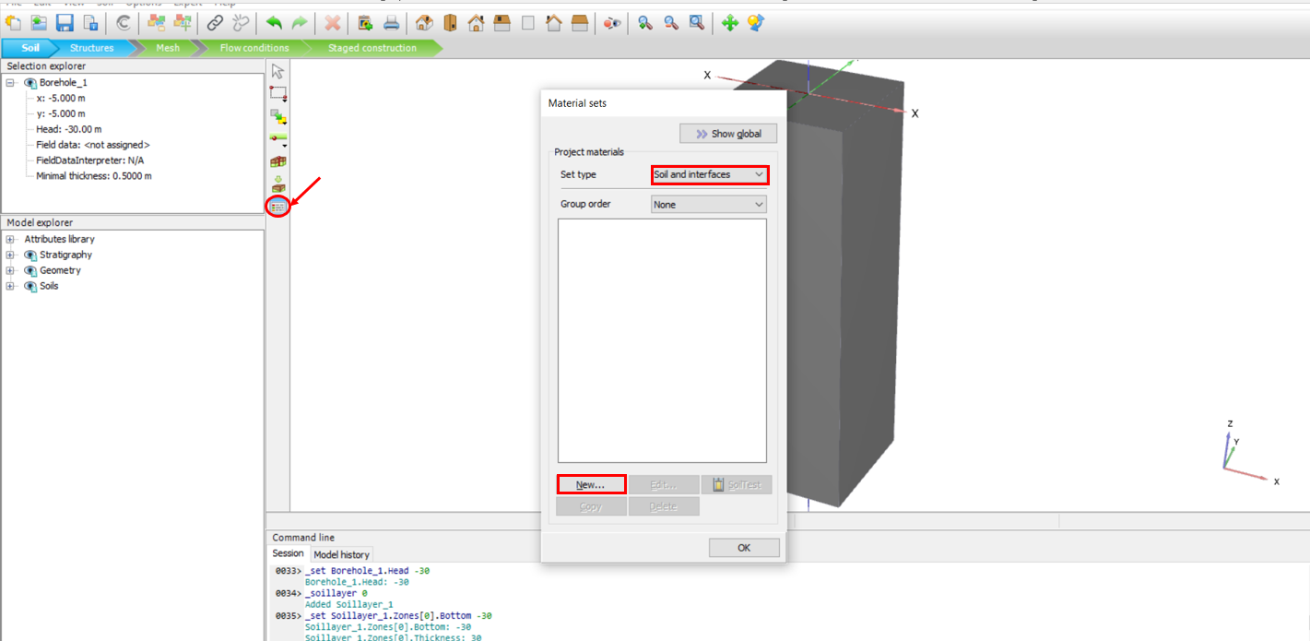
- In the opened window, choose a name for the soil. For example, type in “Sand” in the Identification box.
- Click on the drop-down arrow in the Drainage type box, and choose Drained.
- Enter soil unit weights as follows: γ_{unsat} :20 kN/m³, γ_{sat} :22 kN/m³
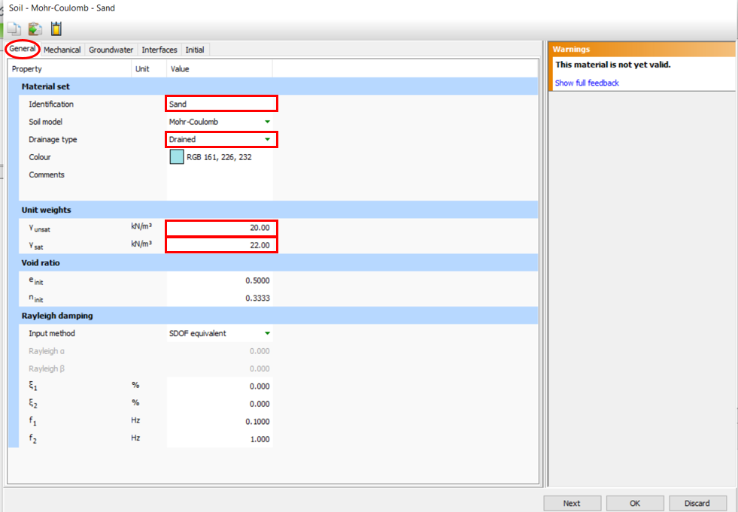

- To define the Mechanical properties of the soil, click on the Mechanical tab and enter them as follows: $E_{ref}^{'}$: 27000 kN/m³, ט(nu): 0.3, $C_{ref}^{'}$: 6 kN/m³, ø’(phi): 31
- Click OK.
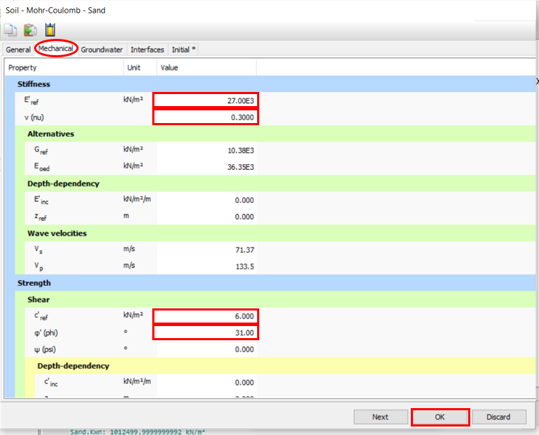
- To define the pile properties, in the Material sets window, change Set type to “ Embedded beam” by clicking on the drop-down arrow sign.
- Click New.
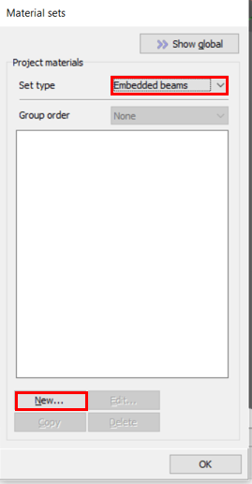
- In the opened window, type in “Pile” in the Identification box.
- For the Unit weight, enter a value of “4”. (Note: This value is the result of subtracting the Soil’s density(γ= 20 kN/m³) from the Concrete’s density (γ= 24 kN/m³))
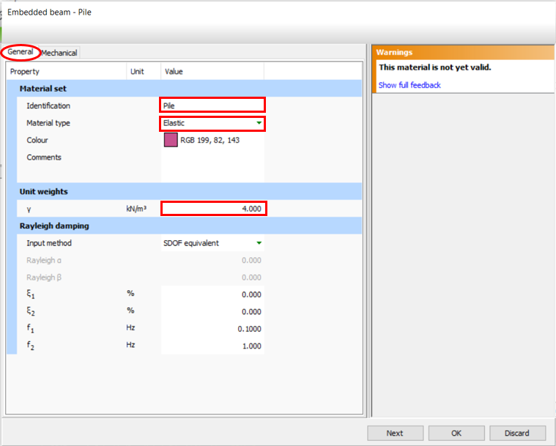
- Click on the Mechanical tab to define the Mechanical properties of the pile, and enter values as following:
- Diameter: 8 m, E: 24E6 kN/m²,Side frictions: AT top of the pile: T_{skin,start,max}: 0 kN/m, At bottom of the pile: T_{skin,end,max}: 180 kN/m,
- Toe friction: Fmax: 7680 Kn
(Calculation details: Toe frinction: q′_{n} = BγNγ * + σ′ _{ZD}Nq =0.8*20*8+240*49.5=12000 kpa→Fmax= 12000*(3.14*0.8^2)=7680 kN, Side friction: f_{n} = σ′_{x} tan ø_{f} =120*0.6=72.1→F= 72*2*3.14*0.4*1=180 kN/m)
- Click OK.
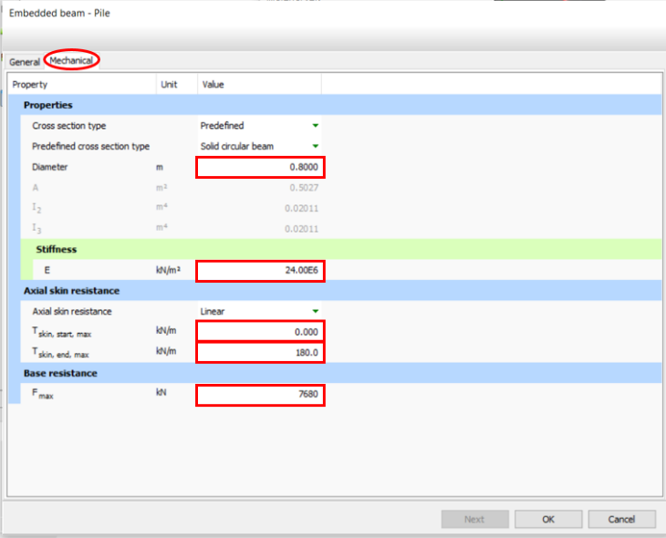
- To create a pile, go to Structures mode, and then click on the Create line icon.
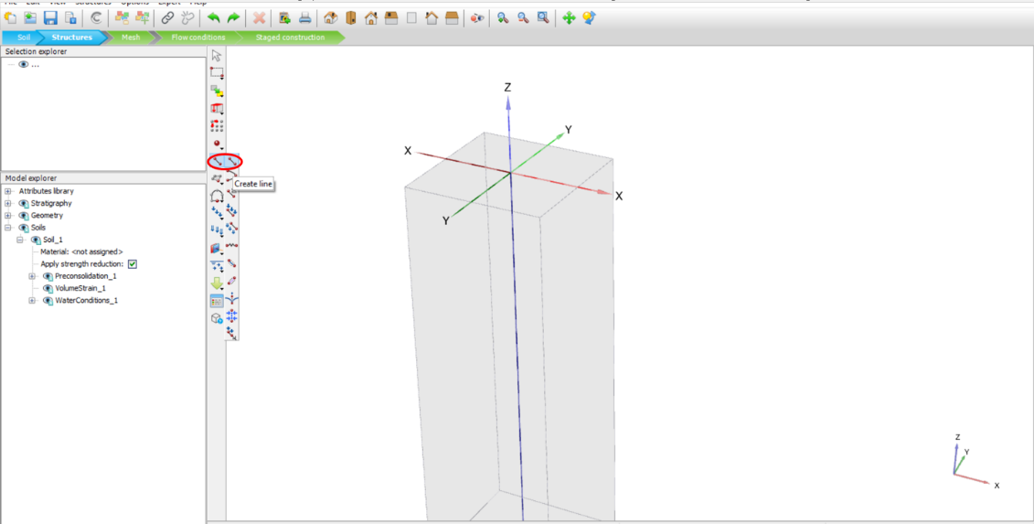

- Click on the (X=0, Y=0, Z=0) coordinates to specify the start point, then click on the (X=0, Y=0, Z=-12) to specify the end point of the pile. (You can also click on two random points and assign the coordinates in the Selection explorer section.)
- Right click on the just created line and click Create, then click on the Create embedded beam icon.
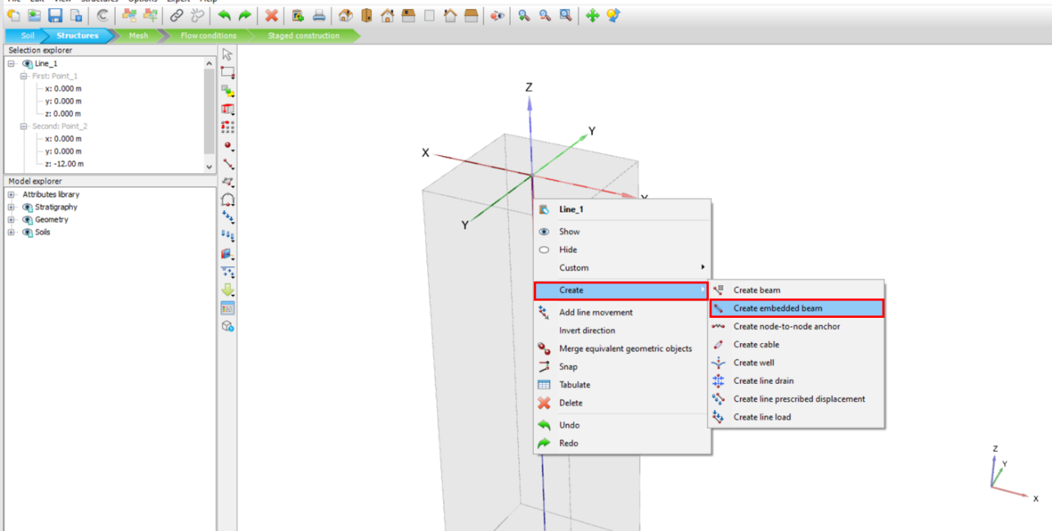

- To create a load, click on the Create load icon, and chose create point load. Place the load in the center of the pile by clicking on the X,Y,Z=0 coordinates.
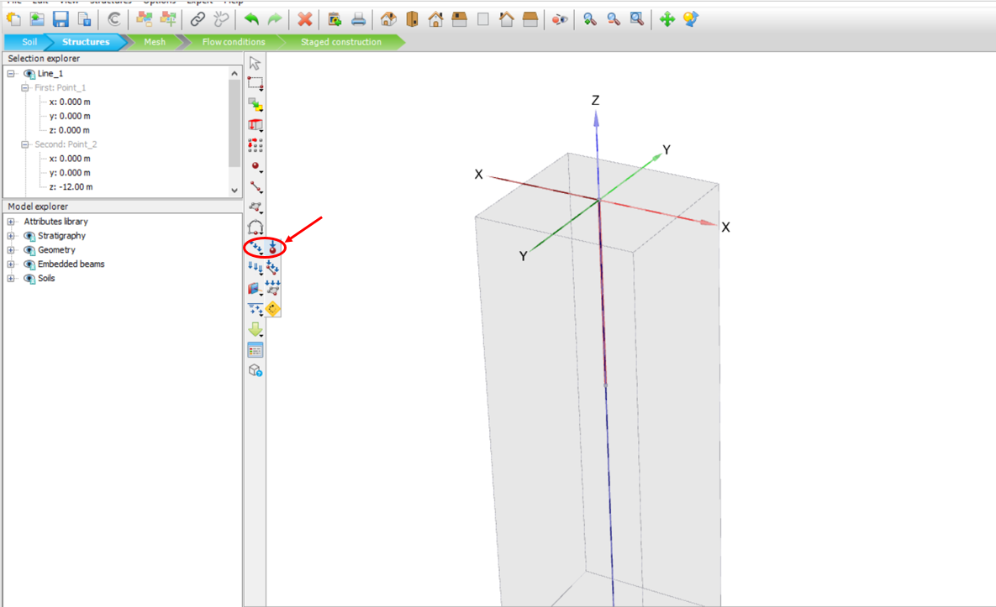
- To create a lateral load, in the Model explorer section, click on the + sign next to the Point loads, click on the + sign next to the PointLoad_1, enter Fx= -1000 kN and Fy=Fz= 0 kN
- To assign materials to the pile in the same window, click on the + sign next to the Embedded beams, click on the + sign next to the EmbeddedBeam_1, click on the drop-down arrow next to Material, and choose “Pile”.
- To assign materials to the soil in the same window, click on the + sign next to the Soils, click on the + sign next to the Soil_1, click on the drop-down arrow next to Material, and choose “Sand”.
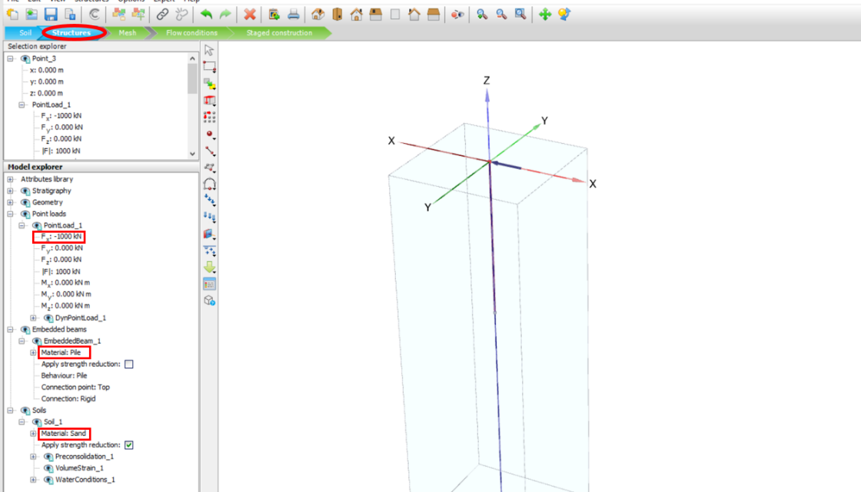

- Repeat Task 5 to mesh the model and choose calculation point.
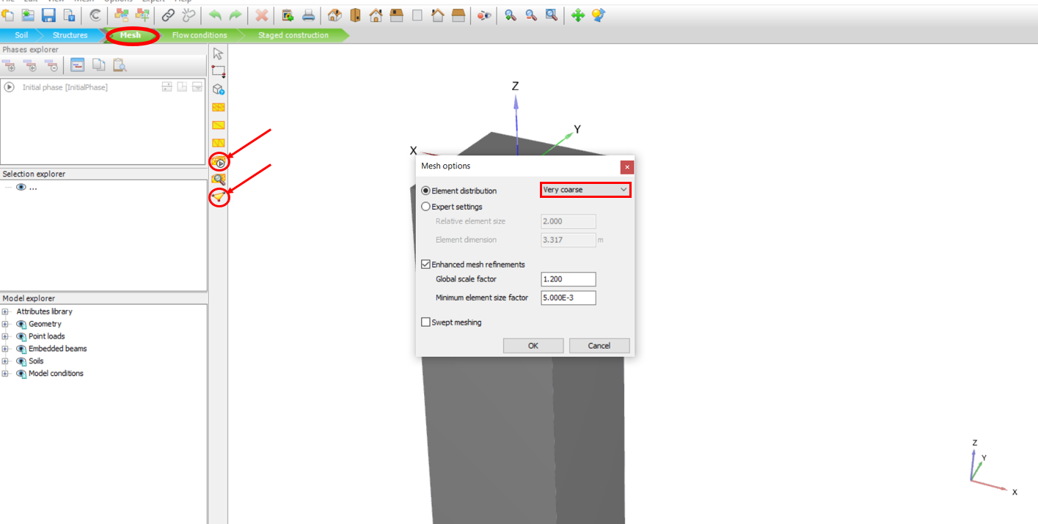
- In the output window associated with calculation point, consider choosing data from an embedded beam node.
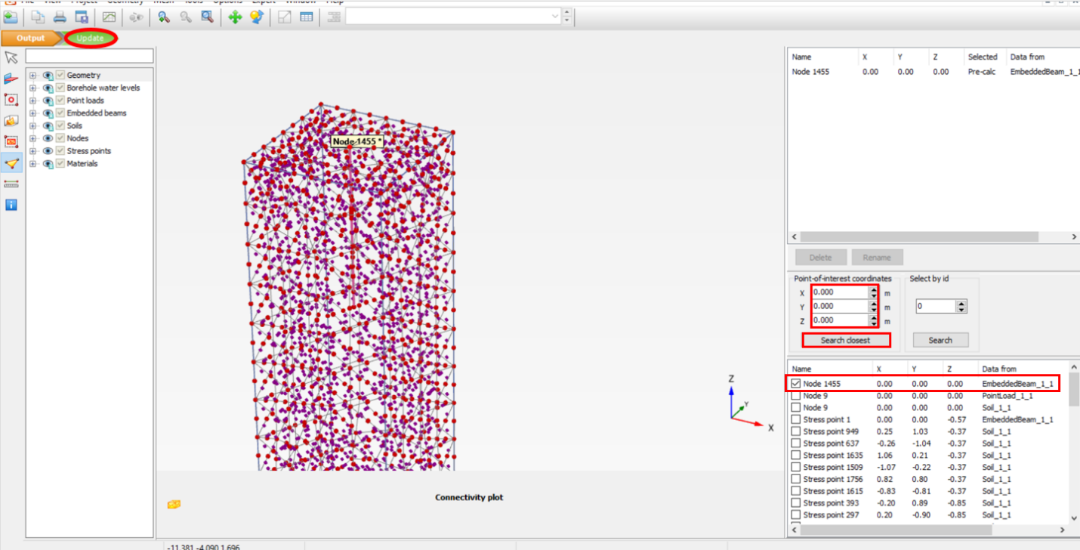

- Click on the Staged construction mode in the Phases explorer, and click on Add Phase to add a new phase.
- In the Model explorer, make sure the box next to Embedded beams is checked.
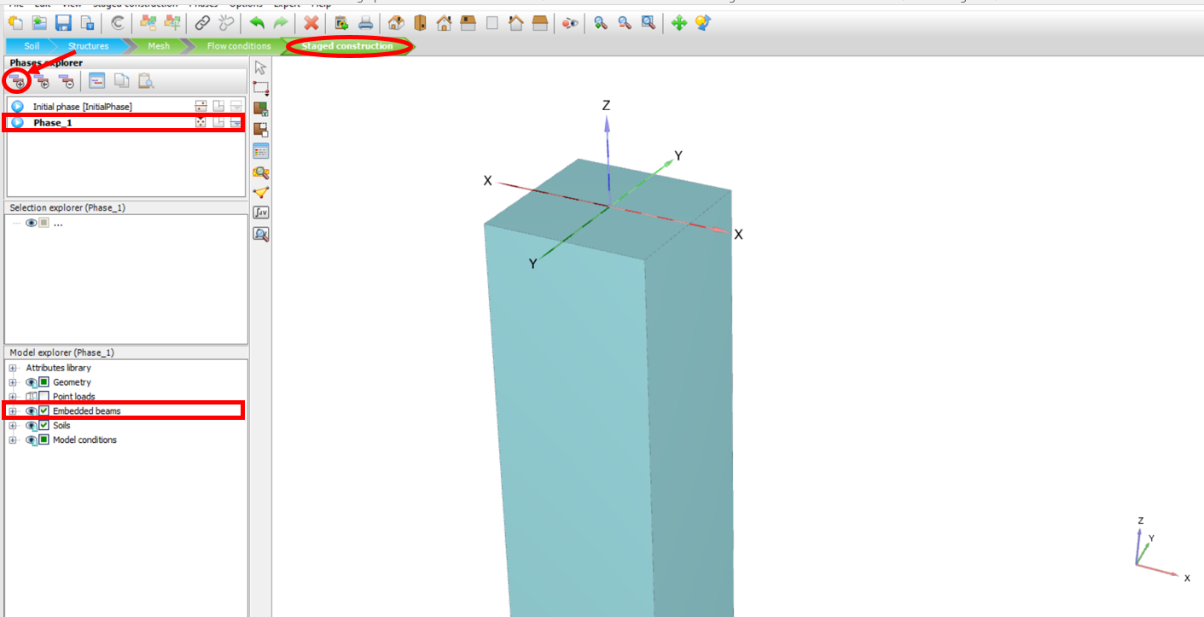
- In the Phases explorer, click on Add Phase to add a new phase.
- In the Model explorer, make sure the box next to Point loads is checked.
- Click on Edit phase. In the opened window, make sure to check mark the box next to “Reset displacement to zero”.
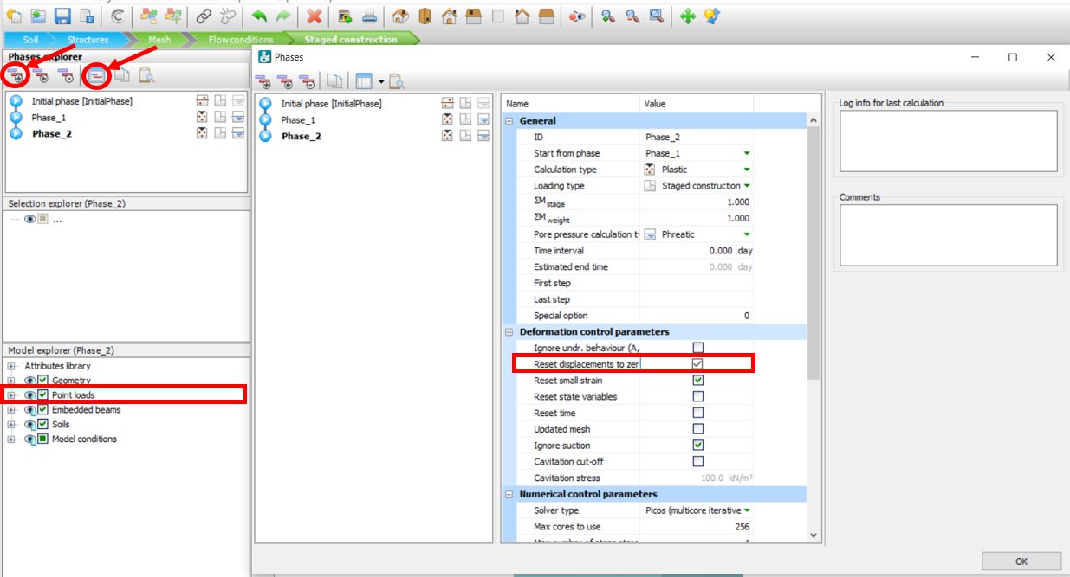

- Repeat Task 6 to calculate and view the calculation results.
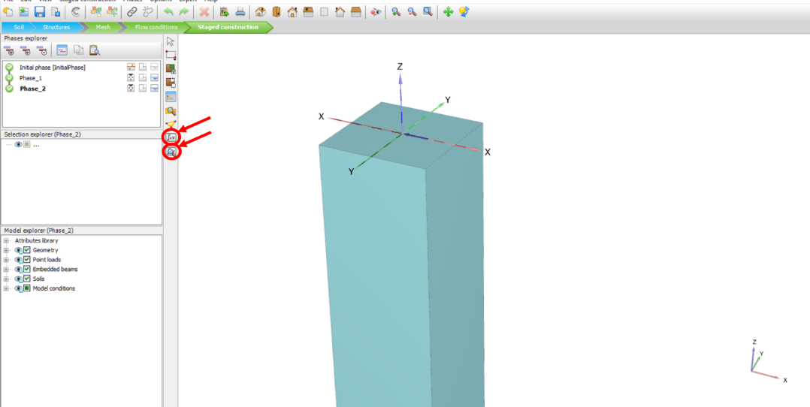
- To see the total the displacement results, in the output window, click on the Deformation tab, click on Total displacement, and then click on u_{z}.
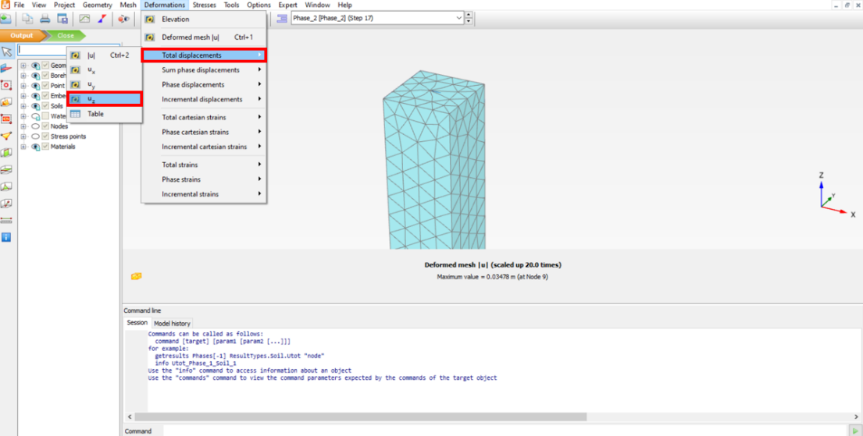
- In the figure below, you can see the total displacement results on the top surface of the model:
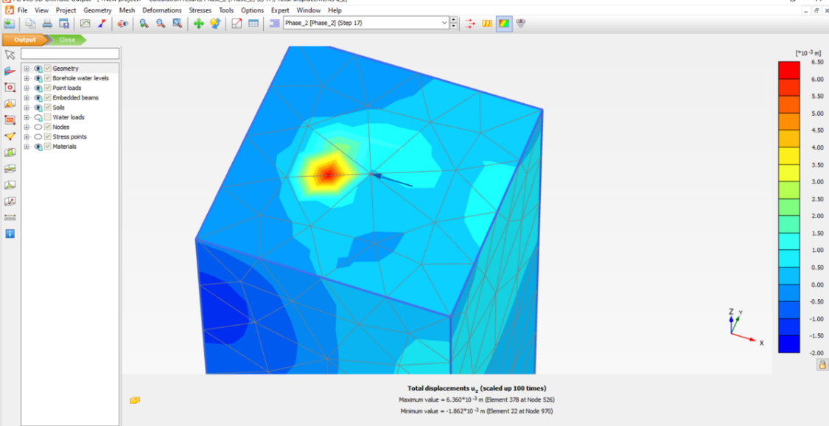
- In the figure below, you can see total displacement results in the cross-section of the model:
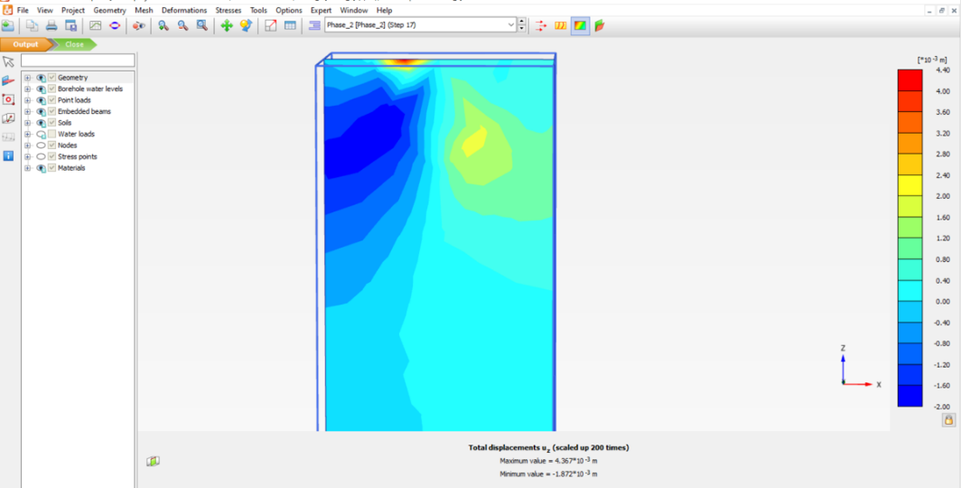
- In the figure below, you can see the Plastic points in the model:
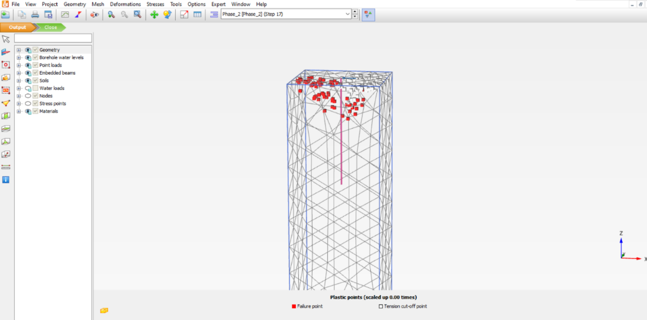

- In the figure below, you can see the Load-Displacement curve:
