# PLAXIS 3D Lesson 6:

**Learning Objective:** This lesson aims to teach you how to create and analyze the effects of geogrid on stress distribution and settlement of square footing.

* Open the saved project (Lesson 2: bearing capacity of square footing)
* Click on the **File** tab in the toolbar, then click on **Save project as…** to create a copy of the current file and apply new changes in the new file.

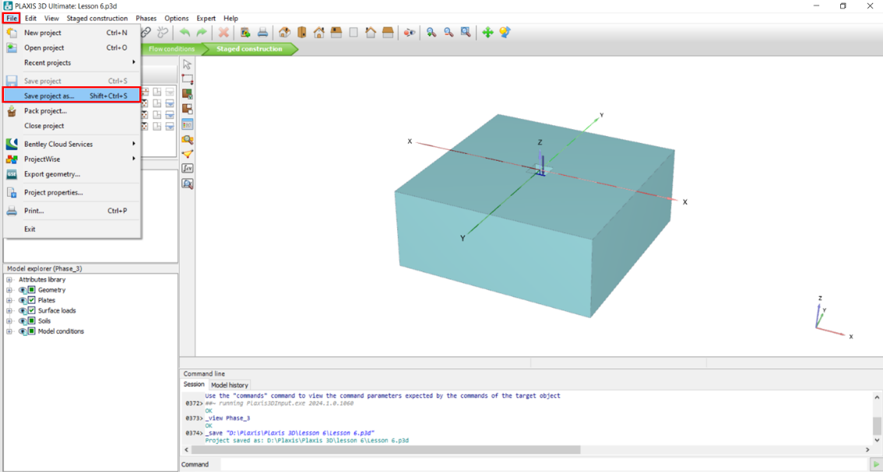

* In the opened window, choose a name to be saved with, for example, type in: Lesson 6
* Click **Save**.

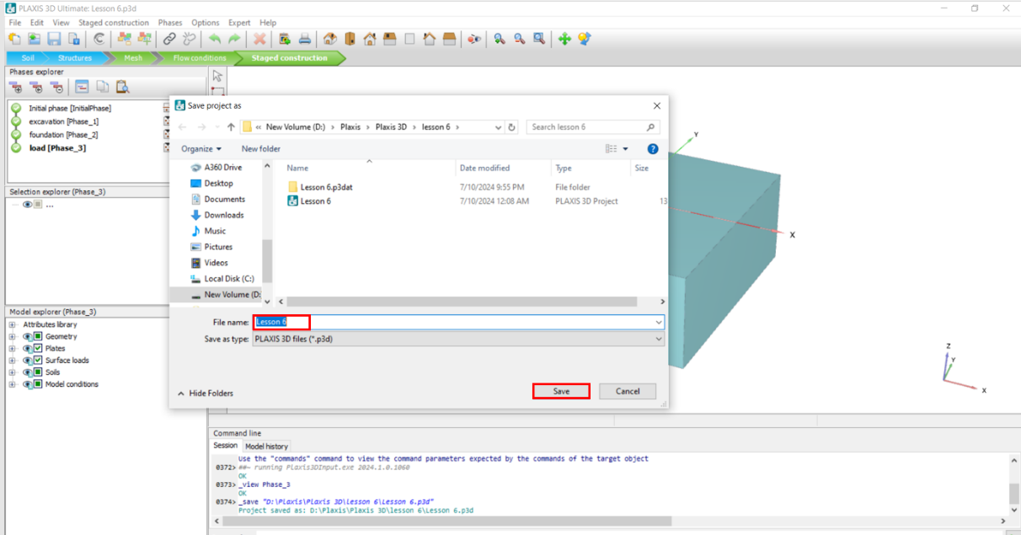.

* To see how geogrids can prevent soil failure, we will replace the soil with weaker soil that is not capable of withstanding 1000 kN surface load. Click on the **Show materials** icon, then “Silt”, and click **Edit.**

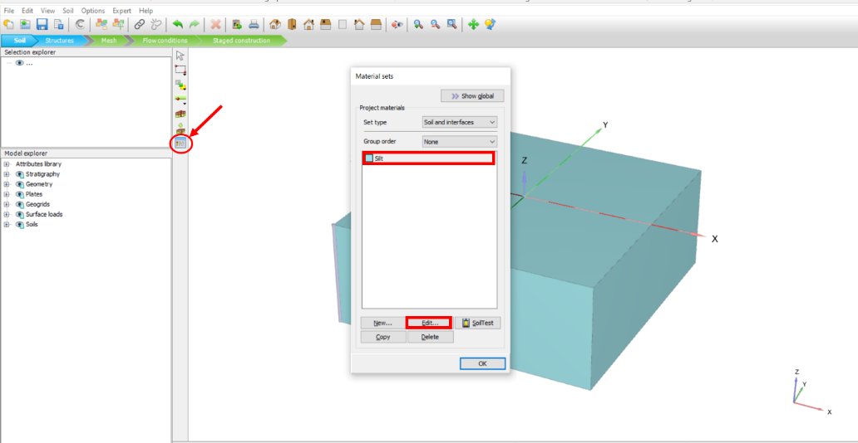

* In the opened window, click on the Mechanical tab and change ø(phi) value to 20, then click **OK**.

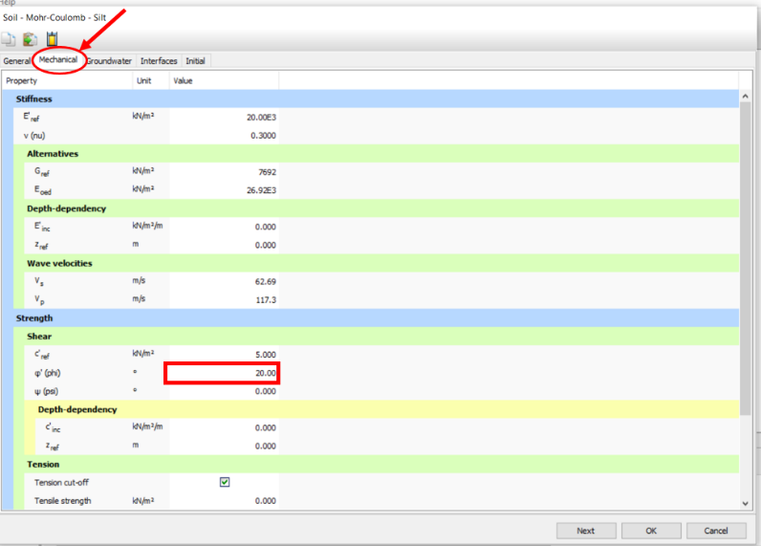

**Task 1: Generate Mesh and Perform Initial Calculations**

To compare the results before and after adding geogrids, do the following steps to obtain the results before adding geogrids:

1. Go to **Mesh** mode
2. Click on **Generate mesh**.
3. Choose Mesh size (Very coarse).
4. Choose a point for calculation by clicking on **Choose a point for curves** icon.
5. In the opened window, choose desired coordinates (X=0, Y=0, Z=-0.5), **Search closest** nodes, check the box next to the desired node, and click **Update**.

* In the figure below, you can see steps 1 to 5:

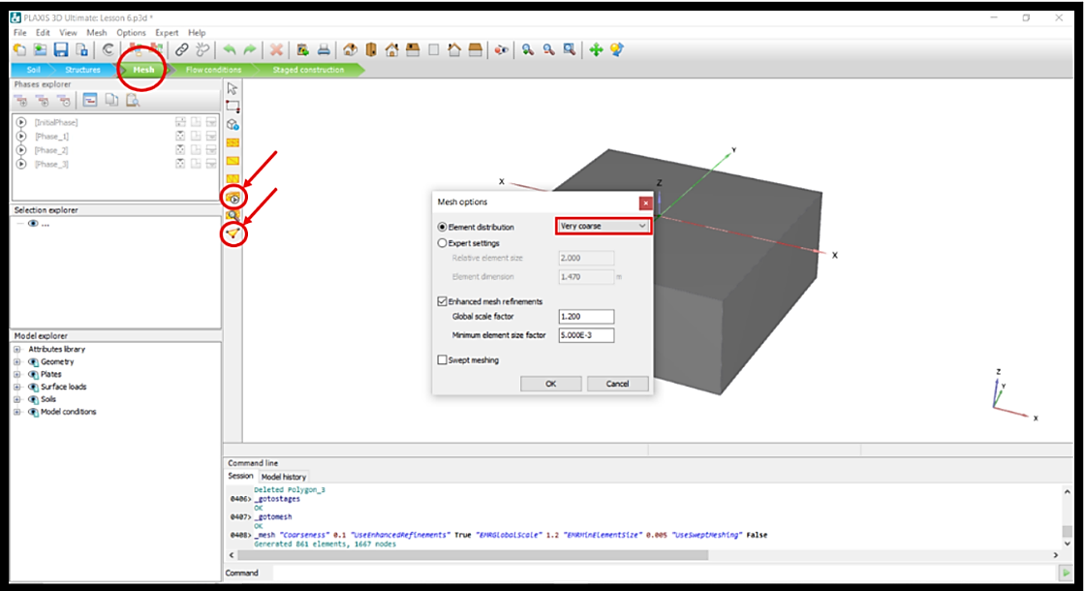

1. Go to **Staged construction** mode.
2. Click **Calculate**.
3. After the calculation is finished, notice the **red X sign** next to the Phase_3 in the Phases explorer section (this indicates that the soils failed and this footing with the current size cannot withstand the applied load):

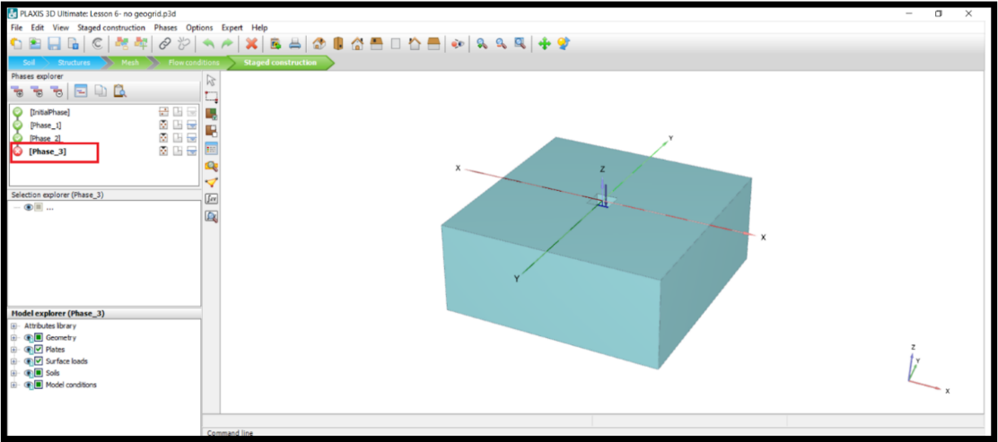

1. Click on **View Calculation results**.

* In the figure below, you can see steps 6 to 8:

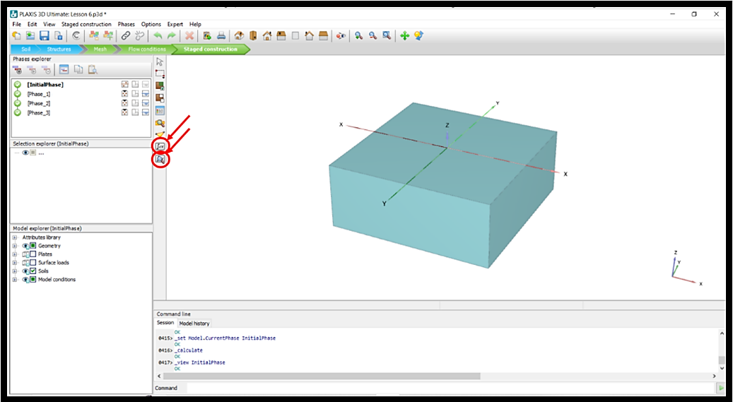

1. To see the effective stress distribution, in the opened Output window, click on Stresses in the toolbar, and click on the **Cartesian effective stresses**, then click on $σ_{zz}^{'}$.

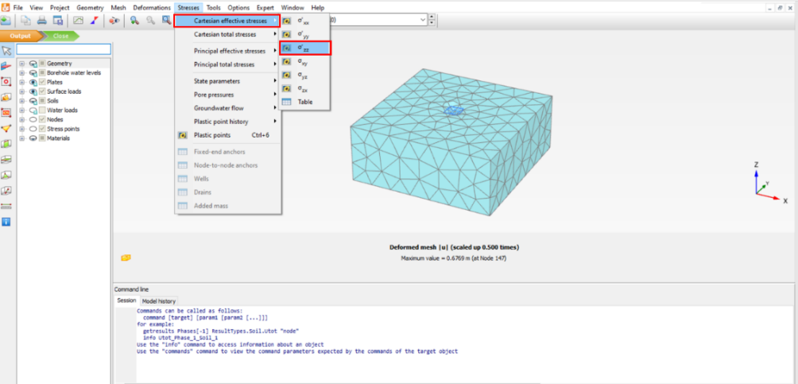

* To observe the result of total displacement in the cross-section, click on the **Vertical cross section** icon and click on the two desired points on the two sides of the model:

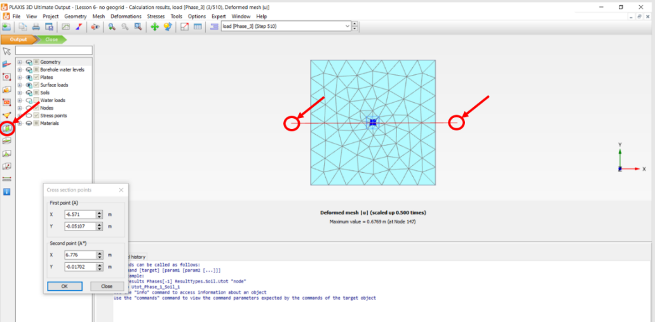

* To view the contours from the front view, click on **View** in the toolbar, and then click on **Viewpoint.**

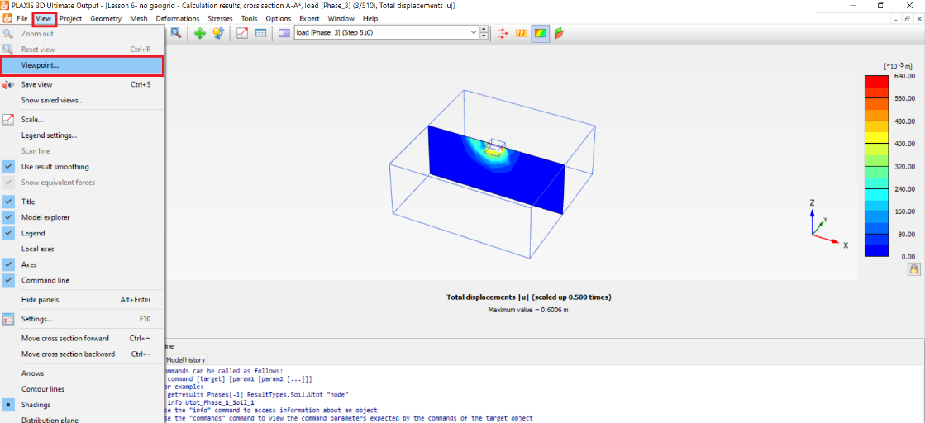

* In the opened window, click on **Front view**, click **Apply** and close the window.

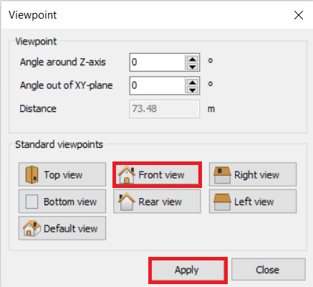

* In the figure below, you can see the cross-section of effective stress distribution (without any geogrid in the model).

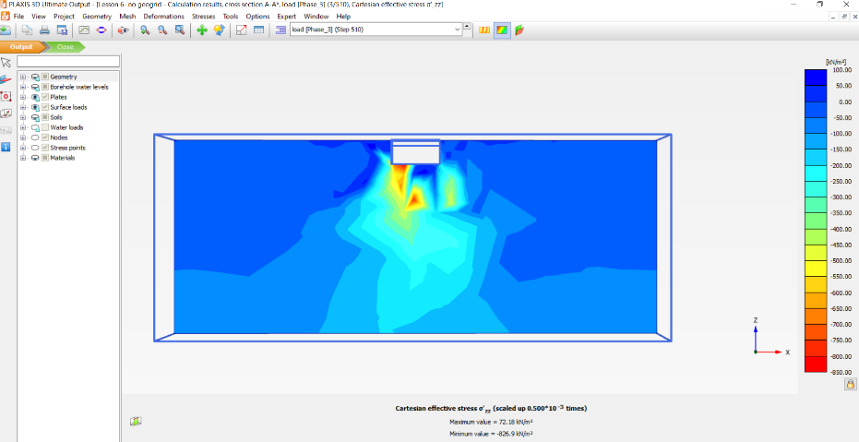

1. To see the Incremental displacement in z direction, in the opened Output window, click on **Deformation** in the toolbar, then click on **Incremental displacement**, click on ${∆u}_{z}$.
2. Click on the **Arrows** icon to see the displacement directions and intensity.

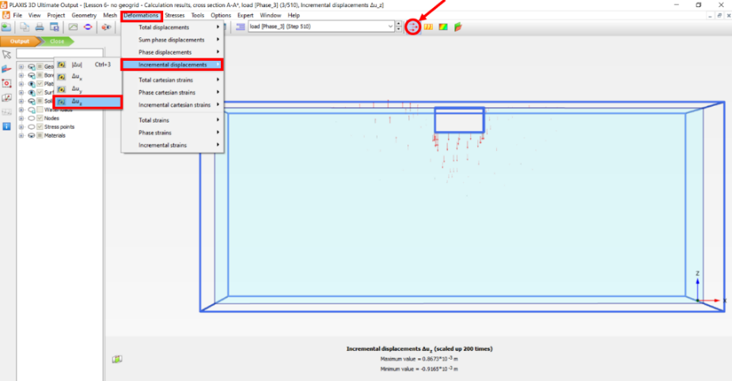

* Right-click on the model and click on **Scale**.

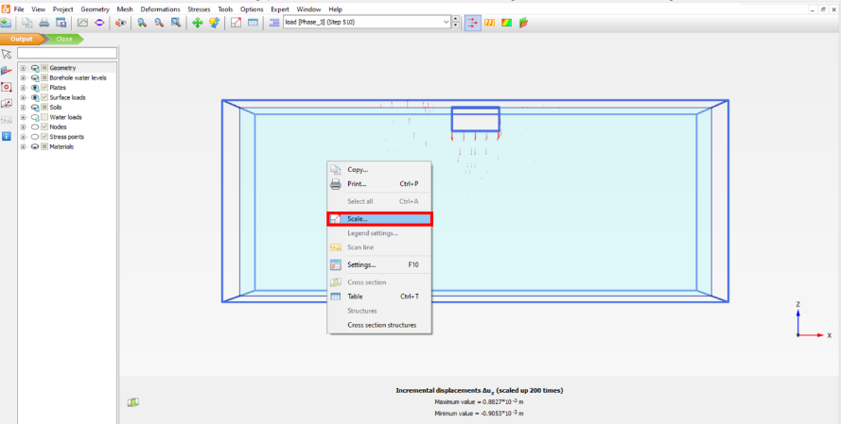

* In the opened window, click on **Manual scale**, and type “800” in the **scale factor** box.

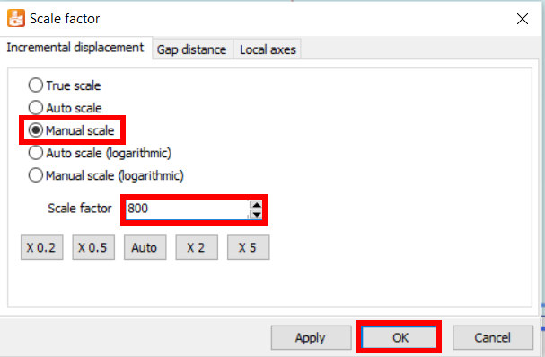

* In the figure below, you can see the incremental displacement direction and intensity in z direction (without any geogrid in the model).

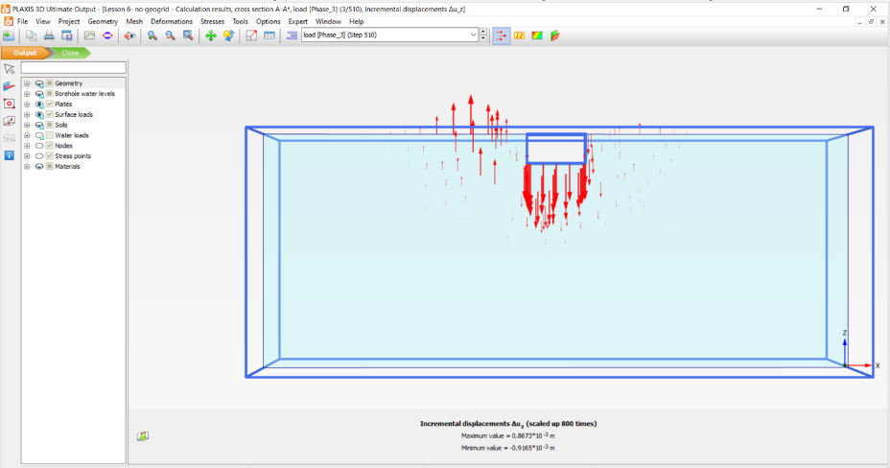

* Click on Shadings icon to see incremental displacement shading.
* In the figure below, you can see incremental displacement in z direction (without any geogrid in the model).

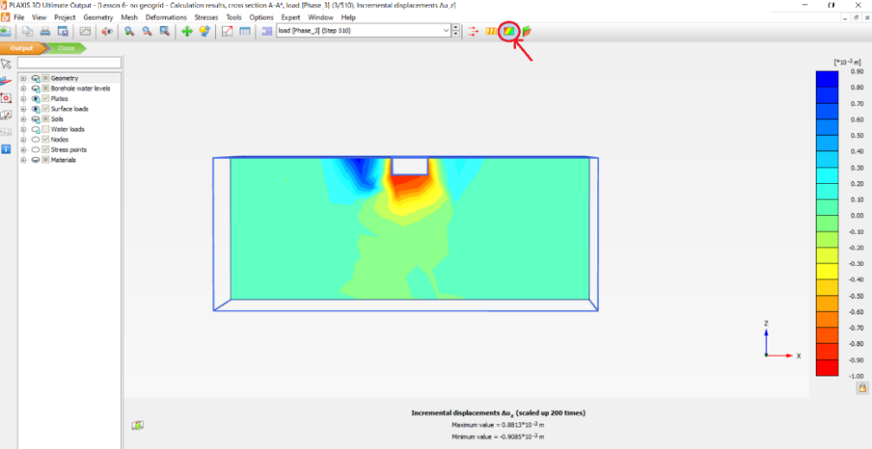

1. Go to **Curve manager** and click **New.**

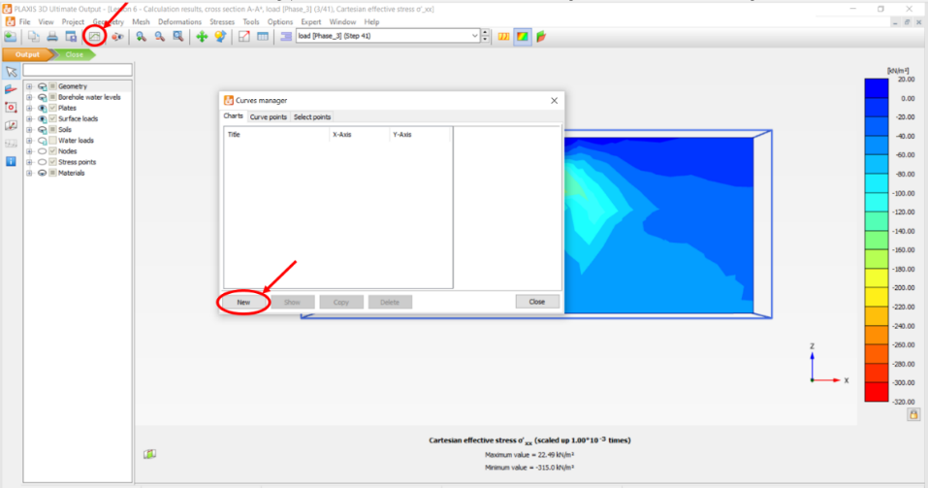

* Plot Load-Displacement curve. In the **X-Axis** section, click on the drop-down arrow under the y-axis and choose the node you defined in previous sections. Then, click on + sign next to **Deformation**, then click on + sign next to **Total displacement**, and choose “uz”. Check the box next to **Invert sign**. In the **Y-Axis** section, keep the drop-down selection on Project, and in the **Step** subsection, click on the + sign next to Multiplier, and choose **ƩMstage**.

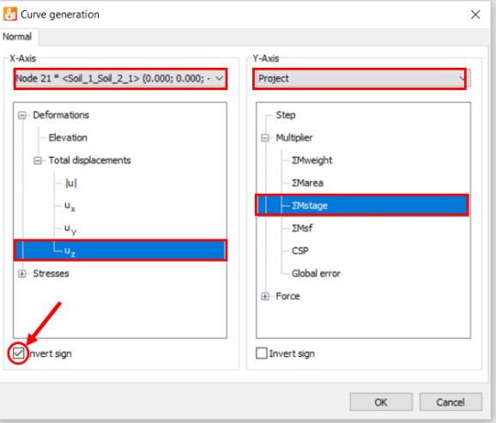

* Click on **Tables**, Copy data into Excel, and plot corresponding load-displacement curves.
* In the figure below, you can see the load-displacement curve (without any geogrid in the model). Notice how the curve plateaus after about $u_{z}=$ 0.25. This is also an indication of the soil failure.

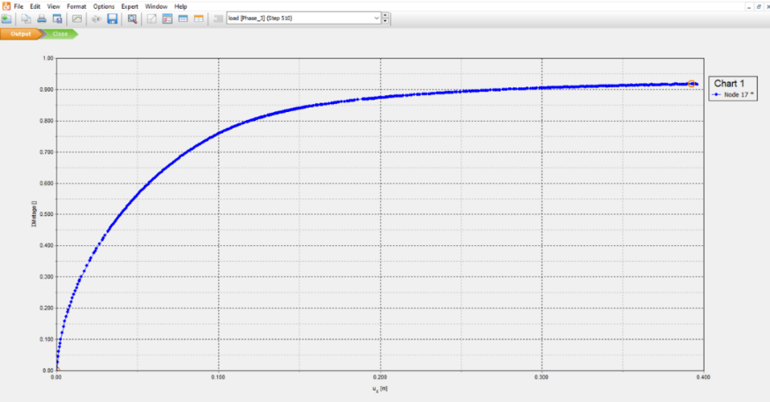

**Question:**

**Based on this plot, what is the bearing capacity of this foundation on this soil?**

* Remember to delete undesired points by right-clicking on the plot, **Settings,** select the Node tab, **Phases**, and unchecking all the phase boxes except [Phase_3].

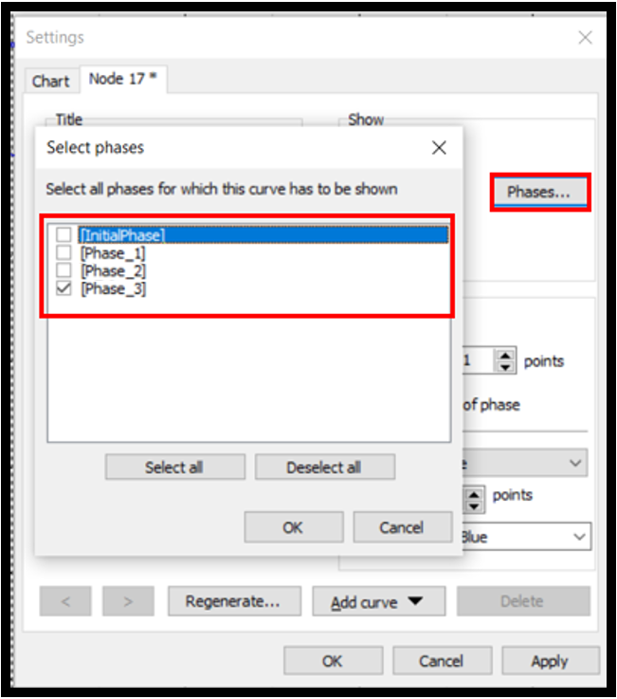

* Right-click on ƩMstage, Copy and paste in Excel file.
* Right-click on displacement (uz), Copy and paste in the excel file.

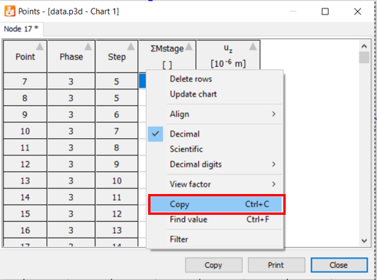

* Multiply ƩMstage numbers by the number of the assigned surface load (in this case 1000) to get actual **loads**.
* Multiply uz numbers by 1000 to change the numbers’ unit to millimeters for **displacements**.
* Change the sheet cell’s format to **General**.

**Task 2: Define Geogrids**

* To define Geogrids in the model, click on the **Structures** mode, click on the **Create surface** icon, and draw a 1.5×1.5 surface in -1 elevation (you can manage drawing points by clicking on desired points on the model or in the **Surface points** window).

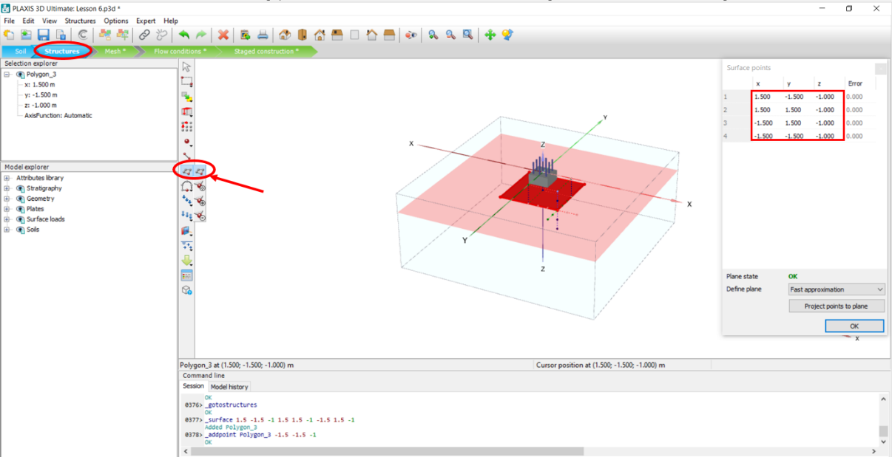

* Select created surfaces in the 3D model, right-click on the surface, click **Create**, and then **Create geogrid**.

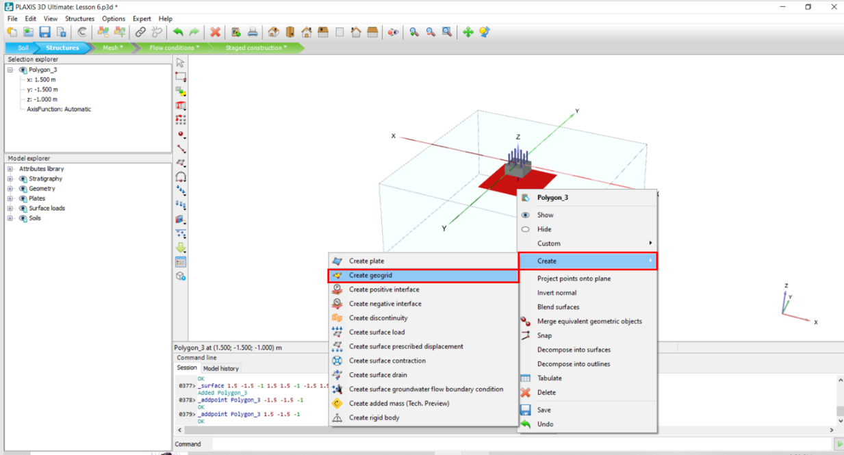

* To define geogrid material, click on the **Show materials** icon, click on drop-down arrow in **Set type** and choose **Geogrids.** Click on **New** to define new material.

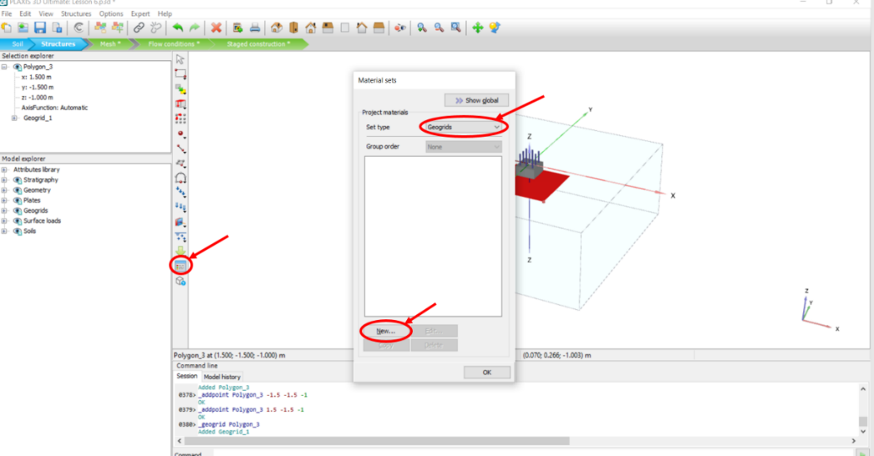

* In the opened window, in the **General** tab type in Geogrid in the **Identification** box.

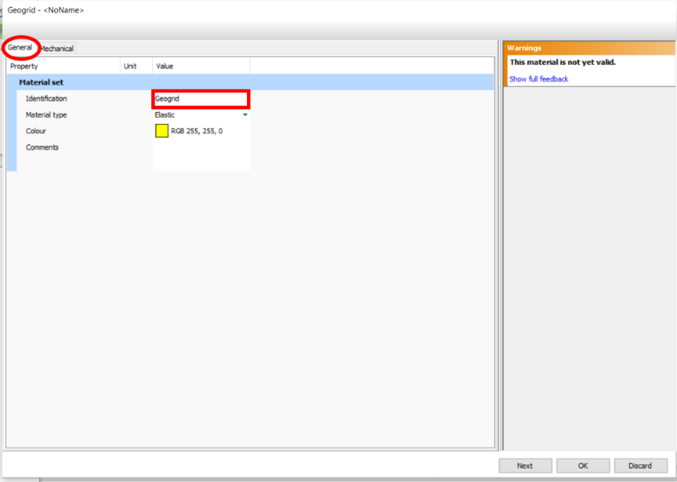

* Click on the **Mechanical** tab and enter geogrid **Stiffness:** **EA1**: 800 kN/m
* Click **OK.**

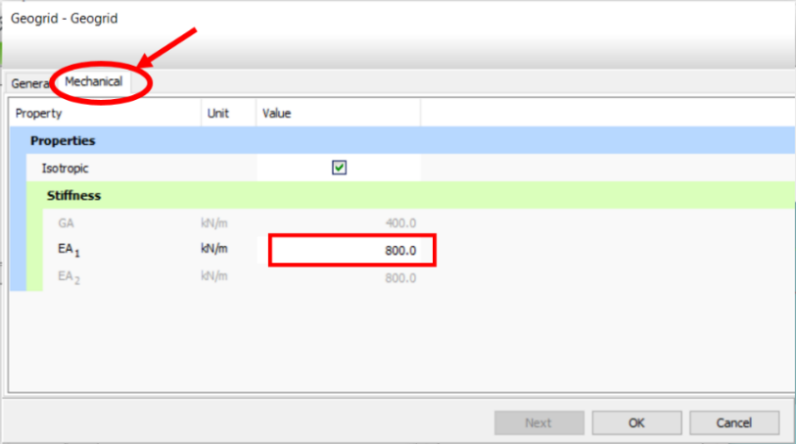

* In the **Model explorer**, click on the + sign next to **Geogrids**, and change the **Material** to “Geogrid” by clicking on the drop-sown arrow.

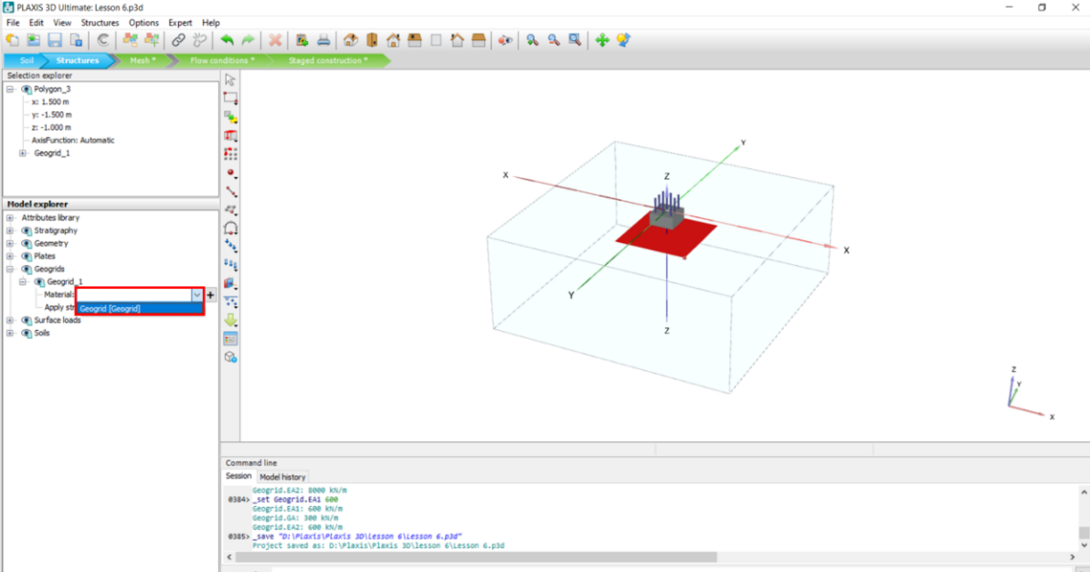

* Follow steps 1-13 for the model with the created geogrid.

In step 6, make sure Geogrids are activated in all the phases (InitialPhase, Phase_1, Phase_2, Phase_3) by clicking on the check mark next to **Geogrids.**

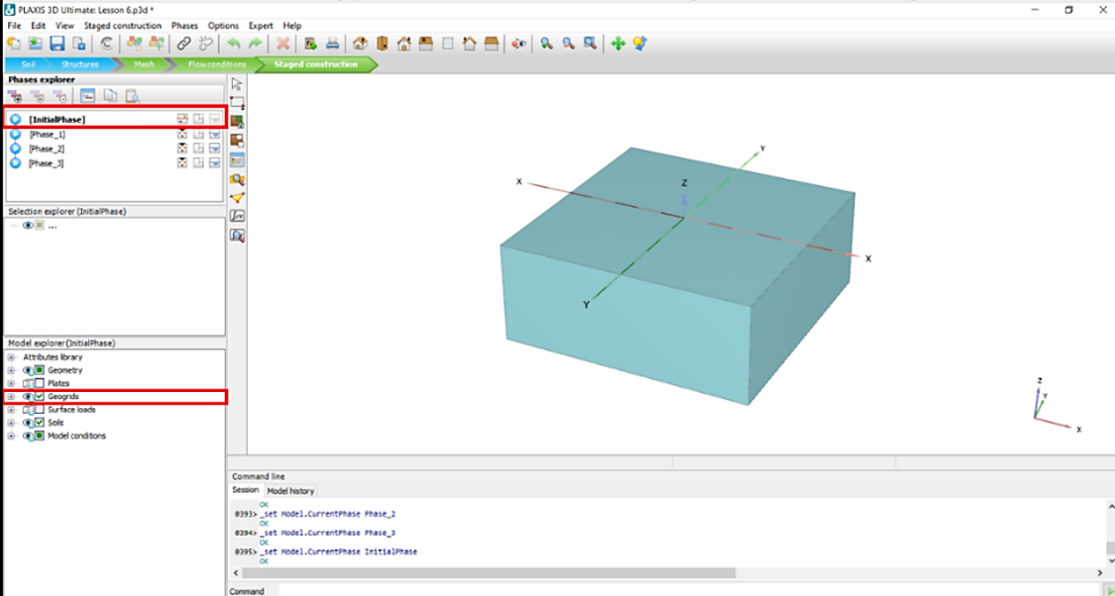

* After the calculation is finished, notice there is no **red X sign** next to the Phase_3 in the Phases explorer section (this indicates that the soils did not fail and this footing with the current size and the installed geogrid can withstand the applied load without bearing capacity failure. You still need to check to see if the settlement criteria are met).

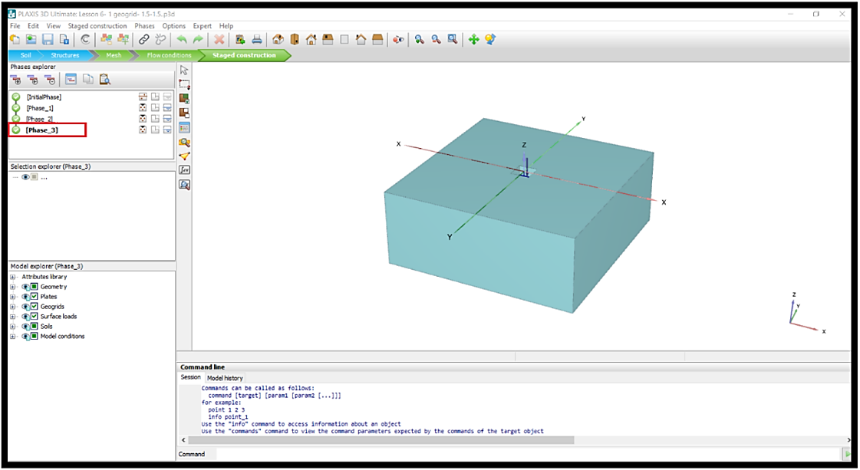

Important: This is a simplified project and just an introduction to creating geogrids in PLAXIS3D. In the real world, there is an excavation, placement of the geogrid, backfilling, compacting, and each step MUST be defined as it proceeds in the project construction! Unless otherwise noted, all tools in this exercise can be accessed using the “OpenRoads Modeling” workflow.

* In the figure below, you can see the cross-section of effective stress distribution (one 1.5*1.5 geogrid in the model).

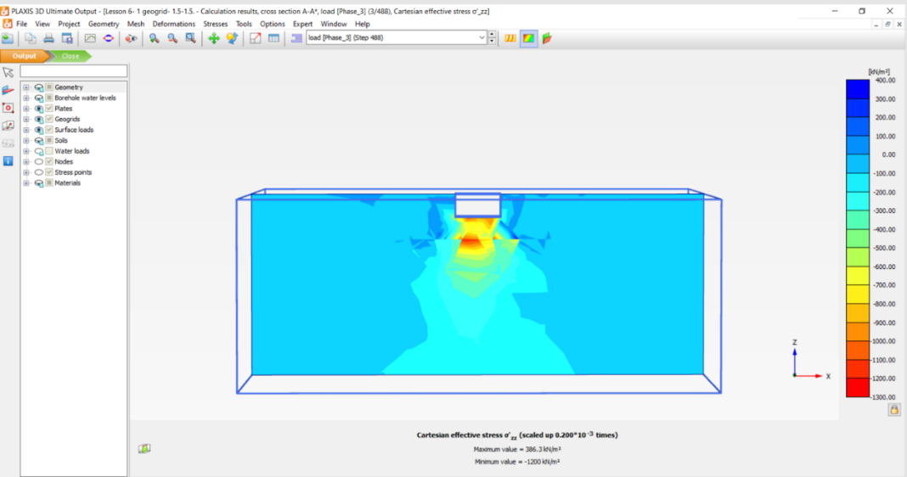

* In the figure below, you can see the incremental displacement direction and intensity in the z-direction (one 1.5 × 1.5 geogrid in the model).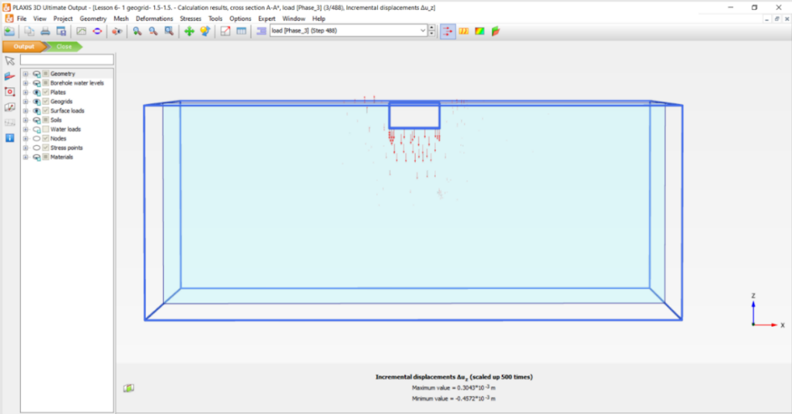
* In the figure below, you can see the incremental displacement shading in the z-direction (one 1.5 × 1.5 geogrid in the model).

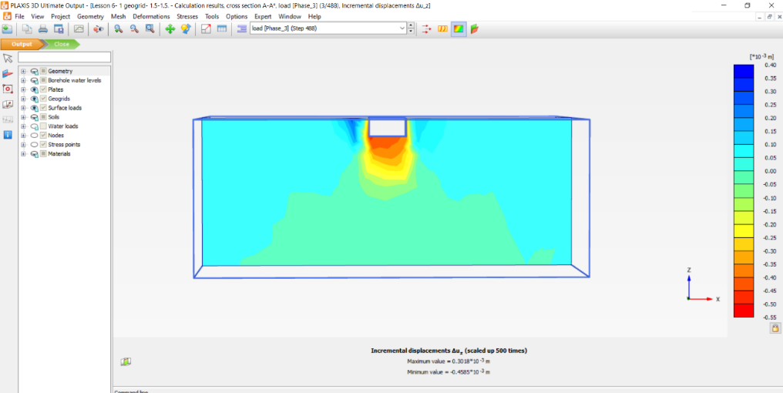

* In the figure below, you can see load-displacement curve (one 1.5*1.5 geogrid in the model).

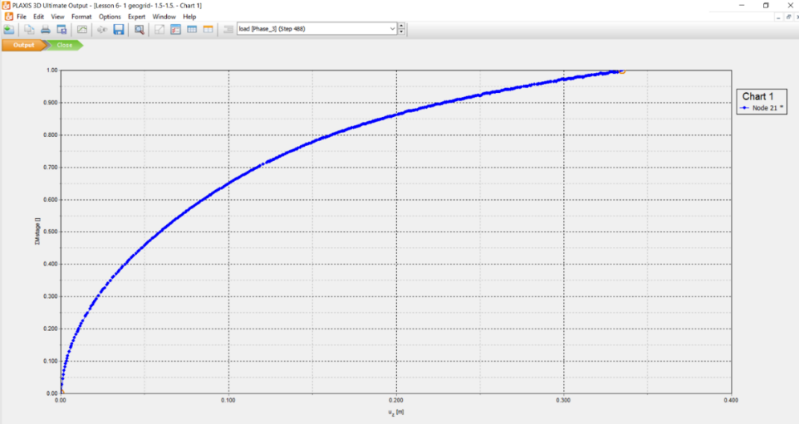

**Task 3: Change Geogrid Size**

* To change the geogrid size, select the created geogrid surface in the 3D model or find its corresponding item in **Model explorer** (Polygon_3), and click **Delete**.

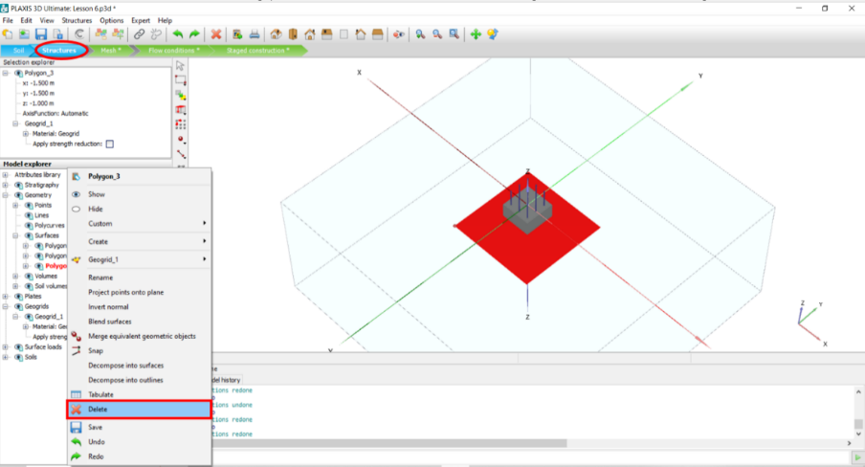

* Click on Create surface and draw a 2.5*2.5 surface in -1 elevation.

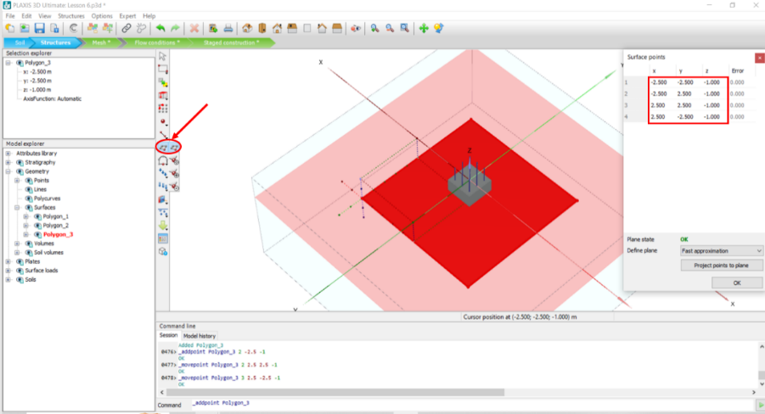

* Repeat steps 1-13 and make sure **Geogrids** are activated in all the phases.
* In the figure below, you can see the cross-section of effective stress distribution (one 2.5*2.5 geogrid in the model).

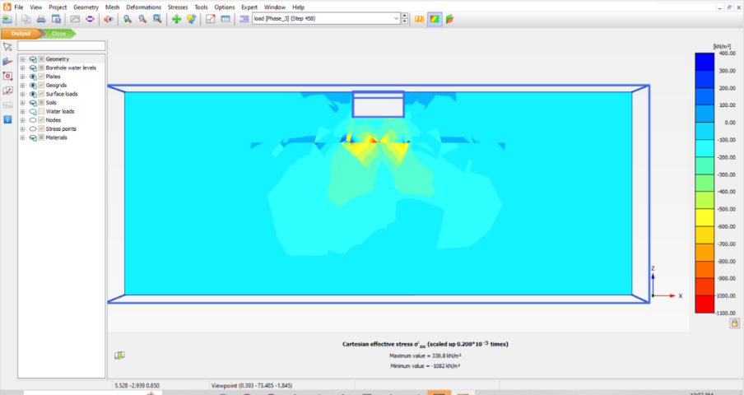

* In the figure below, you can see the incremental displacement direction and intensity in z direction (one 2.5*2.5 geogrid in the model).

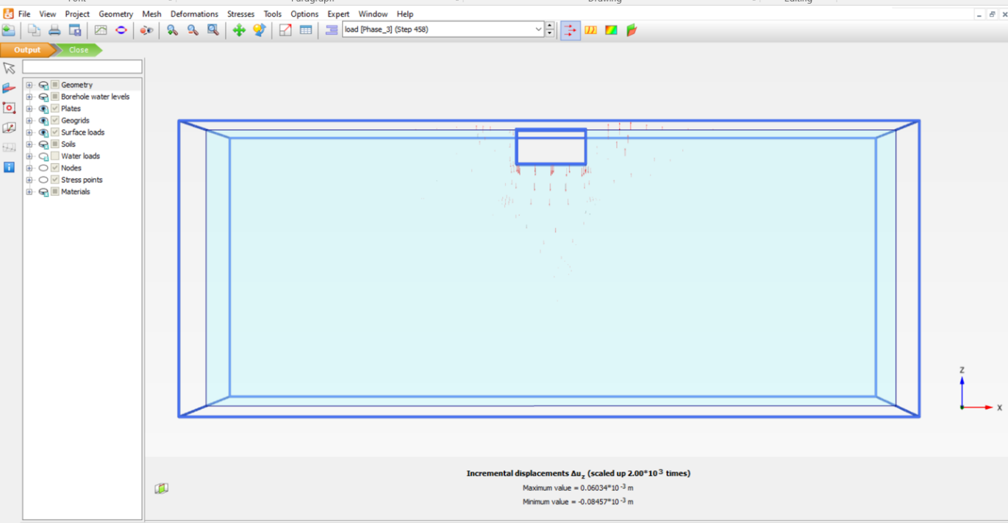

* In the figure below, you can see the incremental displacement shading in z direction (one 2.5*2.5 geogrid in the model).

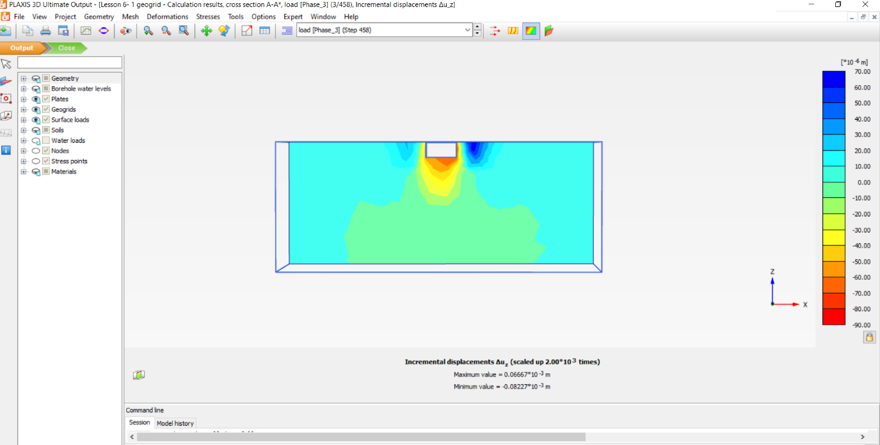

* In the figure below, you can see the load-displacement curve (one 2.5*2.5 geogrid in the model).

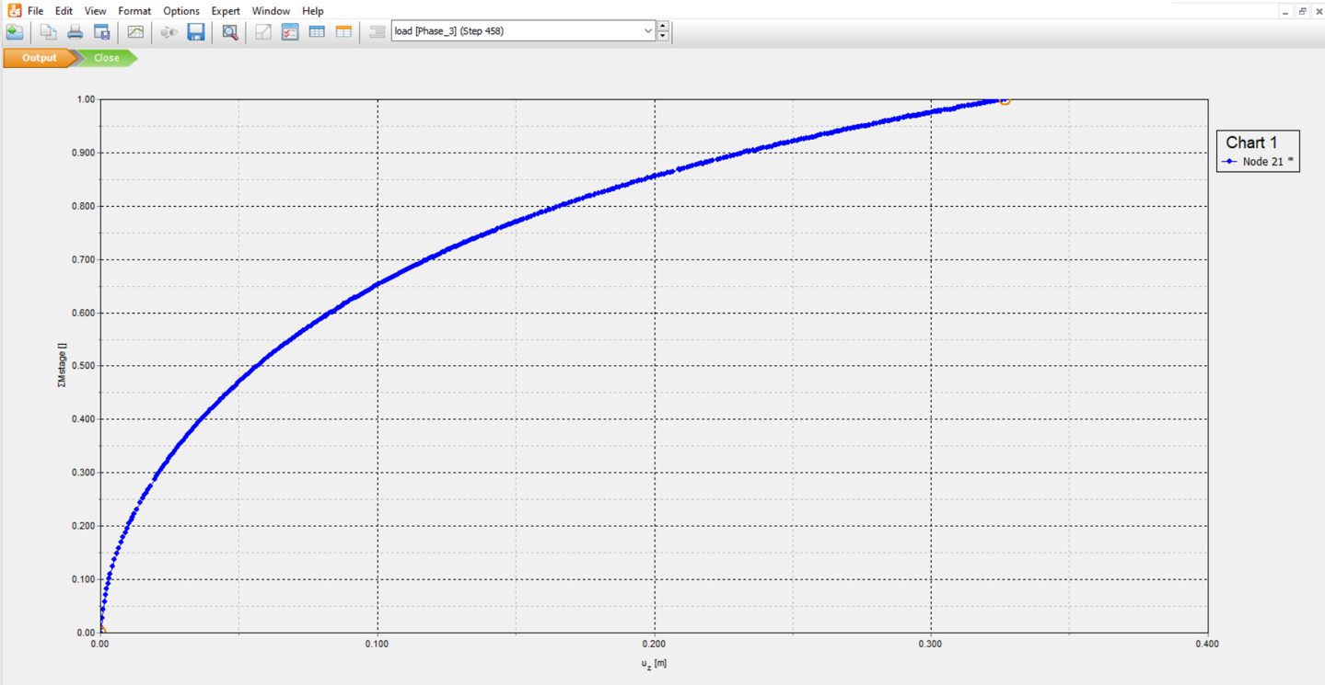

**Task 4: Add Multiple Geogrids**

To see the effect of multiple geogrids perform the following steps:

* Select the geogrid you just created in the 3D model.
* Click on **Create array** to add multiple surfaces and copy the selected surface in the desired distance.
* In the opened window, choose “1D,in z direction” by clicking on drop-down arrow in Shape , and enter 0.3 in the Z box.
* Click **OK**.

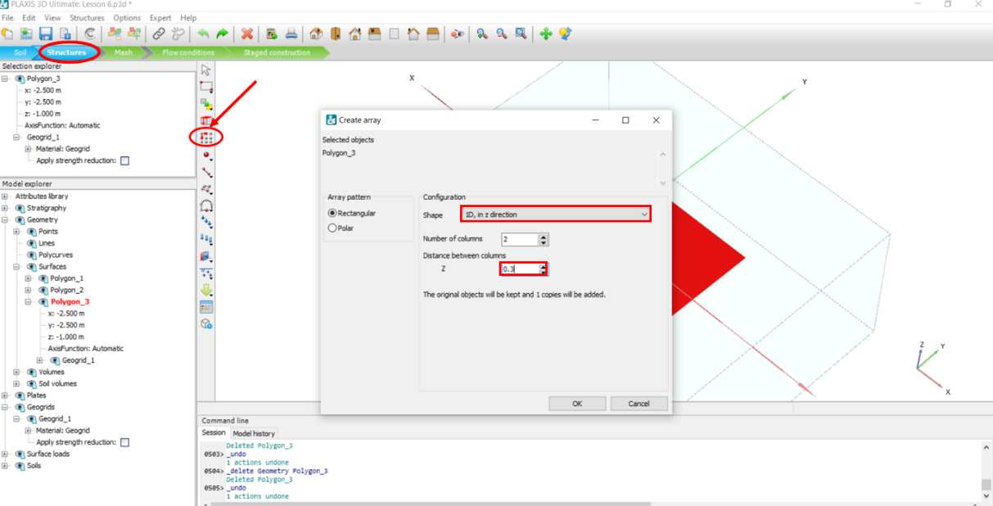

* In the **Model explorer**, click on the + sign next to **Geogrids,** and make sure both materials are changed to “Geogrid”.

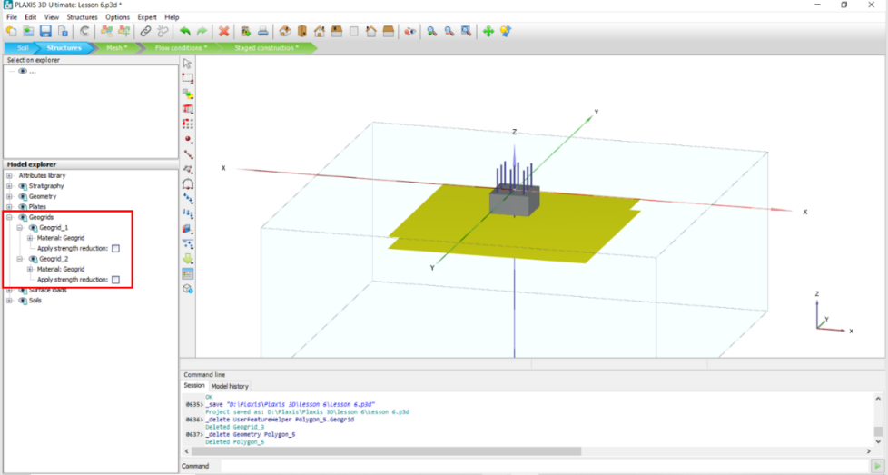

* Repeat steps 1-13 and make sure both Geogrids are activated in all the phases.

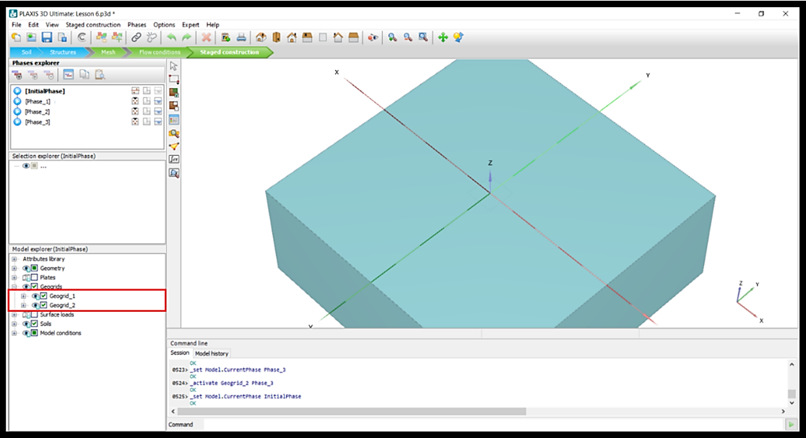

* In the figure below, you can see the cross-section of effective stress distribution (two 2.5*2.5 geogrids in the model).

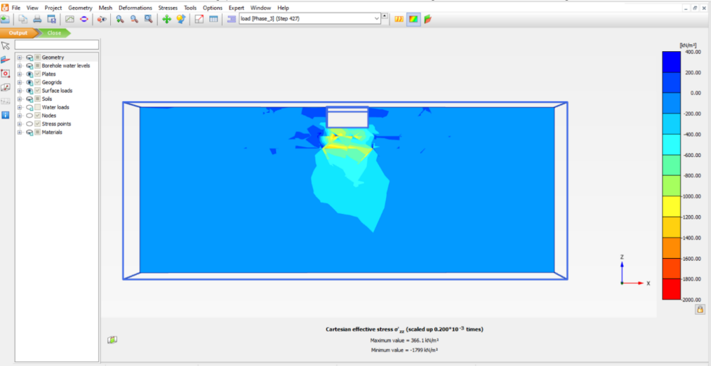

* In the figure below, you can see the incremental displacement direction and intensity in z direction (two 2.5*2.5 geogrids in the model).

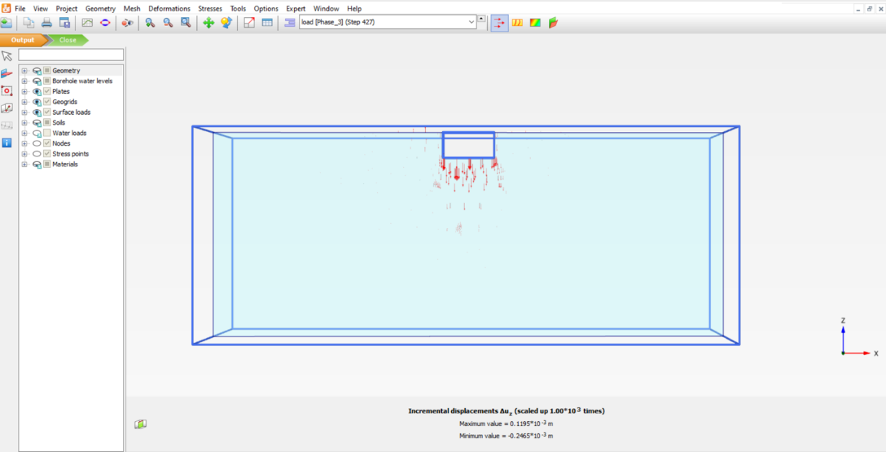

* In the figure below, you can see the incremental displacement shading in z direction (two 2.5*2.5 geogrids in the model).

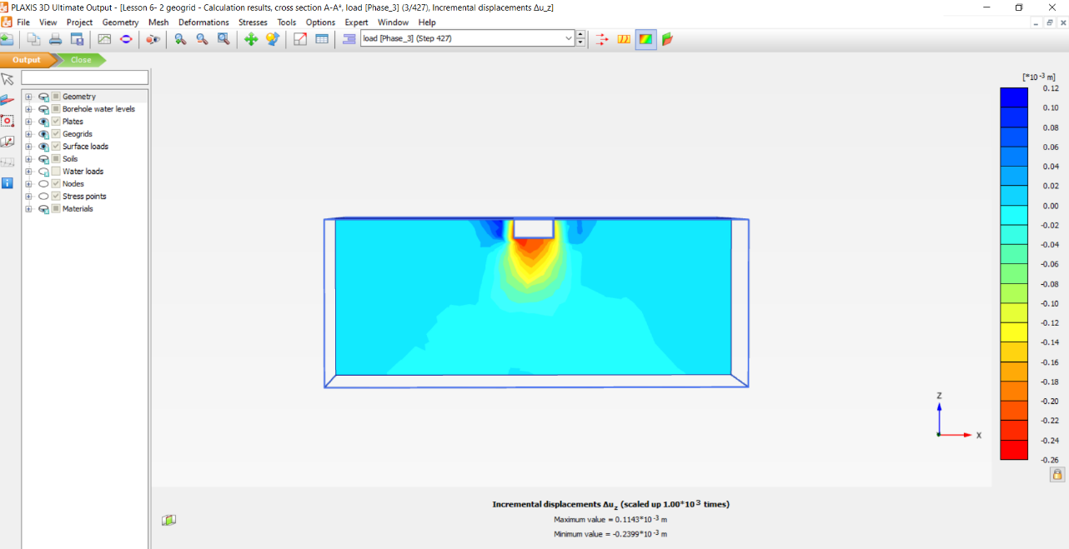

* In the figure below, you can see load-displacement curve (two 2.5*2.5 geogrids in the model).

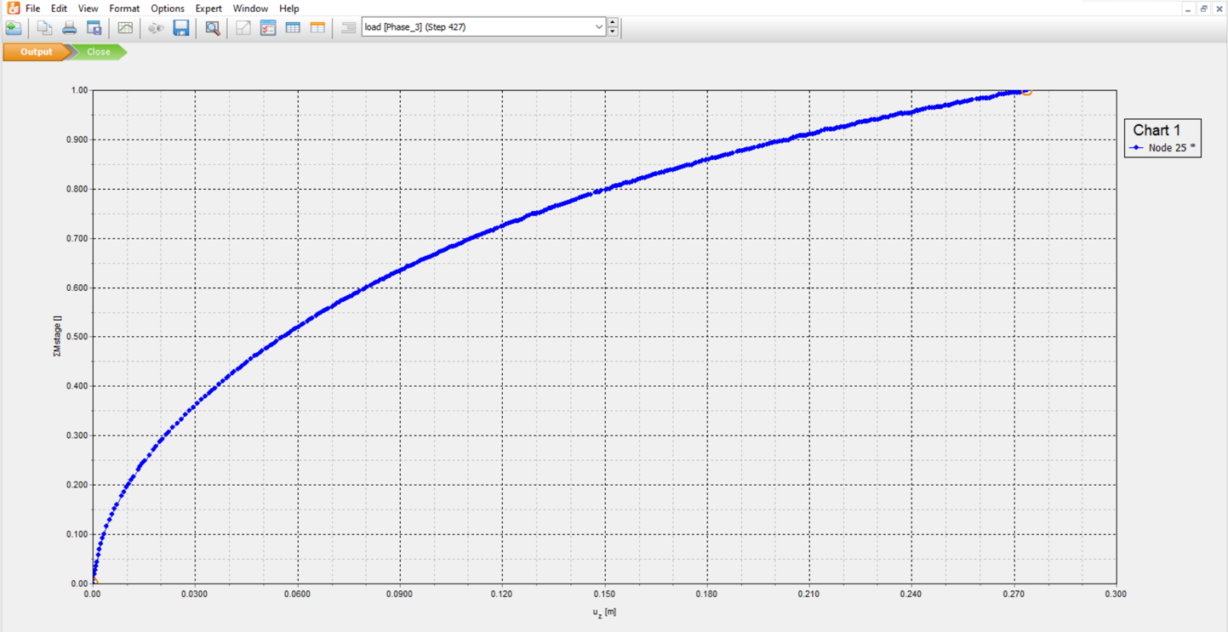

To add another geogrid layer perform following steps:

* Make sure the initial surface is still selected, click on **Create array**, in the opened window, choose “1D,in z direction” by clicking on drop-down arrow in Shape , enter -0.3 in the Z box.
* Click **Ok**.

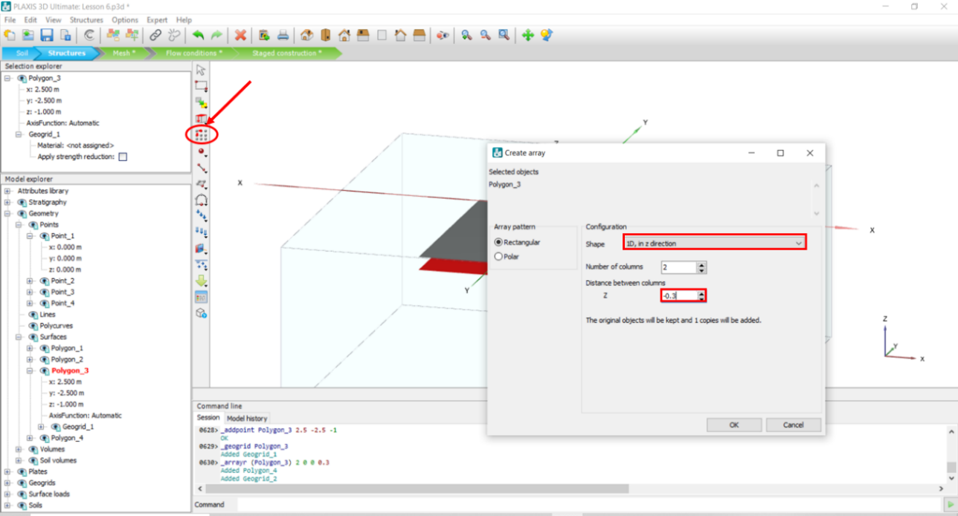

* In the **Model explorer**, click on the + sign beside Geogrids, choose the Geogrid material by clicking on the + sign next to **Material** for Geogrid_1, Geogrid_2, Geogrid_3.

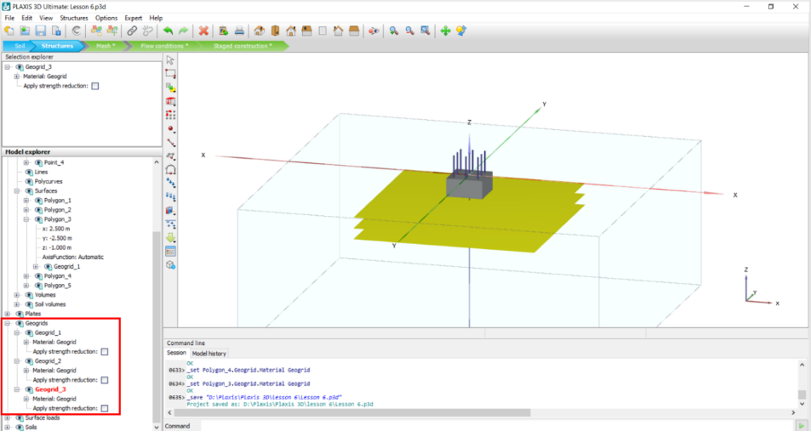

* Repeat steps 1-13 and make sure both **Geogrids** are activated in all the phases.

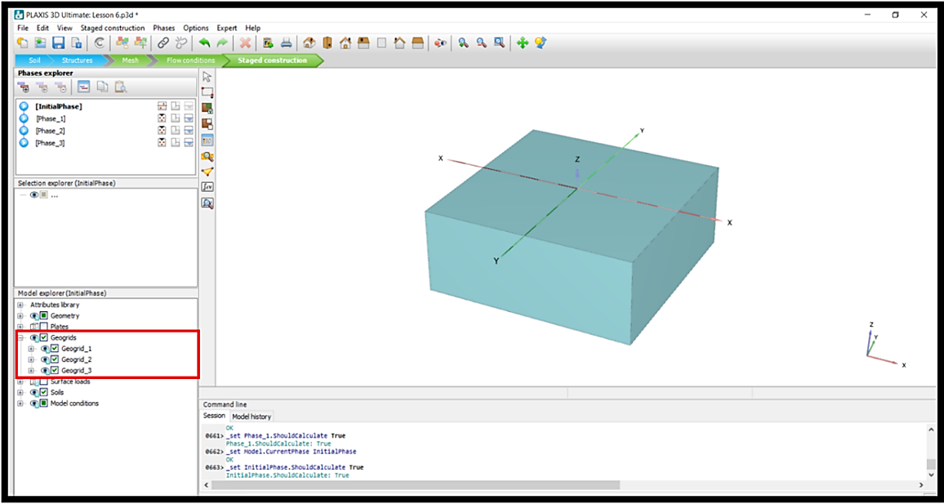

* In the figure below, you can see the cross-section of effective stress distribution (three 2.5*2.5 geogrids in the model).

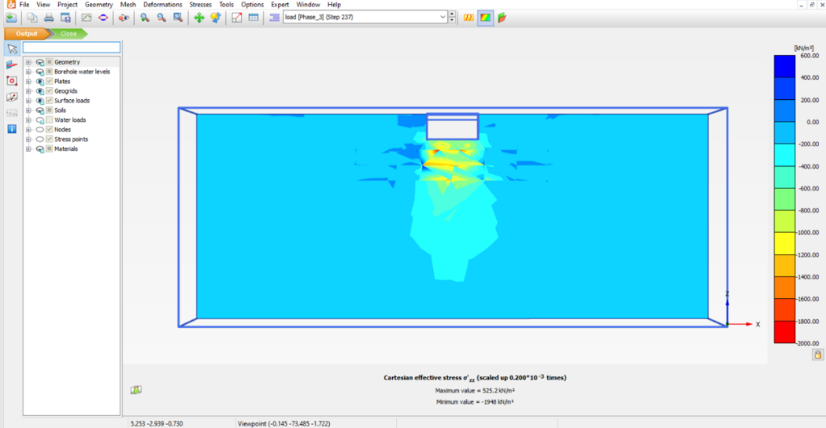

* In the figure below, you can see the incremental displacement direction and intensity in z direction (three 2.5*2.5 geogrids in the model).

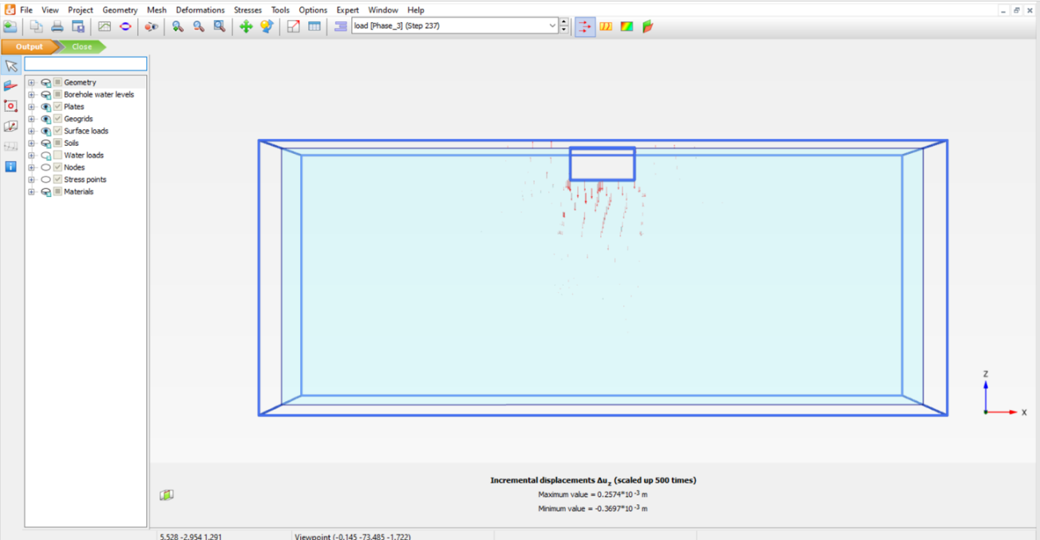

* In the figure below, you can see the incremental shading displacement in z direction (three 2.5*2.5 geogrids in the model).

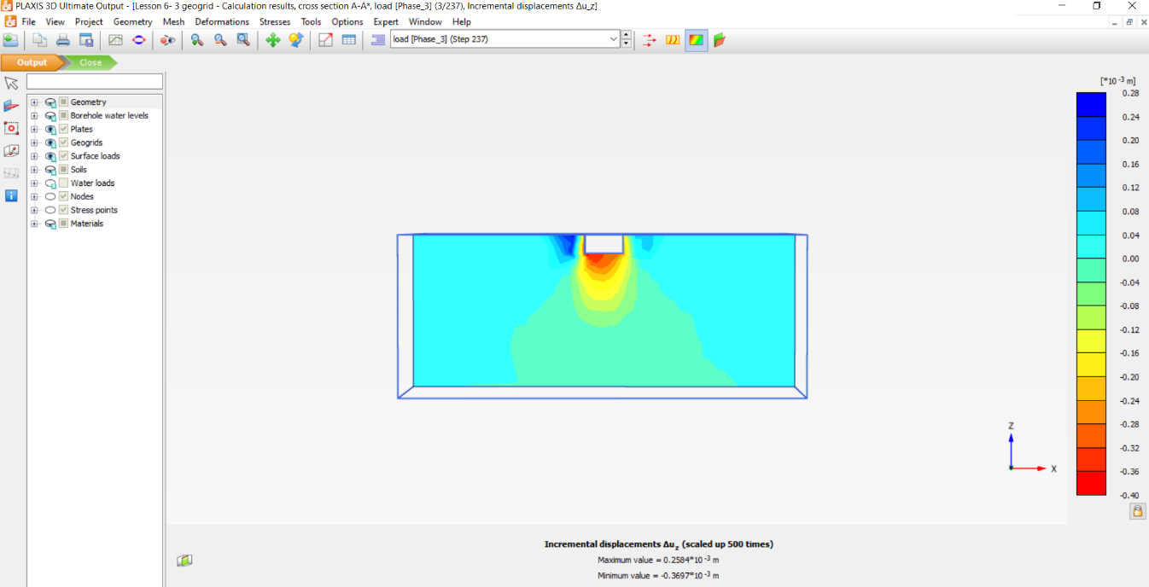

* In the figure below, you can see load-displacement curve (three 2.5*2.5 geogrids in the model).

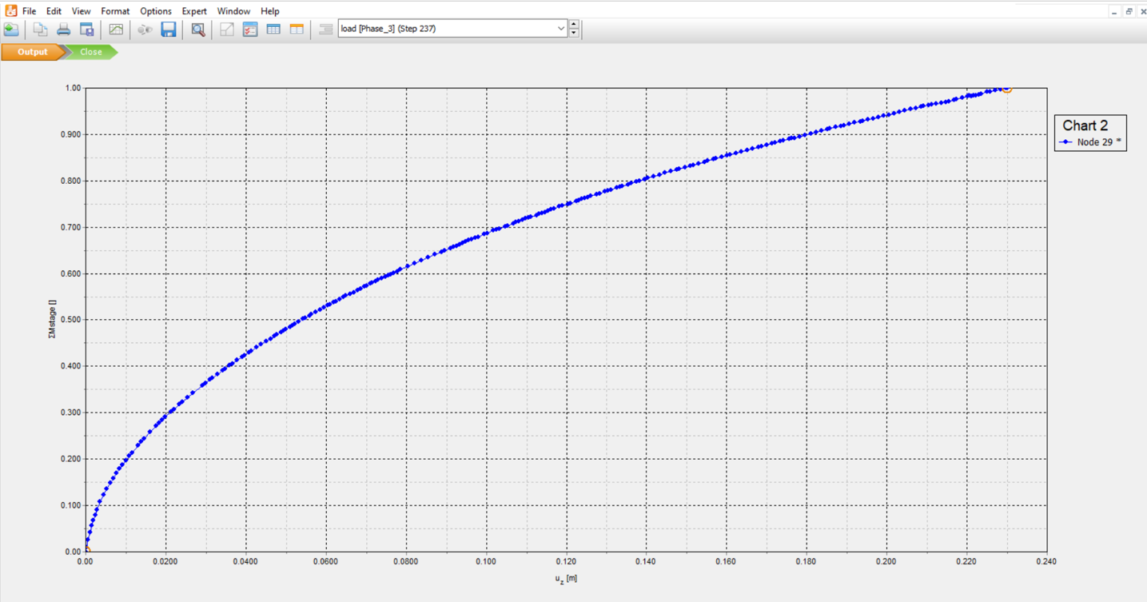

* Comparing the Load-Displacement curve for different geogrid’s condition:

