**PLAXIS 3D Lesson 3:**

**Learning Objective:** This lesson is intended to introduce you to determining expected settlement caused by any specific surface load and help you understand the effects of water level on square footing settlement.

* Open the saved project (Lesson 2: bearing capacity of square footing)
* Click on the **File** tab in the toolbar, and then click **Save project as…** to create a copy of the current file and apply the new changes in the new file.

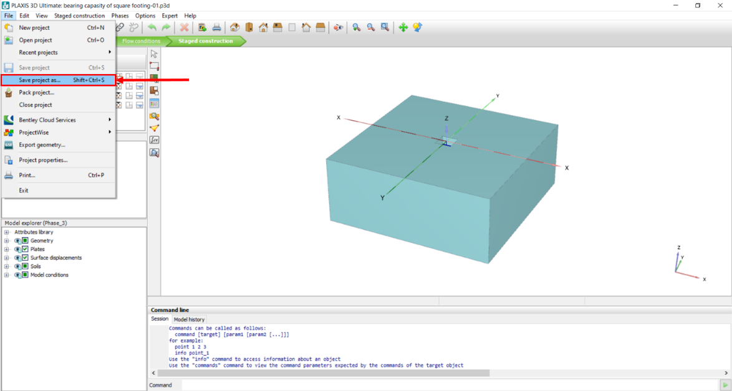

* In the opened window, choose a name to be saved with, for example, type in: bearing capacity of square footing-load.
* Click **Save**.

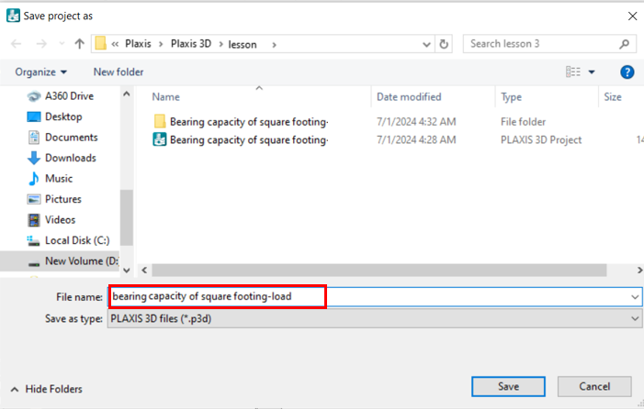

**Task 1: Apply Surface Load**

You can apply a specified load and calculate displacement corresponding to the applied load:

1. Click on the **Structures** mode. This is specified with a Red circle in the figure below.
2. To apply load instead of prescribed displacement, select the **Model explorer section**, click on the + sign next to Surface displacement, right-click on **Surface Displacement,** and then click **Delete**.

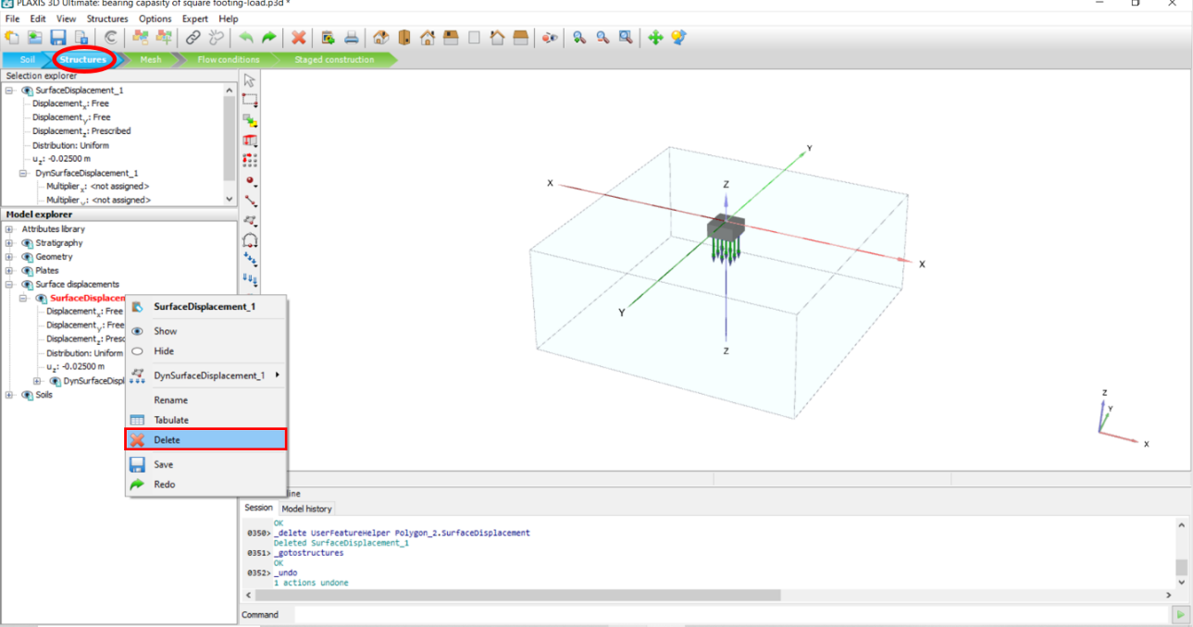

1. Click on the volume object in the 3D model (the selected object will change to red color), then right-click on the selected volume, and press **Hide**.

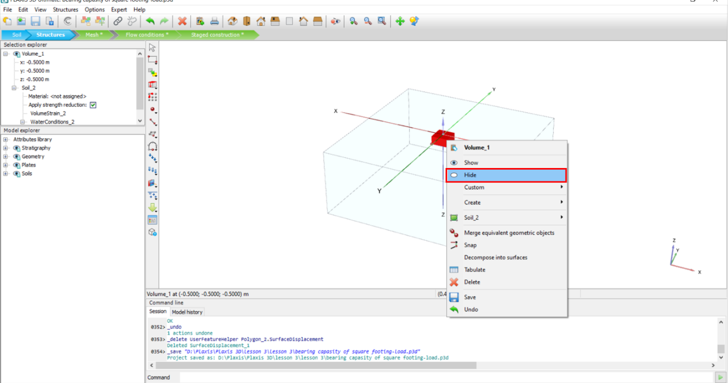

1. Select the plate object in the 3D model, right click on the selected plate, select **Create**, and then click **Create surface load**.

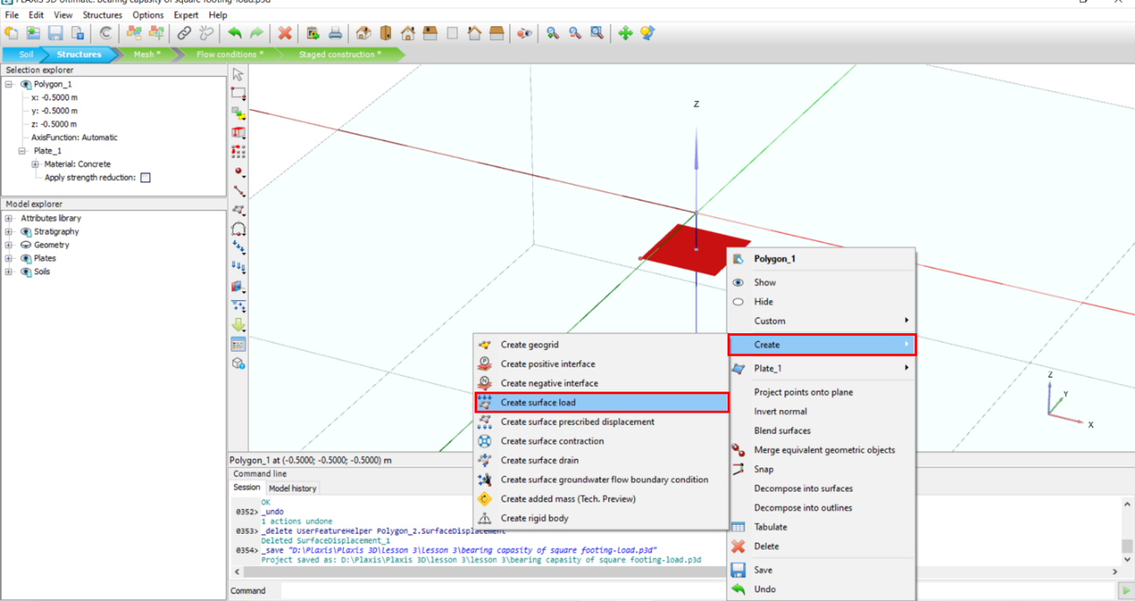

* To assign a specific load, in the **Model explorer** section, click on the + sign next to **Surface loads**, then click the + sign next to **SurfaceLoad_1**, enter **σz**value: -1000 kN (note: - before the number indicates its downward direction).

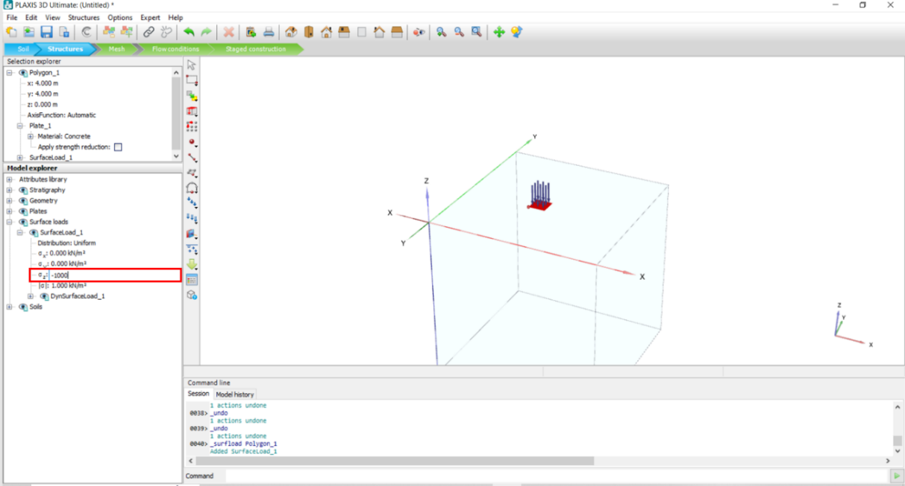

**Task 2: Create the Mesh and Generate Model**

* Go to **Mesh** mode.
* Click on the **Generate mesh** icon. In the opened window, click on the drop-down arrow and choose Very coarse for **Element distribution**.
* Click **OK**.
* Click on **Select points for curves** to select a point for calculations.

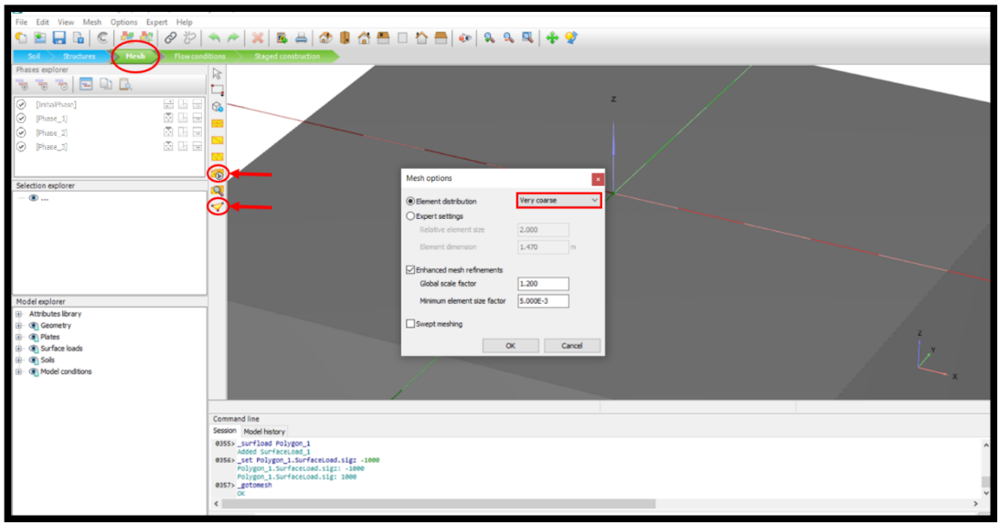

* In the opened window, enter -0.5 m in the Z box (this is the footing depth defined before), click on **Search closest**, among the found nodes, and check the closest one to the specified position. Make sure to select a point on the plate. In the found notes section, under the “**Data from**” column, the selected point should be on a Plate (specified with a Green circle in the figure below)
* Click **Update**.

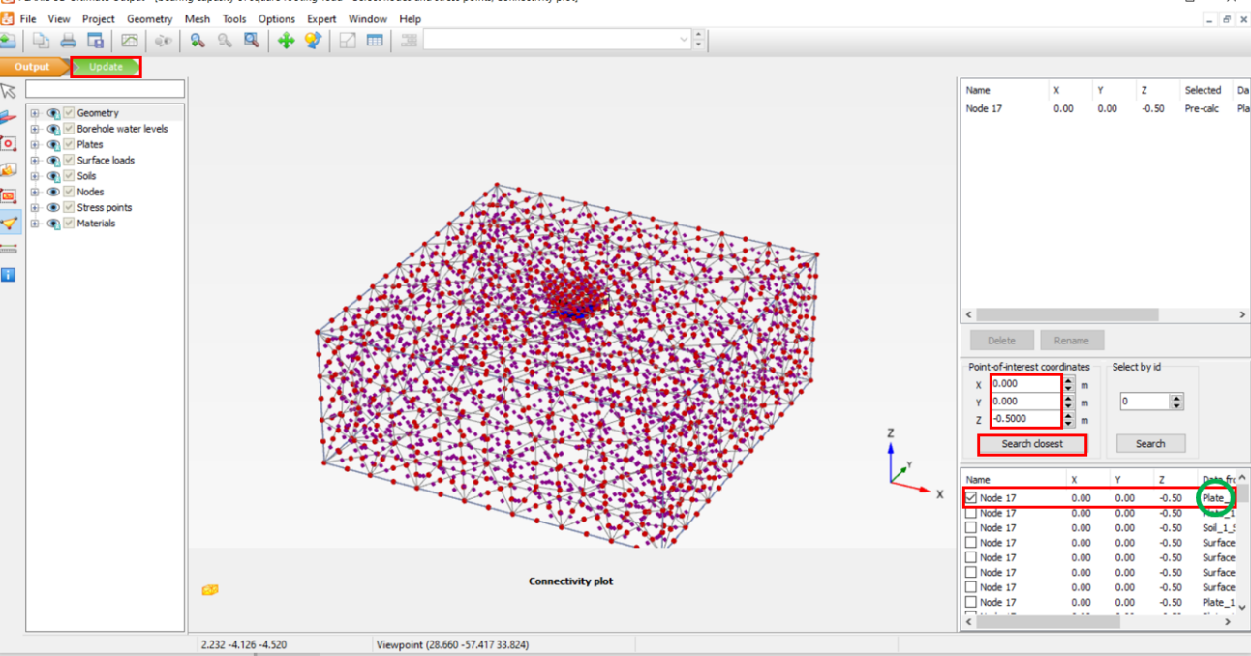

**Task 3: Define phases**

* Go to the **Staged construction** mode to define construction phases.
* In the **Phases explorer**, click **Edit phase**.
* In the opened window, some phases should be already defined from the previous example.
* In the opened window, go to the Phase_2. Make sure “Reset the displacement to zero” in the **Deformation control parameters** is checked.

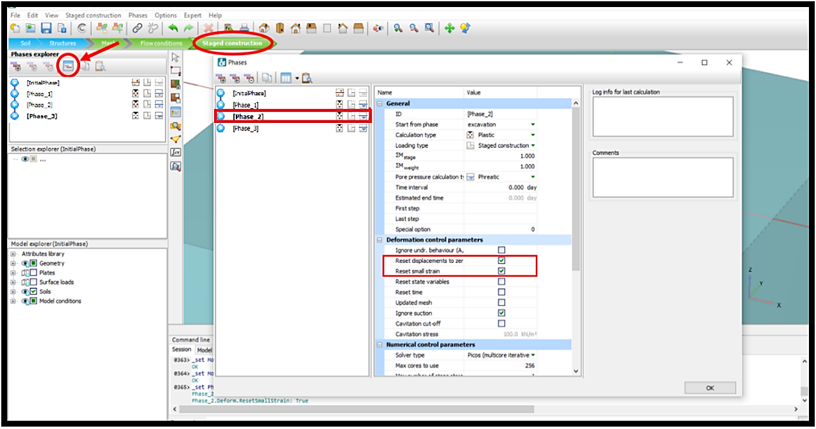

* Go to Phase_3. Make sure “Reset displacement to zero” in the **Deformation control parameters** is checked.
* Click **OK**.

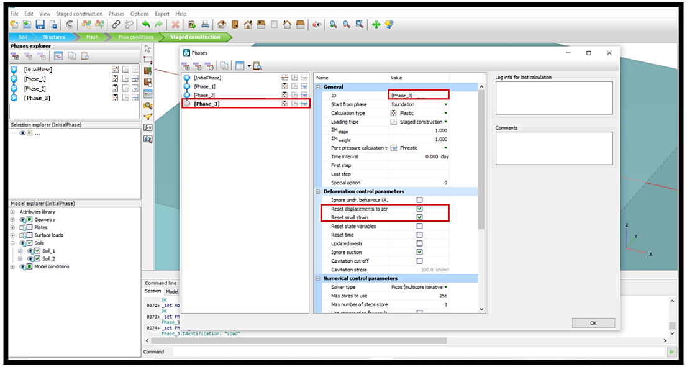

* Click on the **Initial phase** in the **Phases explorer**, then, in **Model explorer,** make sure “Soils” is checked (both Soil_1 and Soil_2 have to be checked).

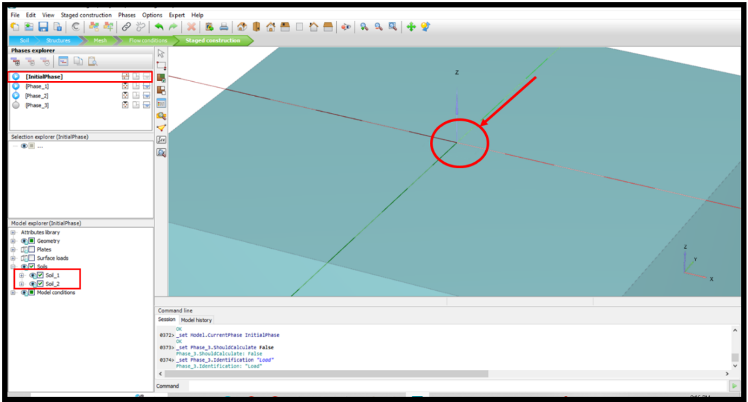

* Click on the **Phase_1** in the **Phases explorer**, then, in the **Model explorer,** uncheck the box next to **Soil_2**.

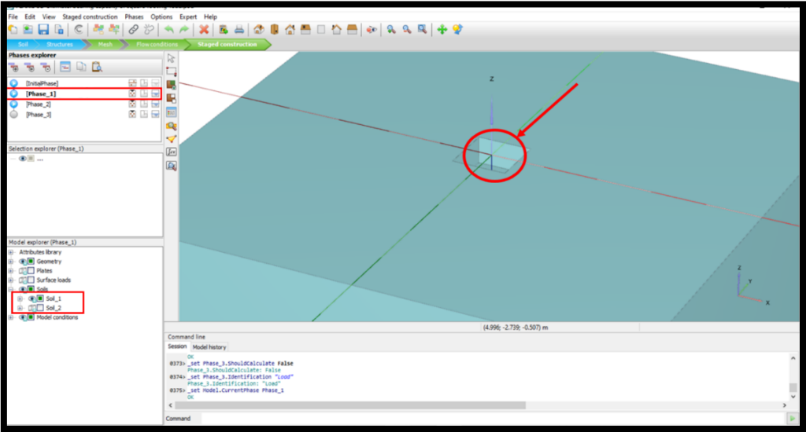

* Click on the **Phase_2** in the **Phases explorer**, then, in the **Model explorer,** check the box next to **Plates**.

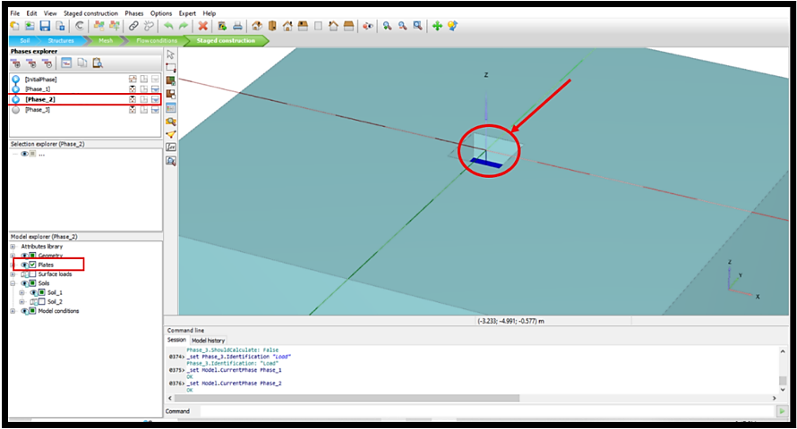

* Click on the **Phase_3** in the **Phases explorer**, then, in the **Model explorer,** check the box next to **Surface loads**.

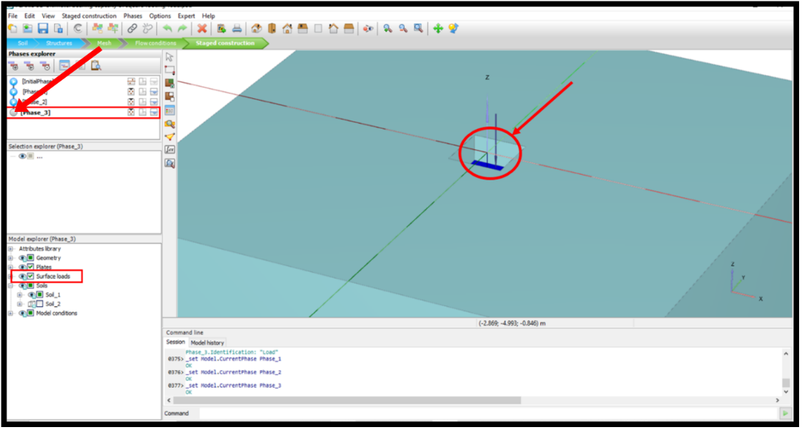

**Task 4: Perform Calculations and View Results**

* Click **Calculate**.
* After finishing the process, select **View calculation Results**.

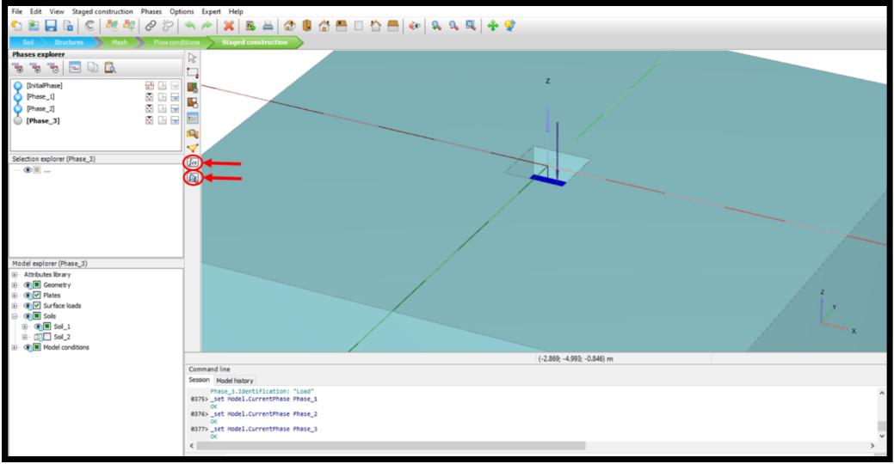

* To observe the result of total displacement in Z direction, click on the **Deformation** tab in the toolbar, then **Total displacements**, and select **uz**.

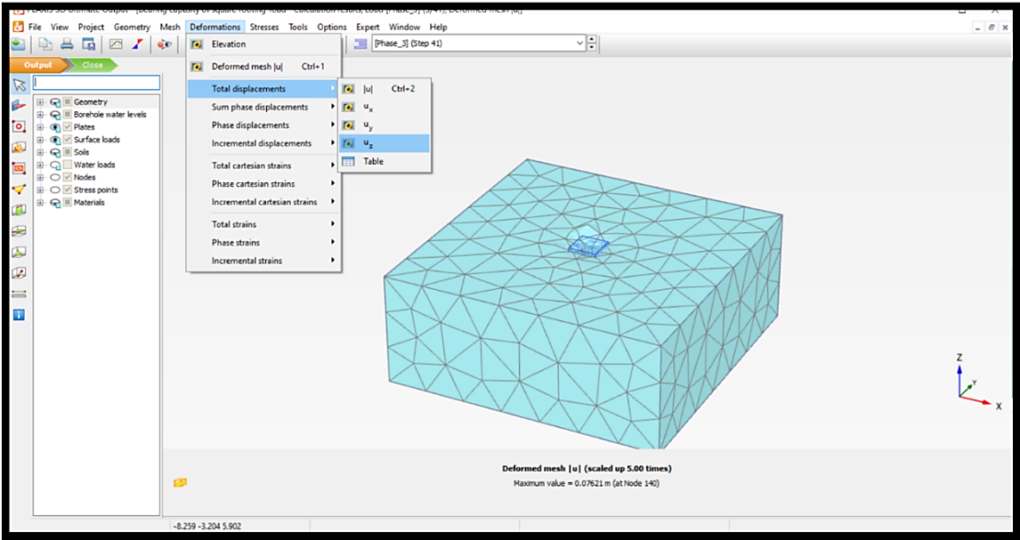

* To plot a load vs. settlement graph, in the PLAXIS output window, click on **Curves manager**.
* In the opened window, click on **New** to define the desired curve.

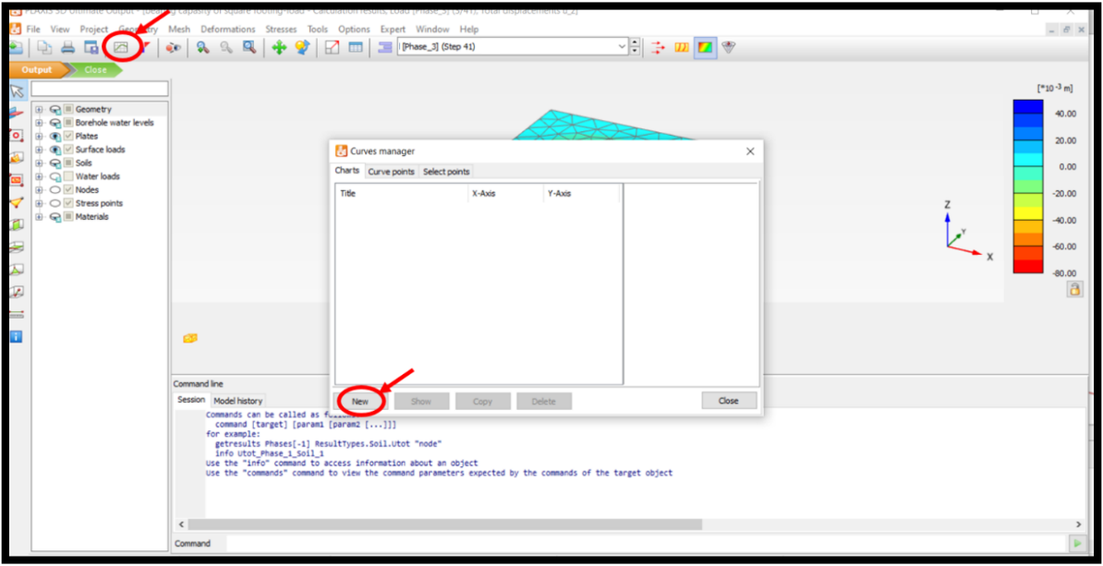

* To see a desired cross-section of the model, click on the **Vertical cross section** icon. You can draw a section line by clicking on two points of a section, as shown in the figure below, or by adding each point’s coordinates in the opened window.

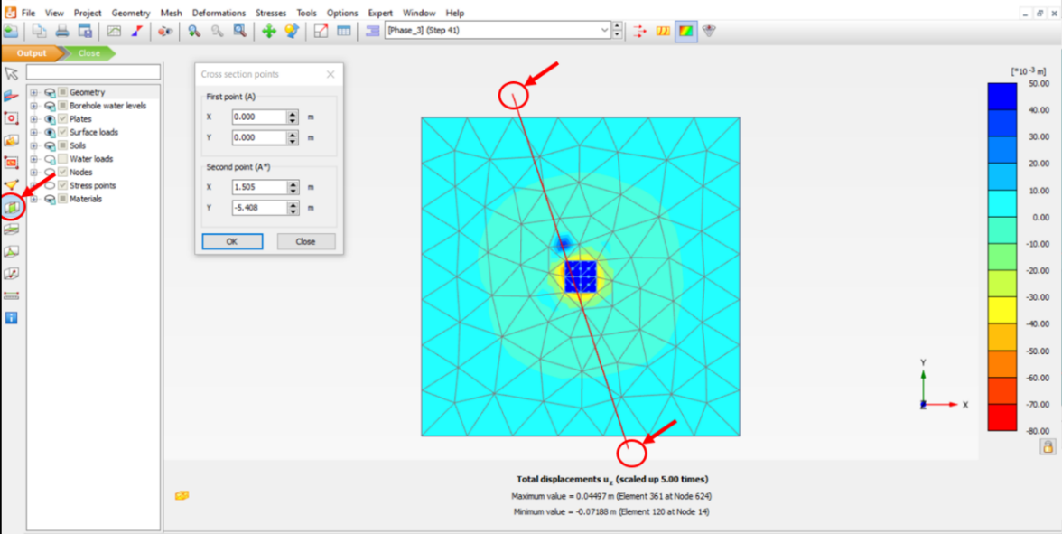

* After creating a section view, you can go to the **View** tab, select **Viewpoint**, and then choose a direction to see the section.

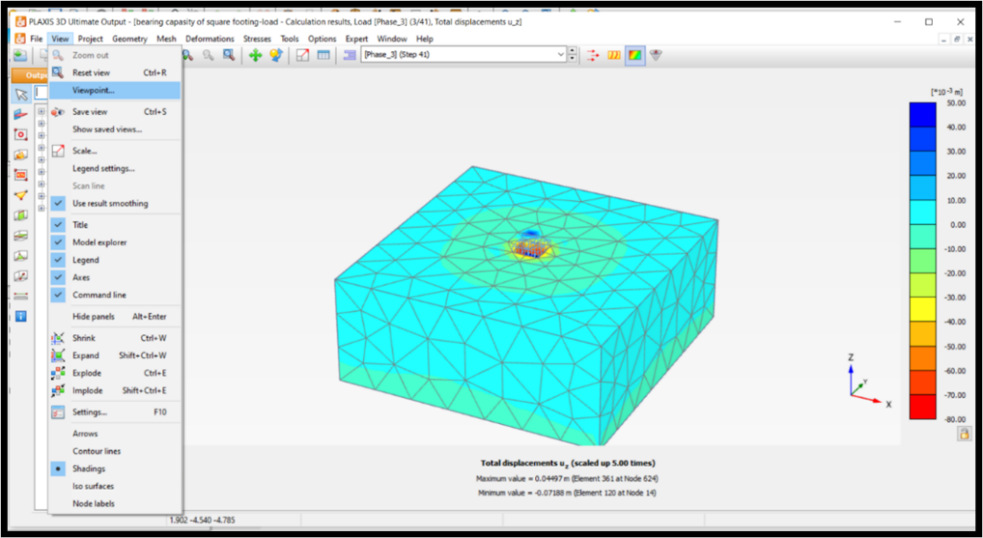

* In the opened window, by clicking on the **Right view** icon, you can see the displacement values.

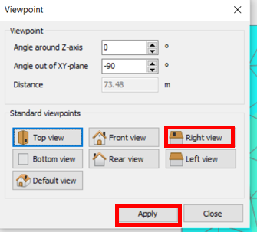

* The view can be adjusted by Pan camera (for moving model) and Rotate camera (for rotating model).

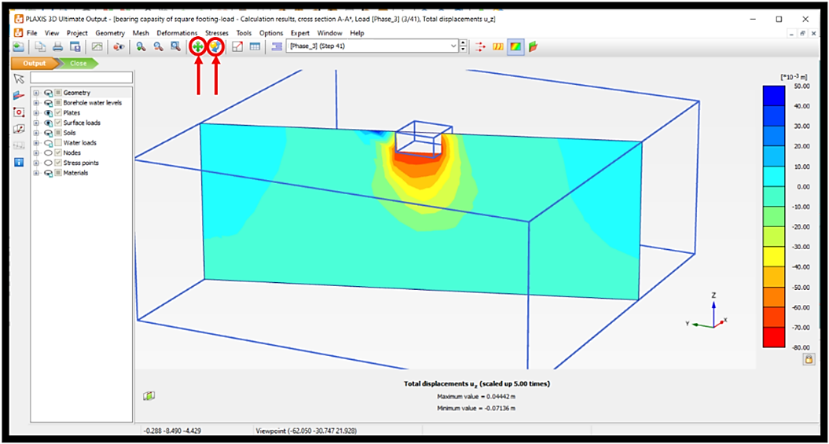

* Click on the icon with the arrows as shown in figure below to see the displacement movement direction, the upward direction indicate soil heave due to foundation settlement.

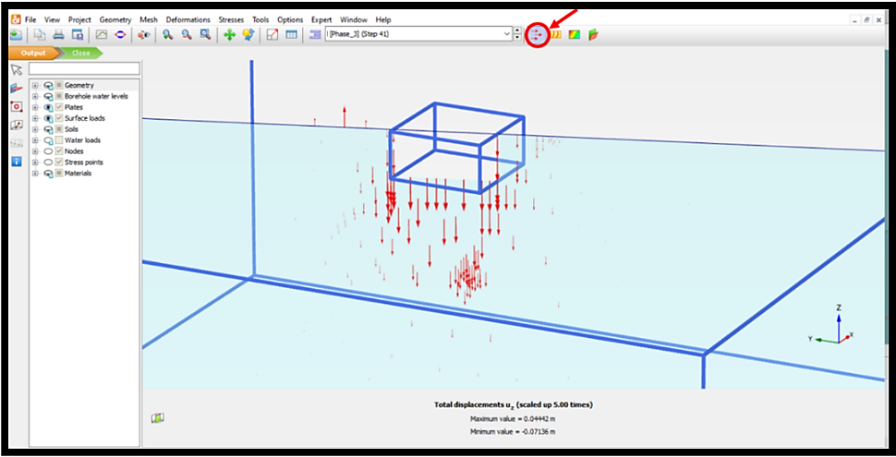

* To draw Load vs. Displacement curve, in the **X-Axis** section, keep the dashboard on Project, in the **Step** subsection, Choose “ƩMstage”. In the **Y-Axis** section, click on the drop-down arrow under the y-axis and choose the node you defined in previous sections. Then, click on the + sign next to **Deformation**, then click on the + sign next to **Total displacement**, and choose “uz”.
* Click **OK**.

* In the opened window, you can see the Load-Displacement plot.
* To delete data from undesired phases, right-click on the plot sheet and go to **Settings.**

* In the opened window, go to the **Node** tab, select **Phases**, make sure to uncheck all the phases except Phase_3.
* Click **OK**.

* To export data for further analysis, click on the **Table** icon (shown in figure below).

* Right-click on parameters specified with Red circles in figure below, and click copy.

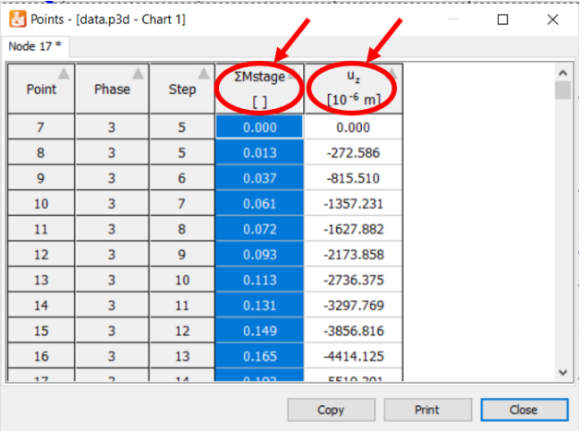

* Open an Excel file and paste each specified column.

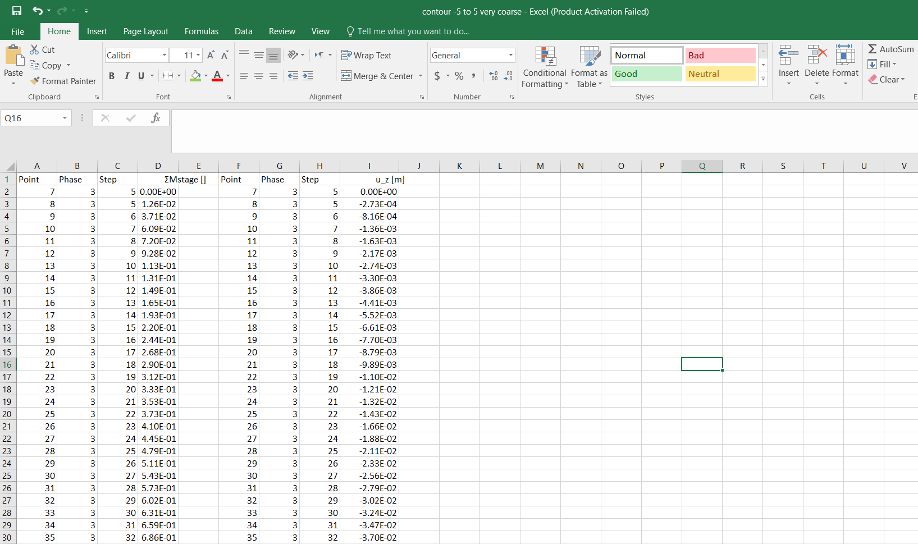

* Multiply the ƩMstage column by the applied load value (1000).
* Multiply the u_z column by -1 to get positive numbers and by 1000 to convert it to millimeters.

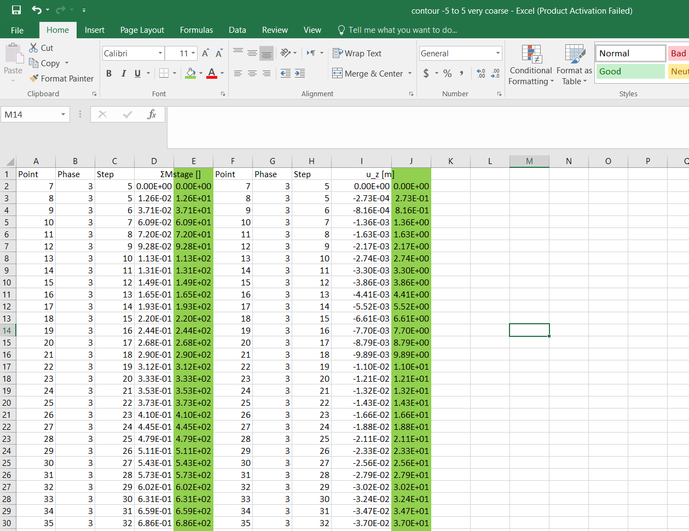

* In the Excel file, click on the item specified with a red circle in the figure below to select the entire sheet. Click on the drop-down arrow to choose cell format, and choose **General**.

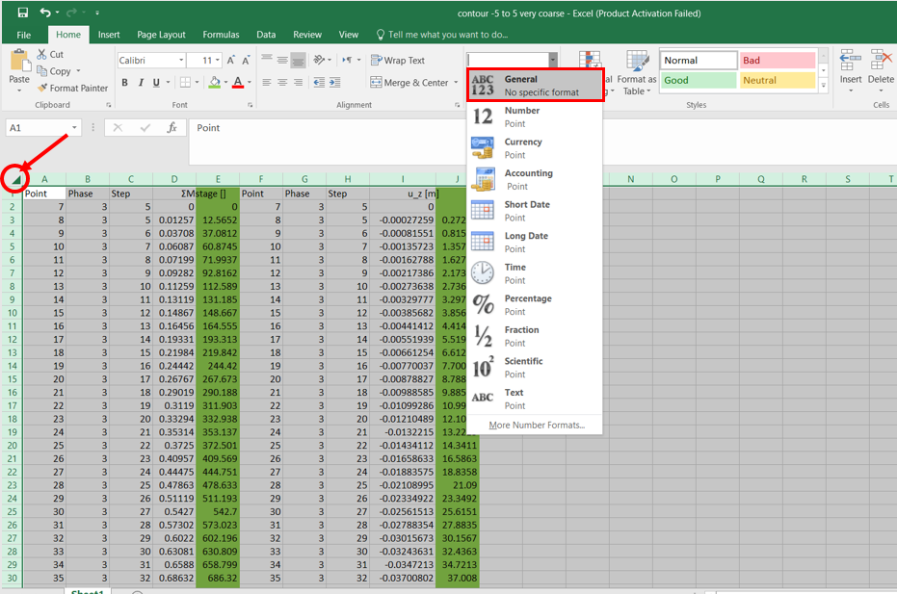

* Plot the Load-Displacement curve in the Excel file and save it for later.

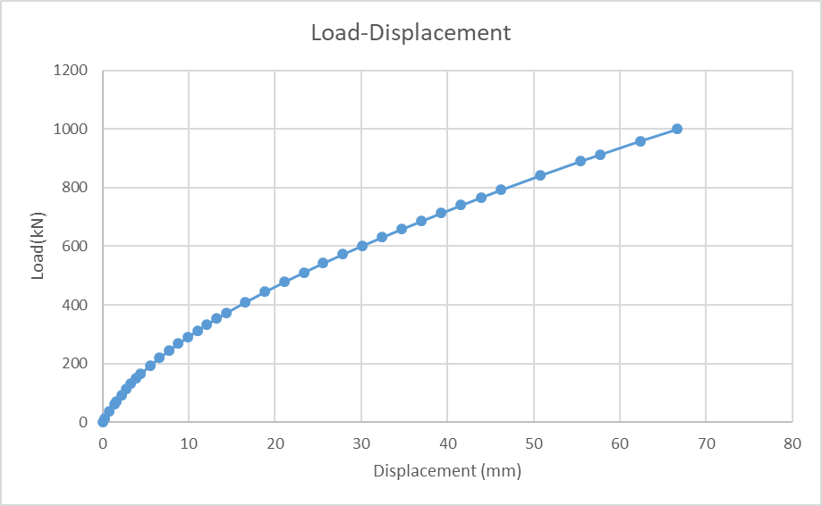

**Task 6: Define Cohesive Soil and Analyze Water Level Effects**

To see the effect of groundwater level on the behavior of the foundation, first, define a cohesive soil:

* Use “Save as” to save the project you were working on with a new name. For example: bearing capacity of square footing- water level.

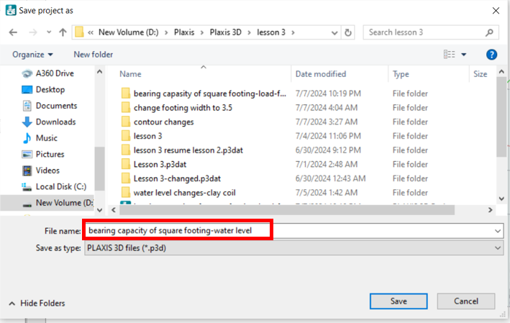

* Click on **Soil** mode, then **Show materials**, and then **New** to define the new soil.

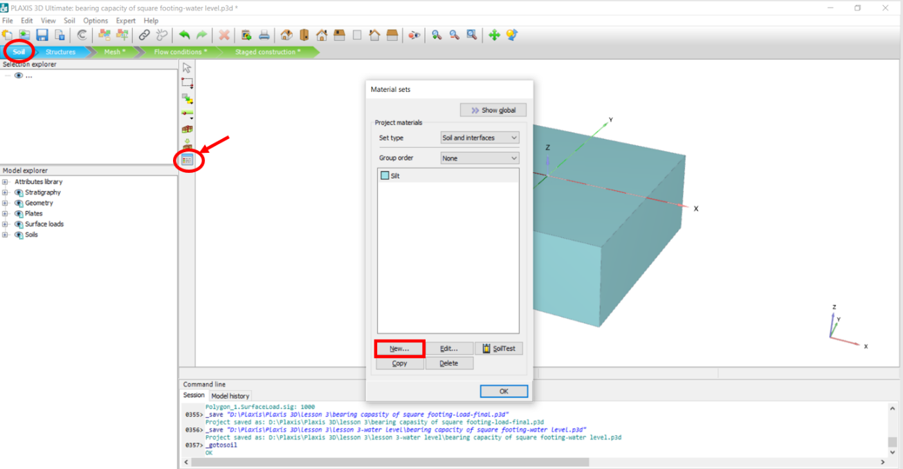

* In the opened window, type “Clay” in **Identification**, change the **Drainage type** by clicking on drop-down arrow and choose, “Undrained A”.
* Enter unsaturated and saturated soil densities: γunsat : 16 kN/m2 , γsat : 19 kN/m2

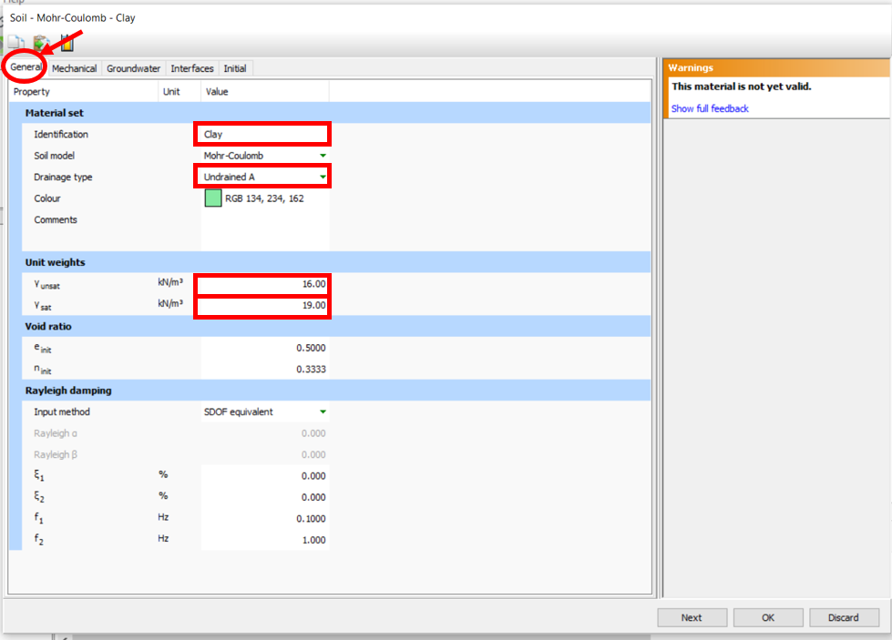

* Click on the **Material** tab, and enter soil mechanical soil properties:

$E_{ref}^{'}$: 8000 kN/m2, : 30 kN/m2 , : 15

* Click **OK.**

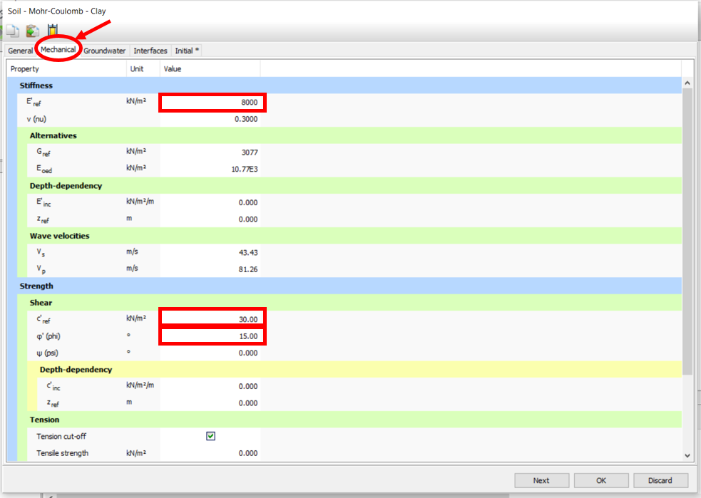

* After defining soil properties, click **OK**.

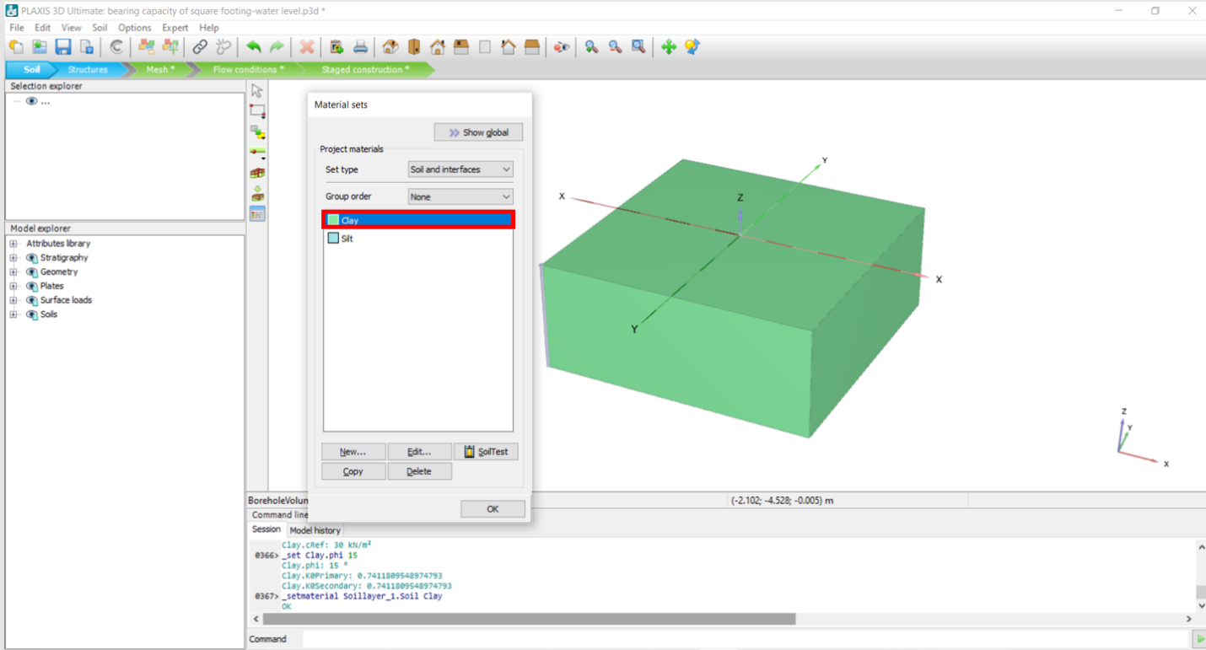

* In the **Model explorer**, click on the + sign next to **Stratigraphy**, click on the + sign next to **Borehole_1**, and change the **Head** value to -0.5 m.
* Click on the + sign next to **Soils** and make sure to change both **Soil_1** and **Soil_2** Materials to “Clay” by clicking on the drop-down arrow next to its box.

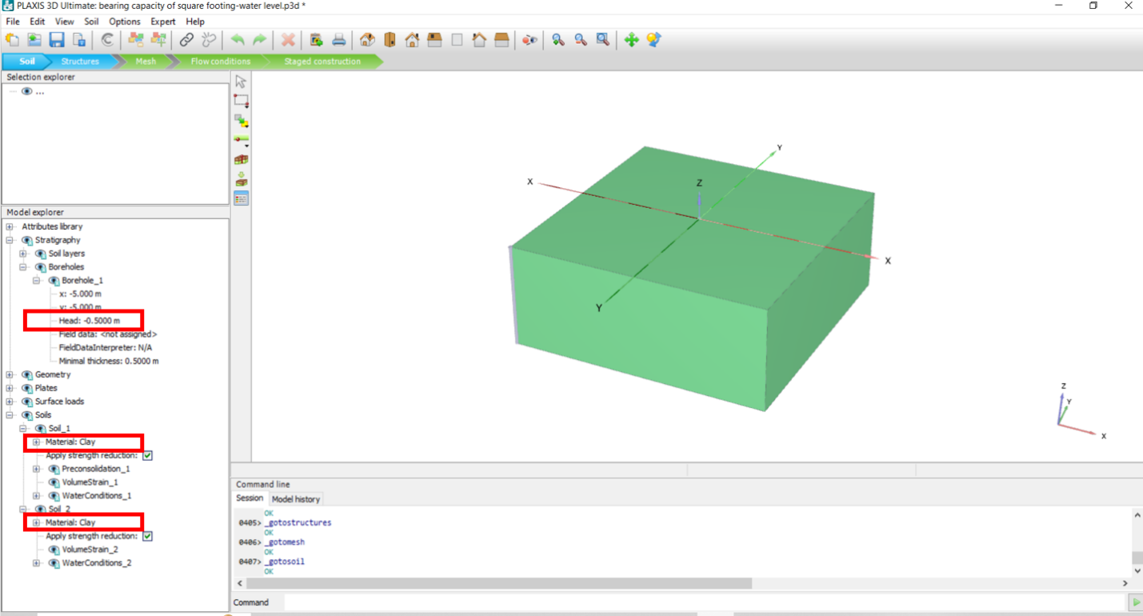

* Perform **Task 3, Task 4,** and **Task 5** again and plot the Load-Displacement curve in Excel.
* Change the head to -5 m, then perform **Task 3, Task 4,** and **Task 5** again and plot the Load-Displacement curve in the same excel file as above.
* The figure below shows the Load-Displacement plot for two different water levels in the defined cohesive soil: