# PLAXIS 3D Lesson 2:

**Learning Objective**: This lesson is intended to provide you with an introduction to shallow foundation design using PLAXIS 3D.

In this lesson, we will be modeling the following problem using PLAXIS3D:

***Calculate the bearing capacity of a square footing (width = 1 m) embedded 0.5 m into a silty sand with a dry unit weight of 19.2 kN/m3, effective cohesion of 5 kPa, and effective friction angle of 30°. The silty sand is very thick (10 m) and the groundwater is at 5 m. (The bearing capacity based on Terzaghi and Vesic methods are, 603 kN/m2 and 736 kN/m2 respectively).***

***Other data:***

***Esoil: 20000 kN/m2 , טsoil = 0.3, Gs: 2.65,***

***: 24 kN/m3 , Econcrete: 23500000 kN/m2 , טconcrete= 0.2, d (concrete thickness): 0.5 m***

***Silt thickness: 400 m***

**Theoretical solution of the problem**

Solution based on Terzaghi’s theoretical/emperical formula:

Terzagi formula for square footing:

qult​=1.3CNc​+qNq​+0.4γBNγ

Nc​=37.16 Nq=22.45 Nγ=19.13

q = γ × Df = 19.2*0.5 = 9.6 kPa

qf= Wf/A = 0.5*24=12 kN/m2

qult​=1.3CNc​+qNq​+0.4γBNγ =1.3*5*37.16+9.6*22.45+0.4*19.2*1*19.13= 603 kN/m2

Vesic formula for square footing

qult​=CNcscdcicbcgc​+σzdNqsqdqiqbqgq​+0.5γBNγsγdγiγbγgγ

Nc​=30.1 Nq=18.4 Nγ=22.4

=5*30.1*1.61*1.2+0.5*19.2*18.4*1.14*1.57+0.5*19.2*22.4*0.6*1=736 kN/m2

Note 1: In practice, numerical methods (PLAXIS3D) are not typically used for simple problems like this as they can be solved using simple hand calculations shown above. This simple example was chosen to get us started with PLAXIS3D. It also allows us to compare the numerical results (from PLAXIS3D) with the theoretical ones. In future lessons, after you get comfortable with numerical modeling in PLAXIS3D, more complicated problems that are not easily solved with simple hand calculations will be solved using PLAXIS3D.

Note 2: When trying to solve a large, complicated problem, it is always a good practice to start the project with a simple model, leaving out details that complicate the project. After the simple model is developed and solved (modeled), make sure that the results are reasonable (if possible, by comparing the results of the numerical model with the theoretical solution). Resolve any possible issues/errors until you are satisfied with the results. Then you can start adding the details and further develop the model until the entire project is modeled.

**Task 1: Setup and Define Problem**

* Open the software, click on **Start a new project,** and type in, “Bearing Capacity Square Footing” as the title. Go to the **Model** tab, define contours from -10 to 10 for both X and Y axis, and then click **OK**.

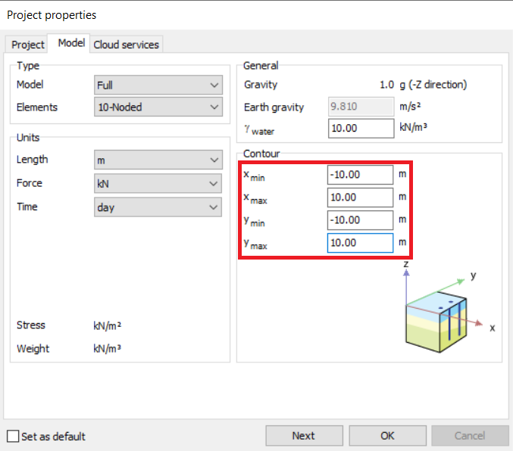

**Task 2: Create Borehole and Soil Layers**

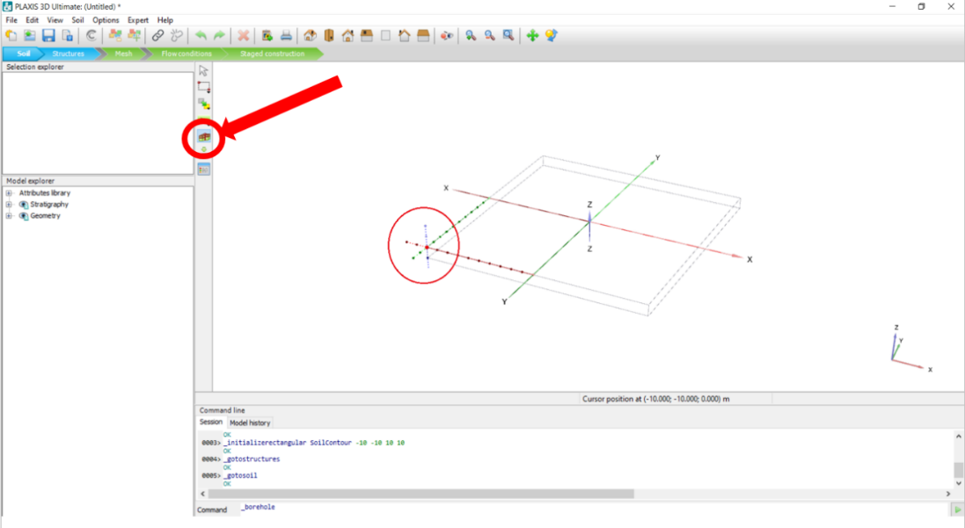Define the soil layer: click on the **Create Borehole icon**. Place the mouse cursor at the right corner of the boundary (x=-10, y=-10) and left-click.

* When you place the borehole (by click on the point mentioned above), the **Modify soil layer** window will open. Click **Add**.

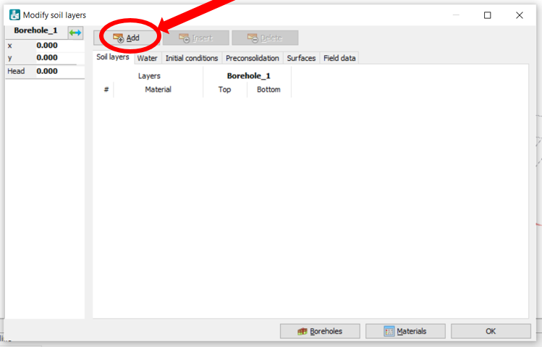

* Under Borehole_1 tab, type in the following values: top: 0; Bottom: -10 as soil layer elevation.
* In the **Head** box, type in -5 value as water head elevation.
* Click on **Material** icon to define soil properties.

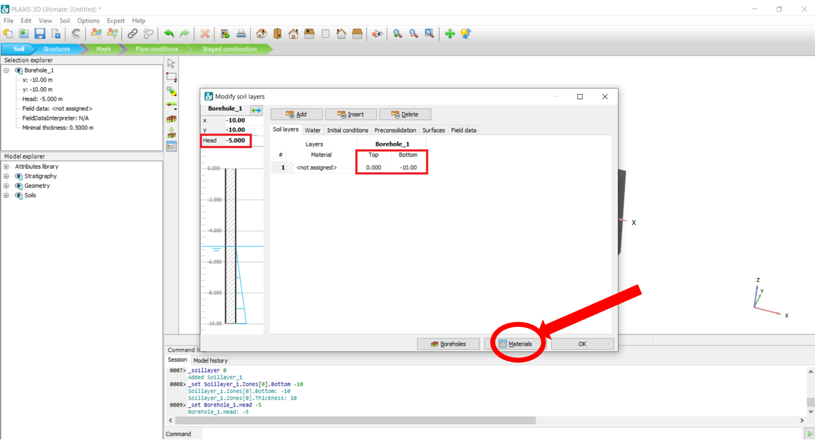

* In the opened window, set type to “Soil and interfaces”, then click on **New** to define a new material.

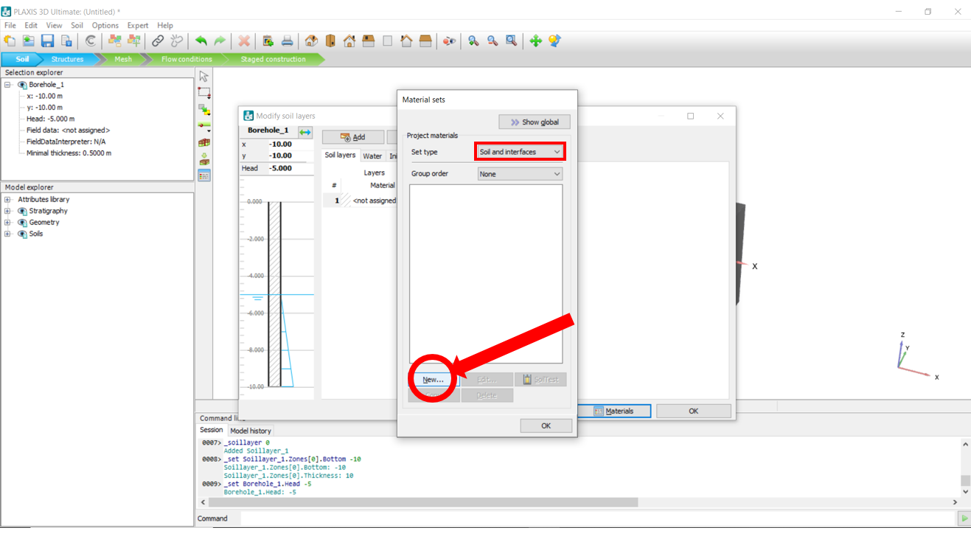

In the opened window, add soil properties as follows:

* In the **General** tab, add a name for the soil: type in Silty Soil in the **Identification** box.
* Enter the unsaturated ( kN/m3) and saturated( kN/m3) unit weights in the Unit Weight boxes.

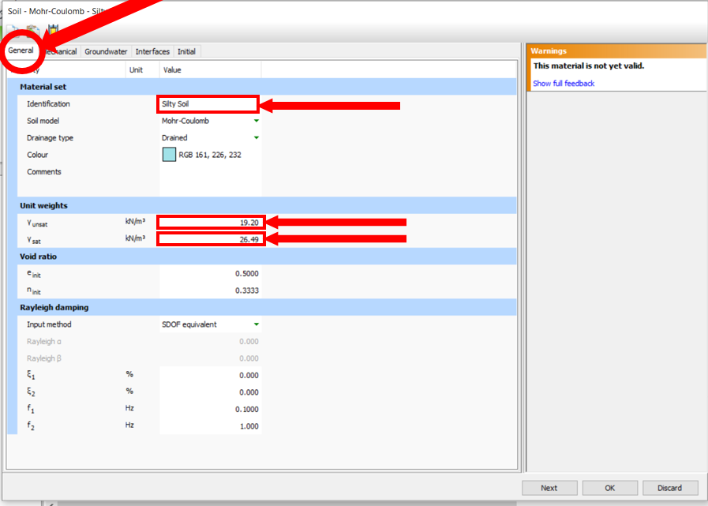

* Now, click on the **Mechanical** tab (see figure below):
* Add soil’s $E_{ref}^{ˈ}$ (Module of elasticity) and v (nu) Poisson's ratio in the **stiffness** section as follows: kN/m2, v (nu) : 0.3.
* Add the soil’s $ø^{ˈ}$ (phi) (friction angle) and $C_{ref}^{ˈ}$ (cohesion) in the **strength** section as follows:

$ø^{ˈ}$ (phi): 30 , 5 kN/m2.

* After adding soil properties, click **OK.**

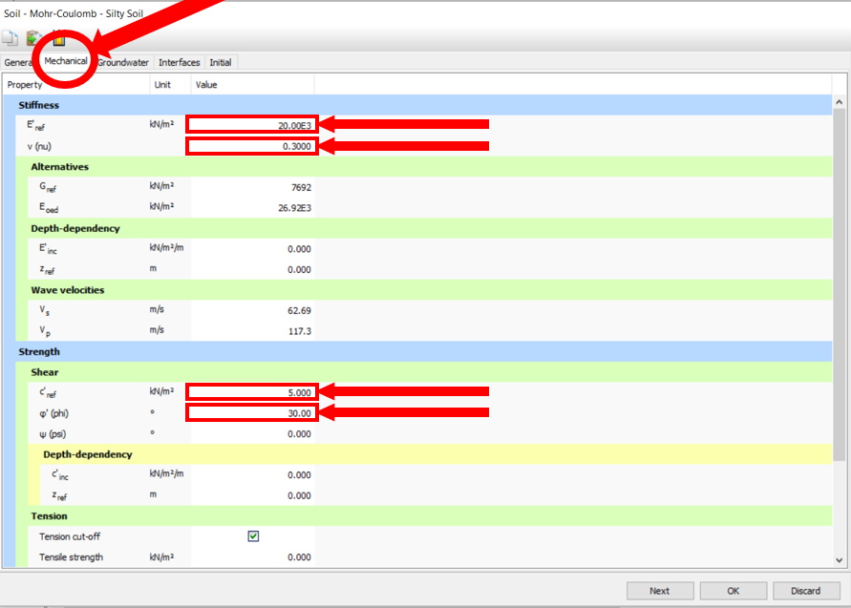

* Assign the defined material to the borehole: drag the created soil material (“Silt Soil”) and drop it on the borehole symbol as shown in the figure below:

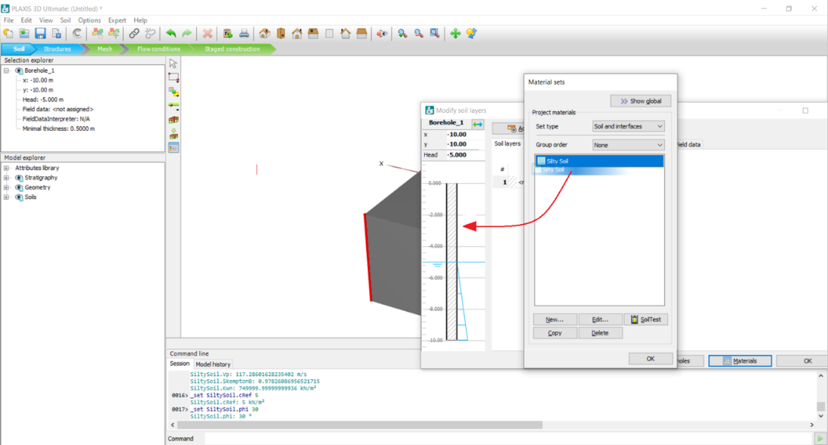

**Task 3: Define Concrete Material and Excavation**

* To define concrete material, click on **Show Materials**. Set type to **Plates**, and click **New**.

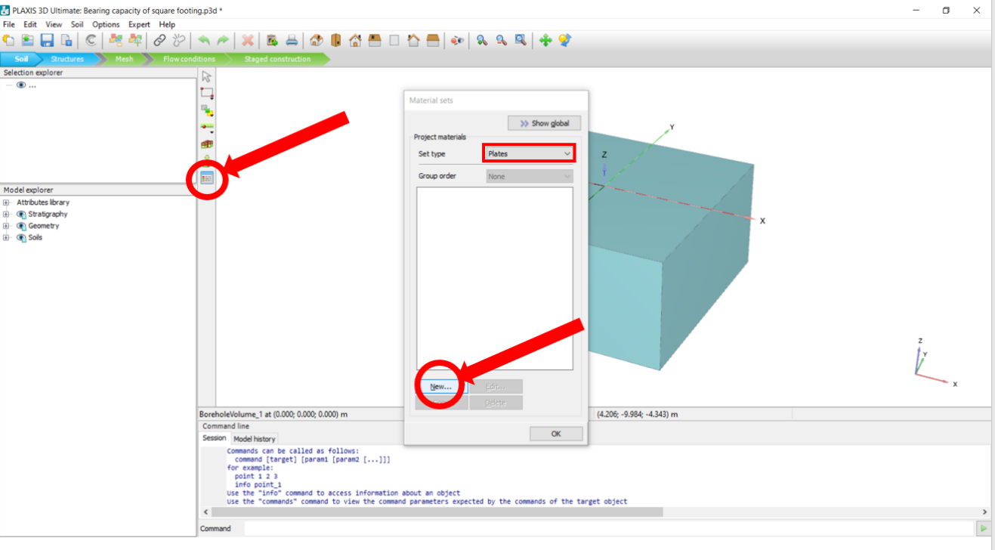

In the opened window, you can assign concrete properties in the **General** and **Mechanical** tabs:

* In the **General** tab, add “square footing” as the name in **Identification** box. Click on the drop-down arrow in **Material type** box (see the figure below) and change Material type to **Elastic** and type in 24 kN/m3 for the unit weight:

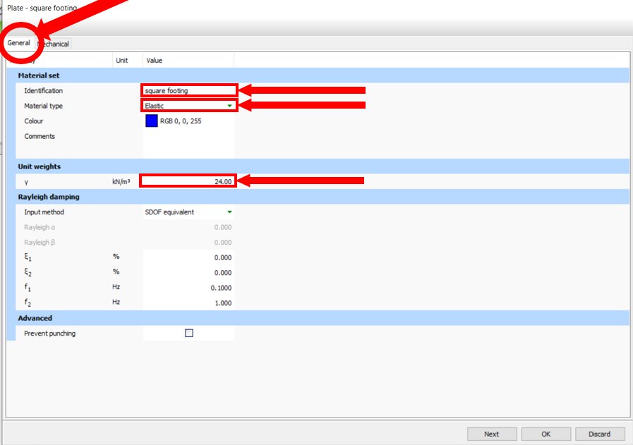

* Click on the **Mechanical** tab:
* In this window, change the E1 (Young’s modulus) to 23500000 kN/m2, to 0.2, and the d (thickness of the concrete) to 0.5, and click **OK**.

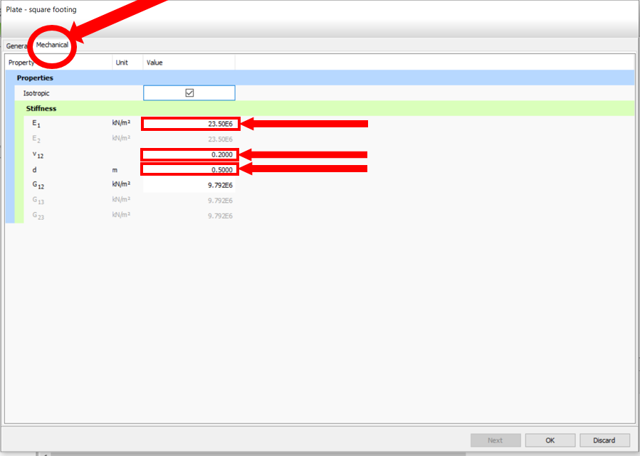

* To make drawing the footing easier, you can change the view by clicking on the **View** tab in the toolbar. Select **Default views** and then click on **Top view**. You can return to the previous view by selecting **Perspective** **view** in the same manner.

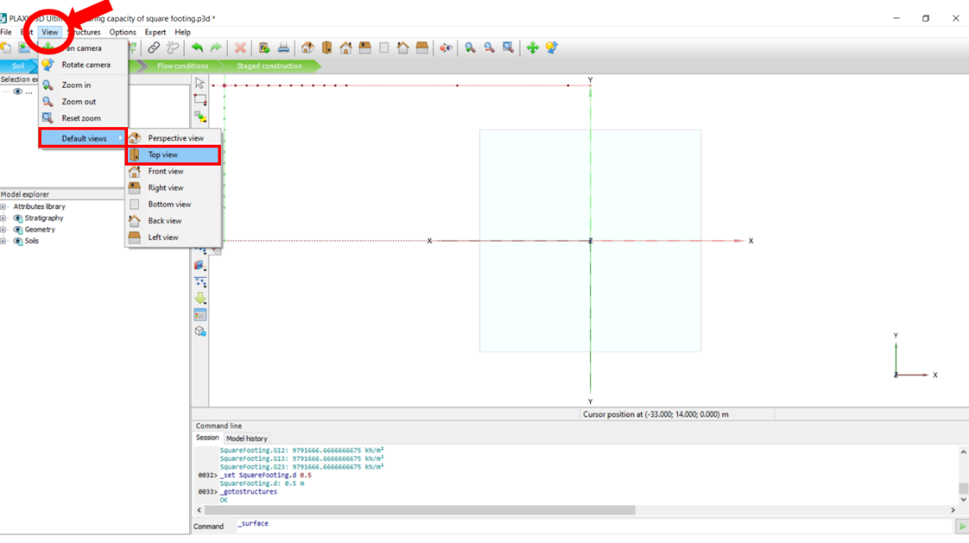

In this problem, the square footing width is 1 meter. To draw a square at the center of the boundary, the default spacing of 1 meter in the software should be changed to 0.5 meters.

* To change grid spacing, click on the **Options** in the toolbar, then click on the **Visualization setting.**

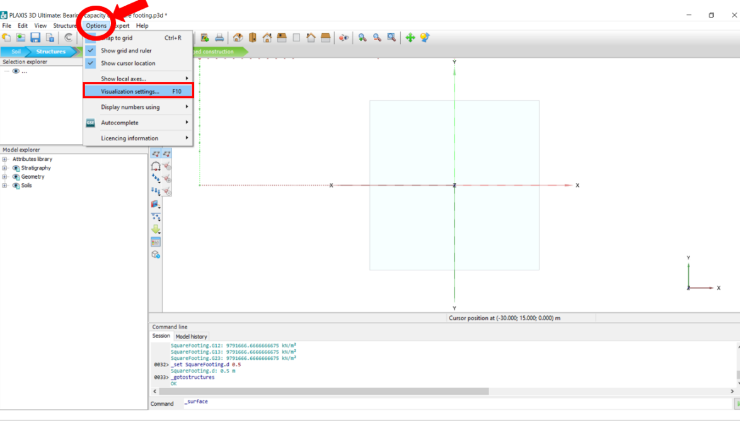

* In the opened window, go to the **Grid** tab and change the Spacing to 0.5, then click **OK**.

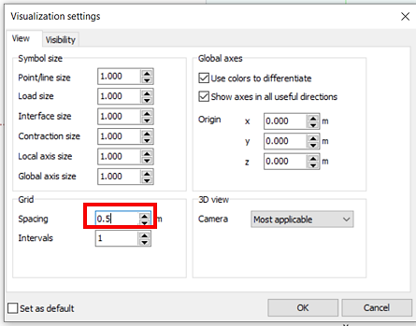

* Click on the structure mode (shown with a red circle in the figure below).
* To draw the square footing, click on the **Create surface** icon and draw points to create a 1 meter by 1 meter square: Place the mouse cursor at coordinate X= - 0.5, Y= - 0.5 and click. Then, move the mouse cursor to coordinate X= - 0.5, Y= 0.5 and click again. Move the mouse cursor to coordinate X= 0.5, Y= 0.5 and click again. Finally, move the mouse cursor to coordinate X= - 0.5, Y= -0.5 and click again. Now, go to the “**surface points**” window and click **OK**.

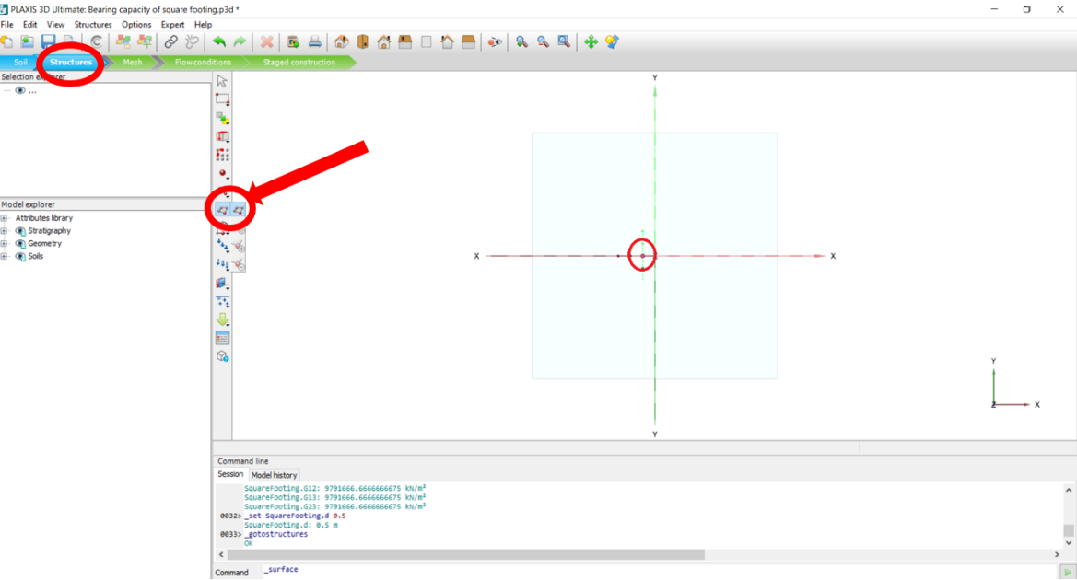

* You should see a square like the figure below:

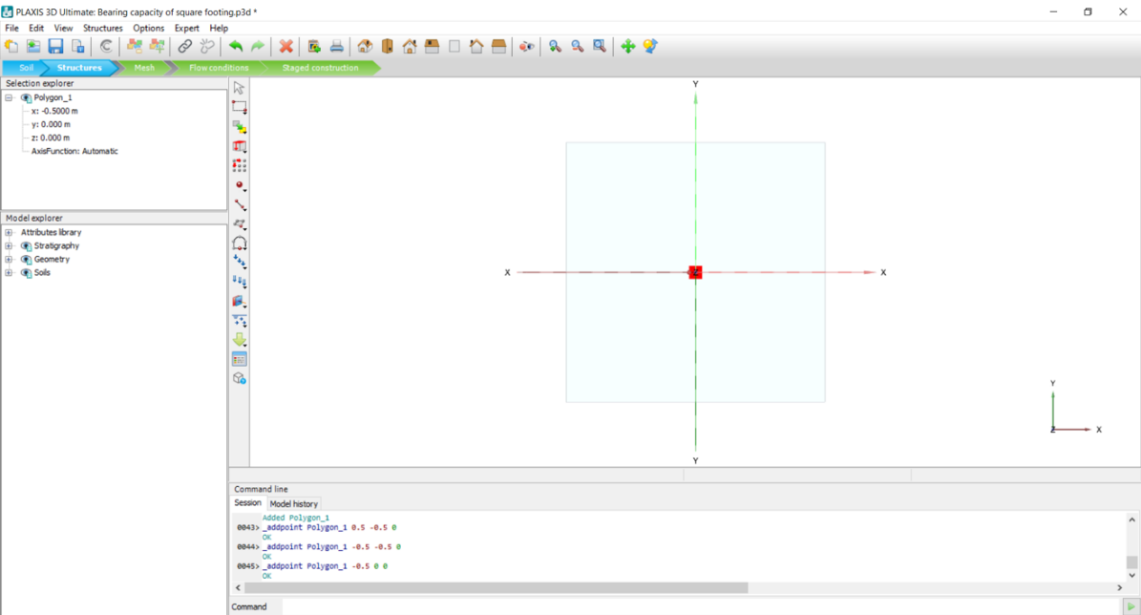

* After drawing the surface, click on the **Extrude** icon to create an excavation volume. In the opened window change the z number to the depth of embedment (z=-0.5), and click apply:

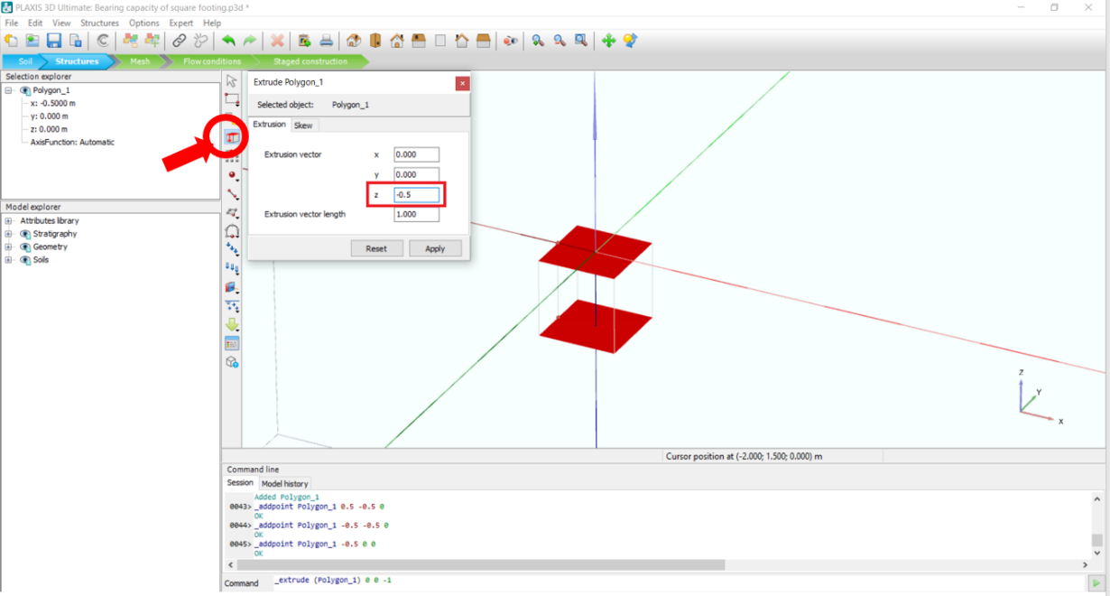

* Press the **ESC key** on the keyboard to deselect any selected item. Then, click on the top surface of the extruded volume.
* To locate a surface at the foundation depth, click on the **Create array** icon. In the opened window, go to **Configuration** section, click on drop-down arrow next to the **shape** and choose “1D, in z direction”.
* In the same window, change **Distance between columns** to “-0.5” (the – sign indicates downward movement and 0.5 is the distance of movement). Then click **OK**.

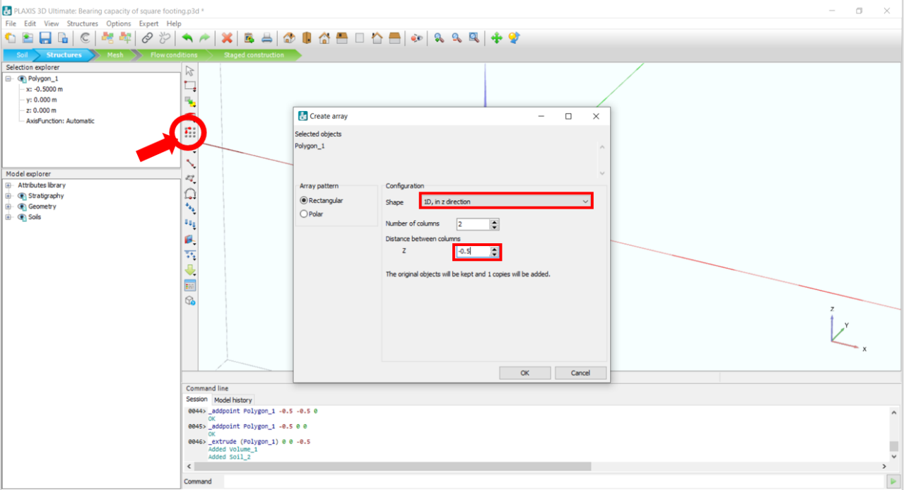

* Press the **ESC key** on the keyboard to deselect any selected item. Then, click on **Select** icon and select the top surface, right click on the selected surface and click **Delete**.

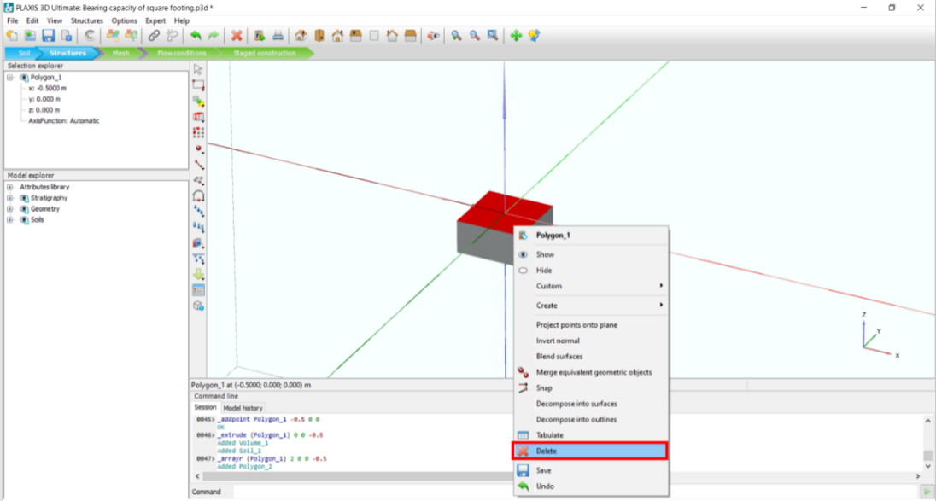

* You can see the arrayed surface by right clicking on created volume and clicking on **Hide**.

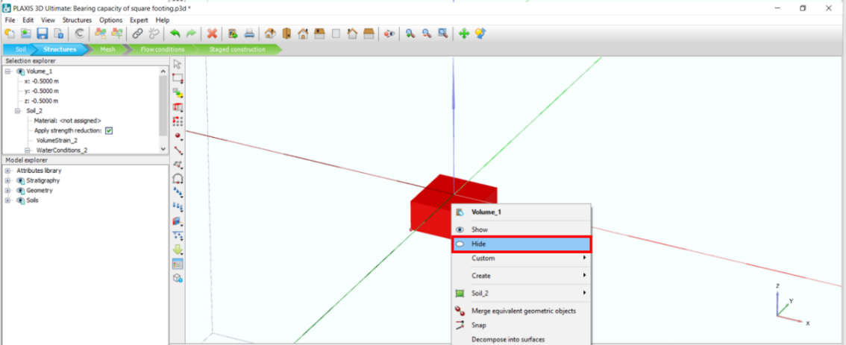

* To create Plate structure, right click on the surface, click **Create** and click **Create plate.**

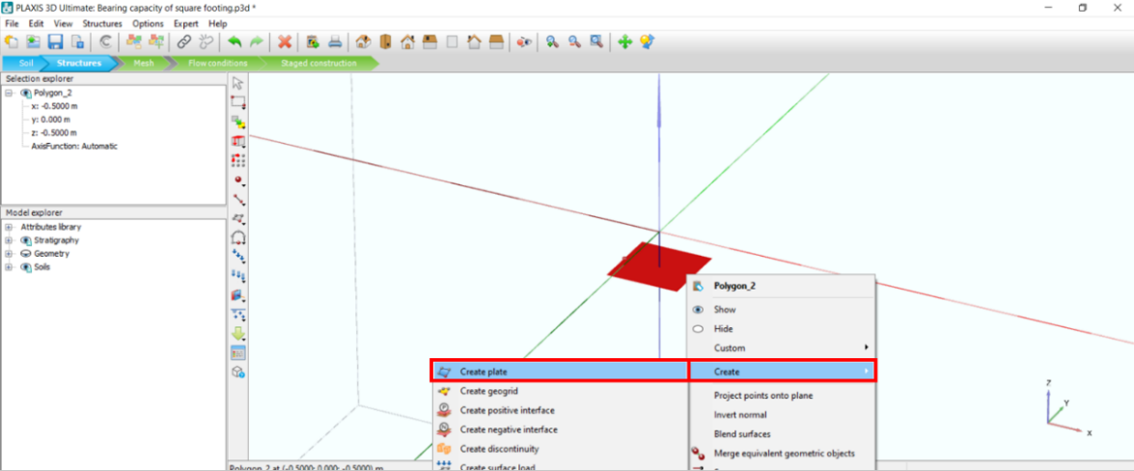

* To assign the concrete material created before to this plate, right-click on the plate in the 3D model, click on Plate_1, click on set material, and choose “square footing[SquareFooting]”

* For calculating bearing capacity, click on **Create prescribed displacement**. After that, click on **Create surface prescribed displacement**.
* Now, you can place the displacement surface corners in the model (they should be placed at the same corners as the plate corners):
* Move the mouse cursor to the coordinate X= - 0.5, Y= - 0.5 and see if the Z coordinate is 0 or the Z coordinate is -0.5. If it is -0.5, you can click on this point and keep moving the cursor to the other three corners ([X= - 0.5, Y= 0.5]; [X= 0.5, Y= 0.5]; and [X= 0.5, Y= - 0.5]) and clicking at each point. If the Z coordinate is 0, press and hold the shift key on the keyboard and move your mouse downward to go to the Z=-0.5 coordinate. Then, you can click on the 4 corners mentioned above. When all 4 corners with Z=0.5 are selected, click ok in the “**Surface points**” window.

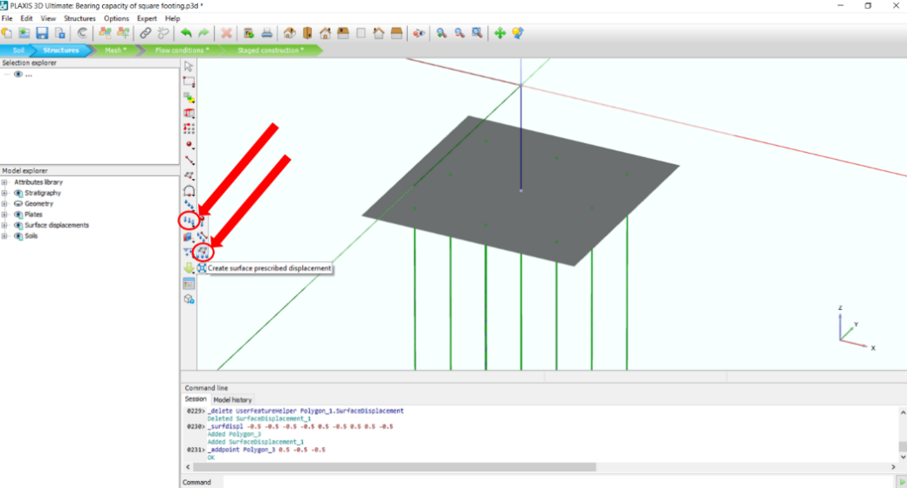

* To assign a prescribed displacement to the foundation, go to **the Model explorer** section, click on the + sign next to the **Surface displacement**, then click on the + sign next to the SurfaceDisplacement_1: change Uz to -2 (or any huge number).

At this point, the design is complete, and we are ready to discretize (mesh) the model and solve it.

Important: You can use this method to design for allowable settlement by entering the allowable displacement as the Uz value.

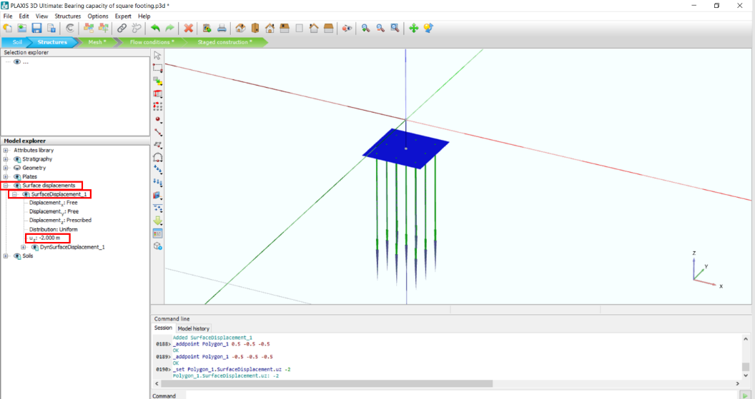

**Task 4: Mesh the Model and Define Construction Phases**

* Click on the **Mesh** mode (shown with a red circle in the figure below).
* Click on **Generate mesh** icon, Choose **Medium** for Element distribution, and click **OK**.
* After the mesh is created, click on the **View Mesh** icon to view the generated mesh on your model.

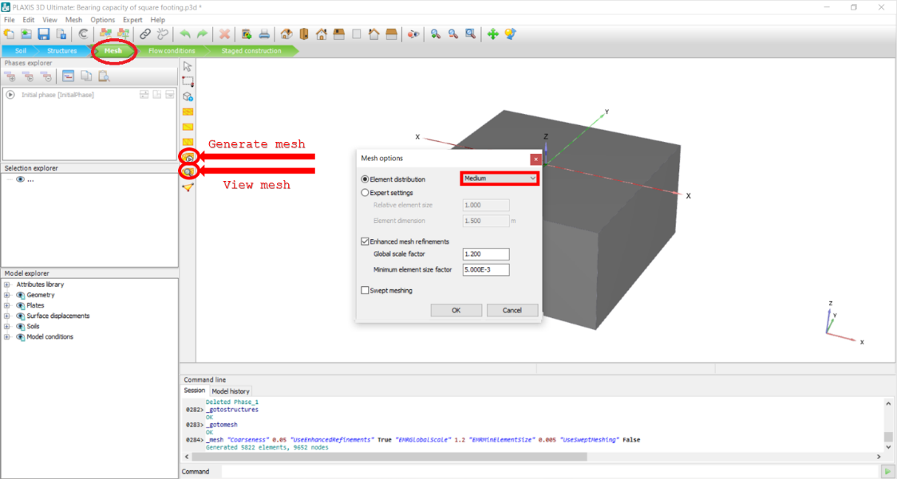

* In the opened window, you should be able to see the discretized model (mesh):

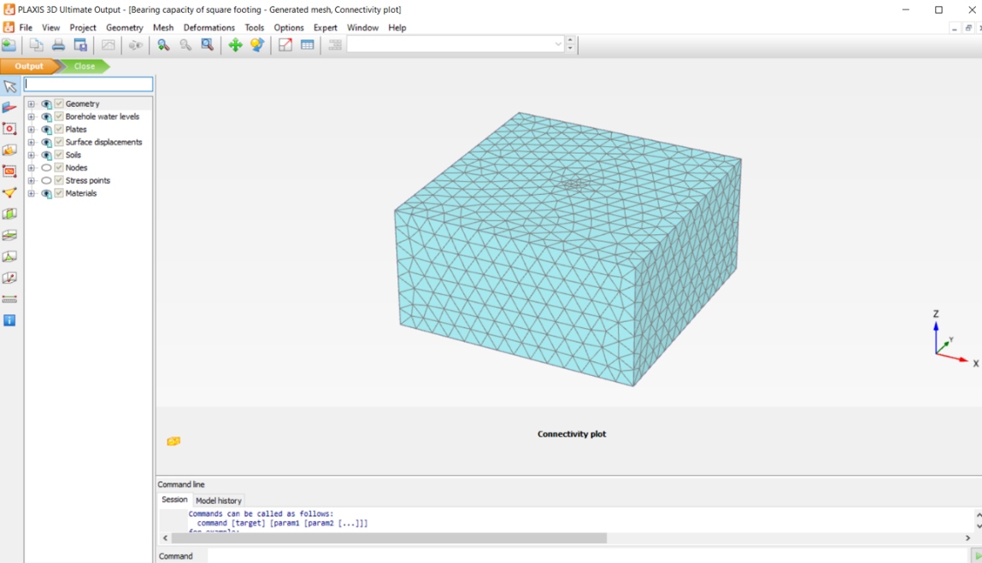

* Now, click on **Staged construction** modeto define construction steps (shown with a red circle in the figure below).
* You should be able to see that in the initial phase, both **Soil_1** and **Soil_2** are activated by clicking on the + sign next to the “Soils” in the Model explorer section.

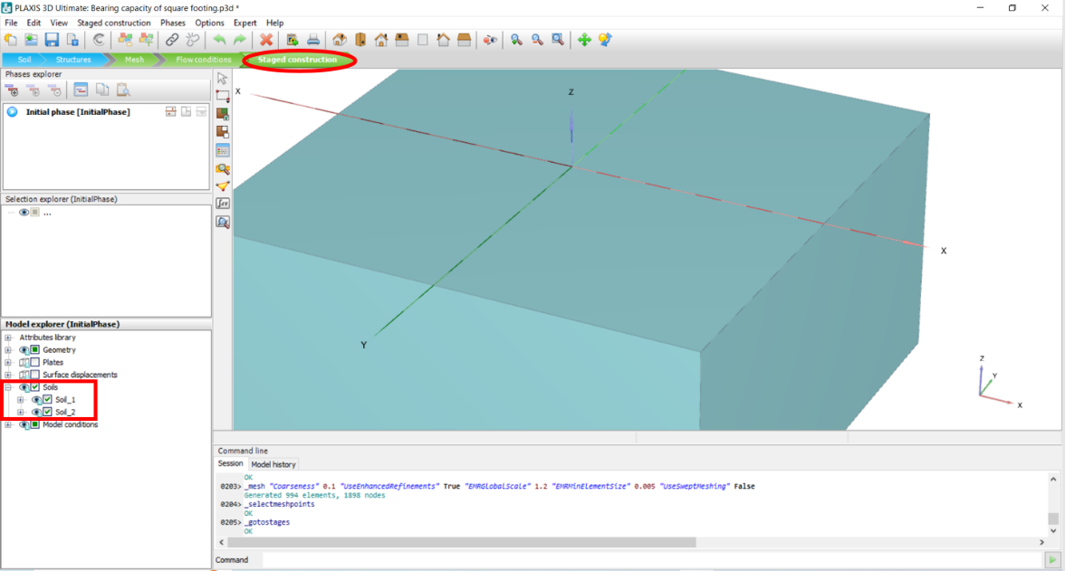

* Click on the **Add phase** icon in the **Phases explorer** section to add a new phase.
* In the **Model explorer** section, uncheck the **Soil_2** box to deactivate soil volume which represents the excavation of that volume.

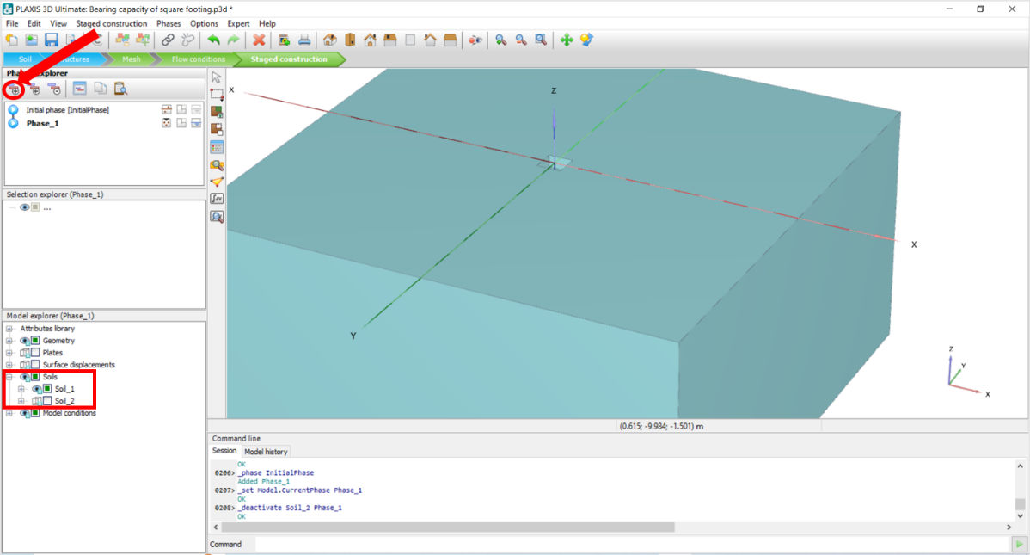

* Add one more phase and check the box next to the Plates: in the **Model explorer** section to activate the plate.

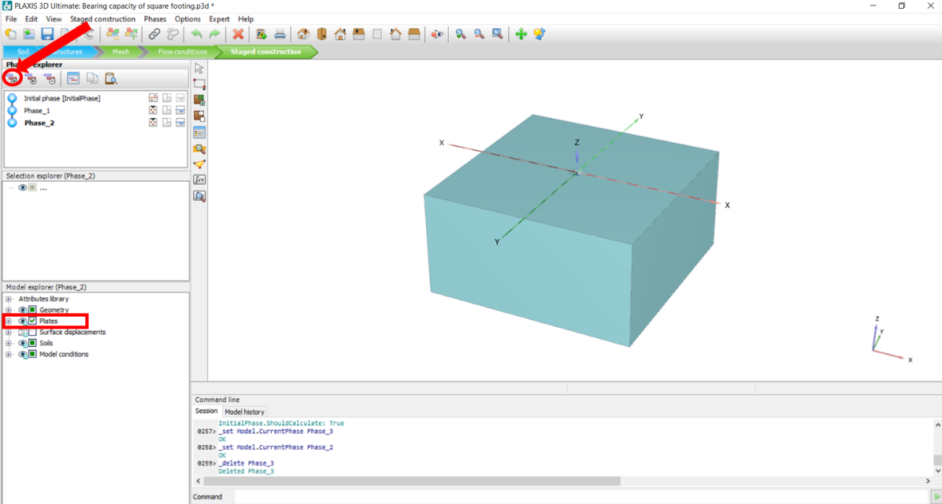

* Add a new phase to apply prescribed settlement and make sure to check the box next to “Surface displacements” in the **Model explorer** section.
* Click on Edit phase icon and make sure, check the box next to “**Reset displacement to zero**”. For all three created phases, select **OK**.

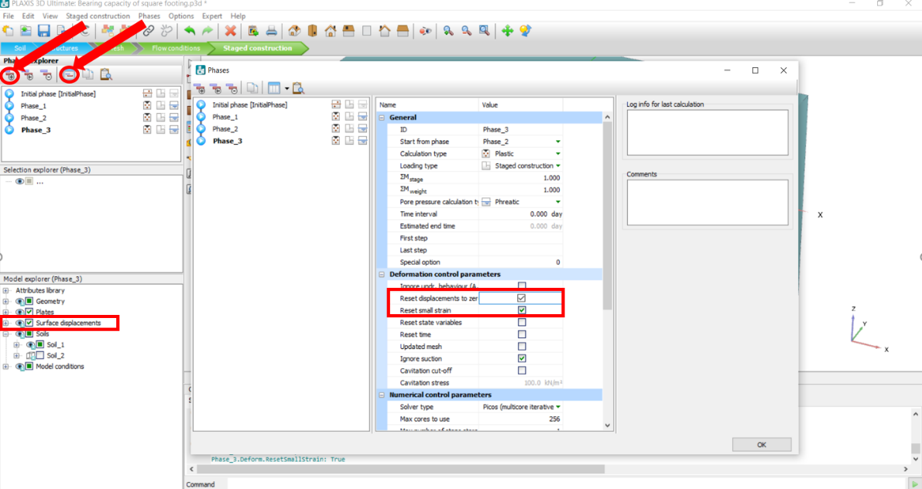

**Task 5: Run Calculation and View Results**

* Now, click on the **Select Points for Curves** icon to select a point for calculations.

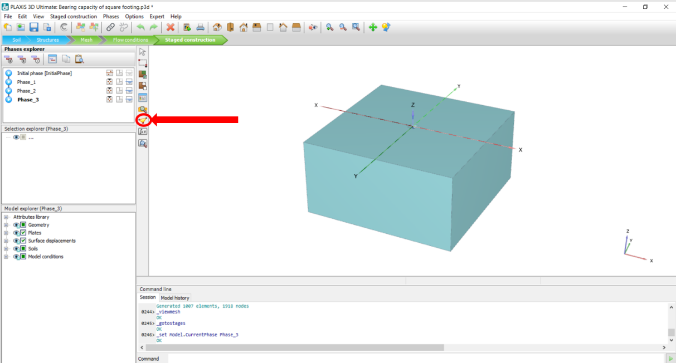

* In the opened window, enter Z = -0.5 and click on the **search closest**. Choose the first found node in the search results box (shown below) and click on the **Update** icon.

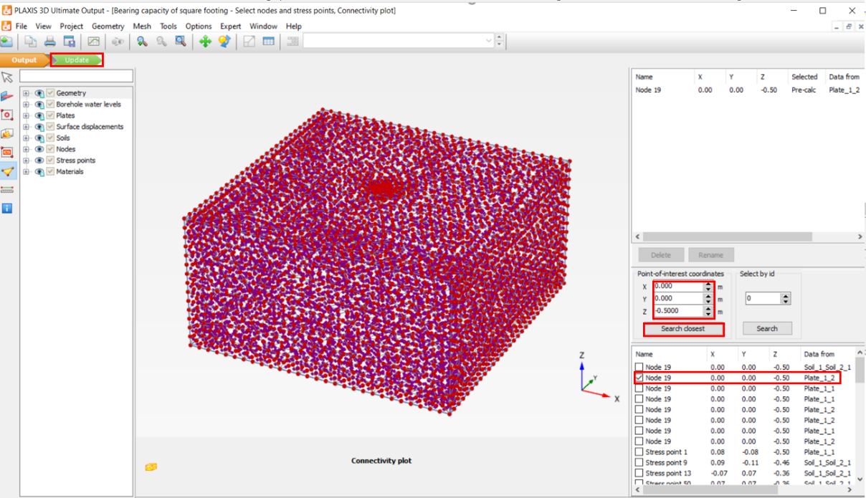

* To start the calculation, click on the **Calculate** icon. When the process is finished, you can see the results by clicking on the **View calculation results** icon.

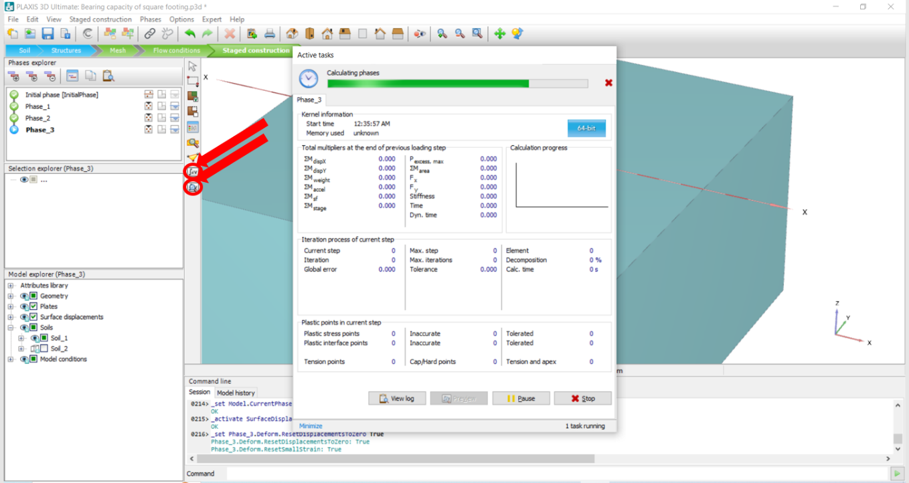

**Results:**

* For drawing curves, you can click on the **Curve manager icon**, in the PLAXIS3D output window as shown below. Then click on **New**.

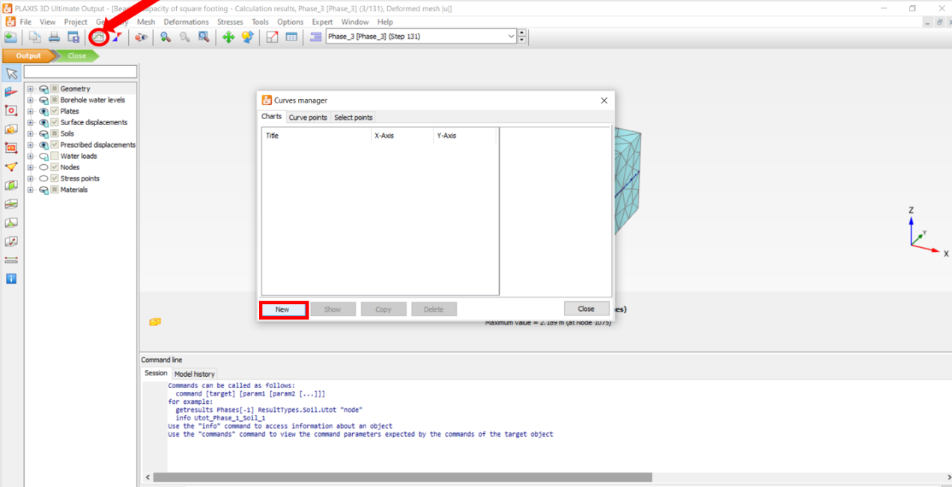

* For plotting Load to Displacement, choose **Project** in the X-axis section, click on the + sign next to **Force**, click on **Fz** and check the box next to **Invert sign**. Then, go to the Y-axis section, click on + sign next to the **Total displacements** and click on Uz. Then, click **OK**.

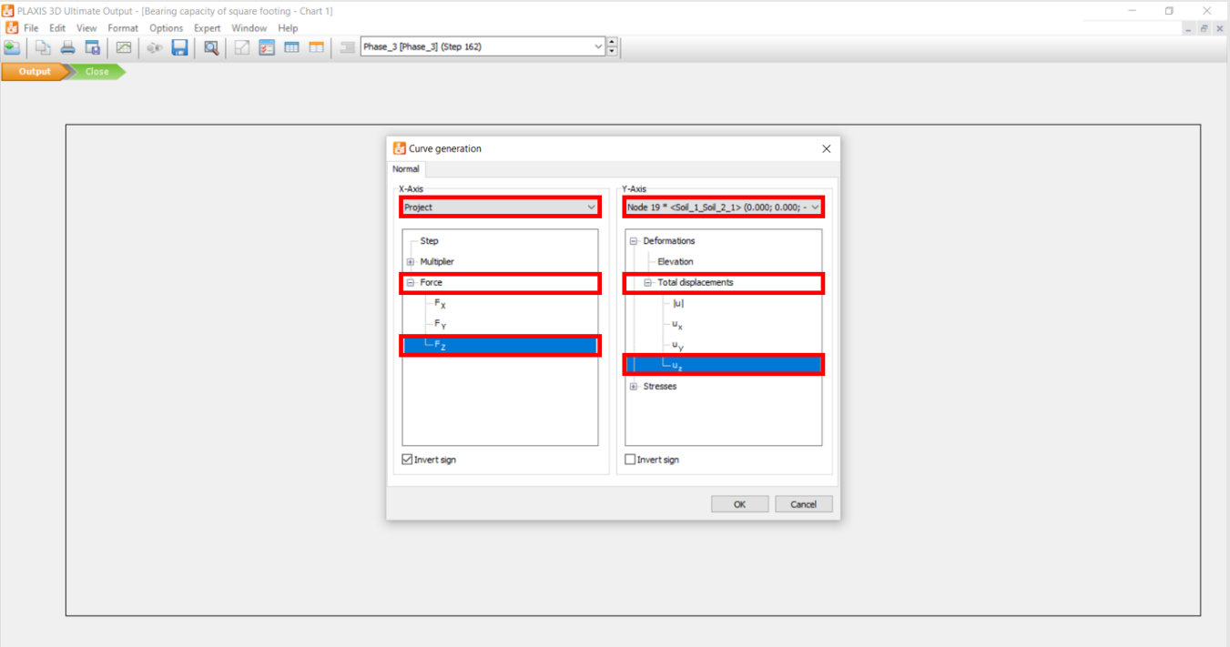

* The results should look like this:

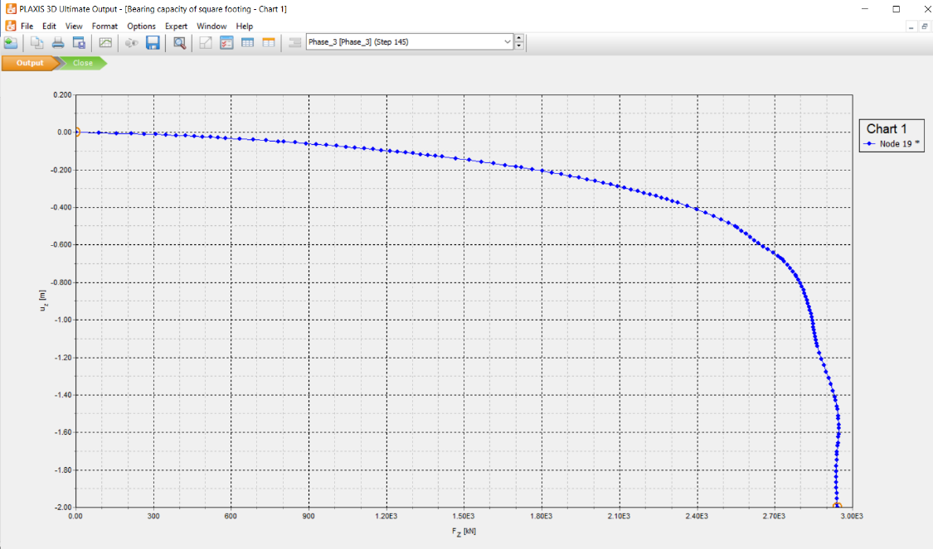

In the figure above, you can see the force-displacement curve and find the ultimate bearing capacity.

**Question:**

**How does this compare to the hand calculations based on Terzaghi’s method?**

* In the PLAXIS3D output window, you can check other results such as deformation, stresses, etc. Follow the figures below to plot Total displacement and Deformed mesh, using the available tools (follow the steps in the figures).

