**PLAXIS 3D Lesson 1:**

**Learning Objective**: This lesson is intended to provide you with an introduction to Bentley PLAXIS 3D by introducing the main modes and their applications.

**PLAXIS SOFTWARE**

Plaxis (occasionally written in all caps; originally named for Plane strain and axial symmetry, which refer to the geometric types managed in the initial version) is a software application designed for performing finite element analyses (FEA) in geotechnical engineering. It covers areas such as deformation, stability, and water flow. The input procedures and advanced output features allow for a comprehensive presentation of the computational results. With just a few hours of training, new users can begin working with PLAXIS. In 2018, Plaxis BV was acquired by the American company Bentley Systems, Inc.

**The Origin of PLAXIS**

PLAXIS originated as a research project at Delft University of Technology (TU Delft) in the Netherlands, in collaboration with the Dutch Ministry of Infrastructure and Water Management (Rijkswaterstaat), during the latter half of the 1980s. The project aimed to merge the finite element method with non-linear constitutive stress-strain models to effectively simulate the behavior of soil structures in infrastructure projects.

At the time, the rapid growth and improved performance of personal computers created an ideal environment for the development of advanced software. This technological backdrop allowed the research team at Delft to create PLAXIS as a sophisticated and user-friendly program. By incorporating state-of-the-art research and robust numerical algorithms, the team ensured that PLAXIS would be a practical tool for geotechnical professionals.

The development of PLAXIS marked a significant advancement in geotechnical engineering software. Its ability to provide accurate simulations of soil behavior in various infrastructure scenarios made it an invaluable resource for engineers. The software's ease of use meant that even those new to the field could quickly become proficient, further contributing to its widespread adoption in the engineering community.

**References:**

<https://en.wikipedia.org/wiki/Plaxis>

<https://www.seequent.com/how-the-past-30-years-of-plaxis-history-pave-the-way-for-a-promising-future/>

**Task 1- Starting a project**

* To get started open PLAXIS 3D by clicking on the PLAXIS 3D Input icon:



* The following window will open up where you can choose the appropriate licenses:

* Make sure the appropriate licenses (the licenses that you have purchased) are selected. If not, click on the configure licenses (see figure above), select the correct licenses, and then click accept. When the appropriate licenses are selected click continue in the window above. The PLAXIS 3D software will open with the following window:

* In the window shown above, click on “Start a new project” which opens up the following window:

* In the window shown above, type in an appropriate title. For example: “Basics”. Then click on the Model tab (highlighted with a red arrow and a red circle in the figure below):

* In the **Model** tab (shown in the figure below), you can define some basic parameters of your project including the units, and the boundary of the project (ground): For example, you can choose the boundaries of your project as follows:

Go to the contour section (figure below), enter the values shown in the figure, and then click ok:

* The boundary of the project you just created should look like the figure below (the values of X and Y will not be shown in PLAXIS. They are added to the figure below to help you understand the values you entered in the previous step).

* The soil contours you just created can be adjusted by clicking on the **Adjust soil contour** icon.

* Click on the Adjust soil contour icon shown in the figure above. Three options will appear. Click on **Move contour points/lines** to adjust the corners of your boundary.

* Click on the Adjust soil contour icon again. click on **Move contour points/lines.** Go to the Surface Points tab that is opened and adjust the points by changing the coordinates to the numbers shown below:

* Click ok.

**Different Modes in the PLAXIS3D**

****In the PLAXIS software, five main “Modes” are available:

* **Soil:** Soil properties can be defined in the soil section.
* **Structure:** Structures can be defined in the structure section.
* **Mesh:** After modeling, we need to discretize (create mesh) the model for calculation based on finite elements.
* **Flow condition:** This section is used for adjusting flow properties.
* **Staged construction:** In this section, construction phases can be defined and calculated.

**These sections are discussed in some detail in the following sections. More details are provided as needed in future lessons.**

**Task 2- Soil**

* You can assign soil properties by clicking on the "Create borehole" icon as shown in the picture. After clicking on the icon, a borehole symbol will appear on the mouse cursor. You can place the borehole at the desired location by clicking on the desired coordinates.

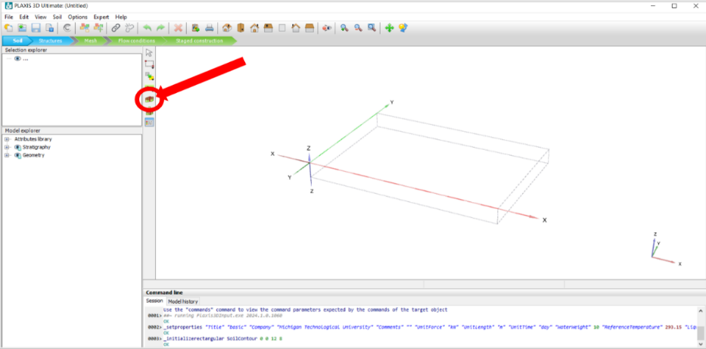

* Place the mouse cursor on position X, Y, Z = 0, 0, 0 as shown in the figure below. Left-click on this position.

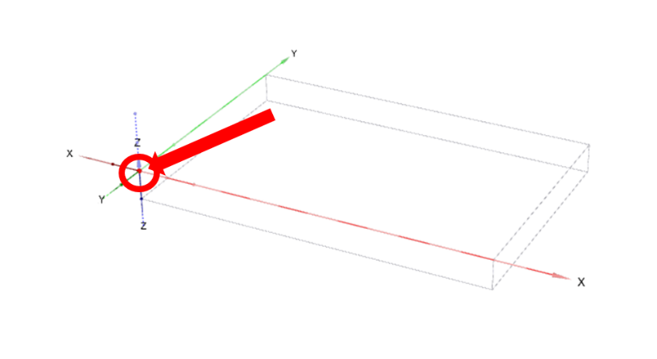

* After placing the borehole, a window will open. In the opened window, click on "Add" to add a new soil layer. Then click on "Materials" to define soil parameters.

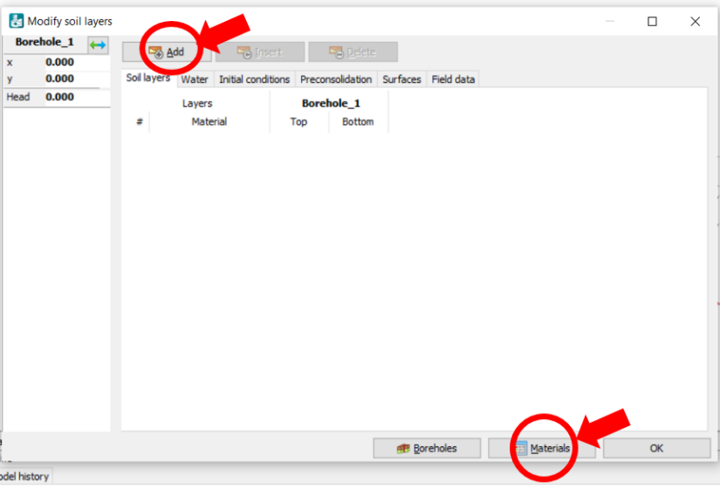

* 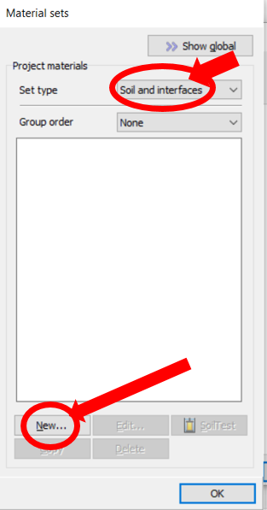In the opened window, go to **Set type** and choose ”Soil and interfaces”, which is used to define soils. Then click on "New," to define soil layer properties.

A window will open which has five tabs for assigning General, Mechanical, Groundwater, Interface, and Initial Condition of soil.

* In the General tab, add a name for the soil in the **Identification** box. Type in soil 1 in the Identification box. You can choose a **Soil model** by clicking on the drop-down arrow and selecting the desired model. There are several options to choose from but the Mohr-Coulomb is the most commonly use model. In this tutorial, Mohr-Coulomb will be used unless otherwise stated. You can choose **Drainage type** by clicking on the drop-down arrow and choosing the desired type of drainage. Choose the Drained condition. Enter the unsaturated and saturated unit weights in the Unit Weight boxes as shown below ( kN/m3 and kN/m3 are considered for the soil 1).

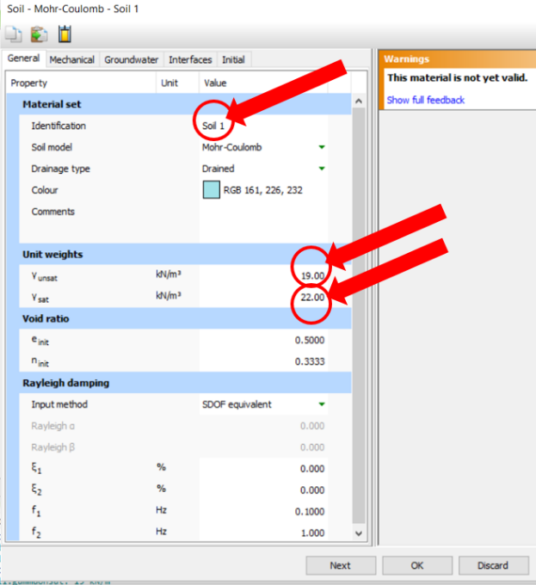

* Now, click on the Mechanical tab:

* In the **Mechanical** tab, you can add mechanical parameters of soil such as stiffness and strength. Add soil’s $E_{ref}^{ˈ}$ (Module of elasticity) and v (nu) Poisson's ratio in the **Stiffness** section as follows: kN/m2, v (nu) : 0.3.
* Add the soil’s $ø^{ˈ}$ (phi) (friction angle) and $C_{ref}^{ˈ}$ (cohesion) in the **Strength** section as follows:

$ø^{ˈ}$ (phi): 24 , 6 kN/m2.

* After adding soil properties click **OK.**

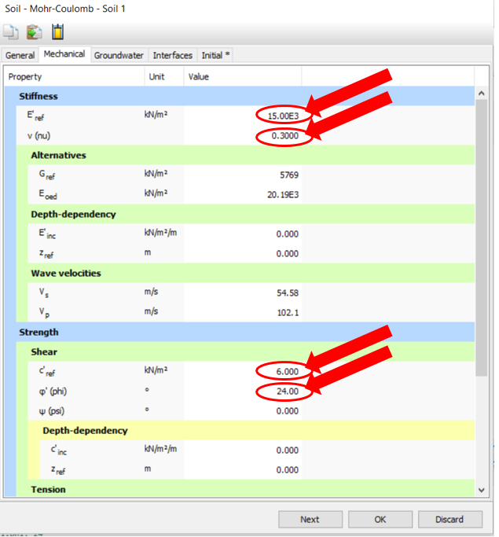

* After defining soil properties, you can assign them to the layer by clicking on the drop-down arrow (see figure below) and choosing the name of the soil you just created (Soil 1). After that, you can add the soil depth according to its elevation in the boxes located under the Top and Bottom text fields. In this example, borehole elevation starts from zero to -15 in depth. After adding the layer, click on OK.

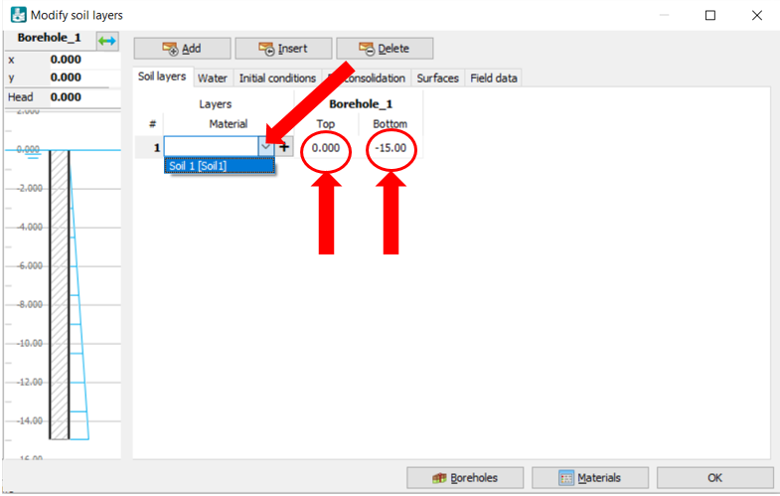

* The defined soil layer can be adjusted as follows:
* Clicking on the + sign next to the **Stratigraphy** subsection in the **Model explorer** section (see figure below)
* Click on the + sign next to the boreholes, and then right-click on the desired borehole (Borehole_1 in this example) and click on **Edit** for further editing.

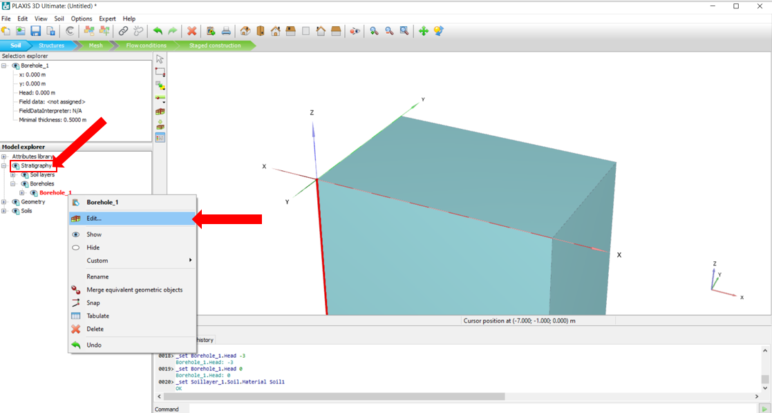

* After clicking on the "Edit" command from the previous step, click on "Add" to add another soil layer.
* Click on Materials and follow the previous steps to create a new soil. Choose the name “Soil 2” for this new soil layer and assign this new soil 2 to the second layer in the Borehole_1 (see figure below).
* Change the top and bottom depths in the Borehole_1 as shown in the figure below, and then click **OK**.

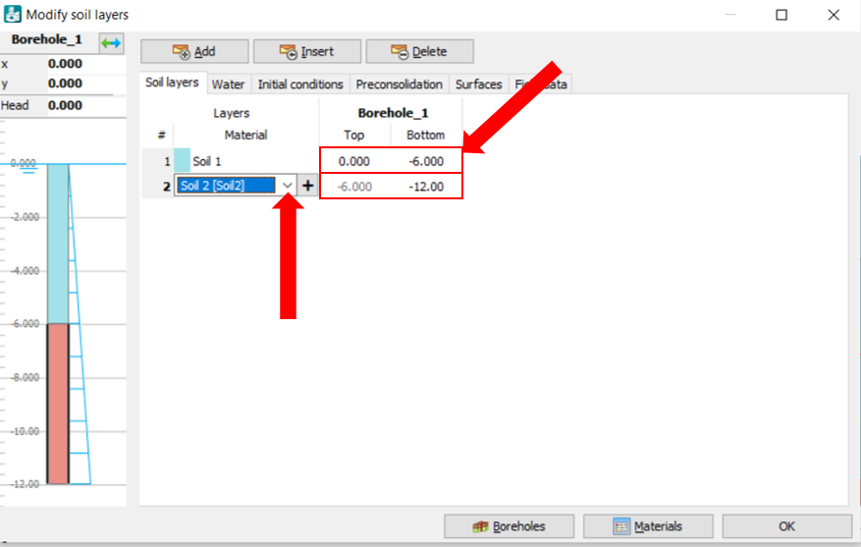

* Sometimes, it is required to define more than one borehole to accurately represent the soil stratigraphy and site topography. Other boreholes can be added by clicking on the **Create borehole** icon as described in the previous steps.
* Click on the **Create Borehole** icon, and place the borehole at the desired coordinate just by clicking on any location in the model. Go ahead and place the borehole at a random location for now. The position will be corrected in the next step.
* Borehole positions can be adjusted by changing their coordinates in the **Selection explorer** section as follows: In the **Model explorer** section, click on the Borehole_1 and check the X and Y in the **Selection explorer** section (You should see X: 0.000m, and Y=0.000m).
* Now, go back to the **Model explorer** section again and click on the Borehole_2:
* Now, in the **Selection explorer** section, change the X and Y of the Borehole_2 to X: 9.000m and Y: 5.000m, and hit enter:

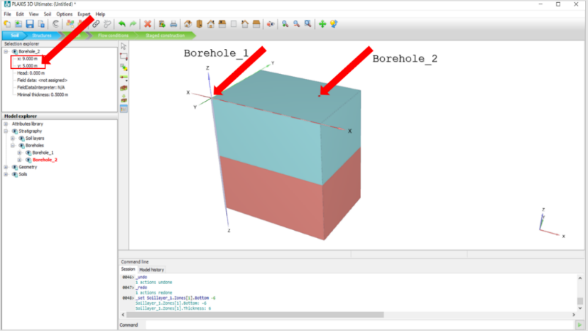

* After locating the new borehole, you can define its soil layers as follows:
* In the **Model explorer** section: right-click on the Borehole_2 and click on edit
* In the opened window (which is called “**Modify soil layers**” window), change the layers as shown in the figure below: (Notice that by having different depths for the two layers, you can create inclined interfaces instead of horizontal interfaces between layers).
* Also, notice that the X and Y of the boreholes can be changed in this window as well (In PLAXIS3D, there are usually multiple ways of doing a particular task, and it is up to you to choose the most convenient method for yourself).

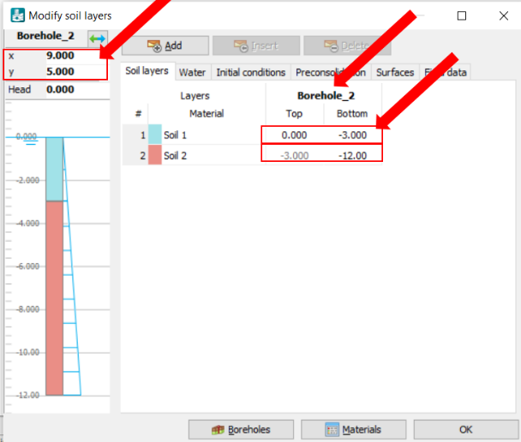

* In the same window, you can define the water level in the box in front of the Head and define its properties as shown in the figure below. Click on the **Water** tab. Change the Head to -2.000. Other options (i.e., hydrostatic, Interpolate,) will be discussed as needed later. For this example, choose Head.

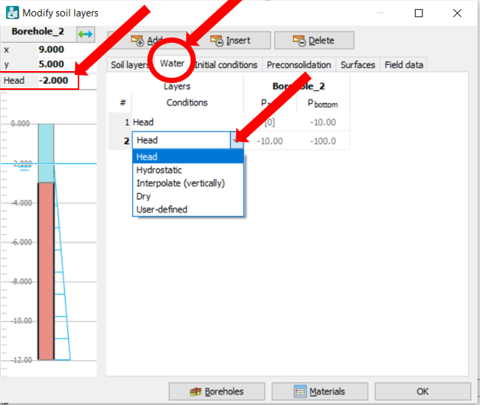

* While you are moving your cursor on the model to find the locations mentioned above, you will notice that the coordinates of the points that you can choose change by 1. For example, you can choose a point with the X coordinate of 0, 1, 2, 3, …., 12. Sometimes you need to have one of the points located at X=1.5, for example. To do that, click on the **Options** tab in the menu bar:

* Click on the visualization settings:

* In the visualization settings window that opens up, go to the Grid tab, change the spacing to 0.5, and click ok:

* Now, go back to create a surface and move your cursor on the model to find the locations mentioned above again. You will notice that this time the coordinates of the points that you can choose change by 0.5.

**Task 3- Structures**

Structures can be modeled in the **Structures** mode.

There are different tools for drawing and assigning structures such as lines, surfaces, polycureves, hydraulic conditions, loads, and displacements, which can be found in the structures mode.

* After defining soil properties, click on the structure mode to design structural elements.

* To create a surface (a structure such as a concrete slab for a square footing), click on the **Create Surface** icon (see the figure below), then click on the first option in the sub-menu (the icon with four points). Then, move your cursor onto the soil boundary (box) that you created in the previous section and select the four points representing the four corners of your square footing: point 1: X:5.00, Y:3.00; point 2: X:5.00, Y:5.00; point 3: X:7.00, Y:5.00; point 4: X:7.00, Y:3.00. You can adjust points' positions by assigning their coordinates in the surface points window shown in figure below.

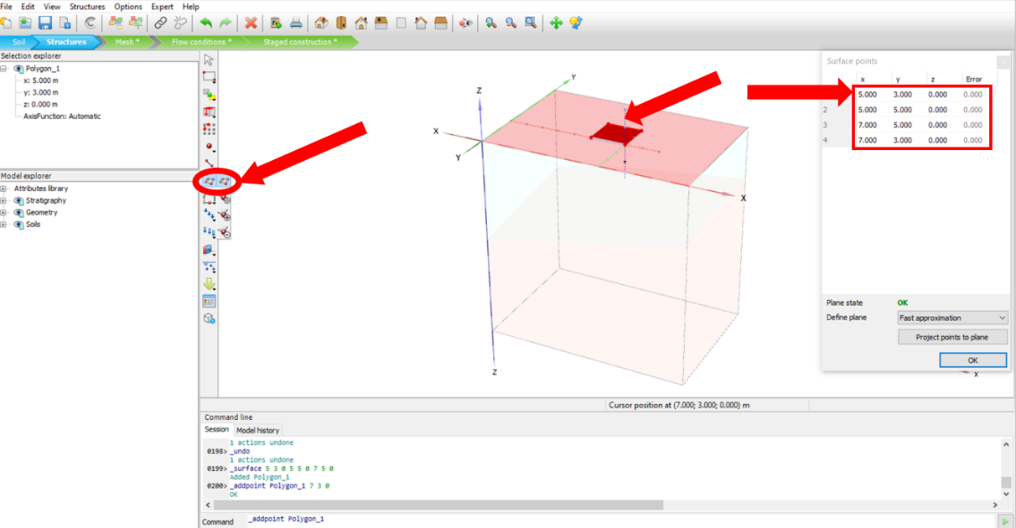

* To model the excavation volume, while the created surface in selected, click on the **Extrude object** icon, in the opened window, enter “-1” value in z box which represents -1 m of excavation.
* Then click **Apply**.

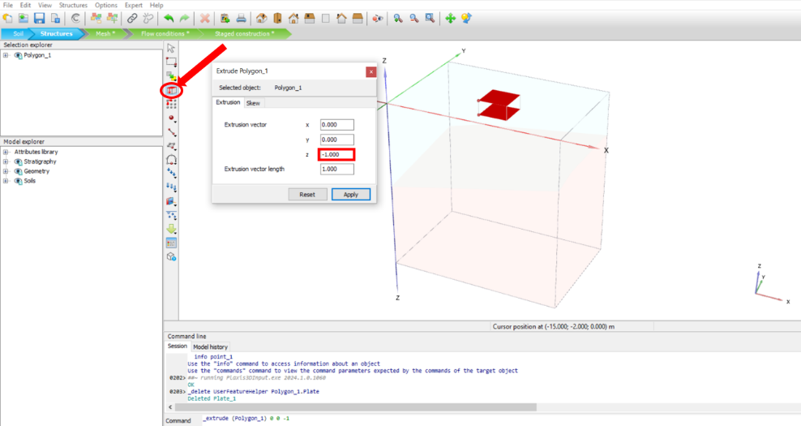

* To create a plate in the excavation level, while the created surface is selected, click on the **Create array** icon. In the opened window, in Configuration section, click on the drop-down arrow next to the Shape and choose ”1D, in z direction”.
* In the Number of column box, enter “2” value.
* In the Distance between columns box, enter “-1” value infront of Z.
* Click **OK**.

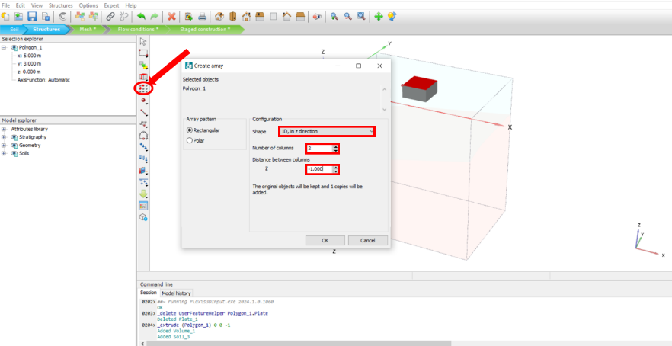

* Click on the created volume object to select it, then **right click** on that and click **Hide** to see the surfaces.

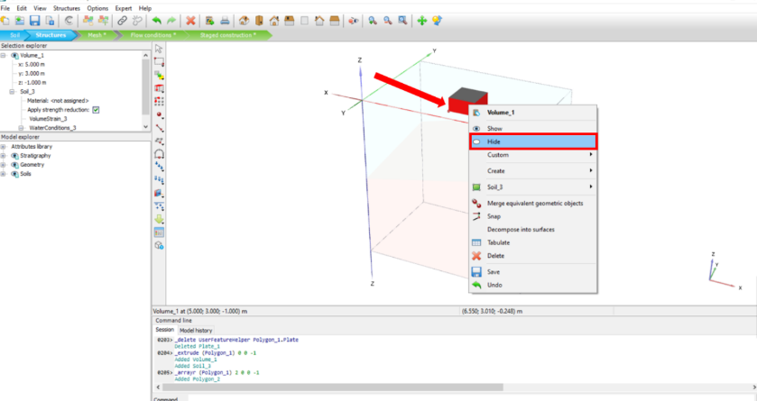

* Click on the top surface to select it, then right-click on it and choose 'Delete' to remove the top surface, as it is no longer needed.

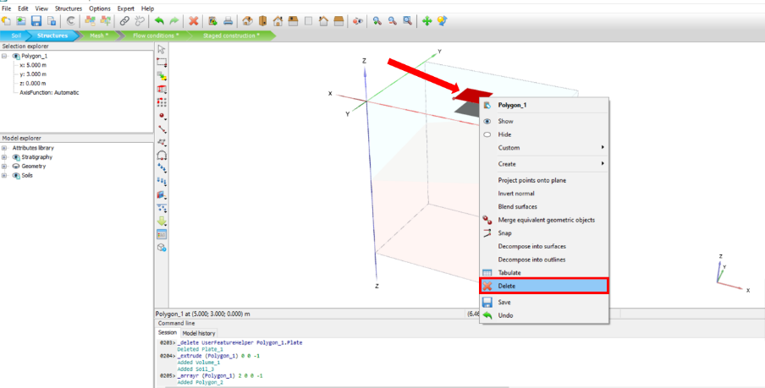

* Now, you can create a plate to represent a concrete slab for a square footing:
* Right-click on the surface in the model, click on **Create** in the opened menu, and then click **Create plate:**

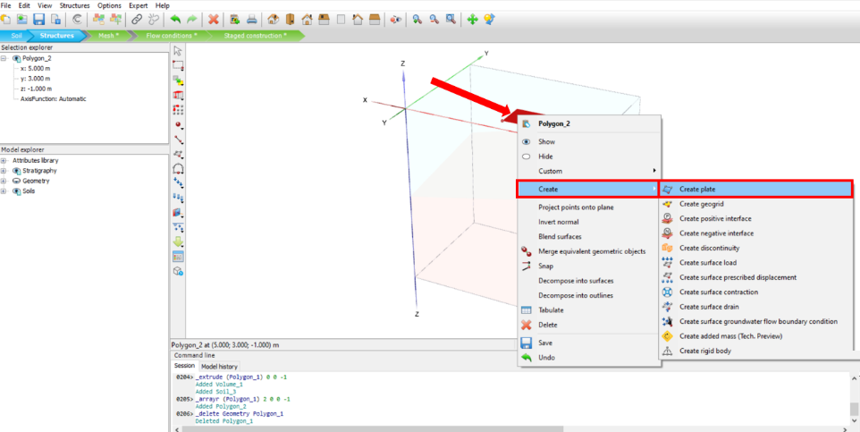

* Now, you can define a concrete material that you can later assign to this plate you just created. Click on the show material icon:
* In the **Material set** window that opens up, change the set type to plate, then click on new:

* In the opened window, change the **Identification** to concrete. Here, you can define the unit weight and other mechanical properties of the concrete foundation similar to defining soil properties. Change the material type to elastic and enter the 24 kN/m3 for the unit weight:

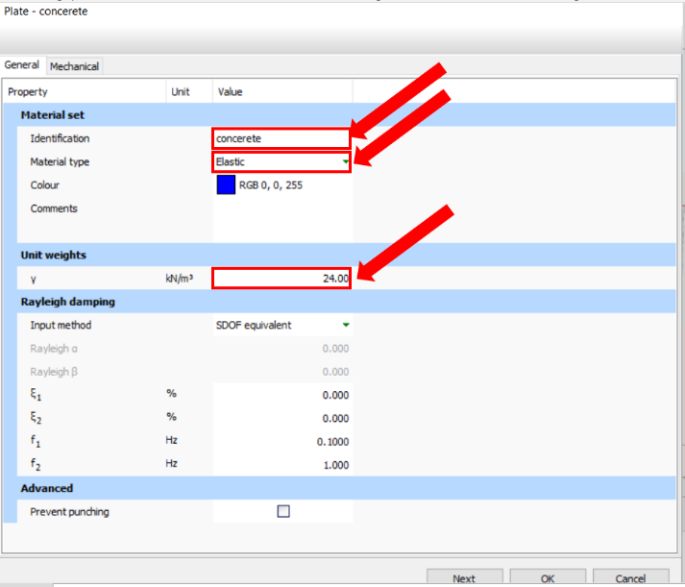

* Click on the **Mechanical** tap:
* In this window, change the E1 (Young’s modulus) to 23000 kN/m2, to 0.2, and the d (thickness of the concrete) to 1, and click ok:

* Now, you can assign the concrete material that you just created to the plate. There are multiple ways to do this. We are going to try one of these methods here:
* Click on the show material icon:

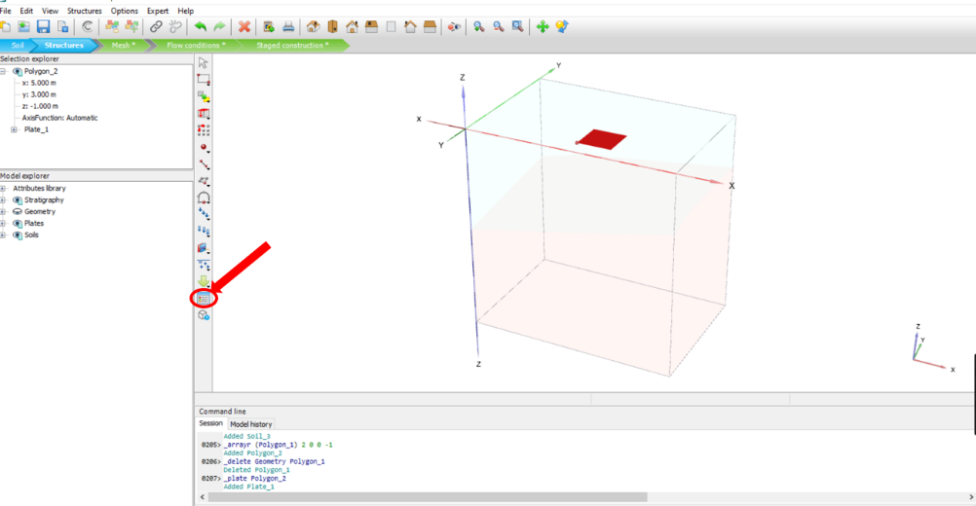

* In the **material set** window that opens up, change the set type to plates:

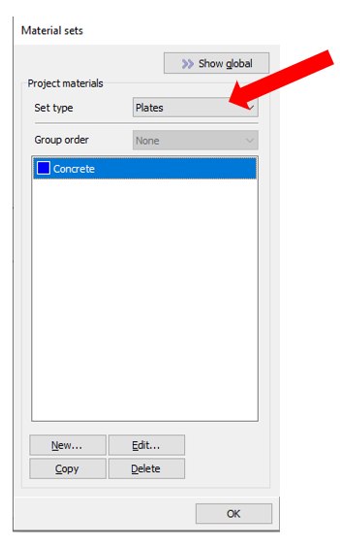

Now, click and hold on to the concrete material shown in the figure above, drag it onto the plate in the model, and release it. This will assign the concrete material to the plate.

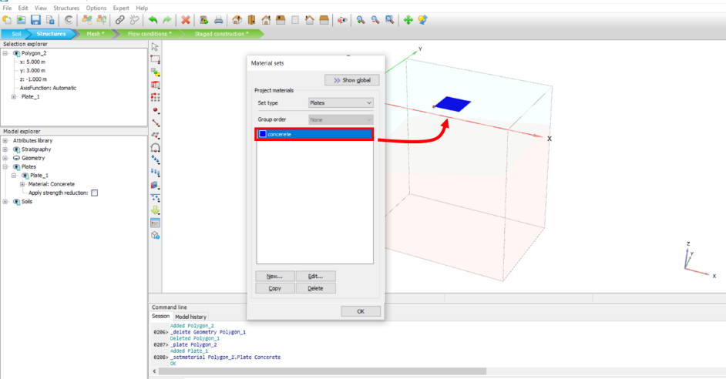

**Task 4 – Creating Mesh**

* After defining soil properties and designing structures, click on the Mesh mode:

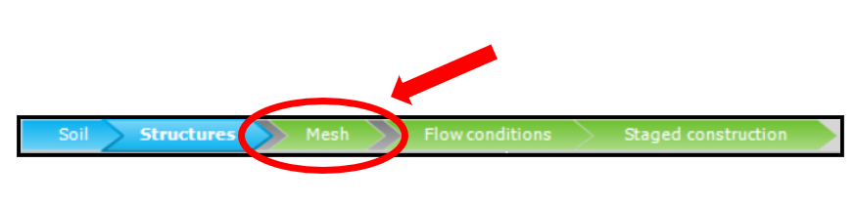

* Click on the **Generate Mesh** icon. A window will open up where you can choose the mesh size according to the required accuracy, time, and computational demand which depends on the size of the project. Click on **very coarse,** and then click ok.

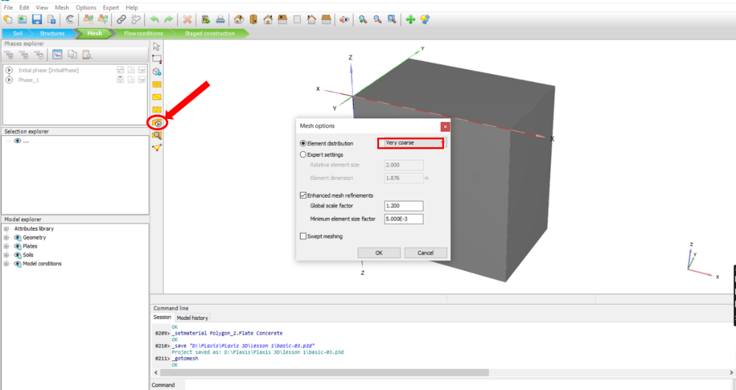

* View the generated mesh on your model by clicking on the **View Mesh** icon:

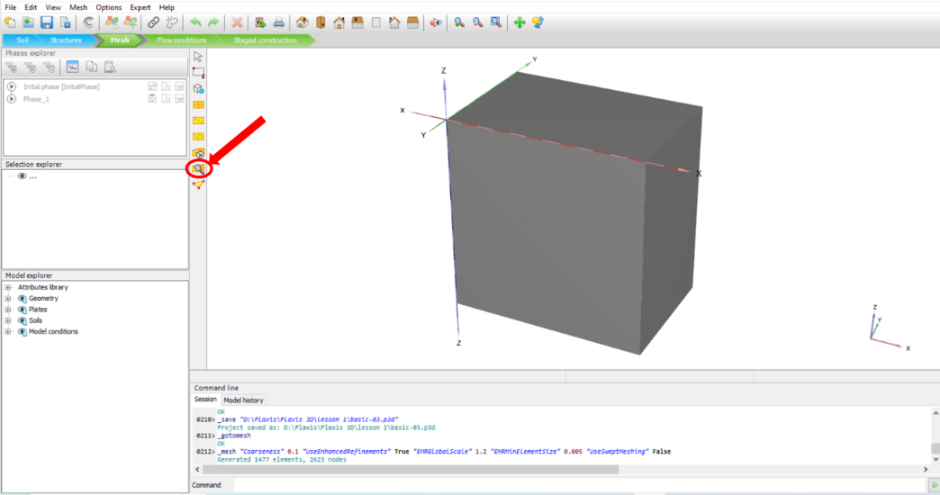

* A new window will open and you can see the meshed model:

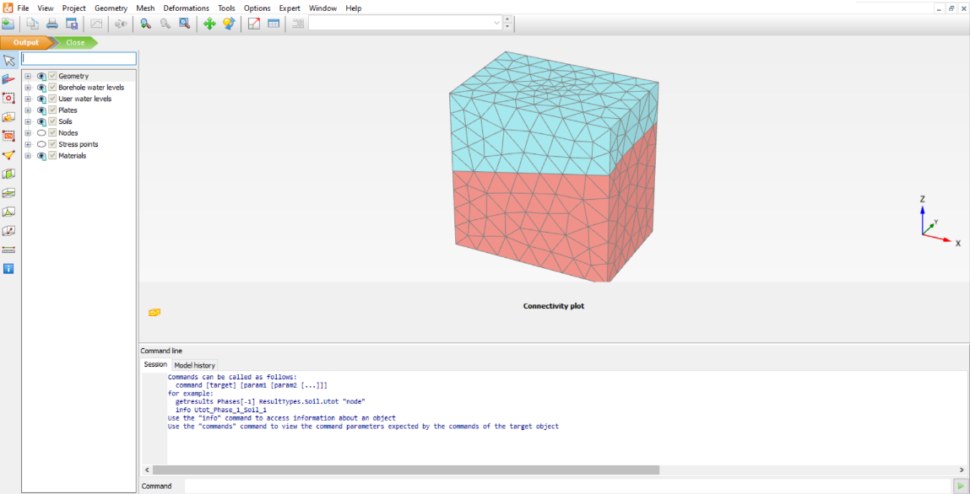

**Task 5: Flow condition**

* **Flow condition** can be defined in the Flow Condition mode. Click on the flow condition mode:

* Click on **Create Water Level**, and then click on **Add Water Level Points**.

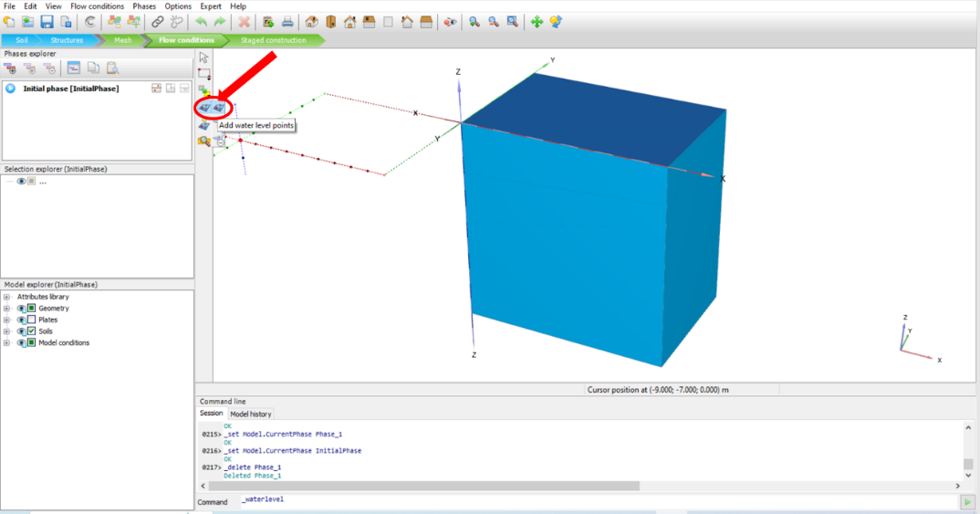

* Now, you can click on any point at your desired coordinates. You can also adjust points from the window which opens after clicking on the points. Click on four corners of the project contour to assign the water level points:

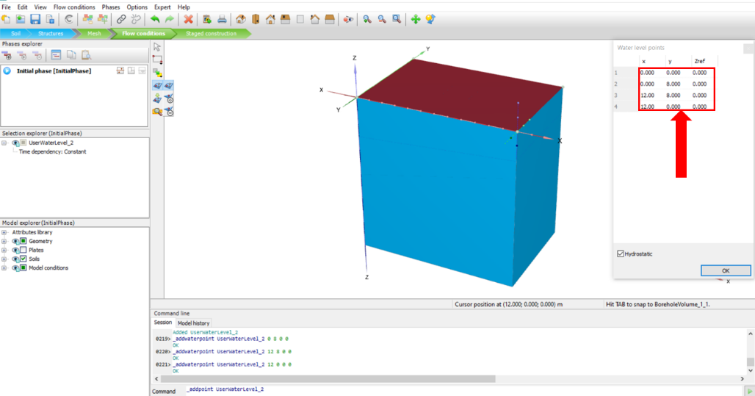

**Task 6- Staged construction**

* After designing soil, structures, flow conditions, and meshing the model, click on the Staged Construction mode to define phases and prepare for calculations.

* Construction phases can be added or edited by the icons shown in the picture below.
* When you go to the **Staged Construction** mode, there is an Initial phase which is associated with the initial condition of your soil. Each step in construction will be defined as a phase and those other phases can be added or edited.
* Click on **Add phase** (shown in the figure below) to add a new phase, then click on **Edit phase** (Also shown in the figure below).

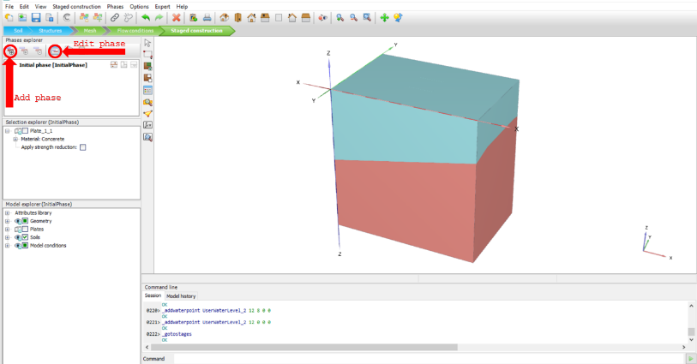

* A window will appear and calculation parameters can be chosen. By clicking on each phase in the left section, you can assign a name and other parameters for each phase. Leave everything as default for now, and click **OK**.

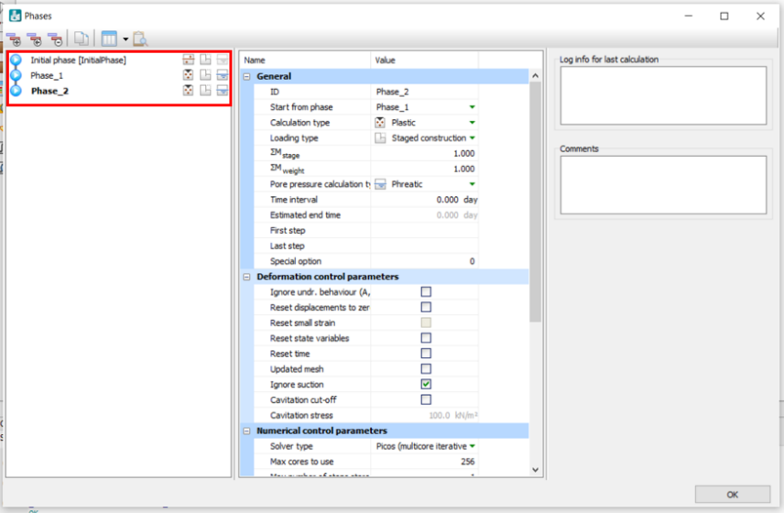

* After adding all the phases of construction, different items should be activated or deactivated for each phase in the **Model explorer** according to their construction stage. In the **Phases explorer** section, click on the Initial phase and see that soil layers (Soil 1, Soil 2, and soil 3) are activated.

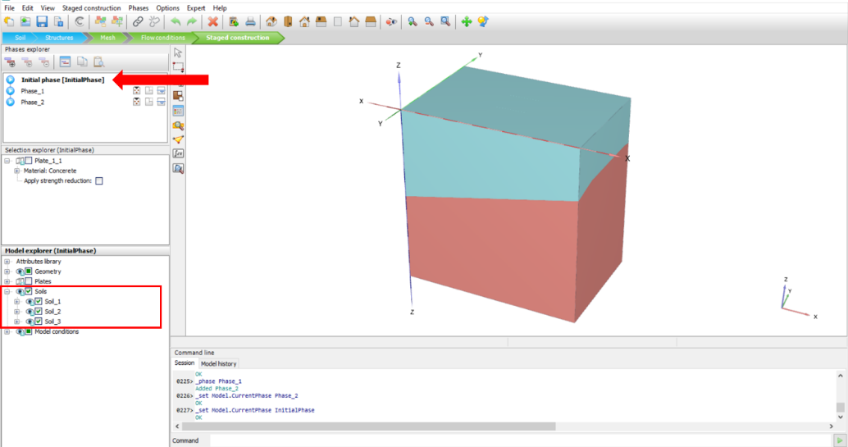

* In the **Phases explorer** section, click on Phase_1 and uncheck the box next to the Soil_3 in the **Model explorer**.

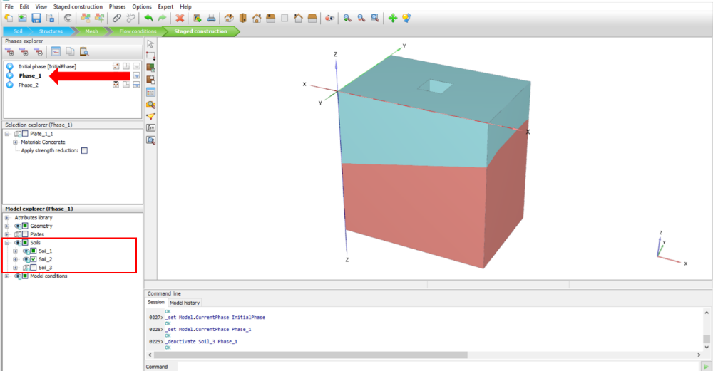

* In the **Phases explorer** section, click on Phase_2 and check the box next to the Plate in the **Model explorer.**

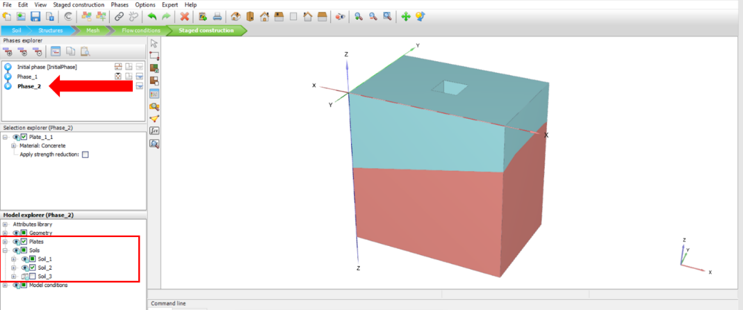

Important note: If you add all the phases first, you should make all the changes in each step and check the checked/unchecked boxes. If you make the changes before adding a new phase, created changes will be applied in your new phase.

* After defining phases, you need to select a point for calculation (this is a point where model properties such as force, displacement, etc… are recorded during the numerical modeling steps so that they can be plotted later). Click on the **Select Points for Curves icon**.

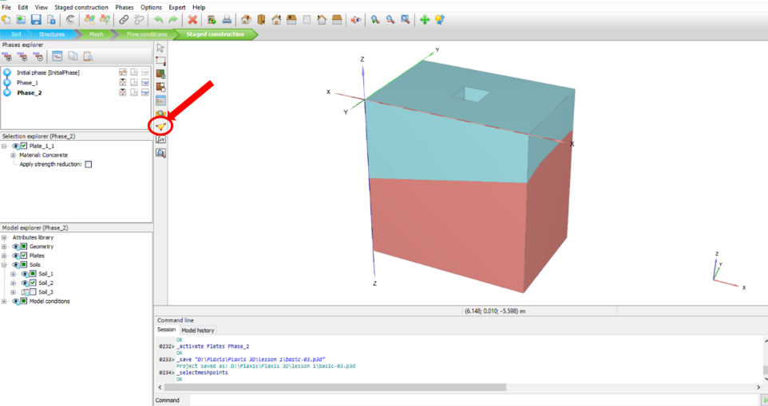

* In the opened window, you can clickon your desired point and then click on **Update**. Alternatively, You can find your desired point by entering its coordinates in the red box shown in the figure below (Enter: X=6, Y=4, Z=-1 in the **point of interest coordinates** highlighted with a red box shown below) and click on the **Search Closest** icon:

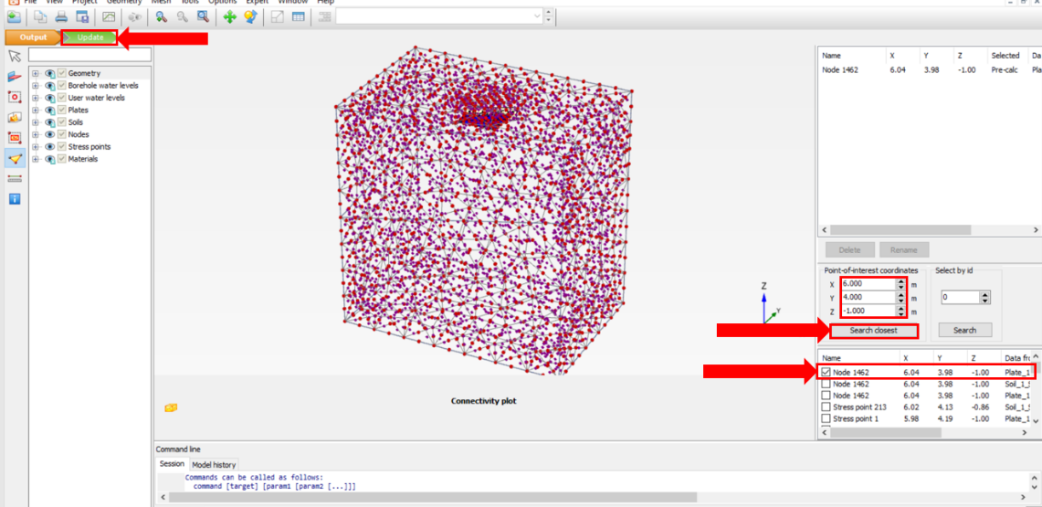

* As can be seen in the figure above, after clicking on **search closest**, several options appear in the box below it. Choose the first one and then click **Update** (see figure above).
* After choosing a point, click on the **Calculate icon** to start the calculation. When the calculation is completed, click on **View Calculation Results** to observe the calculation results:

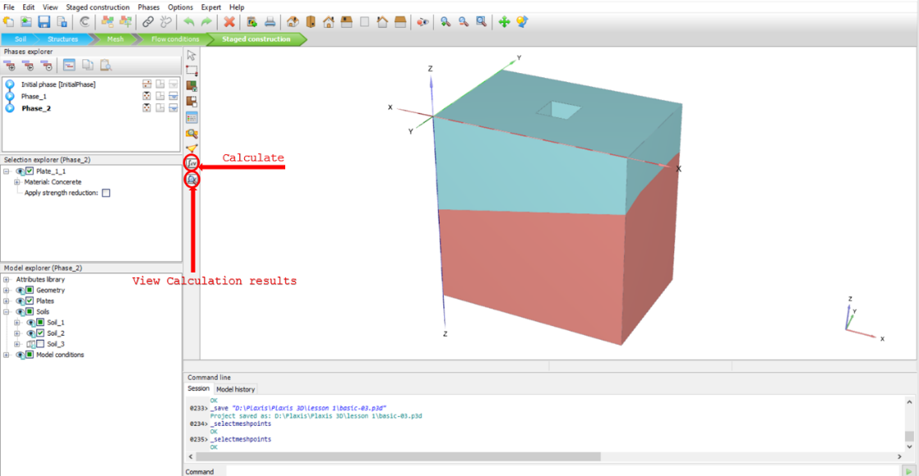

* Here, you can see the results by looking at plots such as deformed mesh, stresses, total displacement, etc (the steps are shown in the figures):

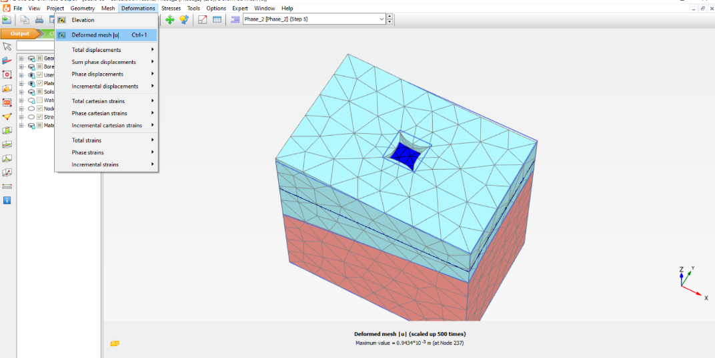

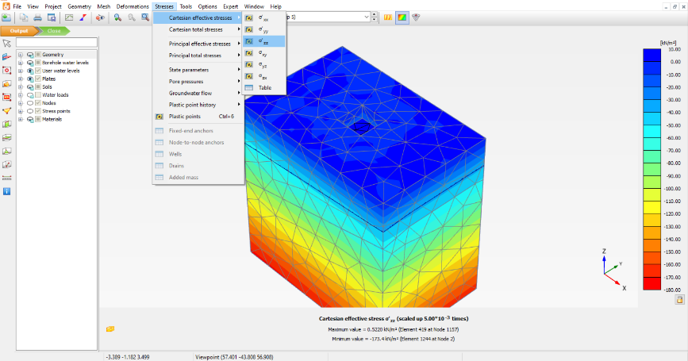

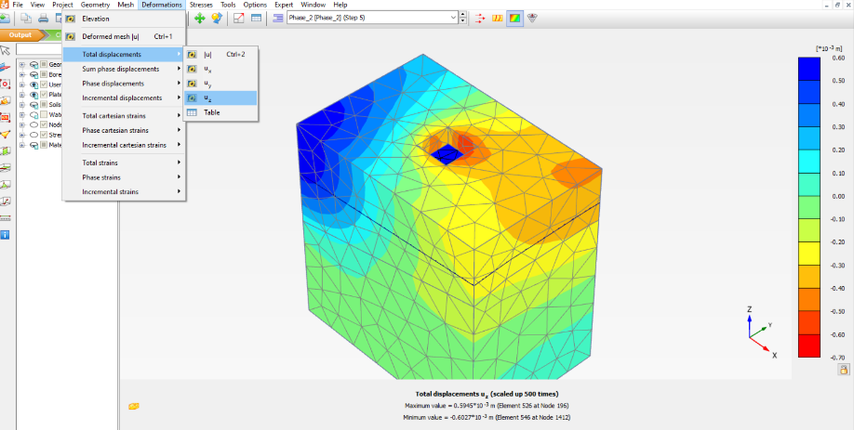

* Save the project by clicking on **file** and **save project**.