# **ORD Lesson 2: Using Civil Geometry Tools to Create a Basic Alignment with Curves and Tangents**

**Learning Objective:** This lesson will familiarize you with using OpenRoads civil geometry tools and rules-based geometry to create a simple centerline alignment. It will also help you understand the effects of changing curve geometry on tangent lengths.

**Task 1: Getting Started**

1. Download the *Lesson2.dgn* file and store in a preferred location.
2. Open ORD and select “Browse”. Locate and open *Lesson 2.dgn*.
3. Verify the working units of the drawing are in feet by doing the following:
   * Select the **File Tab** and then select **Settings**
   * Select **File** and then **Design File Settings**
   * Select “Working Units” from the Category box and verify the settings are as shown below. Once correct, select OK and return to the drawing.

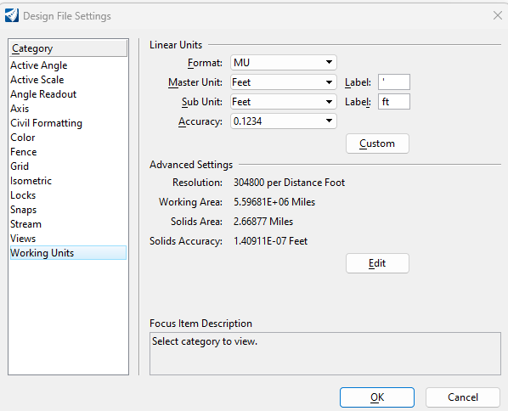

**Important Note:**

Unless otherwise noted, all tools in this exercise can be accessed using the “OpenRoads Modeling” workflow.

**Task 2: Using Feature Definitions**

1. Under the **Geometry** tab, in the *General Tools* ribbon group, select the fly down next to **Standards**. Select **Feature Definition Toolbar**. The toolbar will appear as shown below:

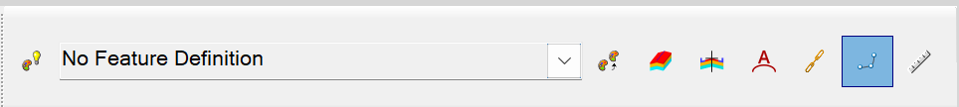

1. In this lesson, we will be creating a centerline alignment and need to select the appropriate feature definition for this.
   * In the feature definition drop down, select the Geom_Baseline feature definition and set it to active, as shown below:

Select icon to make “active”

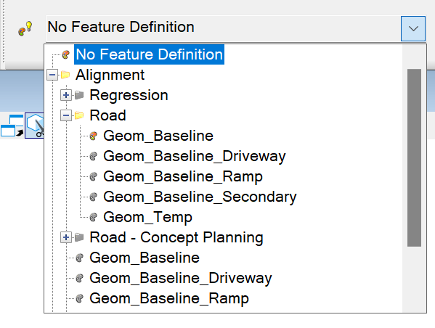

**What are feature definitions used for?**

Feature definitions are a set of attributes specific to an element type (such as a centerline alignment) and control how that element is displayed, annotated (labeled), and computed.

**Task 3: Comparing Drawing Tools to Civil Engineering Geometry and Understanding Rule-Based Geometry**

In Lesson One, we used basic drawing tools to create a subdivision plat. In this lesson, we will understand the difference between those tools and the civil geometry tools used to create civil geometry elements. For this task, we will create a simple centerline alignment consisting of two tangents using both the basic drawing tools and civil geometry tools.

First let’s use the basic drawing tools:

1. Find an empty area in the drawing and use the **Place Line** Tool to draw a 500’ long line (direction/angle of the line does not matter).
2. Use the tools found in the*Manipulate* ribbon group found in the *Drawing* ribbon tab to create another 500’ long tangent with an intersection angle of 22 degrees as shown in the picture below.

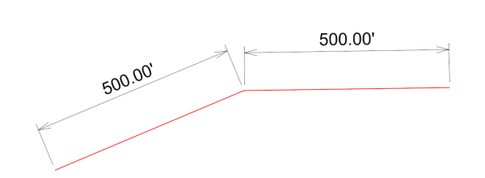

∆=22°

1. Now, use the tools in the *Manipulate* ribbon group to create a copy, extending the rightmost tangent to a length of 700’ and changing the angle of intersection to 20 degrees pictured below.

∆=20°

Now, let’s recreate the same set of tangents (500’, ∆=22 degrees) using the civil geometry tools instead.



1. Find an area in the drawing near the tangents you drew in the previous step and locate the **Line** Tool located under the *Geometry* ribbon tab in the *Horizontal* ribbon group. Use the drop down next to the Line icon to select **Line Between Points**.
2. Place a 500’ long line (tangent) by setting the distance to 500’ in the dialog box. The line can be placed in any direction.
3. Next, place the other 500’ tangent by using the **By Angle From Element** Tool to create the second 500’ tangent shown below. Follow the prompts on the screen, enter the values for skew (20 degrees) and end distance (500’) and select the right end of the tangent as your start point.

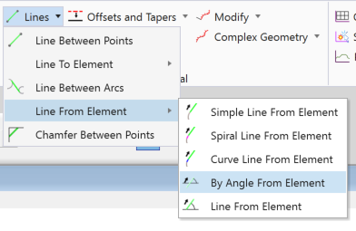

1. Use the Element Selection Tool to select the rightmost tangent. You should see geometry on your screen similar to that shown below.

Holds angle between tangents at 22 degrees

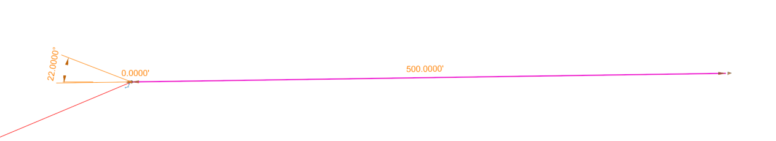

Maintains start point of line at 0’ from end point of leftmost tangent

Icon indicating that tangent will snap to end point of leftmost tangent

Maintains 500’ distance from start point

The text and icons shown each indicate an editable “rule”. For example, if we move or change the angle of the leftmost tangent, the rightmost tangent will move with the leftmost tangent and maintain the 22-degree angle of intersection. This built-in intelligence and ability to maintain relationships between elements is a key feature of civil geometry in OpenRoads. Text is colored in orange is dynamic and can be edited.

Now, let’s alter the rightmost tangent to be 700’ long with a 20-degree angle of intersection as we did with the basic drawing tools.

1. With the rightmost tangent selected, click on the 500’ label and enter 700’. Notice the length automatically updates while keeping the starting point of the line at the end of the leftmost tangent.
2. Repeat the same process, except this time change the angle to 20 degrees. Your geometry should look similar to that shown below:

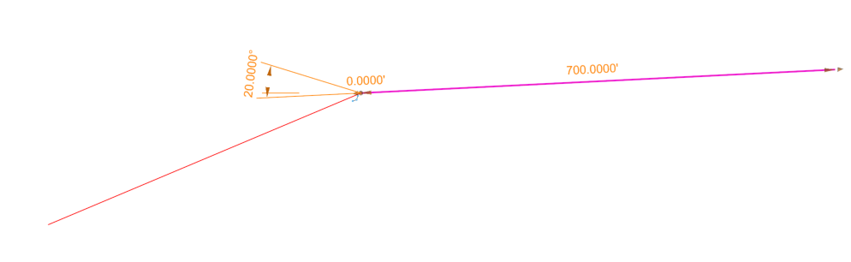

You should have noticed how much easier it is to update geometry when using the civil geometry tools as compared to the basic drawing tools found within OpenRoads. Civil geometry tools are very powerful features in OpenRoads and are critical to use when creating any civil engineering geometry.

**Important Notes:**

* Using the tools found within the Manipulate ribbon group may not work on civil geometry where rules have been established. In cases where the tool does work, such as use of the copy tool, all rules that have been created will be lost with the copy.
* On-Screen graphic manipulators can also be used to change the geometry by clicking and dragging on the screen.
* It is important to never mix basic CAD drawing tools with civil geometry tools.

**Task 4: Creating Curves within an Alignment**

1. Using the two tangents you created in the previous step (using civil geometry), create a third tangent using the **By Angle From Element** Tool with a length of 800’ and ∆ of 15 degrees. Your alignment should look similar to that shown below.

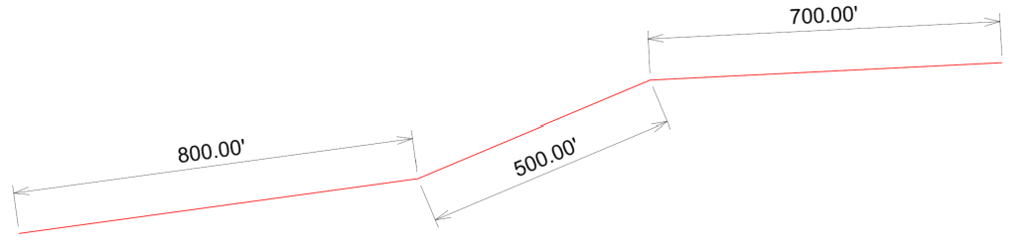

∆=15°

∆=20°



1. Select the **Arcs** tool found under the Horizontal ribbon group within the Geometry ribbon tab
   * Select Arc Between Elements and then **Simple Arc** as shown below.

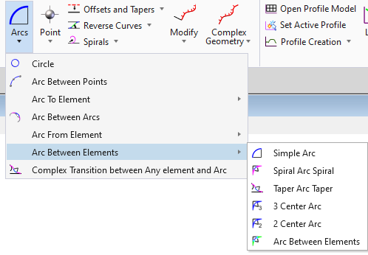

1. While in the Arc Tool, select the middle and rightmost tangents to create an arc between them.
2. In the Simple Arc dialog box enter a radius of 1145.92’ and set the “Trim/Extend” option to “Both”.
3. Repeat steps 6-7 for the curve between the left/middle tangents, except this time we will do it by entering in a 5 degree curve instead of a radius. This can be done by entering “d5:0” into the radius input box which is then automatically converted to the corresponding radius.

**Important Note:**

When converting the degree of curvature to a corresponding radius, ORD uses the arc definition of a curve by default. If you are working on a railroad alignment, it is typically appropriate to use the chord definition to establish curve properties. This setting can be modified in the design file settings under the “Civil Formatting” category.

1. Your geometry should look similar to that shown below: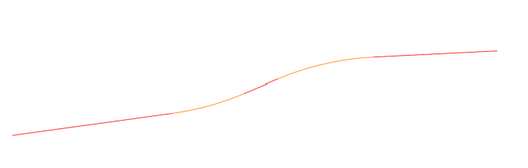

We will now combine each individual element (curves and tangents are their own elements) into one single complex element (an alignment).

1. From the Horizontal ribbon group, select the fly down next to the Complex Geometry Tool and select the Complex By Element Tool.
2. Select the three tangents and two curves in your alignment working from **left to right** (west to east). Once all are selected, right click (reset) to complete. Your elements will now all be combined into a single complex element.
3. Use the Element Selection Tool to select your newly created alignment. You should see labels for various features of your alignment. Please write the length of each of the tangents below.

Question 1:

1. Left Tangent Length = ___________ feet
2. Middle Tangent Length = ___________feet
3. Right Tangent Length = ___________feet

**Task 3: Exploring the Effects of Changing Tangent and Curve Geometry**

1. Now, make the following adjustments to your alignment and report the tangent lengths for each scenario in the box provided.

Scenario 1: Change the curve with ∆=15° to ∆=10°.

Question 2:

1. Left Tangent Length = ___________ feet
2. Middle Tangent Length = ___________feet
3. Right Tangent Length = ___________feet

Scenario 2: Maintain ∆=15° but increase the degree of curvature to 8 degrees for the left-most curve. Hint: Select the radius value and enter “d8:0”.

Question 3:

1. Left Tangent Length = ___________ feet
2. Middle Tangent Length = ___________feet
3. Right Tangent Length = ___________feet

Scenario 3: Rotate the middle tangent clockwise 3 degrees (starting with the original 15-degree and 20-degree angles of intersection). Use 5-degree curves for both curves.

*Hint: Due to the rules created when setting up the alignment, you cannot directly rotate the middle tangent (the angle of the tangent is shown in gray as its angle is dependent on other elements). Instead, you will need to rotate it by altering the values for angle of intersection (∆) for each curve.*

Question 4:

1. Left Tangent Length = ___________ feet
2. Middle Tangent Length = ___________feet
3. Right Tangent Length = ___________feet

Question 5:

Which scenario creates the most tangent length between the curves? _________________

**Task 4: Creating a Curve with a Precise Tangent Length**

The objective of this task is to determine the maximum radius for a curve on that leaves 125’ of tangent between the loading dock and the end of the curve.

1. Within the Lesson 2.dgn file, locate the top set of two red tangents and loading dock. The green line is used to display where the loading dock begins.
2. Using the **Arc** Tool, draw a 10-degree curve between the two tangents. Select to Trim/Extend both.
3. Using the complex geometry tool, select the two red tangents and 10-degree curve you created from right to left to combine them into a complex element (alignment). Do **not** include the green line.
4. Use the Element Selection Tool to select the alignment and view the distance between the end of the curve and the beginning of the loading dock (where the green line begins).
5. Test some other degrees of curvature by editing the radius value to see how the radius affects the tangent length.
6. Use trial and error to determine the largest radius (smallest degree of curvature) that can be used to still maintain the 125’ minimum distance.

**Helpful Tip:**

The degree of curvature/radius found in step 6 through iteration could also be found by using mathematical computations relying on tangent length formula $T=R*tan⁡(\frac{∆}{2})$, and measuring the angle of intersection between the two red tangent lines.

Question 6:

Which degree of curvature did you choose for step 6? _________________

**Task 5: Drawing a Spiral-Arc-Spiral Combination**

Some curves used on roads are spiraled, meaning they are no longer circular in shape but rather are a complex shape known as a “clothoid”. In this task, we will use the same tangents and loading dock used in the previous task to construct a spiraled curve approaching the loading dock.

1. Using the bottom set of red tangents/loading dock, create a spiraled curve by using the **Arc** Tool, **Arc Between Elements**, and then **Simple Arc Spiral**.
2. Enter a 10-degree curve with entry (back transition) and exit (ahead transition) spirals of 108.50’. Notice the curve body is shown in orange, while the transition (spirals) are shown in yellow.
3. Use the Complex Geometry Tool to create an alignment. Again, do not select the green line.
4. Use the Element Selection Tool to select the alignment and view the distance between the end of the spiral and the beginning of the loading dock (where the green line begins).

Question 7:

Which is the distance between the end of the spiral and loading dock? _________________

**Task 6: Submit Your Work**

1. Submit your answers to questions 1 through 7 along with your *Lesson2.dgn* file.