Instructions for Use of This Template
Read instructions thoroughly before proceeding
- Everything must be saved in the same folder to work properly.
- Complete eight Roadsoft exports outlined in the instructions document first. All Roadsoft files must be saved as described in the export instructions.
- Complete steps in the Excel workbook to create the graphs to fill this template.
- Complete autofill information from Excel into this template.
- Once information is transferred, edit/delete information from this template. DO NOT remove information prior to the transfer from Excel process.
Common checks that agencies need to do before finalizing the template
- Insert cover logo in the picture placeholder by selecting the image in the center of the placeholder. Change color bar by selecting it; then select the Format ribbon and a color from the Shape Fill options in the Shape Styles group. Change color of Cover and Heading 1 styles by selecting Home ribbon, the expansion arrow in the lower right of the style group, the drop-down arrow at the right end of the style’s name, and “Modify…” from the drop-down menu.
- Search for autofill contextual errors or missed auto-fills. You may scroll to each of these using F11 on your keyboard; alternatively, you can find them by searching for orange text or doing a Find for: <# .
- Remove all optional sections, which are placed in content controls. Instructions highlighted in blue precede or follow the content controls. Accept and modify suggested content by right-clicking anywhere in the control and selecting “Remove Control” from the drop-down menu; remove suggested content by selecting the handle in the upper left and striking the Delete key on your keyboard.
- Remove/address comments. Search for comments and verify comments are addressed.
- Update Table of Contents and Table of Figures. Create Table of Tables at end of document and cut/paste it in the current example location.
Updating in future years
- Complete the required Roadsoft exports as before and complete the steps in the excel document.
- An original template must be saved or requested from CTT with the link data.
- Once an original template is available then the transfer can be completed from Excel to the Word template.

<#AGENCY>
<#yearpublication> Pavement
Asset Management Plan

A plan describing the <#AGENCY>’s roadway assets and conditions

Prepared by:
Author
Author's title
Contact information

Contents
Table of Figures ii
Table of Tables v
Executive Summary vi
Introduction 8
Pavement Primer 9
1. Pavement Assets 19
Inventory 20
Goals 28
Modelled Trends 30
Planned Projects 37
Gap Analysis 42
2. Financial Resources 46
<#NETWORK1> Network 46
<#NETWORK2> Network 46
3. Risk of Failure Analysis 48
4. Coordination with Other Entities 50
Appendix A: <#YOUR CONTENT HERE> Paved <#NETWORK1> Road Planned Projects 52
Appendix B: <#YOUR CONTENT HERE> Paved <#NETWORK2> Road Planned Projects 53
Appendix C: <#YOUR CONTENT HERE> Unpaved Road Planned Projects 54
Appendix D: A Quick Check of Your Highway Network Health 55
Appendix E: Roadsoft Network-level Model Inputs and Outputs 61
Appendix F: Meeting Minutes Verifying Plan Acceptance by Governing Body 62

Table of Figures
Figure 1: PASER examples. 12
Figure 2: IBR examples. 13
Figure 3: Examples of reconstruction treatments 14
Figure 4: Examples of structural improvement treatments 15
Figure 5: Examples of capital preventive maintenance treatments 16
Figure 6: Examples of capital preventive maintenance treatments, cont’d 18
Figure 16: Map showing road assets and conditions 20
Figure 17: Percentage of <#NETWORK1> and <#NETWORK2> roads for the <#AGENCYSHORT>. 20
Figure 18: <#NETWORK1> and <#NETWORK2> roads by township for <#AGENCYSHORT>’s jurisdiction. 20
Figure 19: Miles of roads managed by <#AGENCYSHORT> that are part of the National Highway System and condition. 21
Figure 20: Pavement type 21
Figure 21: Pavement type by township. 21
Figure 22: Road network conditions by percentage of good, fair, or poor 22
Figure 23: Statewide road network conditions by percentage of good, fair, or poor, 22
Figure 24: <#AGENCYSHORT> paved <#NETWORK1> road network conditions.. 23
Figure 25: <#AGENCYSHORT> paved <#NETWORK2> network condition by PASER rating 23
Figure 26: Number of miles of paved road in each township divided into PASER categories. 23
Figure 27: Map of the current paved road condition. 24
Figure 28: Historical <#AGENCYSHORT> paved <#NETWORK1> road network condition trend 24
Figure 29: Historical statewide <#NETWORK1> road network condition trend 25
Figure 30: Historical <#AGENCYSHORT> paved <#NETWORK2> road network condition trend 25
Figure 31: Historical statewide paved <#NETWORK2> road network condition trend 25
Figure 32: <#AGENCYSHORT>’s unpaved road network condition by percentage. 26
Figure 33: Number of miles of unpaved road in each township divided in categories of roads with IBR numbers 26
Figure 34: Map of the current IBR for surface width. 26
Figure 35: Map of the current IBR for drainage adequacy. 27
Figure 36: Map of the current IBR structural adequacy good 28
Figure 37: <#AGENCYSHORT>’s <#YEAR> <#NETWORK1> road network condition by percentage of good/fair/poor 29
Figure 38: <#AGENCYSHORT> <#YEAR> paved <#NETWORK2> road network condition by percentage of good/fair/poor 29
Figure 39: <#AGENCYSHORT>’s <#YEAR> unpaved road network condition by percentage of good/fair/poor 29
Figure 40: Pavement condition forecast model in the software program Roadsoft. 34
Figure 41: Forecast good/fair/poor changes to <#AGENCYSHORT> network condition from planned projects on the <#NETWORK1> road network. 35
Figure 42: Pavement condition forecast model in the software program Roadsoft. 35
Figure 43: Forecast good/fair/poor changes to <#AGENCYSHORT> network condition from planned projects on the paved <#NETWORK2> road network. 36
Figure 44: Map showing paved <#NETWORK1> road projects planned for 2018. 38
Figure 45: Map showing paved <#NETWORK1> road projects planned for 2019. 38
Figure 46: Map showing paved <#NETWORK1> road projects planned for 2020. 39
Figure 47: Map showing paved <#NETWORK2> road projects planned for 2018. 40
Figure 48: Map showing paved <#NETWORK2> road projects planned for 2019. 40
Figure 49: Map showing paved <#NETWORK2> road projects planned for 2020. 41
Figure 50: Map showing unpaved road projects planned for 2018-2020. 42
Figure 51: Forecast good/fair/poor Changes to <#AGENCYSHORT> Network Condition from planned projects on the <#NETWORK2> paved road network. 44
Figure 54: Key transportation links in <#AGENCYSHORT>’s road network 49

Table of Tables

Table 1: Service Life Extension (in Years) for Pavement Types Gained by Fix Type¹ 34
Table 2: NCPP Quick Check Method for Paved <#NETWORK1> Road Network – <#NET1MILES> miles 35
Table 3: NCPP Quick Check Method for Paved <#NETWORK2> Road Network –<#NET2MILES> miles 36
Table 4: Roadsoft Annual Work Program for HMA Paved <#NETWORK1> Road Network Forecast 37
Table 5: Roadsoft Annual Work Program for HMA-paved <#NETWORK2> Road Network Forecast 39
Table 6: NCPP Quick Check Method for Paved <#NETWORK2> Road Network –<#NET2MILES> miles—Future Annual Planned Work & Additional Work Needed to Overcome Deficit 46
Table 7: Roadsoft Annual Work Program for HMA Paved <#NETWORK2> Road Network Forecast 46

Executive Summary
As conduits for commerce and connections to vital services, roads are among the most important assets in any community along with other assets like bridges, culverts, traffic signs, traffic signals, and utilities that support and affect roads. The <#AGENCY>’s (<#AGENCYSHORT>) roads, other transportation assets, and support systems are also some of the most valuable and extensive public assets, all of which are paid for with taxes collected from ordinary citizens and businesses. The cost of building and maintaining roads, their importance to society, and the investment made by taxpayers all place a high level of responsibility on local agencies to plan, build, and maintain the road network in an efficient and effective manner. This asset management plan is intended to report on how <#AGENCYSHORT> is meeting its obligations to maintain the public assets for which it is responsible.
This plan overviews <#AGENCYSHORT>’s road assets and condition, and explains how <#AGENCYSHORT> works to maintain and improve the overall condition of those assets. These explanations can help answer the following questions:
- What kinds of road assets <#AGENCYSHORT> has in its jurisdiction, who owns them, and the different options for maintaining these assets.
- What tools and processes <#AGENCYSHORT> uses to track and manage road assets and funds.
- What condition <#AGENCYSHORT>’s road assets are in compared to statewide averages.
- Why some road assets are in better condition than others and the path to maintaining and improving road asset conditions through proper planning and maintenance.
- How agency transportation assets are funded and where those funds come from.
- How funds are used and the costs incurred during <#AGENCYSHORT>’s road assets’ normal life cycle.
- What condition <#AGENCYSHORT> can expect its road assets if those assets continue to be funded at the current funding levels
- How changes in funding levels can affect the overall condition of all of <#AGENCYSHORT>’s road assets.
<#AGENCYSHORT> owns and/or manages <#MILES> <#MILETYPE> of roads. This road network can be divided into the <#NETWORK1> network, the <#NETWORK2> network, the unpaved road network, and the National Highway System (NHS) network based on the different factors these roads have that influence asset management decisions. A summary of <#AGENCYSHORT> historical and current network conditions, projected trends, and goals for <#NETWORK1> network and <#NETWORK2> network can be seen in Figure and Figure:

A summary of <#AGENCYSHORT> historical and current network conditions, projected trend and goal for the unpaved road network can be seen in Figure:

An asset management plan is required by Michigan Public Act 325 of 2018, and this document represents fulfillment of some of <#AGENCYSHORT>’s obligations towards meeting these requirements. This asset management plan also helps demonstrate <#AGENCYSHORT>’s responsible use of public funds by providing elected and appointed officials as well as the general public with inventory and condition information of <#AGENCYSHORT>’s road assets, and gives taxpayers the information they need to make informed decisions about investing in its essential transportation infrastructure.

Introduction
Asset management is defined by Public Act 325 of 2018 as “an ongoing process of maintaining, preserving, upgrading, and operating physical assets cost effectively, based on a continuous physical inventory and condition assessment and investment to achieve established performance goals”. In other words, asset management is a process that uses data to manage and track assets, like roads and bridges, in a cost-effective manner using a combination of engineering and business principles. This process is endorsed by leaders in municipal planning and transportation infrastructure, including the Michigan Municipal League, County Road Association of Michigan, the Michigan Department of Transportation (MDOT), and the Federal Highway Administration (FHWA). <#AGENCYSHORT> is supported in its use of asset management principles and processes by the Michigan Transportation Asset Management Council (TAMC), formed by the State of Michigan.
Asset management, in the context of this plan, ensures that public funds are spent as effectively as possible to maximize the condition of the road network. Asset management also provides a transparent decision-making process that allows the public to understand the technical and financial challenges of managing road infrastructure with a limited budget.
The <#AGENCY> (<#AGENCYSHORT>) has adopted an “asset management” business process to overcome the challenges presented by having limited financial, staffing, and other resources while needing to meet road users’ expectations. <#AGENCYSHORT> is responsible for maintaining and operating over <#MILES> <#MILETYPE> of roads.
This plan outlines how <#AGENCYSHORT> determines its strategy to maintain and upgrade road asset condition given agency goals, priorities of its road users, and resources provided. An updated plan is to be released approximately every <#FreqUpdates> years to reflect changes in road conditions, finances, and priorities.
Questions regarding the use or content of this plan should be directed to <#AMPcontactname> at <#AMPcontactaddress> or at <#AMPcontactphoneemail>.<#AMPwhere> Key terms used in this plan are defined in <#AGENCYSHORT>’s comprehensive transportation asset management plan (also known as the “compliance plan”) used for compliance with PA 325 or 2018.
Knowing the basic features of the asset classes themselves is a crucial starting point to understanding the rationale behind an asset management approach. The following primer provides an introduction to pavements.

Pavement Primer
Roads come in two basic forms—paved and unpaved. Paved roads have hard surfaces. These hard surfaces can be constructed from asphalt, concrete, composite (asphalt and concrete), sealcoat, and brick and block materials. On the other hand, unpaved roads have no hard surfaces. Examples of these surfaces are gravel and unimproved earth.
The decision to pave with a particular material as well as the decision to leave a road unpaved allows road-owning agencies to tailor a road to a particular purpose, environment, and budget. Thus, selecting a pavement type or leaving a road unpaved depends upon purpose, materials available, and budget. Each choice represents a trade-off between budget and costs for construction and maintenance.
Maintenance enables the road to fulfill its particular purpose. To achieve the maximum service for a pavement or an unpaved road, continual monitoring of a road’s pavement condition is essential for choosing the right time to apply the right fix in the right place.
Here is a brief overview of the different types of pavements, how condition is assessed, and treatment options that can lengthen a road’s service life.

Surfacing
Pavement type is influenced by several different factors, such as cost of construction, cost of maintenance, frequency of maintenance, and type of maintenance. These factors can have benefits affecting asset life and road user experience.

Paved Surfacing
Typical benefits and tradeoffs for hard surface types include:
- Concrete pavement: Concrete pavement, which is sometimes called a rigid pavement, is durable and lasts a long time when properly constructed and maintained. Concrete pavement can have longer service periods between maintenance activities, which can help reduce maintenance-related traffic disruptions. However, concrete pavements have a high initial cost and can be challenging to rehabilitate and maintain at the end of their service life. A typical concrete pavement design life will provide service for 30 years before major rehabilitation is necessary.
- Hot-mix asphalt pavement (HMA): HMA pavement, sometimes known as asphalt or flexible pavement, is currently less expensive to construct than concrete pavement (this is, in some part, due to the closer link between HMA material costs and oil prices that HMA pavements have in comparison with other pavement types). However, they require frequent maintenance activities to maximize their service life. A typical HMA pavement design life will provide service for 18 years before major rehabilitation is necessary. The vast majority of local-agency-owned pavements are HMA pavements.
- Composite pavements: Composite pavement is a combination of concrete and asphalt layers. Typically, composite pavements are old concrete pavements exhibiting ride-related issues that were overlaid by several inches of HMA in order to gain more service life from the pavement before it would need reconstruction. Converting a concrete pavement to a composite pavement is typically used as a “holding pattern” treatment to maintain the road in usable condition until reconstruction funds become available.
- Sealcoat pavement: Sealcoat pavement is a gravel road that have been sealed with a thin asphalt binder coating that has stone chips spread on top (not to be confused with a chip seal treatment over HMA pavement). This type of a pavement relies on the gravel layer to provide structure to support traffic, and the asphalt binder coating and stone chips shed water and eliminate the need for maintenance grading. Nonetheless, sealcoat pavement does require additional maintenance steps that asphalt and gravel do not require and does not last as long as HMA pavement, but it provides a low-cost alternative for lightly-trafficked areas and competes with asphalt for ride quality when properly constructed and maintained. Sealcoat pavement can provide service for ten or more years before the surface layer deteriorates and needs to be replaced.

Unpaved Surfacing
Typical benefits and tradeoffs for non-hard surfacing include:
- Gravel: Gravel is a low-cost, easy-to-maintain road surface made from layers of soil and aggregate (gravel). However, there are several potential drawbacks such as dust, mud, and ride smoothness when maintenance is delayed or traffic volume exceeds design expectations. Gravel roads require frequent low-cost maintenance activities. Gravel can be very cost effective for lower-volume, lower-speed roads. In the right conditions, a properly constructed and maintained gravel road can provide a service life comparable to an HMA pavement and can be significantly less expensive than the other pavement types.

Pavement Condition
Besides traffic congestion, pavement condition is what road users typically notice most about the quality of the roads that they regularly use—the better the pavement condition, the more satisfied users are with the service provided by the roadwork performed by road-owning agencies. Pavement condition is also a major factor in determining the most cost-effective treatment—that is, routine maintenance, capital preventive maintenance, or structural improvement—for a given section of pavement. As pavements age, they transition between “windows” of opportunity when a specific type of treatment can be applied to gain an increase in quality and extension of service life. Routine maintenance is day-to-day, regularly-scheduled, low-cost activity applied to “good” roads to prevent water or debris intrusion. Capital preventive maintenance (CPM) is a planned set of cost-effective treatments for “fair” roads that corrects pavement defects, slows further deterioration, and maintains the functional condition without increasing structural capacity. <#AGENCYSHORT> uses pavement condition and age to anticipate when a specific section of pavement will be a potential candidate for preventive maintenance. More detail on this topic is included in the Pavement Treatment section of this primer.
Pavement condition data is also important because it allows road owners to evaluate the benefits of preventive maintenance projects. This data helps road owners to identify the most cost-effective use of road construction and maintenance dollars. Further, historic pavement condition data can enable road owners to predict future road conditions based on budget constraints and to determine if a road network’s condition will improve, stay the same, or degrade at the current or planned investment level. This analysis can help determine how much additional funding is necessary to meet a network’s condition improvement goals.

Paved Road Condition Rating System
<#AGENCYSHORT> is committed to monitoring the condition of its road network and using pavement condition data to drive cost-effective decision-making and preservation of valuable road assets. <#AGENCYSHORT> uses the Pavement Surface Evaluation and Rating (PASER) system to assess its paved roads. PASER was developed by the University of Wisconsin Transportation Information Center to provide a simple, efficient, and consistent method for evaluating road condition through visual inspection. The widely-used PASER system has specific criteria for assessing asphalt, concrete, sealcoat, and brick and block pavements. Information regarding the PASER system and PASER manuals may be found on the TAMC website at: http://www.michigan.gov/tamc/0,7308,7-356-82158_82627---,00.html.
The TAMC has adopted the PASER system for measuring statewide pavement conditions in Michigan for asphalt, concrete, composite, sealcoat, and brick-and-block paved roads. Broad use of the PASER system means that data collected at <#AGENCYSHORT> is consistent with data collected statewide. PASER data is collected using trained inspectors in a slow-moving vehicle using GPS-enabled data collection software provided to road-owning agencies at no cost to them. The method does not require extensive training or specialized equipment, and data can be collected rapidly, which minimizes the expense for collecting and maintaining this data.
The PASER system rates surface condition using a 1-10 scale where 10 is a brand new road with no defects that can be treated with routine maintenance, 5 is a road with distresses but is structurally sound that can be treated with preventive maintenance, and 1 is a road with extensive surface and structural distresses that is in need of total reconstruction.
Roads with lower PASER scores generally require costlier treatments to restore their quality than roads with higher PASER scores. The cost effectiveness of treatments generally decreases the as the PASER number decreases. In other words, as a road deteriorates, it costs more dollars per mile to fix it, and the dollars spent are less efficient in increasing the road’s service life. Nationwide experience and asset management principles tell us that a road that has deteriorated to a PASER 4 or less will cost more to improve and the dollars spent are less efficient. Understanding this cost principle helps to draw meaning from the current PASER condition assessment.
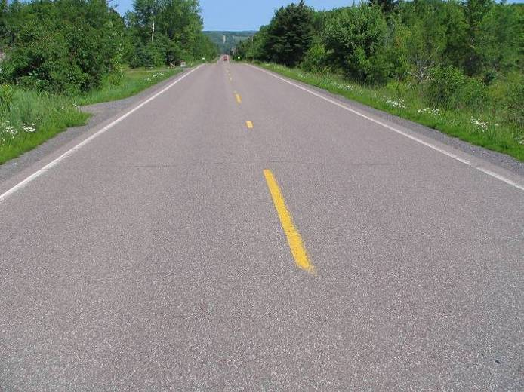
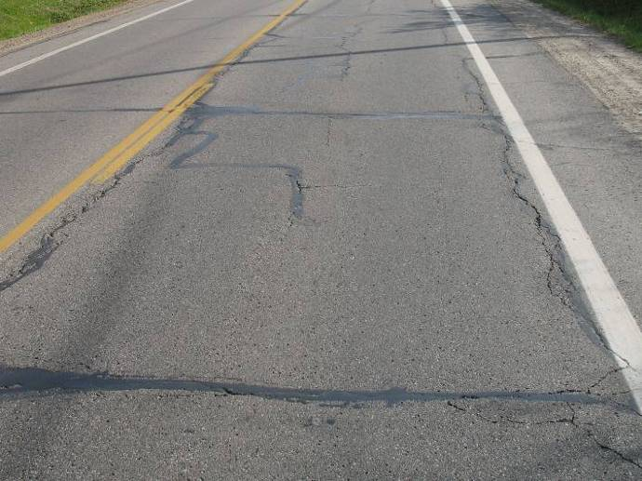
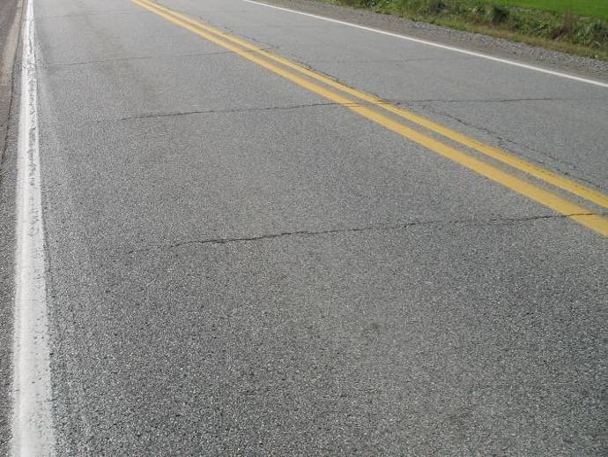
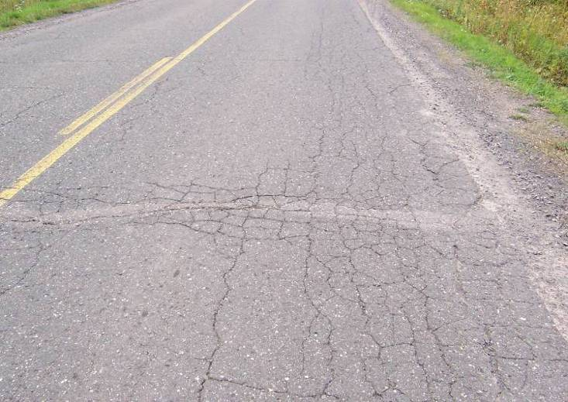
The TAMC has developed statewide definitions of road condition by creating three simplified condition categories—“good”, “fair”, and “poor”—that represent bin ranges of PASER scores having similar contexts with regard to maintenance and/or reconstruction. The definitions of these rating conditions are:
Figure 1: Top image, right– PASER 8 road that is considered “good” by the TAMC exhibit only minor defects. Second image, right– PASER 5 road that is considered “fair” by the TAMC. Exhibiting structural soundness but could benefit from CPM. Third image, right– PASER 6 road that is considered “fair” by the TAMC. Bottom image, right– PASER 2 road that is considered “poor” by the TAMC exhibiting significant structural distress.

- “Good” roads, according to the TAMC, have PASER scores of 8, 9, or 10. Roads in this category have very few, if any, defects and only require minimal maintenance; they may be kept in this category longer using PPM. These roads may include those that have been recently seal coated or newly constructed. Figure 1 illustrates an example of a road in this category.
- “Fair” roads, according to the TAMC, have PASER scores of 5, 6, or 7. Roads in this category still show good structural support, but their surface is starting to deteriorate. Figure 1 illustrates two road examples in this category. CPM can be cost effective for maintaining the road’s “fair” condition or even raising it to “good” condition before the structural integrity of the pavement has been severely impacted. CPM treatments can be likened to shingles on a roof of a house: while the shingles add no structural value, they protect the house from structural damage by maintaining the protective function of a roof covering.
- “Poor” roads, according to the TAMC, have PASER scores of 1, 2, 3, or 4. These roads exhibit evidence that the underlying structure is failing, such as alligator cracking and rutting. These roads must be rehabilitated with treatments like a heavy overlay, crush and shape, or total reconstruction. Figure 1 illustrates a road in this category.
The TAMC’s good, fair, and poor categories are based solely on the definitions, above. Therefore, caution should be exercised when comparing other condition assessments with these categories because other condition assessments may have “good”, “fair”, or “poor” designations similar to the TAMC condition categories but may not share the same definition. Often, other condition assessment systems define the “good”, “fair”, and “poor” categories differently, thus rendering the data of little use for cross-system comparison. The TAMC’s definitions provide a statewide standard for all of Michigan’s road-owning agencies to use for comparison purposes.
PASER data is collected 100 percent every two years on all federal-aid-eligible roads in Michigan. The TAMC dictates and funds the required training and the format for this collection, and it shares the data regionally and statewide. In addition, <#AGENCYSHORT> collects <#YOUR CONTENT HERE> percent of its paved non-federal-aid-eligible network using its own staff and resources.
Unpaved Road Condition Rating System (IBR System™)
Figure 2: Top– Road with IBR number of 1 road that has poor surface width, poor drainage adequacy, and poor structural adequacy. Middle– Road IBR number of 7 that has fair surface width, fair drainage adequacy, and fair structural adequacy. Bottom– Road with IBR number of 9 road that has good surface width, good drainage adequacy, and good structural adequacy.

The condition of unpaved roads can be rapidly changing, which makes it difficult to obtain a consistent surface condition rating over the course of weeks or even days. The PASER system works well on most paved roads, which have a relatively-stable surface condition over several months, but it is difficult to adapt to unpaved roads. To address the need for a reliable condition assessment system for unpaved roads, the TAMC adopted the Inventory Based Rating (IBR) System™, and <#AGENCYSHORT> also uses the IBR System™ for rating its unpaved roads. Information about the IBR System™ can be found at http://ctt.mtu.edu/inventory-based-rating-system.
The IBR System™ gathers reliable condition assessment data for unpaved road by evaluating three features—surface width, drainage adequacy, and structural adequacy—in comparison to a baseline, or generally considered “good”, road. These three assessments come together to generate an overall 1-10 IBR number. A high IBR number reflects a road with wide surface width, good drainage, and a well-designed and well-constructed base, whereas a low IBR number reflects a narrow road with no ditches and little gravel. A good, fair, or poor assessment of each feature is not an endorsement or indictment of a road’s suitability for use but simply provides context on how these road elements compare to a baseline condition.
Figure 2 illustrates the range over which features may be assessed. The top example in Figure 2 shows an unpaved road with a narrow surface width, little or no drainage, and very little gravel thickness. Using the IBR System™, these assessments would yield an IBR number of “1” for this road. The middle example in Figure 2 shows a road with fair surface width, fair drainage adequacy, and fair structural adequacy. These assessments would yield an IBR number of “7” for this road. The bottom example in Figure 2 shows a road with good surface width, good drainage adequacy, and good structural adequacy. These assessments would yield an IBR number of “9” for this road.
Unpaved roads are constructed and used differently throughout Michigan. A narrow, unpaved road with no ditches and very little gravel (low IBR number) may be perfectly acceptable in a short, terminal end of the road network, for example, on a road segment that ends at a lake or serves a limited number of unoccupied private properties. However, high-volume unpaved roads that serve agricultural or other industrial activities with heavy trucks and equipment will require wide surface width, good drainage, and a well-designed and well-constructed base structure (high IBR number). Where the unpaved road is and how it is used determines how the road must be constructed and maintained: just because a road has a low IBR number does not necessarily mean that it needs to be upgraded. The IBR number are not an endorsement or indictment of the road’s suitability for use but rather, an indication of a road’s capabilities to support different traffic volumes and types in all weather.

Pavement Treatments
Selection of repair treatments for roads aims to balance costs, benefits, and road life expectancy. All pavements are damaged by water, traffic weight, freeze/thaw cycles, and sunlight. Each of the following treatments and strategies—reconstruction, structural improvements, capital preventive maintenance, and others used by <#AGENCYSHORT>—counters at least one of these pavement-damaging forces.

Reconstruction
Pavement reconstruction treats failing or failed pavements by completely removing the old pavement and base and constructing an entirely new road (Figure 3). Every pavement has to eventually be reconstructed and it is usually done as a last resort after more cost-effective treatments are done, or if the road requires significant changes to road geometry, base, or buried utilities. Compared to the other treatments, which are all improvements of the existing road, reconstruction is the most extensive rehabilitation of the roadway and therefore, also the most expensive per mile and most disruptive to regular traffic patterns. Reconstructed pavement will subsequently require one or more of the previous maintenance treatments to maximize service life and performance. A reconstructed road lasts approximately 15 years and costs $250,000 per lane mile. The following descriptions outline the main reconstruction treatments used by <#AGENCYSHORT>.
Figure 3: Examples of reconstruction treatments—(left) reconstructing a road and (right) road prepared for full-depth repair.
Full-depth Concrete Repair
A full-depth concrete repair removes sections of damaged concrete pavement and replaces it with new concrete of the same dimensions (Figure 3). It is usually performed on isolated deteriorated joint locations or entire slabs that are much further deteriorated than adjacent slabs. The purpose is to restore the riding surface, delay water infiltration, restore load transfer from one slab to the next, and eliminate the need to perform costly temporary patching. This repair lasts approximately twelve years and typically costs $100,000 per mile.
Ditching (for Unpaved Roads)
Water needs to drain away from any roadway to delay softening of the pavement structure, and proper drainage is critical for unpaved roads where there is no hard surface on top to stop water infiltration into the road surface and base. To improve drainage, new ditches are dug or old ones are cleaned out. Unpaved roads typically need to be re-ditched every 15 years at a cost of $10,000 per mile.
Gravel Overlay (for Unpaved Roads)
Unpaved roads will exhibit gravel loss over time due to traffic, wind, and rain. Gravel on an unpaved road provides a wear surface and contributes to the structure of the entire road. Unpaved roads typically need to be overlaid with four inches of new gravel every 15 years at a cost of $25,000 per mile.

Structural Improvement
Roads requiring structural improvements exhibit alligator cracking and rutting and rated poor in the TAMC scale. Road rutting is evidence that the underlying structure is beginning to fail and it must be either rehabilitated with a structural treatment. Examples of structural improvement treatments include HMA overlay with or without milling, and crush and shape (Figure 4). The following descriptions outline the main structural improvement treatments used by <#AGENCYSHORT>.
Figure 4: Examples of structural improvement treatments—(from left) HMA overlay on an unmilled pavement, milling asphalt pavement, and pulverization of a road during a crush-and-shape project.
Hot-mix Asphalt (HMA) Overlay with/without Milling
An HMA overlay is a layer of new asphalt (liquid asphalt and stones) placed on an existing pavement (Figure 4). Depending on the overlay thickness, this treatment can add significant structural strength. This treatment also creates a new wearing surface for traffic and seals the pavement from water, debris, and sunlight damage. An HMA overlay lasts approximately five to ten years and costs $50,000 to $100,000 per lane mile. The top layer of severely damaged pavement can be removed by the milling, a technique that helps prevent structural problems from being quickly reflected up to the new surface. Milling is also done to keep roads at the same height of curb and gutter that is not being raised or reinstalled in the project. Milling adds $10,000 per lane mile to the HMA overlay cost.
Crush and Shape
During a crush and shape treatment, the existing pavement and base are pulverized and then the road surface is reshaped to correct imperfections in the road’s profile (Figure 4). An additional layer of gravel is often added along with a new wearing surface such as an HMA overlay or chip seal. Additional gravel and an HMA overlay give an increase in the pavements structural capacity. This treatment is usually done on rural roads with severe structural distress; Adding gravel and a wearing surface makes it more prohibitive for urban roads if the curb and gutter is not raised up. Crush and shape treatments last approximately 14 years and cost $150,000 per lane mile.

Capital Preventive Maintenance
Capital preventive maintenance (CPM) addresses pavement problems of fair-rated roads before the structural integrity of the pavement has been severely impacted. CPM is a planned set of cost-effective treatments applied to an existing roadway that slows further deterioration and that maintains or improves the functional condition of the system without significantly increasing the structural capacity. Examples of such treatments include crack seal, fog seal, chip seal, slurry seal, and microsurface (Figure 5). The purpose of the following CPM treatments is to protect the pavement structure, slow the rate of deterioration, and/or correct pavement surface deficiencies. The following descriptions outline the main CPM treatments used by <#AGENCYSHORT>.
Figure 5: Examples of capital preventive maintenance treatments—(from left) crack seal, fog seal, chip seal, and slurry seal/microsurface.

Crack Seal
Water that infiltrates the pavement surface softens the pavement structure and allows traffic loads to cause more damage to the pavement than in normal dry conditions. Crack sealing helps prevent water infiltration by sealing cracks in the pavement with asphalt sealant (Figure 5). <#AGENCYSHORT> seals pavement cracks early in the life of the pavement to keep it functioning as strong as it can and for as long as it can. Crack sealing lasts approximately two years and costs $4,000 per lane mile. Even though it does not last very long compared to other treatments, it does not cost very much compared to other treatments. This makes it a very cost effective treatment when <#AGENCYSHORT> looks at what crack filling costs per year of the treatment’s life.
Fog Seal
Fog sealing sprays a liquid asphalt coating onto the entire pavement surface to fill hairline cracks and prevent damage from sunlight (Figure 5). Fog seals are best for good to very good pavements and last approximately two years at a cost of $1,000 per lane mile.
Chip Seal
A chip seal, also known as a sealcoat, is a two-part treatment that starts with liquid asphalt sprayed onto the old pavement surface followed by a single layer of small stone chips spread onto the wet liquid asphalt layer (Figure 5). The liquid asphalt seals the pavement from water and debris and holds the stone chips in place, providing a new wearing surface for traffic that can correct friction problems and helping to prevent further surface deterioration. Chip seals are best applied to pavements that are not exhibiting problems with strength, and their purpose is to help preserve that strength. These treatments last approximately five years and cost $12,000 per lane mile.
Slurry Seal/Microsurface
A slurry seal or microsurface’s purpose is to protect existing pavement from being damaged by water and sunlight. The primary ingredients are liquid asphalt (slurry seal) or modified liquid asphalt (microsurface), small stones, water and portland cement applied in a very thin (less than a half an inch) layer (Figure 5). The main difference between a slurry seal and a microsurface is the modified liquid asphalt used in microsurfacing provides different curing and durability properties, which allows microsurfacing to be used for filling pavement ruts. Since the application is very thin, these treatments do not add any strength to the pavement and only serves to protect the pavement’s existing strength by sealing the pavement from sunlight and water damage. These treatments work best when applied before cracks are too wide and too numerous. A slurry seal treatment lasts approximately four years and costs $20,000 per lane mile, while a microsurface treatment tends to last for seven years and costs $25,000 per lane mile.
Partial-Depth Concrete Repair
A partial-depth concrete repair involves removing spalled (i.e., fragmented) or delaminated (i.e., separated into layers) areas of concrete pavement, usually near joints and cracks and replacing with new concrete (Figure 6). This is done to provide a new wearing surface in isolated areas, to slow down water infiltration, and to help delay further freeze/thaw damage. This repair lasts approximately five years and typically costs $20,000 per mile.
Maintenance Grading (for Unpaved Roads)
Maintenance grading involves regrading an unpaved road to remove isolated potholes, washboarding, and ruts then restoring the compacted crust layer (Figure 6). Crust on an unpaved road is a very tightly compacted surface that sheds water with ease but takes time to be created, so destroying a crusted surface with maintenance grading requires a plan to restore the crust. Maintenance grading often needs to be performed three to five times per year and each grading costs $300 per mile.
Dust Control (for Unpaved Roads)
Dust control typically involves spraying chloride or other chemicals on a gravel surface to reduce dust loss, aggregate loss, and maintenance (Figure 6). This is a relatively short-term fix that helps create a crusted surface. Chlorides work by attracting moisture from the air and existing gravel. This fix is not effective if the surface is too dry or heavy rain is imminent, so timing is very important. Dust control is done two to four times per year and each application costs $700 per mile.
Figure 6: Examples of capital preventive maintenance treatments, cont’d—(left) concrete road prepared for partial-depth repair and (right) gravel road undergoing maintenance grading.

Innovative Treatments
<#YOUR CONTENT HERE> Innovative treatments are those newer, unique, non-standard treatments that provide ways of treating pavements using established engineering principles in new and cost-effective ways. <#AGENCYSHORT> strives to be innovative with its pavement treatments by looking for ways to prevent pavement damage and save taxpayer dollars.
Innovative Treatment
<#YOUR CONTENT HERE>
Innovative Treatment
<#YOUR CONTENT HERE>

Maintenance
Maintenance is the most cost-effective strategy for managing road infrastructure and prevents good and fair roads from reaching the poor category, which require costly rehabilitation and reconstruction treatments to create a year of service life. It is most effective to spend money on routine maintenance and CPM treatments, first; then, when all maintenance project candidates are treated, reconstruction and rehabilitation can be performed as money is available. This strategy is called a “mix-of-fixes” approach to managing pavements.

1. Pavement Assets
Building a mile of new road can cost over $1 million due to the large volume of materials and equipment that are necessary. The high cost of constructing road assets underlines the critical nature of properly managing and maintaining the investments made in this vital infrastructure. The specific needs of every mile of road within an agency’s overall road network is a complex assessment, especially when considering rapidly changing conditions and the varying requisites of road users; understanding each road-mile’s needs is an essential duty of the road-owning agency.
In Michigan, many different governmental units (or agencies) own and maintain roads, so it can be difficult for the public to understand who is responsible for items such as planning and funding construction projects, [patching] repairs, traffic control, safety, and winter maintenance for any given road. MDOT is responsible for state trunkline roads, which are typically named with “M”, “I”, or “US” designations regardless of their geographic location in Michigan. Cities and villages are typically responsible for all public roads within their geographic boundary with the exception of the previously mentioned state trunkline roads managed by MDOT. County road commissions (or departments) are typically responsible for all public roads within the county’s geographic boundary, with the exception of those managed by cities, villages, and MDOT.
In cases where non-trunkline roads fall along jurisdictional borders, local and intergovernmental agreements dictate ownership and maintenance responsibility. Quite frequently, roads owned by one agency may be maintained by another agency because of geographic features that make it more cost effective for a neighboring agency to maintain the road instead of the actual road owner. Other times, road-owning agencies may mutually agree to coordinate maintenance activities in order to create economies of scale and take advantage of those efficiencies.
The <#AGENCYSHORT> is responsible for a total of <#MILES> <#MILETYPE> of public roads, as shown in Figure 16.

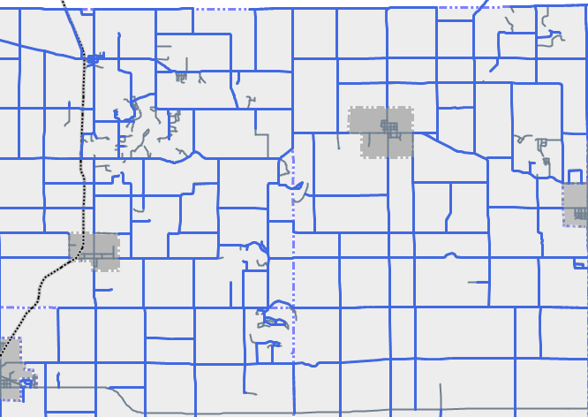
Figure 16: Map showing location of <#AGENCYSHORT>’s paved roads (i.e., those managed by <#AGENCYSHORT>) and their current condition for paved roads with green for good (i.e., PASER 10, 9, 8), yellow for fair (i.e., PASER 7, 6, 5), and red for poor (i.e., PASER 4, 3, 2, 1), as well as the location of <#AGENCYSHORT>’s unpaved roads in blue

Inventory
Michigan Public Act 51 of 1951 (PA 51), which defines how funds from the Michigan Transportation Fund (MTF) are distributed to and spent by road-owning agencies, classifies roads owned by <#AGENCYSHORT> as either <#NETWORK1> or <#NETWORK2> roads. State statute prioritizes expenditures on the <#NETWORK1> road netowrk.
Of the <#MILES> <#MILETYPE> of public roads owned and/or managed by <#AGENCYSHORT>, <#ROADCLASS1> <#ROADCLASS2> <#ROADCLASS3>.
Figure 17 illustrates the percentage of roads owned by <#AGENCYSHORT> that are classified as <#NETWORK1> and <#NETWORK2> roads. Figure 18 illustrates this breakdown of these road networks by township boundary within <#AGENCYSHORT>’s jurisdiction.

Figure 17: Percentage of <#NETWORK1> and <#NETWORK2> roads for <#AGENCYSHORT>.

Figure 18: <#NETWORK1> and <#NETWORK2> roads by township for <#AGENCYSHORT>’s jurisdiction.
<#AGENCYSHORT> manages <#NET3MILES> miles of roads that are part of the National Highway System (NHS)—in other words, those roads that are critical to the nation’s economy, defense, and mobility—and monitors and maintains their condition. The NHS is subject to special rules and regulations and has its own performance metrics dictated by the FHWA. While most NHS roads in Michigan are managed by MDOT, <#AGENCYSHORT> manages a percentage of those roads located in its jurisdiction, as shown in Figure 19.

Figure 19: Miles of roads managed by <#AGENCYSHORT> that are part of the National Highway System and condition.
<#AGENCYSHORT> also owns and manages <#NET4MILES> miles of unpaved roads.

Types
<#AGENCYSHORT> has multiple types of pavements in its jurisdiction, including: <#pavementtypes>. Factors influencing pavement type include cost of construction, cost of maintenance, frequency of maintenance, type of maintenance, asset life, and road user experience. More information on pavement types is available in the Introduction’s Pavement Primer.
Figure 20 illustrates the percentage of various pavement types that <#AGENCYSHORT> has in its network. Figure 21 shows the pavement type by Township boundary for <#AGENCYSHORT>’s jurisdiction.

Figure 20: Pavement type by percentage maintained by <#AGENCYSHORT> Undefined pavements have not been inventoried in <#AGENCYSHORT>’s asset management system to date, but will be included as data becomes available.

Figure 21: Pavement type by township within <#AGENCYSHORT>’s jurisdiction. Undefined pavements have not been inventoried in <#AGENCYSHORT>’s asset management system to date, but will be included as data becomes available.

Locations
Locations and sizes of each asset can be found in <#AGENCYSHORT>’s Roadsoft database. For more detail, please refer to the agency contact listed in the Introduction of this pavement asset management plan.

Condition
The road characteristic that road users most readily notice is pavement condition. Pavement condition is a major factor in determining the most cost-effective treatment—that is, routine maintenance, capital preventive maintenance, or structural improvement—for a given section of pavement. <#AGENCYSHORT> uses pavement condition and age to anticipate when a specific section of pavement will be a potential candidate for preventive maintenance. Pavement condition data enables <#AGENCYSHORT> to evaluate the benefits of preventive maintenance projects and to identify the most cost-effective use of road construction and maintenance dollars. Historic pavement condition data can be used to predict future road conditions based on budget constraints and to determine if a road network’s condition will improve, stay the same, or degrade at the current or planned investment level. This analysis helps to determine how much additional funding is necessary to meet a network’s condition improvement goals. More detail on this topic is included in the Introduction’s Pavement Primer.

Paved Roads
<#AGENCYSHORT> is committed to monitoring the condition of its road network and using pavement condition data to drive cost-effective decision-making and preservation of valuable road assets. <#AGENCYSHORT> uses the Pavement Surface Evaluation and Rating (PASER) system, which has been adopted by the TAMC for measuring statewide pavement conditions, to assess its paved roads. The PASER system provides a simple, efficient, and consistent method for evaluating road condition through visual inspection. More information regarding the PASER system can be found in the Introduction’s Pavement Primer.
<#AGENCYSHORT> collects 100 percent of its PASER data every two years on all federal-aid-eligible roads in Michigan. In addition, <#AGENCYSHORT> collects <#YOUR CONTENT HERE> percent of its paved non-federal-aid-eligible network using its own staff and resources.
<#AGENCYSHORT>’s <#YEAR> paved <#NETWORK1> road network has <#pctnet1good> percent of roads in the TAMC good condition category, <#pctnet1fair> percent in fair, and <#pctnet1poor> percent in poor (Figure 22A). The paved <#NETWORK2> road network has <#pctnet2good> percent in good, <#pctnet2fair> percent in fair, and <#pctnet2poor> percent in poor (Figure 22B).

Figure 22: (A) Left: <#AGENCYSHORT> paved <#NETWORK1> road network conditions by percentage of good, fair, or poor, and (B) Right: paved <#NETWORK2> road network conditions by percentage of good, fair, or poor
In comparison, the statewide paved <#NETWORK1> road network has <#statepctnet1good> percent of roads in the TAMC good condition category, <#statepctnet1fair> percent in fair, and <#statepctnet1poor> percent in poor (Figure 23A). The statewide paved <#NETWORK2> road network has <#statepctnet2good> percent in good, <#statepctnet2fair> percent in fair, and <#statepctnet2poor> percent in poor (Figure 23B). Comparing Figure 22A and Figure 23A shows that <#AGENCYSHORT>’s paved <#NETWORK1> road network is <#YOUR CONTENT HERE>Choose an item. than similarly-classified roads in the rest of the state, while Figure 22B and Figure 23B show that <#AGENCYSHORT>’s paved <#NETWORK2> road network is <#YOUR CONTENT HERE>Choose an item. than similarly-classified roads in the rest of the state. Other road condition graphs can be viewed on the TAMC pavement condition dashboard at: http://www.mcgi.state.mi.us/mitrp/Data/PaserDashboard.aspx.

Figure 23: (A) Left: Statewide paved <#NETWORK1> road network conditions by percentage of good, fair, or poor, and (B) Right: paved <#NETWORK2> road network conditions by percentage of good, fair, or poor
<#YOUR CONTENT HERE>
Figure 24 and Figure 25 show the number of miles for <#AGENCYSHORT>’s roads with PASER scores expressed in TAMC definition categories for the paved <#NETWORK1> road network (Figure 24) and the paved <#NETWORK2> road network (Figure 25). <#AGENCYSHORT> considers road miles on the transition line between good and fair (PASER 8) and the transition line between fair and poor (PASER 5) as representing parts of the road network where there is a risk of losing the opportunity to apply less expensive treatments that gain significant improvements in service life.

Figure 24: <#AGENCYSHORT> paved <#NETWORK1> road network conditions. Bar graph colors correspond to good/fair/poor TAMC designations.

Figure 25: <#AGENCYSHORT> paved <#NETWORK2> network condition by PASER rating. Bar graph colors correspond to good/fair/poor TAMC designations.

Figure 26 illustrates <#AGENCYSHORT>’s entire paved road network divided by township into the TAMC good/fair/poor designations.
Figure 27 provides a map illustrating the geographic location of paved roads and their respective PASER condition. An online version of the most recent PASER data is located at https://www.mcgi.state.mi.us/tamcMap/.

Figure 26: Number of miles of paved road in each township divided in categories of good (PASER 10, 9, 8), fair (PASER 7, 6, 5), and poor (PASER 4, 3, 2, 1).
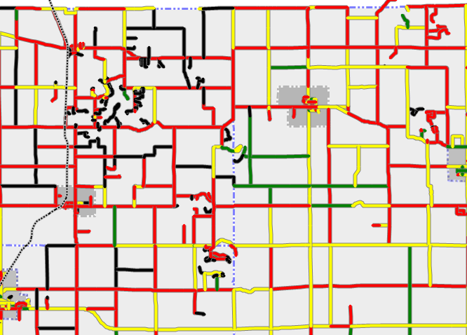
Figure 27: Map of the current paved road condition in good (PASER 10, 9, 8) shown in green, fair (PASER 7, 6, 5) shown in yellow, and poor (PASER 4, 3, 2, 1) shown in red. Only Roads owned by <#AGENCYSHORT> are shown.
<#YOUR CONTENT HERE>
Historically, the overall quality of <#AGENCYSHORT>’s paved <#NETWORK1> roads have been <#YOUR CONTENT HERE>Choose an item., as can be observed in Figure 28. <#YOUR CONTENT HERE>
Comparing <#AGENCYSHORT>’s paved <#NETWORK1> road condition trends illustrated in Figure 28 with overall statewide condition trends for similarly-classified roads, which are illustrated in Figure 29, shows a <#YOUR CONTENT HERE>Choose an item. trend locally as in the rest of the state.
<#YOUR CONTENT HERE>

Figure 28: Historical <#AGENCYSHORT> paved <#NETWORK1> road network condition trend

Figure 29: Historical statewide <#NETWORK1> road network condition trend
Historically, the overall quality of <#AGENCYSHORT>’s paved <#NETWORK2> roads have been <#YOUR CONTENT HERE>Choose an item. than the paved
<#NETWORK1> road network because they lack a source of state and federal funding and therefore must be supported locally. Figure 30 illustrates the condition of the paved <#NETWORK2> road network in <#AGENCYSHORT> while Figure 31 illustrates these conditions statewide.
Comparing <#AGENCYSHORT>’s paved <#NETWORK2> road condition trends illustrated in Figure 30 with overall statewide condition trends for all paved <#NETWORK2> roads illustrated in Figure 31 indicates a <#YOUR CONTENT HERE>Choose an item. trend locally as in the rest of the state. <#YOUR CONTENT HERE> The year-to-year variation in the paved <#NETWORK2> road network is likely due to the fact that only a portion of the network is collected each year, both locally and statewide. This variation is likely a result of reporting bias since a representative sample of roads is not collected each year.

Figure 30: Historical <#AGENCYSHORT> paved <#NETWORK2> road network condition trend

Figure 31: Historical statewide paved <#NETWORK2> road network condition trend

Unpaved Roads
The condition of unpaved roads can be rapidly changing, which makes it difficult to obtain a consistent surface condition rating over the course of weeks or even days. The TAMC adopted the Inventory Based Rating (IBR) System™ for rating unpaved roads, and <#AGENCYSHORT> uses the IBR System™ for rating its unpaved roads. More information regarding the IBR System™ can be found in Introduction’s Pavement Primer.
<#YOUR CONTENT HERE>
Figure 32 shows the percentage of unpaved roads in each IBR number ranges of 10, 9, and 8; 7, 6, and 5; and 4, 3, 2, and 1, for all roads. Figure 33 illustrates the miles of unpaved roads in IBR number ranges of 10, 9, and 8; 7, 6, and 5; and 4, 3, 2, and 1, for each township.

Figure 32: <#AGENCYSHORT>’s unpaved road network condition by percentage of roads with IBR numbers of 10, 9, and 8; roads with IBR numbers of 7, 6, and 5; and IBR numbers of 4, 3, 2, and 1.

Figure 33: Number of miles of unpaved road in each township divided in categories of roads with IBR numbers of 10, 9, and 8; IBR numbers of 7, 6, and 5; and IBR numbers of 4, 3, 2, and 1.
Figure 35, Figure 36, and Figure 52 are maps illustrating the geographic location of unpaved roads and the assessment of the IBR elements, respectively: surface width, drainage adequecy, and structural adequecy.
Figure 34: Map of the current IBR for surface width with good (22’ and greater) shown in green, fair (16’ to 21’) shown in orange, and poor (15’ or less) shown in red. Only unpaved roads owned by <#AGENCYSHORT> are shown.
Figure 35: Map of the current IBR for drainage adequacy with good (2’ or more) shown in green, fair (0.5’ to less than 2’) shown in orange, and poor (less than 0.5’) shown in red. Only unpaved roads owned by <#AGENCYSHORT> are shown.
Figure 36: Map of the current IBR structural adequacy good (greater than 7”) shown in green, fair (4” to 7”) shown in orange, and poor (less than 4”) shown in red. Only unpaved roads owned by <#AGENCYSHORT> are shown.
<#YOUR CONTENT HERE>

Goals
Goals help set expectations to how pavement conditions will change in the future. Pavement condition changes are influenced by water infiltration, soil conditions, sunlight exposure, traffic loading, and repair work performed. <#AGENCYSHORT> is not able to control any of these factors fully due to seasonal weather changes, traffic pattern changes, and its limited budget. In spite of the uncontrollable variables, it is still important to set realistic network condition goals that efficiently use budget resources to build and maintain roads meeting taxpayer expectations. An assessment of the progress toward these goals is provided in the 1. Pavement Assets: Gap Analysis section of this plan.

Goals for Paved <#NETWORK1> Roads

The overall goal for <#AGENCYSHORT>’s paved <#NETWORK1> road network is to maintain or improve road conditions network-wide at <#YEAR> levels. The baseline condition for this goal is illustrated in Figure 37.

Figure 37: <#AGENCYSHORT>’s <#YEAR> <#NETWORK1> road network condition by percentage of good/fair/poor
<#AGENCYSHORT>’s network-level pavement condition strategy for paved <#NETWORK1> roads is:
- Prevent its good and fair (PASER 10 - 5) paved <#NETWORK1> from becoming poor (PASER 4 - 1).
- Move <#YOUR CONTENT HERE> percent of paved <#NETWORK1> roads out of the poor category.

Goals for Paved <#NETWORK2> Roads

The overall goal for <#AGENCYSHORT>’s paved <#NETWORK2> road network is to maintain or improve road conditions network-wide at <#YEAR> levels. The baseline condition for this goal is illustrated in Figure 38.

Figure 38: <#AGENCYSHORT> <#YEAR> paved <#NETWORK2> road network condition by percentage of good/fair/poor
<#AGENCYSHORT>’s network-level pavement condition strategy for paved <#NETWORK2> roads is:
- Prevent its good and fair (PASER 10 - 5) paved <#NETWORK2> roads from becoming poor (PASER 4 - 1).
- Move <#YOUR CONTENT HERE> percent of paved <#NETWORK2> roads out of the poor category.

Goals for Unpaved Roads

The overall goal for <#AGENCYSHORT>’s unpaved road network is to maintain or improve road conditions network-wide at <#YEAR> levels. The baseline condition for this goal is illustrated in Figure 39.

Figure 39: <#AGENCYSHORT>’s <#YEAR> unpaved road network condition by percentage of good/fair/poor
Our year-round unpaved roads will be maintained at their current structural adequacy assessments and current drainage adequacy assessments for roads where these two IBR elements are assessed as good or fair. Currently, <#YOUR CONTENT HERE> percent of <#AGENCYSHORT>’s year-round unpaved roads have good or fair structural adequacy and <#YOUR CONTENT HERE> percent have good or fair drainage adequacy. Year-round unpaved roads that have either or both of these two categories assessed as poor will be strategically upgraded as funding is available to address, first, drainage issues and, then, structural issues. Surface widths will be addressed on an as-needed basis to provide service or to address safety issues. Seasonal roads will be addressed to provide passability and safety but do not have a goal associated with them.

Modelled Trends
Roads age and deteriorate just like any other asset. All pavements are damaged by water, traffic weight, freeze/thaw cycles, sunlight, and traffic weight. To offset natural deterioration and normal wear-and-tear on the road, <#AGENCYSHORT> must complete treatment projects that either protect and/or add life to its pavements. The year-end condition of the whole network depends upon changes or preservation of individual road section condition that preservation treatments have affected.
<#AGENCYSHORT> uses many types of repair treatments for its roads, each selected to balance costs, benefits, and road life expectancy. When agency trends are modelled, any gap between goals and accomplishable work becomes evident. Financial resources influence how much work can be accomplished across the network within agency budget and what treatments and strategies can be afforded; a full discussion of <#AGENCYSHORT>’s financial resources can be found in the 5. Financial Resources section.
Treatments and strategies that counter pavement-damaging forces include reconstruction, structural improvement, capital preventive maintenance, innovative treatments, and maintenance. For a complete discussion on the pavement treatment tools, refer to the 1. Introduction’s Pavement Primer.
Correlating with each PASER score are specific types of treatments best performed either to protect the pavement (CPM) or to add strength back into the pavement (structural improvement) (Table 1). MDOT provides guidance regarding when a specific pavement may be a candidate for a particular treatment. These identified PASER scores “trigger” the timing of projects appropriately to direct the right pavement fix at the right time, thereby providing the best chance for a successful project. The information provided in Table 1 is a guide for identifying potential projects; however, this table should not be the sole criteria for pavement treatment selection. Other information such as future development, traffic volume, utility projects, and budget play a role in project selection. This table should not be a substitute for engineering judgement. <#YOUR CONTENT HERE>

Table 1: Service Life Extension (in Years) for Pavement Types Gained by Fix Type1
 | Life Extension (in years)*
Fix Type | Flexible | Composite | Rigid | PASER
HMA crack treatment | 1-3 | 1-3 | N/A | 6-7
Overband crack filling | 1-2 | 1-2 | N/A | 6-7
One course non-structural HMA overlay | 5-7 | 4-7 | N/A | 4-5****
Mill and one course non-structural HMA overlay | 5-7 | 4-7 | N/A | 3-5
Single course chip seal | 3-6 | N/A | N/A | 5-7†
Double chip seal | 4-7 | 3-6 | N/A | 5-7†
Single course microsurface | 3-5 | ** | N/A | 5-6
Multiple course microsurface | 4-6 | ** | N/A | 4-6****
Ultra-thin HMA overlay | 3-6 | 3-6 | N/A | 4-6****
Paver placed surface seal | 4-6 | ** | N/A | 5-7
Full-depth concrete repair | N/A | N/A | 3-10 | 4-5***
Concrete joint resealing | N/A | N/A | 1-3 | 5-8
Concrete spall repair | N/A | N/A | 1-3 | 5-7
Concrete crack sealing | N/A | N/A | 1-3 | 4-7
Diamond grinding | N/A | N/A | 3-5 | 4-6
Dowel bar retrofit | N/A | N/A | 2-3 | 3-5***
Longitudinal HMA wedge/scratch coat with surface treatment | 3-7 | N/A | N/A | 3-5****
Flexible patching | ** | ** | N/A | N/A
Mastic joint repair | 1-3 | 1-3 | N/A | 4-7
Cape seal | 4-7 | 4-7 | N/A | 4-7
Flexible interlayer “A” | 4-7 | 4-7 | N/A | 4-7
Flexible interlayer “B” (SAMI) | 4-7 | 4-7 | N/A | 3-7
Flexible interlayer “C” | 4-7 | 4-7 | N/A | 3-7
Fiber reinforced flexible membrane | 4-7 | 4-7 | N/A | 3-7
Fog seal | ** | ** | N/A | 7-10
GSB 88 | ** | ** | N/A | 7-10
Mastic surface treatment | ** | ** | N/A | 7-10
Scrub seal | ** | ** | N/A | 4-8
* The time range is the expected life extending benefit given to the pavement, not the anticipated longevity of the treatment.
** Data is not available to quantify the life extension.
*** The concrete slabs must be in fair to good condition.
**** Can be used on a pavement with a PASER equal to 3 when the sole reason for rating is rutting or severe raveling of the surface asphalt layer.
† For PASER 4 or less providing structural soundness exists and that additional pre-treatment will be required for example, wedging, bar seals, spot double chip seals, injection spray patching or other pre-treatments.
¹ Part of Appendix D-1 from MDOT Local Agency Programs Guidelines for Geometrics on Local Agency Projects 2017 Edition Approved Preventive Maintenance Treatments

NCPP Network Quick Check to Forecast Future Trends
The National Center for Pavement Preservation (NCPP) has developed an analysis method that gives an overall indicator of likely future road network condition trends. An example of this method along with a description is included as Appendix D.
The NCPP Quick Check works under the premise that a one-mile road segment loses one year of life each year that it is not treated with a maintenance, rehabilitation, or reconstruction project. For example, a 100-mile network loses 100 mile-years’ worth of life each year that it is not treated. Construction and maintenance projects add life to a road network, offsetting the steady yearly loss. For example, an overlay project that is expected to last 10 years and constructed on 5 miles of pavement will add 10-years x 5 miles = 50 mile-years of improvement, which is about half the value lost in one year on the example 100-mile network. In order for the network to remain stable, an agency would need to complete projects every year that offset all of the mile-years of loss, for this example 100 mile-years.

Paved <#NETWORK1> Roads
Table 2 illustrates the calculations for the NCPP Quick Check method of <#AGENCYSHORT>’s paved <#NETWORK1> road network. The treatments outlined in Table 2 are the average treatment volume of planned projects scheduled to be completed in <#YOUR CONTENT HERE>. The 1. Pavement Assets: Planned Projects section of this plan provides further detail. Results from the NCPP Quick Check for the paved <#NETWORK1> roads indicate the average volume of work that <#AGENCYSHORT> has been able to afford over the last five years <#YOUR CONTENT HERE>Choose an item. keeping up with the natural deterioration of the road network due to age and use. Continuing the current treatment volume on this network will result in an ongoing <#YOUR CONTENT HERE>Choose an item. of <#YOUR CONTENT HERE> mile-years of project benefit to stabilize this trend and maintain current conditions.
Table 2: <#Modelled Trends, Planned Projects, and Gap Analysis for Road Assets>—Modelled Trends: NCPP Quick Check Method for Paved <#NETWORK1> Road Network (<#NET1MILES> miles)
Treatment Name | Average Yearly Miles of Treatment | Years of Life | Mile - Years
Crack Seal | <##> | <##> | <##>
Chip Seal | <##> | <##> | <##>
Overlay | <##> | <##> | <##>
Reconstruction | <##> | <##> | <##>
Total |  |  | <##>
(Deficit)/Surplus |  |  | <##>

The NCPP analysis of <#AGENCYSHORT>’s planned projects from its currently-available budget <#YOUR CONTENT HERE>Choose an item. allow <#AGENCYSHORT> to reach its pavement condition goal given the projects planned for the next three years. <#YOUR CONTENT HERE>

Paved <#NETWORK2> Road
Table 3 illustrates the calculations for the NCPP Quick Check method of <#AGENCYSHORT>’s paved <#NETWORK2> road network. The treatments outlined in Table 3 are the average treatment volume of planned projects scheduled to be completed in <#YOUR CONTENT HERE>. The 1. Pavement Assets: Planned Projects section of this plan provides further detail. Results from the NCPP Quick Check for the paved <#NETWORK2> roads indicate the average volume of work that <#AGENCYSHORT> has been able to afford over the last five years <#YOUR CONTENT HERE>Choose an item. keeping up with the natural deterioration of the road network due to age and use. Continuing the current treatment volume on this network will result in an ongoing <#YOUR CONTENT HERE>Choose an item. of <#YOUR CONTENT HERE> mile-years of project benefit to stabilize this trend and maintain current conditions.
Table 3: <#Modelled Trends, Planned Projects, and Gap Analysis for Road Assets>—Modelled Trends: NCPP Quick Check Method for Paved <#NETWORK2> Road Network (<#NET2MILES> miles)
Treatment Name | Average Yearly Miles of Treatment | Years of Life | Mile - Years
Crack Seal | <##> | <##> | <##>
Chip Seal | <##> | <##> | <##>
Overlay | <##> | <##> | <##>
Reconstruction | <##> | <##> | <##>
Total |  |  | <##>
(Deficit)/Surplus |  |  | <##>

The NCPP analysis of <#AGENCYSHORT>’s planned projects from its currently available budget <#YOUR CONTENT HERE>Choose an item. allow <#AGENCYSHORT> to reach its pavement condition goals given the projects planned for the next three years. <#YOUR CONTENT HERE>

Roadsoft Pavement Condition Forecast to Forecast Future Trends
<#AGENCYSHORT> uses Roadsoft, an asset management software suite, to manage road- and bridge-related infrastructure. Roadsoft is developed by Michigan Technological University and is available for Michigan local agencies at no cost to them. Roadsoft uses pavement condition data to drive network-level deterioration models that forecast future road conditions based on planned construction and maintenance work. A screenshot of Roadsoft’s pavement condition model and the associated output is shown in Figure 40.
Figure 40: Pavement condition forecast model in the software program Roadsoft.

Paved <#NETWORK1> Roads
Table 4 illustrates the network-level model inputs for Roadsoft on the HMA-paved <#NETWORK1> road network. Other pavement types in this network were neglected due to their small numbers relative to HMA pavements. The treatments outlined in Table 4 are the average treatment volume of planned projects scheduled to be completed in <#YOUR CONTENT HERE>. See Appendix A of this plan for details on planned projects. Full model inputs and outputs are included in Appendix D.
Table 4: <#Modelled Trends, Planned Projects, and Gap Analysis for Road Assets>—Modelled Trends: Roadsoft Annual Work Program for HMA Paved <#NETWORK1> Road Network Forecast
Treatment Name | Annual Miles of Treatment | Years of Life | Trigger - Reset
Crack Seal | <##> | <##> | <##>
Chip Seal | <##> | <##> | <##>
Overlay | <##> | <##> | <##>
Reconstruction | <##> | <##> | <##>

Results from the Roadsoft network condition model for the <#NETWORK1> roads are shown in Figure 41. The Roadsoft network analysis of <#AGENCYSHORT>’s planned projects from its currently-available budget <#YOUR CONTENT HERE>Choose an item. allow <#AGENCYSHORT> to reach its pavement condition goals given the projects planned for the next three years.
Figure 41: Forecast good/fair/poor changes to <#AGENCYSHORT> network condition from planned projects on the <#NETWORK1> road network.
<#YOUR CONTENT HERE>

Paved <#NETWORK2> Road
A screenshot of Roadsoft’s pavement condition model and the associated output is shown in Figure 42.
Figure 42: Pavement condition forecast model in the software program Roadsoft.
Table 5 illustrates the network-level model inputs for Roadsoft on the HMA-paved <#NETWORK2> road network. Other pavement types in this network were neglected due to their small numbers relative to HMA pavements. The treatments outlined in Table 5 are the average treatment volume of planned projects scheduled to be completed in <#YOUR CONTENT HERE>. Details on planned projects are included in Appendix A, and full model inputs and outputs are included in Appendix D.
Table 5: <#Modelled Trends, Planned Projects, and Gap Analysis for Road Assets>—Modelled Trends: Roadsoft Annual Work Program for HMA-paved <#NETWORK2> Road Network Forecast
Treatment Name | Annual Miles of Treatment | Years of Life | Trigger - Reset
Crack Seal | <##> | <##> | <##>
Chip Seal | <##> | <##> | <##>
Overlay | <##> | <##> | <##>
Reconstruction | <##> | <##> | <##>

Results from the Roadsoft network condition model for the paved <#NETWORK2> roads are shown in Figure 43. The Roadsoft network analysis of <#AGENCYSHORT>’s planned projects from its currently available budget <#YOUR CONTENT HERE>Choose an item. allow <#AGENCYSHORT> to reach its pavement condition goal given the projects planned for the next three years.
Figure 43: Forecast good/fair/poor changes to <#AGENCYSHORT> network condition from planned projects on the paved <#NETWORK2> road network.
<#YOUR CONTENT HERE>
Title - Heading 4
<#YOUR CONTENT HERE>

Unpaved Road Condition Trends
<#YOUR CONTENT HERE>

Planned Projects
<#AGENCYSHORT> plans construction and maintenance projects several years in advance. A multi-year planning threshold is required due to the time necessary to plan, design, and finance construction and maintenance projects on the paved <#NETWORK1> road network. This includes planning and programming requirements from state and federal agencies that must be met prior to starting a project and can include studies on environmental and archeological impacts, review of construction and design documents and plans, documentation of rights-of-way ownership, planning and permitting for storm water discharges, and other regulatory and administrative requirements.
Per PA 499 of 2002 (later amended by PA 199 of 2007), road projects for the upcoming three years are required to be reported annually to the TAMC. Planned projects represent the best estimate of future activity; however, changes in design, funding, and permitting may require <#AGENCYSHORT> to alter initial plans. Project planning information is used to predict the future condition of the road networks that <#AGENCYSHORT> maintains. The 1. Pavement Assets: Modelled Trends section of this plan provides a detailed analysis of the impact of the proposed projects on their respective road networks.
For <#YOUR CONTENT HERE>, <#AGENCYSHORT> plans to do the following projects:

Paved <#NETWORK1> Projects
<#AGENCYSHORT> is currently planning the construction and maintenance projects listed in Appendix A for the paved <#NETWORK1> road network. The locations of these projects are shown in Figure 44, Figure 45, and Figure 46. The total cost of these projects is approximately <#YOUR CONTENT HERE>.
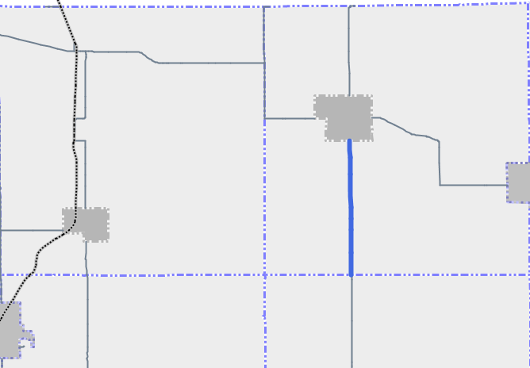
Figure 44: Map showing paved <#NETWORK1> road projects planned for 2018.

Figure 45: Map showing paved <#NETWORK1> road projects planned for 2019.
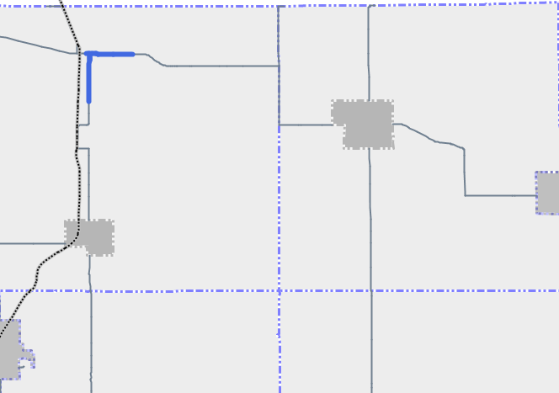
Figure 46: Map showing paved <#NETWORK1> road projects planned for 2020.

Paved <#NETWORK2> Projects
<#AGENCYSHORT> is currently planning the construction and maintenance projects listed in Appendix B for the paved <#NETWORK2> road network. The locations of these projects are shown in Figure 47, Figure 48, and Figure 49. The total cost of these projects is approximately <#YOUR CONTENT HERE>.
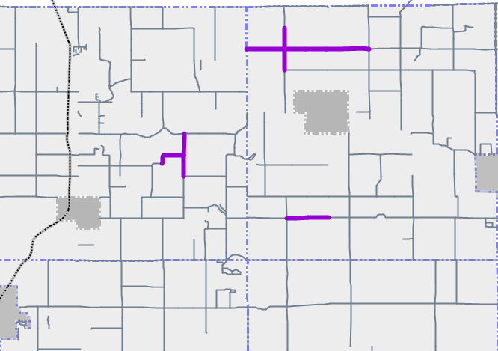
Figure 47: Map showing paved <#NETWORK2> road projects planned for 2018.
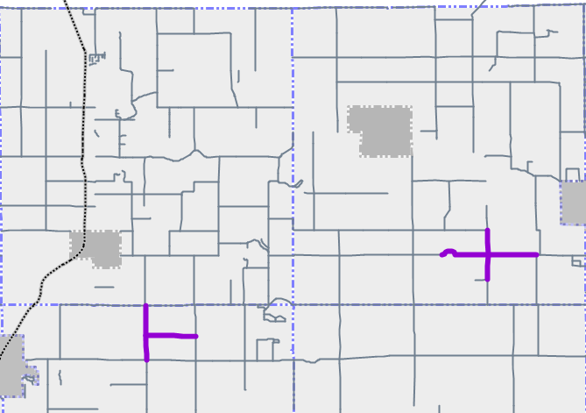
Figure 48: Map showing paved <#NETWORK2> road projects planned for 2019.
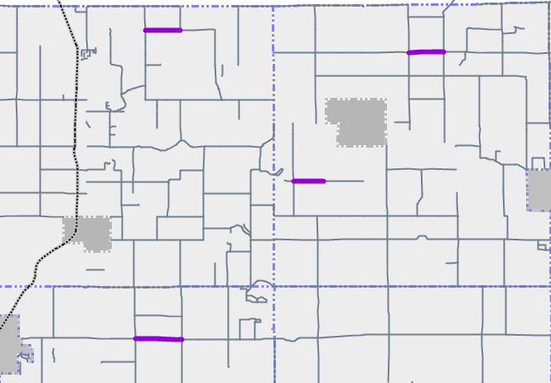
Figure 49: Map showing paved <#NETWORK2> road projects planned for 2020.

Unpaved Road Projects
<#AGENCYSHORT> is currently planning the construction and maintenance projects listed in Appendix C for the unpaved road network. The location of these projects are shown in Figure 50. The total cost of these projects is approximately <#YOUR CONTENT HERE>.
<#YOUR CONTENT HERE>
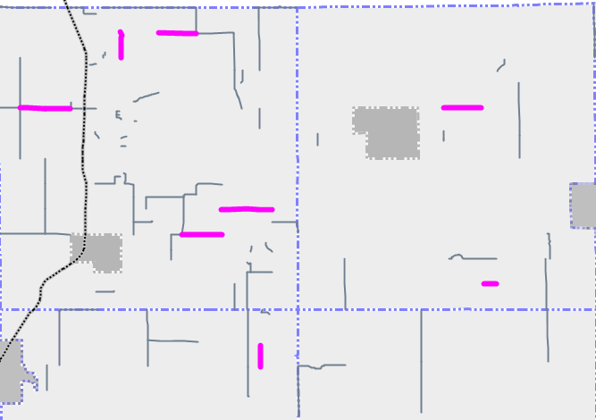
Figure 50: Map showing unpaved road projects planned for 2018-2020.
More detailed information on these projects can be found in Appendix A-C.

Gap Analysis
The current funding levels that <#AGENCYSHORT> receives are not sufficient to meet the goals for the paved <#NETWORK1> road network, the paved <#NETWORK2> road network, and the unpaved road network. The 1. Pavement Assets: Goals section of this plan provides further detail about the goals and the 1. Pavement Assets: Modelled Trends section provides further detail on the shortfall given the current budget. However, <#AGENCYSHORT> believes that the overall condition of this network can be maintained or improved with additional funding for construction and maintenance. An alternate strategy may be used to overcome the current shortfall and meet the goals on the paved <#NETWORK1> road network, the paved <#NETWORK2> road network, and the unpaved road network:
NCPP Network Quick Check to Meet Goals on the Paved <#NETWORK2> Network
The NCPP Quick Check can be used as an indicator of potential change in future pavement conditions based on the planned maintenance and construction work and the network size. This method is described in the 1. Pavement Assets: Modelled Trends section of this plan and further detailed in Appendix D.
Table 6 and Table 7 illustrate the results of the NCPP Quick Check method. Table 6 shows that the paved <#NETWORK1> road network will have a <#YOUR CONTENT HERE>Choose an item. of <#YOUR CONTENT HERE> mile-years of improvement. Table 7 shows that the paved <#NETWORK2> road network will have a <#YOUR CONTENT HERE>Choose an item. of <#YOUR CONTENT HERE> mile-years of improvement. To maintain current road conditions, the deficit must be overcome with a combination of maintenance and construction work.
Table 6: <#Modelled Trends, Planned Projects, and Gap Analysis for Road Assets>—Planned Projects and Gap Analysis: NCPP Quick Check Method for Paved <#NETWORK1> Road Network –<#NET1MILES> miles
Additional Annual Work Necessary To Overcome Deficit
Treatment Name | Average Yearly Miles of Treatment | Years of Life | Mile - Years
Crack Seal | <##> | <##> | <##>
Chip Seal | <##> | <##> | <##>
Overlay | <##> | <##> | <##>
Reconstruction | <##> | <##> | <##>
Total |  |  | <##>
(Deficit)/Surplus |  |  | <##>
Additional Annual Work Necessary To Overcome Deficit
Crack seal | ## | ## | ###
Chip seal | ## | ## | ###
Overlay | ## | ## | ###
Reconstruction | ## | ## | ###
Total |  |  | ###
(Deficit)/Surplus |  |  | ###

Table 7: <#Modelled Trends, Planned Projects, and Gap Analysis for Road Assets>—Planned Projects and Gap Analysis: NCPP Quick Check Method for Paved <#NETWORK2> Road Network (<#NET2MILES> miles)
Additional Annual Work Necessary To Overcome Deficit
Treatment Name | Average Yearly Miles of Treatment | Years of Life | Mile - Years
Crack seal | <##> | <##> | <##>
Chip seal | <##> | <##> | <##>
Overlay | <##> | <##> | <##>
Reconstruction | <##> | <##> | <##>
Total |  |  | <##>
(Deficit)/Surplus |  |  | <##>
Additional Annual Work Necessary To Overcome Deficit
Crack seal | ## | ## | ###
Chip seal | ## | ## | ###
Overlay | ## | ## | ###
Reconstruction | ## | ## | ###
Total |  |  | ###
(Deficit)/Surplus |  |  | ###

Table 6 outlines the additional project work for the paved <#NETWORK1> road network that would be required in order to meet its goal of maintaining <#YOUR CONTENT HERE> road conditions. This additional work on the paved <#NETWORK1> road network is anticipated to cost approximately <#YOUR CONTENT HERE> per year. Table 7 outlines the additional project work for the paved <#NETWORK2> road network that would be required in order to meet its goal of maintaining <#YOUR CONTENT HERE> road conditions. This additional work on the paved <#NETWORK2> road network is anticipated to cost approximately <#YOUR CONTENT HERE> per year.

Roadsoft Pavement Condition Forecast for the Paved <#NETWORK2> Network
<#AGENCYSHORT> used Roadsoft to forecast the necessary additional construction and maintenance work for meeting agency goals on the paved <#NETWORK1> and <#NETWORK2> road network. Table 8 and Table 9 illustrate the network-level model inputs used for this simulation. Full model inputs and outputs are included in Appendix D.
Table 8: <#Modelled Trends, Planned Projects, and Gap Analysis for Road Assets>—Planned Projects and Gap Analysis: Roadsoft Annual Work Program for HMA Paved <#NETWORK1> Road Network Forecast
Treatment Name | Annual Miles of Treatment | Years of Life | Trigger - Reset
Crack Seal | <##> | <##> | <##>
Chip Seal | <##> | <##> | <##>
Overlay | <##> | <##> | <##>
Reconstruction | <##> | <##> | <##>

Table 9: <#Modelled Trends, Planned Projects, and Gap Analysis for Road Assets>—Planned Projects and Gap Analysis: Roadsoft Annual Work Program for HMA Paved <#NETWORK2> Road Network Forecast
Treatment Name | Annual Miles of Treatment | Years of Life | Trigger - Reset
Crack Seal | <##> | <##> | <##>
Chip Seal | <##> | <##> | <##>
Overlay | <##> | <##> | <##>
Reconstruction | <##> | <##> | <##>

Results for the paved <#NETWORK2> road network from the Roadsoft network condition model given the inputs in Table 8 are shown in Figure 51 below. Results indicate that the necessary additional work needed to meet the agency condition goal would cost and additional <#YOUR CONTENT HERE> per year.
Figure 51: Forecast good/fair/poor Changes to <#AGENCYSHORT> Network Condition from planned projects on the <#NETWORK2> paved road network.
<#YOUR CONTENT HERE>

2. Financial Resources
Public entities must balance the quality and extent of services they can provide with the tax resources provided by citizens and businesses, all while maximizing how efficiently funds are used. <#AGENCYSHORT> will overview its general expenditures and financial resources currently devoted to pavement maintenance and construction. This financial information is not intended to be a full financial disclosure or a formal report. Michigan agencies are required to submit an Act 51 Report to the Michigan Department of Transportation each year; this is a full financial report that outlines revenues and expenditures. This report can be obtained <#financialswhere>.

<#NETWORK1> Network
<#AGENCYSHORT> has historical spent <#pnet1spendinghx> annually on pavement-related projects. Over the next three years, <#AGENCYSHORT> plans to spend <#pnet1spending> on <#NETWORK1>-network projects consisting of, but not limited to, reconstruction, overlay, culvert replacement, and preventive maintenance. Spending on projects depends on revenue from <#pnet1revsources>.

<#NETWORK2> Network
<#AGENCYSHORT> has historical spent <#pnet2spendinghx> annually on pavement-related projects. Over the next three years, <#AGENCYSHORT> plans to spend <#pnet2spending> on <#NETWORK2>-network projects consisting of, but not limited to, reconstruction, overlay, culvert replacement, and preventive maintenance. Spending on projects depends on revenue from <#pnet2revsources>.

3. Risk of Failure Analysis
Transportation infrastructure is designed to be resilient. The system of interconnecting roads and bridges maintained by <#AGENCYSHORT> provides road users with multiple alternate options in the event of an unplanned disruption of one part of the system. There are, however, key links in the transportation system that may cause significant inconvenience to users if they are unexpectedly closed to traffic. Figure 54 illustrates the key transportation links in <#AGENCYSHORT>’s road network, including those that meet the following types of situations:
- Geographic divides: Areas where a geographic feature (river, lake, mountain or limited access road) limits crossing points of the feature
- Emergency alternate routes for high-volume roads: Roads which are routinely used as alternate routes for high volume roads or roads that are included in an emergency response plan
- Limited access areas: Roads that serve remote or limited access areas that result in long detours if closed
- Main access to key commercial districts: Areas where large number or large size business will be significantly impacted if a road is unavailable.
Our road network includes the following critical assets: <#pavementrisk> (see Figure 54).

Figure 54: Key transportation links in <#AGENCYSHORT>’s road network

4. Coordination with Other Entities
An asset management plan provides a significant value for infrastructure owners because it serves as a platform to engage other infrastructure owners using the same shared right of way space. <#AGENCYSHORT> communicates with both public and private infrastructure owners to coordinate work in the following ways:

<#YOUR CONTENT HERE>
Example Coordinated Planning Text
<#AGENCYSHORT> maintains drinking water, sanitary and storm sewer assets in addition to transportation assets. <#AGENCYSHORT> follows an asset management process for all of its assets by coordinating the upgrade, maintenance, and operation of all major assets.
Planned projects for subsurface infrastructure that <#AGENCYSHORT> owns are listed in the following asset management plans: drinking water distribution system asset management plan, wastewater collection system asset management plan, storm sewer system asset management plan. These three sub-surface utility plans are coordinated with the transportation infrastructure plans to maximize value and minimize service disruptions and cost to the public.
<#AGENCYSHORT> takes advantage of coordinated infrastructure work to reduce cost and maximize value using the following policies:
- Roads which are in poor condition that have a subsurface infrastructure project planned which will destroy more than half the lane with will be rehabilitated or reconstructed full width using transportation funds to repair the balance of the road width.
- Subsurface infrastructure projects which will cause damage to pavements in good condition will be delayed as long as possible, or will consider methods that do not require pavement cuts.
- Subsurface utility projects will be coordinated to allow all under pavement assets to be upgraded in the same project regardless of ownership.
- Road reconstruction projects will not be completed until agency owned sub surface utilities are upgraded to have at least a 40 years of remaining service life.

Example Summit Text
Annually <#AGENCYSHORT> convenes an infrastructure planning summit in the first quarter of the year. Representatives from all of the major public and private infrastructure owners that have assets in the road right of way are provided notice for the meeting and are invited to attend. An attempt is made to coordinate the schedule of the event to allow the majority of infrastructure owners to attend.
<#AGENCYSHORT> provides all attendees of the infrastructure planning summit with a list of all planned road projects for the next three years that include new pavement structure. Infrastructure owners are encouraged to discuss planned projects that would disrupt transportation services or cause damage to pavements. Projects which may cause damage to pavements in good or fair condition are discussed and mitigation measures are proposed to minimize the impact to pavements. Mitigation measures could include rescheduling and coordinating projects to maximize value and minimize disruptions and cost to the public.

Appendix A: <#YOUR CONTENT HERE> Paved <#NETWORK1> Road Planned Projects

Appendix B: <#YOUR CONTENT HERE> Paved <#NETWORK2> Road Planned Projects

Appendix C: <#YOUR CONTENT HERE> Unpaved Road Planned Projects

Appendix D: A Quick Check of Your Highway Network Health
A Quick Check of Your Highway Network Health
By Larry Galehouse, Director, National Center for Pavement Preservation and
Jim Sorenson, Team Leader, FHWA Office of Asset Management

Historically, many highway agency managers and administrators have tended to view their highway systems as simply a collection of projects. By viewing the network in this manner, there is a certain comfort derived from the ability to match pavement actions with their physical/functional needs. However, by only focusing on projects, opportunities for strategically managing entire road networks and asset needs are overlooked. While the “bottom up” approach is analytically possible, managing networks this way can be a daunting prospect. Instead, road agency administrators have tackled the network problem from the “top down” by allocating budgets and resources based on historical estimates of need. Implicit in this approach, is a belief that the allocated resources will be wisely used and prove adequate to achieve desirable network service levels.
Using a quick checkup tool, road agency managers and administrators can assess the needs of their network and other highway assets and determine the adequacy of their resource allocation effort. A quick checkup is readily available and can be usefully applied with minimum calculations.
It is essential to know whether present and planned program actions (reconstruction, rehabilitation, and preservation) will produce a net improvement in the condition of the network. However, before the effects of any planned actions on the highway network can be analyzed, some basic concepts should be considered.
Assume every lane-mile segment of road in the network was rated by the number of years remaining until the end of life (terminal condition). Remember that terminal condition does not mean a failed road. Rather, it is the level of deterioration that management has set as a minimum operating condition for that road or network. Consider the rated result of the current network condition as shown in Figure 1.
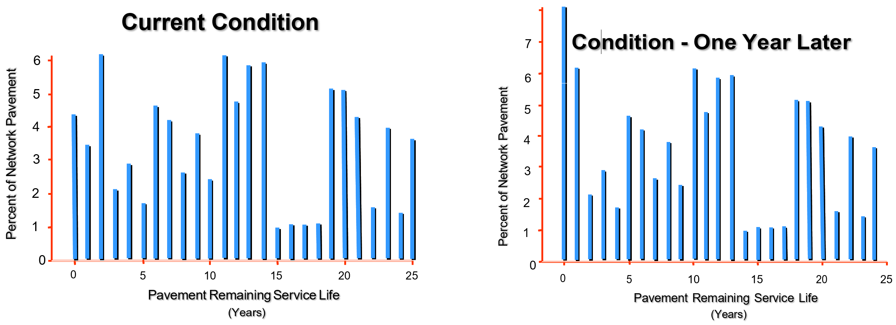
Figure 1 – Current Condition Figure 2 – Condition 1-Year Later
If no improvements are made for one year, then the number of years remaining until the end of life will decrease by one year for each road segment, except for those stacked at zero. The zero- stack will increase significantly because it maintains its previous balance and also becomes the recipient of those roads having previously been stacked with one year remaining. Thus, the entire network will age one year to the condition shown in Figure 2, with the net lane-miles in the zero stack raised from 4% to 8% of the network.
Some highway agencies still subscribe to the old practice of assigning their highest priorities to the reconstruction or rehabilitation of the worst roads. This practice of “worst first”, i.e., continually addressing only those roads in the zero-stack, is a proven death spiral strategy because reconstruction and rehabilitation are the most expensive ways to maintain or restore serviceability. Rarely does sufficient funding exist to sustain such a strategy.
The measurable loss of pavement life can be thought of as the network’s total lane-miles multiplied by 1 year, i.e., lane-mile-years. Consider the following quantitative illustration. Suppose your agency’s highway network consisted of 4,356 lane-miles. Figure 3 shows that without intervention, it will lose 4,356 lane-mile-years per year.
Agency Highway Network = 4,356 lane miles
Each year the network will lose
4,356 lane-mile-years
Figure 3 – Network Lane Miles
To offset this amount of deterioration over the entire network, the agency would need to annually perform a quantity of work equal to the total number of lane-mile-years lost just to maintain the status quo. Performing work which produces fewer than 4,356 lane-mile-years would lessen the natural decline of the overall network, but still fall short of maintaining the status quo. However, if the agency produces more than 4,356 lane-mile-years, it will improve the network.
In the following example, an agency can easily identify the effect of an annual program consisting of reconstruction, rehabilitation, and preservation projects on its network. This assessment involves knowing the only two components for reconstruction and rehabilitation projects: lane-miles and design life of each project fix. Figure 4 displays the agency’s programmed activities for reconstruction and Figure 5 displays it for rehabilitation.
Reconstruction Evaluation
Projects this Year = 2
Project | Design Life | Lane Miles | Lane Mile Years | Lane Mile Cost | Total Cost
No. 1 | 25 yrs | 22 | 550 | $463,425 | $10,195,350
No. 2 | 30 yrs | 18 | 540 | $556,110 | $10,009,980
 | Total | = | 1,090 |  | $20,205,330
Figure 4 - Reconstruction

Rehabilitation Evaluation
Projects this Year = 3
Project | Design Life | Lane Miles | Lane Mile Years | Lane Mile Cost | Total Cost
No. 10 | 18 yrs | 22 | 396 | $263,268 | $5,791,896
No. 11 | 15 yrs | 28 | 420 | $219,390 | $6,142,920
No. 12 | 12 yrs | 32 | 384 | $115,848 | $3,707,136
 | Total | = | 1,200 |  | $15,641,952
Figure 5 – Rehabilitation
When evaluating pavement preservation treatments in this analysis, it is appropriate to think in terms of “extended life” rather than design life. The term design life, as used in the reconstruction and rehabilitation tables, relates better to the new pavement’s structural adequacy to handle repetitive loadings and environmental factors. This is not the goal of pavement preservation. Each type of treatment/repair has unique benefits that should be targeted to the specific mode of pavement deterioration. This means that life extension depends on factors such as type and severity of distress, traffic volume, environment, etc. Figure 6 exhibits the agency’s programmed activities for preservation.

Preservation Evaluation
Project | Life Extension | Lane Miles | Lane Mile Years | Lane Mile Cost | Total Cost
No. 101 | 2 yrs | 12 | 24 | $2,562 | $30,744
No. 102 | 3 yrs | 22 | 66 | $7,743 | $170,346
No. 103 | 5 yrs | 26 | 130 | $13,980 | $363,480
No. 104 | 7 yrs | 16 | 112 | $29,750 | $476,000
No. 105 | 10 yrs | 8 | 80 | $54,410 | $435,280
 | Total | = | 412 |  | $1,475,850
Figure 6 – Preservation
To satisfy the needs of its highway network, the agency must accomplish 4,356 lane-mile-years of work per year. The agency’s program will derive 1,090 lane-mile-years from reconstruction, 1,200 lane-mile-years from rehabilitation, and 412 lane-mile-years from pavement preservation, for a total of 2,702 lane-mile-years. Thus, these programmed activities fall short of the minimum required to maintain the status quo, and hence would contribute to a net loss in network pavement condition of 1,653 lane-mile-years. The agency’s programmed tally is shown in Figure 7.
Network Trend

Programmed Activity |  |  | Lane-Mile-Years |  |  | Total Cost
Reconstruction |  |  | 1,090 |  |  | $20,205,330
Rehabilitation |  |  | 1,200 |  |  | $15,641,952
Preservation |  |  | 412 |  |  | $1,475,850
Total |  |  | 2,702 |  |  | $37,323,132
Network Needs (Loss) |  |  | ( - ) 4,356
Deficit | = |  |  | - 1,654
Figure 7 – Programmed Tally
This exercise can be performed for any pavement network to benchmark its current trend. Using this approach, it is possible to see how various long-term strategies could be devised and evaluated against a policy objective related to total-network condition.
Once the pavement network is benchmarked, an opportunity exists to correct any shortcomings in the programmed tally. A decision must first be made whether to improve the network condition or just to maintain the status quo. This is a management decision and system goal.
Continuing with the previous example, a strategy will be proposed to prevent further network deterioration until additional funding is secured.
The first step is to modify the reconstruction and rehabilitation (R&R) programs. An agonizing decision must be made about which projects to defer, eliminate, or phase differently with multi- year activity. In Figure 8, reductions are made in the R&R programs to recover funds for less costly treatments in the pavement preservation program. The result of this decision recovered slightly over $6 million.
Program Modification

Programmed Activity | Lane-Mile-Years | Cost Savings
Reconstruction 31 lane miles  ( 40 lane-miles ) | 820  ( 1,090 ) | $5,004,990
Rehabilitation 77 lane miles  ( 82 lane-miles ) | 1,125  ( 1,200 ) | $1,096,950
Pavement Preservation  ( 84 lane-miles ) | ( 412 ) | 0
Total = | 2,357  ( 2,702 ) | $6,101,940
Figure 8 – Revised R & R Programs
Modifying the reconstruction and rehabilitation programs has reduced the number of lane-mile- years added to the network from 2,702 to 2,357 lane-mile-years. However, using less costly treatments elsewhere in the network to address roads in better condition will increase the number of lane-mile-years added to the network. A palette of pavement preservation treatments, or mix of fixes, is available to address the network needs at a much lower cost than traditional methods.
Preservation treatments are only suitable if the right treatment is used on the right road at the right time. In Figure 9, the added treatments used include concrete joint resealing, thin hot-mix asphalt (HMA) overlay (≤ 1.5”), microsurfacing, chip seal, and crack seal. By knowing the cost per lane-mile and the treatment life-extension, it is possible to create a new strategy (costing $36,781,144) that satisfies the network need. In this example, the agency saved in excess of $500,000 from traditional methods (costing $37,323,132), while erasing the 1,653 lane-mile-year deficit produced by the initial program tally. Network Strategy

Programmed Activity |  | Lane Mile Years | Total Cost
Reconstruction
 | ( 31 lane-miles ) | 820 | $15,200,340
Rehabilitation
 | ( 77 lane-miles ) | 1,125 | $14,545,002
Pavement Preservation
 | (84 lane-miles) | 412 | $1,475,850
Concrete Resealing | (4 years x 31 lane-miles) | 124 | $979,600
Thin HMA Overlay | (10 years x 16 lane-miles) | 160 | $870,560
Microsurfacing | (7 years x 44 lane-miles) | 308 | $1,309,000
Chip Seal | (5 years x 79 lane-miles) | 395 | $1,104,420
Crack Seal | (2 years x 506 lane-miles) | 1,012 | $1,296,372
 | Total = | 4,356 | $36,781,144
Figure 9 – New Program Tally
In a real-world situation, the highway agency would program its budget to achieve the greatest impact on its network condition. Funds allocated for reconstruction and rehabilitation projects must be viewed as investments in the infrastructure. Conversely, funds directed for preservation projects must be regarded as protecting and preserving past infrastructure investments.
Integrating reconstruction, rehabilitation, and preservation in the proper proportions will substantially improve network conditions for the taxpayer while safeguarding the highway investment.

Appendix E: Roadsoft Network-level Model Inputs and Outputs

Appendix F: Meeting Minutes Verifying Plan Acceptance by Governing Body

